**Analytical Finance Ⅰ**



**MMA707**

18th Oct 2010

**Roll-Geske-Whaley Model**

**Group 4**

**Participants:**

Fan Rui

**Lecturer:**

Jan R. M. Röman

*Department of Mathematics and Physics*

*Mälardalen University, Sweden*

**Abstract**

During the last years there have emerged a number of analytical models for American options. These methods are all approximations in some since. The Roll-Geske-Whaley model is one of the most common analytical models for American contracts.

The aim of this report is try to implement Roll-Geske-Whaley (for a call option) with software and compare the result with the Black-Scholes model .

And Use graphics to present the result.  
**Contents**

Introduction 4

The Roll-Geske-Whaley Model 5

Example 8

Computer algorithm 11

Comparison of two models 18

Example in application 18

Conclusion 18

List of References 20

# Introduction

Roll(1977), Geske (1979a), and Whaley (1981) developed a formula for the valuation of an American call option on a stock paying a single dividend of D, with time to dividend payout t. It has for a long time been considered a closed-form solution for American call options on dividend-paying stocks. however, as pointed out by Beneder and Vorst (2001), Haug, Haug, and Lewis (2003), and others, the model is based on the escrowed dividend price process and is seriously flawed, resulting in arbitrage opportunities among other problems.

During the last years there have emerged a number of analytical models for American options. These methods are all approxima- tions in some since. The Roll-Geske-Whaley model is one of the most common analytical models for American contracts.

The report consists of three parts. The first part will mainly cover formulas. in the second part, I will solve examples for the model . While, I will show the computer algorithm of the model and try to compare the result with the Black-Scholes model in the last part.

# The Roll-Geske-Whaley Model

An American call option can be considered to be a series of call options which expire at the ex-dividend dates, and this case becomes a compound option or (an option on an option) with a closed-form solution (the relationship between the Roll-Geske-Whaley model and Black-Scholes model can be seen in figure 1)as follows:

$$C≈\left(S-De^{-rt}\right)N\left(b_{1}\right)+\left(S-De^{-rt}\right)M\left(a_{1},-b_{1};-\sqrt{\frac{t}{T}}\right)-Xe^{-rT}M\left(a_{2},-b_{2};-\sqrt{\frac{t}{T}}\right)-\left(X-D\right)e^{-rt}N\left(b_{2}\right)$$

(1)

where

$$a_{1}=\frac{In\left[(S-De^{-rt})/X\right]+\left(r+\frac{{}^{2}}{2}\right)T}{\sqrt{T}}$$

$$b_{1}=\frac{ln\left[(S-De^{-rt})/X\right]+\left(r+\frac{{}^{2}}{2}\right)T}{\sqrt{t}}$$

$$b_{2}=b_{1}-\sqrt{t}$$

C =The value of an option

S =The stock price

X =The strike price

T =The time to maturity

t =The time of dividend

r =The risk-free interest rate

 =The volatility

Where N(x) is the cumulative normal distribution function and where *M*(*a*,*b*, ) is the bivariate cumulative normal distribution function with upper integral limits a and b, and correlation coefficient , as described in Chapter 13[1], I is the critical ex-dividend stock price I that solves

$$c\left(I,X,T-t\right)=I+D-X,$$

where c(S) is the price given by Black-Scholes and T- $t_{1}$ time to maturity. The critical stock price can be solved iteratively via the Bisectional method. If $D≤X(1-e^{-r\left(T-t\right)})$ or I= it will not be optimal to exercise the option can be found by using the BSM formula where the stock price is replaced with the stock price minus the present value of the dividend payment $S-De^{-rt}$.

This model was for many years considered a brilliant closed-form solution. As indicated above, the approach has considerable flaws that lead to sighificant arbitrage opportunities, and thus renders it more or less useless for all pratical purposes.[2] 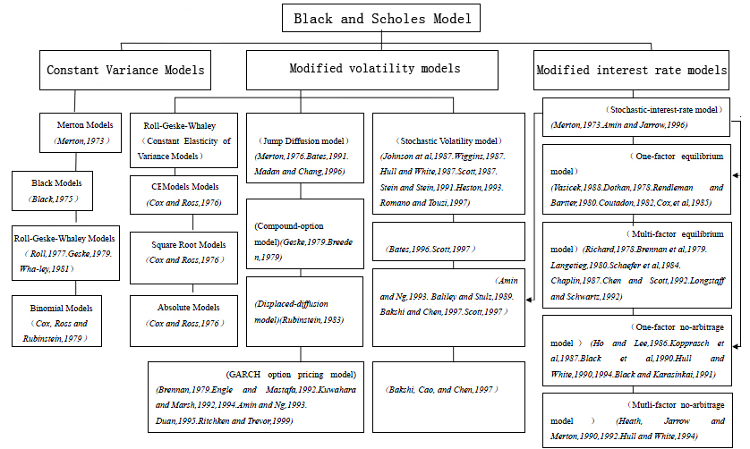

Figure 1, Black-Scholes model

# Example

**Example 1**

Consider an American-style call option on a stock that will pay a dividend of 4 in exactly three months. The stock price is 80, the strike price is 82, time to maturity is four months, the risk-free interest rate is 6%, and the volatility is 30%. S=80, X=82, t=0.25, T=0.3333, r=0.06, D=4, =0.3.

$$a_{1}=\frac{ln\left[(80-4e^{-0.06×0.25)/82}\right]+\left(0.06+\frac{{0.3}^{2}}{2}\right)0.3333}{0.3\sqrt{0.3333}}=-0.2321$$

$a_{2}=a_{1}-0.3\sqrt{0.3333}=-0.4053$

The critical stock price I solves

c(I,82,0.3333-0.25)=I+4-82

The solution, given by a numerical search algorithm, is I=80.1173. Moreover:

$$b_{1}=\frac{ln\left[(80-4e^{-0.06×0.25)/80.1173}\right]+\left(0.06+\frac{{0.3}^{2}}{2}\right)0.25}{0.3\sqrt{0.25}}=-0.1715$$

$$M\left(a_{1},{-b}_{1};-\sqrt{\frac{0.25}{0.3333}}\right)=0.0703$$

$$M\left(a_{2},-b_{2};-\sqrt{\frac{0.25}{0.3333}}\right)=0.0632$$

N（$b_{1})$ =N(-0.1715)=0.4319 N($b_{2})$ =N(-0.3215)=0.3739

$$C≈\left(80-4e^{-0.06×0.25}\right)N\left(b_{1}\right)+\left(80-4e^{-0.06×0.25}\right)M\left(a_{1},{-b}_{1};-\sqrt{\frac{0.25}{0.3333}}\right)-82e^{-0.06×0.3333}M(a_{2},{-b}_{2};-\sqrt{\frac{0.25}{0.3333})}$$

$$-(82-4{)e}^{-0.06×0.25}N\left(b_{2}\right)=4.3860$$

The value of a similar European call is 3.5107.

**Example 2**

Consider the case of an initial stock price of 100, strike 130, risk-free rate 6%, volatility 30%,one year to maturity, and an expected dividend payment of seven in 0.999 years. Using this input, the RGW model posits a value of 4.3007. Consider now another option, expiring just before the dividend payment, say, in 0.9998 years. Since this in effect is an exercise it before maturity. This is, however, an arbitrage opportunity! The arbitrage occurs because the RGW model is misspecified, in that the dynamics of the stock price process depends on the timing of the dividend. Similar examples have been discussed by Beneder and Vorst (2001) and Frishling (2002). This is not just an esoteric example, as several well-known software systems use the RGW model and other similar misspecified models.

# Computer algorithm

q1 = 3209.37758913847 + x2 * (377.485237685302 + x2 * (113.86415415105 + x2 * (3.16112374387057 + x2 * 0.185777706184603)));

q2 = 2844.23683343917 + x2 * (1282.61652607737 + x2 * (244.024637934444 + x2 * (23.6012909523441 + x2)));

the value of q1 and q2 will overflow in VBA.

function RollGeskeWhaley= RollGeskeWhaley( s, x, v, r , T, D, TD )

%UNTITLED5 Summary of this function goes here

% Detailed explanation goes here

BIGNUM= 100000000;

EPSILON= 0.00001;

mCall = 1;

SX = s - D * exp(-r * TD);

% Not optimal to exercise.....

if (D <= x * (1 - exp(-r * (T - TD))))

RollGeskeWhaley = GBlackScholes(mCall, SX, x, T, r, r, v);

else

ci = GBlackScholes(mCall, SX, x, T - TD, r, r, v);

HighS = s;

while ((ci - HighS - D + x) > 0 && (HighS < BIGNUM))

HighS = 2 * HighS;

ci = GBlackScholes(mCall, HighS, x, T - TD, r, r, v);

end

if (HighS < BIGNUM)

RollGeskeWhaley = GBlackScholes(mCall, SX, x, T, r, r, v);

else

LowS = 0;

i = HighS * 0.5;

ci = GBlackScholes(mCall, i, x, T - TD, r, r, v);

% Find the critical Stock Price with Bisection.

while (Abs(ci - i - D + x) > EPSILON && (HighS - LowS) > EPSILON)

if ((ci - i - D + x) < 0)

HighS = i;

else

LowS = i;

end

i = (HighS + LowS) / 2;

ci = GBlackScholes(mCall, i, x, T - TD, r, r, v);

end

a1 = (log(SX / x) + (r + v * v / 2) * T) / (v * sqrt(T));

a2 = a1 - v * sqrt(T);

b1 = (log(SX / i) + (r + v * v / 2) * TD) / (v * sqrt(TD));

b2 = b1 - v * sqrt(TD);

c = SX * (xCND(b1) + M(a1, -b1, sqrt(TD / T))) - x * exp(-r * T) * M(a2, -b2, -sqrt(TD / T)) - (x - D) * exp(-r * TD) * xCND(b2);

RollGeskeWhaley = c;

end

end

end

function GBlackScholes = GBlackScholes( mCall, s , x , T , r , b , v )

%UNTITLED Summary of this function goes here

% Detailed explanation goes here

if (T <= 0)

T = 0.000000001;

end % So we don't divide by zero

d1 = (log(s / x) + (b + v * v / 2) * T) / (v * sqrt(T));

d2 = d1 - v * sqrt(T);

if (mCall)

if (T > 0)

GBlackScholes = s * exp((b - r) * T) * xCND(d1) - x * exp(-r * T) * xCND(d2);

else

GBlackScholes = WorksheetFunction.Max(s - x, 0);

end

else

if (T > 0)

GBlackScholes = x * exp(-r * T) * xCND(-d2) - s * exp((b - r) * T) * xCND(-d1);

else

GBlackScholes = max(x - s, 0);

end

end

end

function xCND=xCND( x )

%UNTITLED3 Summary of this function goes here

% Detailed explanation goes here

if(x<0)

x=-x;

sgn1=-1;

elseif(x>0)

sgn1=1;

else

xCND=0.5;

end

if(x>20)

if(sgn1<0)

xCND=0;

else

xCND=1;

end

end

x = 0.707106781186547 * x;

x2 = x * x;

if (x < 0.46875)

q1 = 3209.37758913847 + x2 * (377.485237685302 + x2 * (113.86415415105 + x2 * (3.16112374387057 + x2 * 0.185777706184603)));

q2 = 2844.23683343917 + x2 * (1282.61652607737 + x2 * (244.024637934444 + x2 * (23.6012909523441 + x2)));

xCND = 0.5 * (1 + sgn1 * x * q1 / q2);

elseif (x < 4)

q1 = 1230.339354798 + x * (2051.07837782607 + x * (1712.04761263407 + x * (881.952221241769 + x * (298.6351381974 + x * (66.1191906371416 + x * (8.88314979438838 + x * (0.56418849698867 + x * 2.15311535474404E-08)))))));

q2 = 1230.33935480375 + x * (3439.36767414372 + x * (4362.61909014325 + x * (3290.79923573346 + x * (1621.38957456669 + x * (537.18110186201 + x * (117.693950891312 + x * (15.7449261107098 + x)))))));

xCND = 0.5 * (1+ sgn1 * (1 - exp(-x2) * q1 / q2));

else

q0 = 1 / x2;

q1 = 6.58749161529838E-04 + q0 * (1.60837851487423E-02 + q0 * (0.125781726111229 + q0 * (0.360344899949804 + q0 * (0.305326634961232 + q0 * 1.63153871373021E-02))));

q2 = 2.33520497626869E-03 + q0 * (6.05183413124413E-02 + q0 * (0.527905102951428 + q0 * (1.87295284992346 + q0 * (2.56852019228982 + q0))));

xCND = 0.5 * (1 + sgn1 * (1 - exp(-x2) / x * (0.564189583547756 - q0 * q1 / q2)));

end

end

Price dynamics

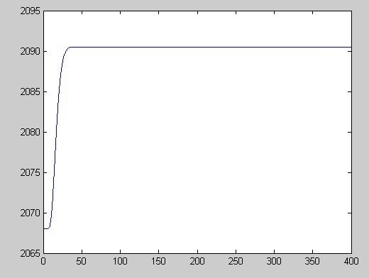

# Comparison of two models

|  |  |  |  |  |  |  |
| --- | --- | --- | --- | --- | --- | --- |
|  | model | Implied volatility estimates | Number  observed | Data  period | Average  error | Average  Absolute  error |
| Stucki  Wasserfalen  (1991) | B-S  RGW | A week before | 1321  1617 | 1986-  1987 | 0.2%  0.2% | 4.3%  4.2% |

# Conclusion

In the report, we consider a model for a call option. First of all, we introduce the formula of the RGW model. The examples above show the process. Then, I implement the RGW model in Matlab. And the price of option can be obtained from that. At last, I compare the RGW model with B-S model.

# **List of References**

* Espen Gaarder Haug, *The Complete Guide To Option Pricing Formulas*, McGraw-Hill, cop.2006
* Lecture notes AFI 2010
* Shang Libin, Mathematical Modeling and Methods of Option Pricing,Higher Education Press,2003

1. See it in The Complete Guide to Option Pricing Formulas (2006 2nd ed. Haug)
2. See Haug, Haug and Lewis (2003) for more details on its shortcomings.