Section 9.2 Discounted Dividend Model

Problem. For the last two years, Hot Prospects Inc. has generated a very high real Return On Investment (Real ROI) of 22.3% and 20.7%. Over the last three years, its dividends per share has increased rapidly from $5.10 to $5.84 to $6.64. As the competition catches up over the next five years, the Hot Prospects Real ROI is expected to gradually slow down. The long-run forecast calls for the firm’s Real ROI to match the the firm’s real discount rate (Real k), which is 9.0% per year. Hot Prospects follows a policy of retaining 50.0% of its earnings and paying out the rest as dividends. The inflation rate over the last two years has been a modest 2.8% and 3.1% and is expected to be 3.0% per year indefinitely. What is the firm’s intrinsic value / share?

Solution Strategy. Construct a two-stage discounted dividend model. In stage one, explicitly forecast the firm’s dividend over a five-year horizon. In stage two, forecast the firm’s dividend from year six to infinity and calculate it’s continuation value as the present value of this constant growth annuity. Then, discount the future dividends and the date 5 continuation value back to the present to get the intrinsic value per share.

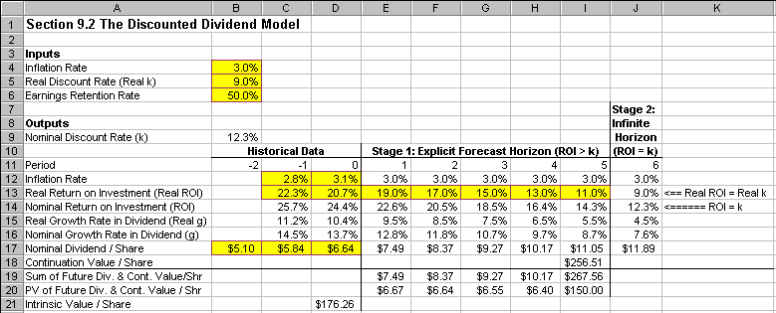
FIGURE 9.2.1 Spreadsheet for Discounted Dividend Model.

How To Build Your Own Spreadsheet Model.

- Inputs. Enter the inflation rate, real discount rate, and earnings retention rate into the range B4:B6. Enter the historical inflation rate and historical Real ROI into the range C12:D13. Enter the historical nominal dividend per share into the range B17:D17.

- Forecast Future Real and Nominal ROI. In the long-run, the firm’s Real ROI is forecast to equal the firm’s real discount rate. Enter =B5 in cell J13. Given the Real ROI of 20.7% on date 0 and a forecast of 9.0% per year starting in year 6, forecast the intermediate years by entering a smooth declining pattern, such as 19.0%, 17.0%, 15.0%, etc. from date 1 to date 5 in the range E13:I13. Calculate the Nominal Return On Investment (ROI) = (1 + Inflation Rate) * (1 + Real ROI) - 1. Enter =(1+E12)*(1+E13)-1 in cell E14 and copy it across the range C14:J14.

- Real and Nominal Growth Rate in Dividends. Calculate the Real Growth Rate in Dividend (Real g) = (Real ROI) * (Earnings Retention Rate). Enter =E13*$B$6 in cell E15 and copy it across the range F15:J15. Calculate the Nominal Growth Rate in Dividend (g) = (1 + Inflation Rate) (1 + Real g) - 1. Enter =(1+$B$4)*(1+E15)-1 in cell E16 and copy it across the range F16:J16.

- Nominal Dividend / Share. Calculate the Date t Nominal Dividend = (Date t-1 Nominal Dividend) * (1 + Date t Nominal Growth Rate in Dividend). Enter =D17*(1+E16) in cell E17 and copy it across the range F17:J17.

- Date 5 Continuation Value. The Date 5 Continuation Value is the present value of the stream of dividends from date 6 to infinity. Using the present value of an infinitely growing annuity formula, calculate Date 5 Continuation Value = (Date 6 Dividend) / (Nominal Discount Rate – Date 6 Nominal Growth Rate in Dividends). Enter =J17/(B9-J16) in cell I18.

- Sum and PV of Future Dividends and the Continuation Value / Share. On each date, sum the future dividend and continuation value / share. Enter =SUM(E17:E18) in cell E19 and copy it across the range F19:J15. Calculate the Present Value of the Future Dividend and Continuation Value / Share = (Date t Sum) * ((1 + Nominal Discount Rate) ^ t). Enter =E19/((1+$B$9)^E11) in cell E20 and copy it across the range F20:J20.

- Intrinsic Value Per Share. Sum the PV of Future Dividends and Continuation Value. Enter =SUM(E20:I20) in cell D21.

Hot Prospects Inc. is estimated to have an intrinsic value per share of $176.26.

Using The Power Of Your Spreadsheet Model.

How sensitive is the Intrinsic Value to changes in: (1) the Inflation Rate, (2) Earnings Retention Rate, and (3) Real Discount Rate (k)? Said differently, how important is it to be very accurate in forecasting these three inputs? You can answer question (1) with a One-Way Data Table and questions (2) and (3) with a Two-Way Data Table.

- Create A List of Input Values and An Output Formula. Create a list of input values for the Inflation Rate (0.0%, 1.0%, 2.0%, etc.) in the range C25:H25. Create an output formula that references the Intrinsic Value by entering the formula =D21 in cell B26.

- One-Way Data Table. Select the range B25:H26 for the One-Way Data Table. Then choose Data Table from the main menu and a Table dialog box pops up. Enter the cell address K10 (Real Growth Rate of Dividend) in the Row Input Cell, enter the cell address B4 (Inflation Rate) in the Column Input Cell, and click on OK.

We see that the Intrinsic Value is always $176.26 for every inflation rate. Hence, the inflation rate has no impact on the Intrinsic Value and accuracy in forecasting the inflation rate is irrelevant.

- Create A List of Input Values and An Output Formula. Create a list of input values for the Earnings Retention Rate in descending order (70.0%, 60.0%, 50.0%, etc.) in the range C31:H31. Similarly, create a list of input values for the Real Discount Rate (k) in descending order (14.0%, 13.0%, 12.0%, etc.) in the range B32:B36. Create an output formula that references the Intrinsic Value by entering the formula =D21 in cell B31.

- Two-Way Data Table. Select the range B31:H36 for the Two-Way Data Table. This range includes both the list of input values at the top and side of the data table and the output formula in the upper left corner. Then choose Data Table from the main menu and a Table dialog box pops up. Enter the cell address B6 (Earnings Retention Rate) in the Row Input Cell, enter the cell address B5 (Real Discount Rate) in the Column Input Cell, and click on OK.

- 3-D Graph of the Sensitivity Analysis. Highlight the interior of the data table (excluding the top or side) in the range C32:H36 and then choose Insert Chart from the main menu. Select a Surface chart type and make other selections to complete the Chart Wizard.

Both the Two-Way Data Table and the 3-D Graph, indicate that the Intrinsic Value is very sensitive to the Earnings Retention Rate and the Real Discount Rate (k). Hence, it is important to be as accurate as possible about both the Earnings Retention Rate and the Real Discount Rate.

FIGURE 9.2.2 Spreadsheet for the Sensitivity Analysis.

