8.7 THE VASICEK YIELD CURVE MODEL

So far we have taken the yields on various bonds as given. But what determines the U.S. Treasury yield curve? And what drives changes in the yield curve over time? A well-known answer, widely used by practitioners, is the famous Vasicek yield curve model.

The Vasicek model assumes that all of the information needed to describe the yield curve can be summarized by a single factor, namely, the short rate r. The short rate is the interest rate on a very short-term bond. Indeed, it is sometimes called the instantaneous short rate. At any moment, the short rate offers a known, risk-free rate of return with no uncertainty.

Vasicek assumes that this single factor, the short rate r, changes continuously through time. The short rate factor may be relatively high or low at any moment in time, but it has a tendency to return to a long-run mean level L. If r is greater than L, then r tends to decrease. If r is less than L, then r tends to increase. This “mean-reverting” feature implies that the short rate does not have a tendency to keep getting bigger and bigger, but instead fluctuates around the long-run mean level L. How fast r tends to revert to L is called the speed of adjustment S. A high value for S means rapid mean reversion to L and implies that r hovers close to L most of the time.

FIGURE 8.7.1 The Mean-Reverting Quality of the Short Rate Factor

Short If r is greater than L,
rate r r tends to go down

⬅ L = Long-run mean level

If r is less than L,
r tends to go up

Time

Specifically, Vasicek assumes that the change in the short rate r is normally distributed over any finite time interval. The mean is positive when r is currently less than L and negative when r is currently greater than L. The standard deviation $σ$ is constant from instant to instant.

Vasicek considers a pure discount bond with time to maturity T which pays $1 at maturity and has no coupon payments. This bond is risky because its price fluctuates as the yield curve shifts up and down. In order for investors to be willing to hold this bond they must receive $λ$, an extra rate of return per unit of interest rate risk. $λ$ is called the market price of interest rate risk.

Vasicek solves for the pure discount bond price P and yield Y
$$\begin{aligned}P=e^{A−\text{Br}} Y=\left(\frac{−A}{T}\right)+\left(\frac{B}{T}\right)r \\ \\ \text{where }B=\frac{1−e^{−\text{ST}}}{S} \\ Y_{∞}=L−\frac{σ^{2}}{2S^{2}}+\frac{\text{λσ}}{S} \\ A=\left(B−T\right)Y_{∞}−\frac{σ^{2}B^{2}}{4S^{2}}\end{aligned}$$

and where

$$\begin{aligned}P=\text{price of the bond} \\ T=\text{time to maturity of the bond} \\ r=\text{short rate factor} \\ L=\text{long-run mean level} \\ S=\text{speed of adjustment} \\ σ=\text{standard deviation} \\ λ=\text{market price of interest rate risk} \\ e=\text{the base of the natural log function }(\text{approximately 2}\text{.}\text{71828})\end{aligned}$$

Notice that the bond price P is $e$to the power $A−\text{Br}$, where the power is a linear function of the single, short-rate factor r. Similarly, the yield Y is a linear function of the same short-rate factor r. The Vasicek model is a Linear Factor model. Linear Factor models constitute a broad class of yield curve models that are flexible enough to capture many real-world features of the yield curve and how those yield curves change over time. All Linear Factor models share the same outcome that bond prices are to a linear function of one (or more) factors and yields are a linear function of the same factors. The linearity is an outcome of the model, not an assumption. It is generated primarily by the assumed normal distribution.

Figure 8.7.2 illustrates how Vasicek model yields are linear in the short rate factor r. Yield to maturity is on the y-axis and bonds of various maturities are plotted. For any given bond, the yield is linear in the short rate factor. Interestingly, bonds with shorter maturities (i.e., 1 year, 5 years) have steeper lines than bonds with longer maturities (i.e., 20 years, 30 years). This implies that yields are short-term bonds are more sensitive to changes in the short rate than yields on long-term bonds.

FIGURE 8.7.2 Example Showing that Yield Is A Linear Function Of The Short-rate Factor

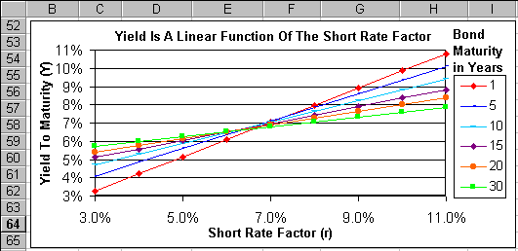
Having yields that are linear functions of the factors does not imply that the yield curve (with time to maturity on the x-axis) is linear. Indeed, even a yield curve model with only one factor driving it can generate a fairly rich family of yield curve shapes. The Vasicek model can generate three different shapes depending on the level of the short rate r. Figure 8.7.3 shows these three shapes. When r is low (3.5% in this example), the yield curve is upward slopping. When r is high (10.0%), the yield curve is downward slopping. When r is intermediate (6.5%), the yield curve is (barely) hump shaped.

FIGURE 8.7.3 Three Shapes of the Vasicek Yield Curve

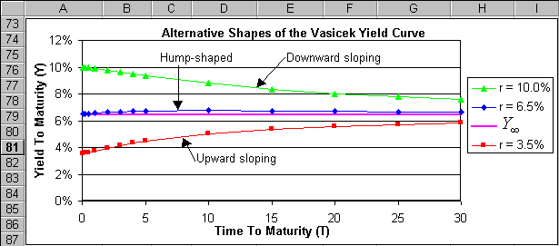
As time to maturity becomes large, all three of these yield curves asymptote to the same point $Y_{∞}$. Thus, the infinitely-long rate of the yield curve (as time to maturity goes to infinity) is fixed and all of the movement in the yield curve is generated by the short-rate r. Yield curve movements in the Vasicek model can be likened to the waging of a dog’s tail. The right end of the tail is fixed to the dog and thus does not move. The left end of the tail is free and thus the tip of the tail can be thought of as wagging the rest of the tail. In this case, the yield on an infinitely-lived bond is fixed at $Y_{∞}$ and the short rate r wags the entire yield curve.

Recall that Vasicek makes the simple assumption that the standard deviation is constant from instant to instant. Clearly this means the standard deviation $σ$ is independent of the level of the short-rate r. This simple model may not be rich enough to capture some of the volatility patterns that we observe in the real world. For example, a crude way to characterize U.S. yield curve history is that the volatility of the yield curve was low in the 1970’s and 1990’s when the level of the yield curve was generally low. By contrast, the volatility of the yield curve was high in the 1980’s (especially the early 80’s), when the level of the yield curve was generally high. The connection between the volatility and level of the yield curve is one of many properties that can be directly observed from a “movie” of U.S. yield curve history. The web site www.kelley.iu.edu/finweb/holden.htm contains a free, interactive spreadsheet model which generates a “movie” of 27 years of monthly U.S. yield curve data.

The connection between volatility and level is addressed by the famous model of Cox, Ingersoll, and Ross (CIR). CIR develops a single factor model of the yield curve which is also based on the short rate r. However, they make a key modification. They assume that the standard deviation is higher when the level of the short-rate r is higher. Potentially, this allows the model to capture the type of real-world volatility patterns described above. Given this modified assumption, CIR solve for the pure discount bond price P and yield Y

$$P=e^{A−\text{Br}} Y=\left(\frac{−A}{T}\right)+\left(\frac{B}{T}\right)r$$

where the CIR formulas for and are relatively complex formulas. An interactive spreadsheet of the CIR model, plus complete formulas for and and additional CIR background, can be downloaded from www.kelley.iu.edu/finweb/holden.htm. The CIR model is clearly a Linear Factor model. Along with the Vasicek model, the CIR model is widely used by practitioners.

Both the Vasicek and CIR models are driven by a single factor, the short rate r. A subtle implication of this approach is that when r increases, the entire yield curve moves up. Similarly, when r decreases, the entire yield curve moves down. However, in the real-world it is not unusual to observe changes in the “slope” of the yield curve. That is, sometimes yields on short-term bonds increase and simultaneously yields on long-term bonds decrease (or visa versa). Thus, we observe two independent changes in the yield curve: namely changes in the slope and changes in the level. A single factor model can not capture two independent changes. A two factor model is required for this.

Longstaff and Schwartz develop a two factor model of the yield curve. The first factor is the short rate r and the second factor is V the volatility of the short rate. Their model allows volatility to change randomly through time. Longstaff and Schwartz solve for the pure discount bond price P and yield Y
$$P=e^{A−\text{Br}−\text{CV}} Y=\left(\frac{−A}{T}\right)+\left(\frac{B}{T}\right)r+\left(\frac{C}{T}\right)V,$$

where the Longstaff and Schwartz formulas for and are relatively complex. An interactive spreadsheet of the Longstaff and Schwartz model, plus complete formulas for and and additional background, can be downloaded from www.kelley.iu.edu/finweb/holden.htm. The Longstaff and Schwartz model is also a Linear Factor model. With two factors, it allows independent changes in the slope and in the level of the yield curve. Further, it does a good job of fitting yield curve data. There are plenty more Linear Factor models based on two or more factors.

Spreadsheet Modeling Exercise: Section 8.7 Vasicek Yield Curve

Problem. The current short rate is 3.5% per year. The short reverts to a long-run mean level of 5.0% at a speed of adjustment of 0.12 with a standard deviation of 2.00% per year. The market price of risk is 0.17 extra return per unit of interest rate risk. What is the price and yield to maturity of a six-month (0.5 year), pure discount bond?

FIGURE 8.7.4 Spreadsheet of the Vasicek Yield Curve

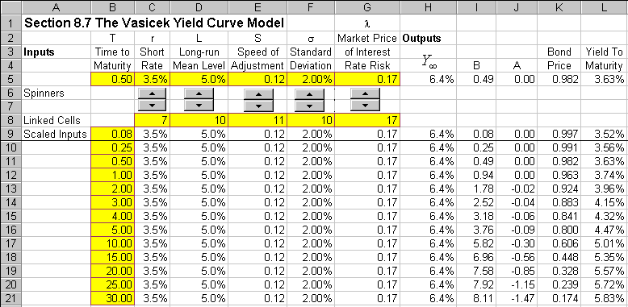
How To Build Your Own Spreadsheet Model.

- Inputs. Enter the inputs described above into the range B5:G5.

- $Y_{∞}$, B, and A Formulas. In cell H5, enter the $Y_{∞}$ formula

=D5-F5^2/(2*E5^2)+G5*F5/E5.

Then in cell I5, enter the formula

=(1-EXP(-E5*B5))/E5.

And next in cell J5, enter the formula

=(I5-B5)*H5-(F5^2*I5^2)/(4*E5).

- Bond Price and Yield Formulas. In cell K5, enter the bond price formula

=EXP(J5-I5*C5)

and in cell L5, enter the yield-to-maturity formula

=-J5/B5+(I5/B5)*C5.

We see that a six-month, pure discount bond which pays $1 at maturity is predicted by the Vasicek yield curve model to have a current price of $0.982 and yield of 3.63%.

Using The Power Of Your Spreadsheet Model.

If you increased the long-run mean level L, what would happen to the yield curve? If you increased the market price of risk $λ$, what would happen to the yield curve? You can answer these questions and more by creating an interactive spreadsheet model using “spinners.” Spinners are up-arrow / down-arrow buttons that allow you to easily change the inputs to the model with the click of a mouse. Then the spreadsheet recalculates the model and instantly redraws the model outputs on the graph.

FIGURE 8.7.5 An Interactive Spreadsheet of the Vasicek Yield Curve

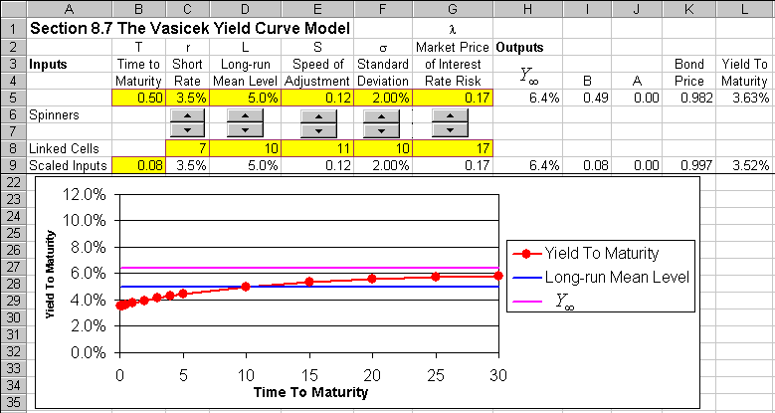
- Display the Forms Toolbar. Select View Toolbars Forms from the main menu.

- Create the Spinners. Look for the up-arrow / down-arrow button on the Forms toolbar (which will display the word “Spinner” if you hover the cursor over it) and click on it. Then draw the box for a spinner from the upper left corner of cell C6 down to the lower right corner of cell C7. Then a spinner appears in the range C6:C7. Right click on the spinner (press the right mouse button while the cursor is above the spinner) and a small menu pops up. Click on Copy. Then select the cell D6 and click on Paste. This creates an identical spinner in the range D6:D7. Repeat three more times. Select E6 and click on Paste. Select F6 and click on Paste. Select G6 and click on Paste. You now have five spinners in a row.

- Create The Cell Links. Right click on the first spinner in the range C6:C7 and a small menu pops up. Click on Format Control and a dialog box pops up. Enter the cell link “C8” in the Cell link edit box and click on OK. Repeat this procedure for the other four spinners. Link the spinner in D6:D7 to cell D8, link the spinner in E6:E7 to cell E8, etc. Click on the up-arrows and down-arrows of the spinners to see how they change the values in the linked cells.

- Create Scaled Inputs. The values in the linked cells are always integers, but they can be scaled appropriately to the problem at hand. In cell C9, enter =C8/200. In cell D9, enter =D8/200. In cell E9, enter =E8/100+0.01. In cell F9, enter =F8/500. In cell G9, enter =G8/100. Adding 0.01 to the speed of adjustment avoids having the formulas fail when that input equals zero.

- Create Time to Maturity Inputs. In the range B9:B21, enter the values =1/12, =1/4, =1/2, 1, 2, 3, …, 20, 25, 30.

- Copy The Other Inputs. In cell C10, enter =C9. Copy the formula in cell C10 across and down the range C10:G21.

- Copy The Formulas. Select the formulas in the range H5:L5 and copy them to the range H9:L21.

- Graph the Long-run Mean Level, $Y_{∞}$, and Yield to Maturity. Highlight the range B9:B21, then hold down the Control button and (while still holding it down) select the ranges D9:D22, H9:H21 and L9:L21. Next choose Insert Chart from the main menu. Select an XY(Scatter) chart type and make other selections to complete the Chart Wizard. Place the graph in the range B22:K35.

- Freeze Panes. Put the cursor in cell A10 and select Window Freeze Panes from the main menu. Move the cursor down to cell A35. This moves the graph into view.

Your interactive spreadsheet model allows you to change the inputs and instantly see the impact on the yield curve graph. This allows you to perform instant experiments on the Vasicek yield curve model. Below is a list of experiments that you might want to perform:

- What happens when the short rate is increased?
- What happens when the long-run mean level is increased?
- What happens when the speed of adjustment is increased over a large range?
- What happens when the standard deviation is increased?
- What happens when the market price of interest rate risk is increased?
- What happens when the standard deviation is decreased over a large range?
- What happens when the market price of interest rate risk is really close to zero?

Vasicek, O. (1977), "An Equilibrium Characterization of the Term Structure," Journal of Financial Economics, 5: 177-88.
Let be the short rate at the current time . Let $\hat{r}$ be the short rate at a future time $\hat{t}$. Vasicek assumes that the change in the short rate $\hat{r}−r$ is normally distributed with a mean $\left(L−r\right)e^{S\left(\hat{t}−t\right)}$ and a standard deviation $\frac{σ^{2}}{2S}\left(1−e^{−2S\left(\hat{t}−t\right)}σ\right)$.
Cox, J., J. Ingersoll Jr., and S. Ross (1985), "A Theory of the Term Structure of Interest Rates," Econometrica, 53: 385-407.
Longstaff and Schwartz (1992), “Interest Rate Volatility and the Term Structure: A Two-Factor General Equilibrium Model,” Journal of Finance, 47, 1259-1282.

