Section 8.4 Reading Bond Listings

Problem. Given bond prices and yields as published by the financial press or other information sources, obtain the U.S. Treasury Yield Curve.

Solution Strategy. Collect information about Treasury Bills and Treasury Strips for a variety of different maturity dates. Graph the ask yield of these bonds against their time to maturity. See the figure below.

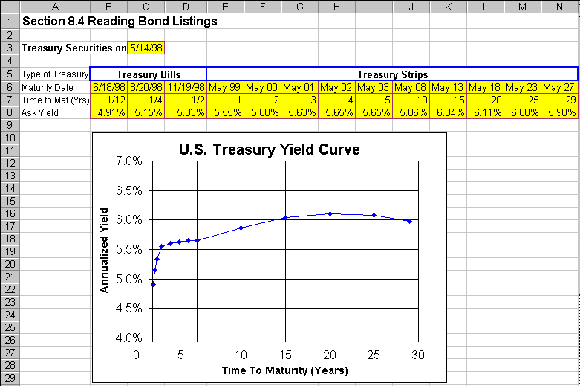
FIGURE 8.4.1 Spreadsheet for Obtaining The U.S. Treasury Yield Curve.

How To Build Your Own Spreadsheet Model.

- Inputs. Enter the current date in cell C3. Identify Treasury Bills and Treasury Strips of a variety of different maturity dates. Generally speaking, there is more curvature in the yield curve at short maturities, so use more frequent maturities (e.g., one month, three months, six months) for short maturities. For each Treasury Bill or Treasury Strip, enter the maturity date, time to maturity in years, and yield to maturity in the range B6:N8. For appearances, the cells B7, C7, and D7 have been formatted using the “fraction” cell format.

- Graph the Yield Curve. Highlight the range B7:N8 and then choose Insert Chart from the main menu. Select an XY(Scatter) chart type and make other selections to complete the Chart Wizard.

The May 24th, 1998 Treasury Yield Curve demonstrates some frequently-observed properties of the yield curve. Often, there is a sharp rise at the short-end (up to 1 year to maturity), a gentle rise after that, and a small dip at the long-end (past 25 years to maturity).

Using The Power Of Your Spreadsheet Model.

Consider a coupon bond that pays an annual coupon of $80 and pays a face value of $1,000 on its maturity date in ten years. You can use the yield curve information from above to figure out the price and yield-to-maturity of the coupon bond.

FIGURE 8.4.2 Spreadsheet for Coupon Bond.

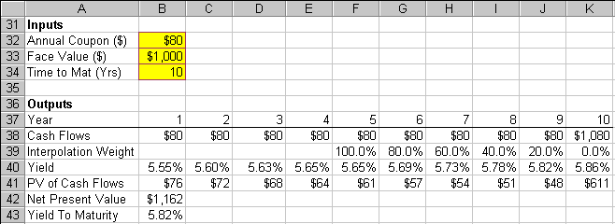
- Inputs. Enter the basic inputs for the coupon bond in the range B32:B34.

- Cash Flows. Calculate the year-by-year cash flows from the basic inputs. Enter =$B$32 in cell B38 and copy the formula in cell B38 across to the range C38:K38. Modify the formula in K38 to incorporate the face value payment, by entering =$B$32+B33 in cell K38.

- Interpolation Weight. The yield curve information directly supplies yields for cash flows in years 1 through 5 and year 10. However, we are missing yields for cash flows in years 6 through 9. Note that we are often missing the exact maturities that we need. We can get the yields that we need by (linearly) interpolating between year 5 and year 10 (e.g., fit a straight line between those two points). Since there is a 5 year difference between year 5 and year 10, each additional year moves us 20% of the distance between the two points. For year 5, enter a 100% in cell F39, because 100% of the interpolation weight is on year 5 and 0% on year 10. For year 6, enter a 80% in cell G39, because 80% of the interpolation weight is on year 5 and 20% on year 10. For year 7, enter a 60% in cell H39, because 60% of the interpolation weight is on year 5 and 40% on year 10. Continue this pattern, entering 40% in cell I39, 20% in cell J39, and 0% in cell K39.

- Yield. Bring the year 1 yield down to cell B40 by entering =E8. Copy the formula from cell B40 across the range C40:E40. Calculate the year 5 yield in cell F40 by entering the interpolation formula

=F39*$I$8+(1-F39)*$J$8

Copy the interpolation formula in F40 across the range G40:K40.

- Present Value of Cash Flows. Discount the year 1 cash flow in cell B38 back to the present at the yield (discount rate) given in cell B40 for the number of periods given in cell B37. Enter the present value formula in cell B41

=B38/((1+B40)^B37)

Copy the present value formula in B41 across the range C41:K41.

- Net Present Value. Sum up the present value of all of the cash flows in cell B42 by entering

=SUM(B41:K41)

- Yield To Maturity. The yield to maturity for the coupon bond can be calculated using the annuity function =RATE(nper,pmt,-pv,fv). In cell B43, enter

=RATE(B34,B32,-B42,B33)

The coupon bond has a price of $1,162 and a yield to maturity of 5.82%. Notice that this yield to maturity is much closer to the year 10 yield of 5.86% than it is to the year 1 yield of 5.55%. This is because there is a much bigger cash flow in year 10 ($1,080) than in year 1 ($80), which heavily weights the overall yield to maturity towards the year 10 yield.

