Section 6.7 NPV of a Cost-Reducing Project

Problem. Suppose a firm is considering a labor-saving investment. In year 0, the project requires a $2,000 investment in equipment, which is depreciated using the straight-line method over five years and there is zero salvage value of the equipment at the end. With or without the cost-reducing investment, all cash flows start in year 1 and end in year 5. Without the cost-reducing investment, the firm’s existing investments will generate year 1 revenue, labor costs, and other cash expenses of $5,000, $1,000, and $2,000, respectively. With the cost-reducing investment, the firm’s year 1 labor costs will be $300 and revenues and other cash expenses will remain the same. All dollar figures are in thousands of dollars. The inflation rate is 3% per year, the real growth rate is 4%, the tax rate is 33.3%, and the cost of capital is 13%. What is the cost-reducing project NPV?

Solution Strategy. Forecast revenues and expenses both without the cost-reducing investment and with it. Calculate the Net Cash Flow both without and with the cost-reducing investment. Subtract one from the other to obtain the incremental Difference Due to Investment. Discount the project net cash flows back to the present and determine the NPV.

How To Build Your Own Spreadsheet Model.

- Set-up Row and Column Titles. Enter column titles, such as 1998, 1999, etc. in row 1 and Year 0, Year 1, etc. in row 2. Then, place the cursor in cell B3 and click on Window Freeze Panes. This freezes the top two rows as column titles at the top and freezes Column A as a row title at the left. This step is essential to navigation in a large spreadsheet model.

- Inputs. Enter the key assumptions in the range B3:B7. Enter the year 1 revenues and expenses without the investment into the input sections of the range C10:C15. Enter the year 1 revenues and expenses with the investment into the input sections of the range C25:C27. Enter the year 0 investment in cell B41.

- Forecast Cash Flows. Forecast each item of the Cash Flows spreadsheet as appropriate.
- Revenue This Year = (Revenue Last Year) * (1 + Inflation Rate) * (1 + Real Growth Rate), so Year 200 Revenue in cell D10 is =C10*(1+$B$4)*(1+$B$5)
- Labor Costs and Other Cash Expenses are forecast similarly
- Depreciation is constant over time due to the use of the straight line method, so cell D15 is =C15.
- Income Taxes = Operating Income * Tax Rate, so cell C18 is =C16*$B$6
- Net Cash Flow = After-tax Profit + Add Back Depreciation, so that cell C22 is =C19+C21.
- Similar formulas are appropriate for forecasting cash flow with the investment. The major difference is With Investment Depreciation = Without Investment Depreciation + (Cost-reducing Investment) / (Number of years to fully depreciate), based on the straight-line method. So cell C30 is =C15-B41/5.
Copy the formulas in columns C and D across the columns D through G.

- Difference Due to Investment and NPV. The Difference Due to Investment = With Investment Net Cash Flows = Without Investment Net Cash Flows. In cell C40, enter

=C37-C22

Combine the year 0 Investment to obtain the Project Net Cash Flows. Discount these cash flows back to the present at the discount rate. In cell B43, enter

=B42+NPV(B7,C42:G42)

The Net Present Value of the Cost-reducing Project is $330. The project should be accepted.

FIGURE 6.7.1 Spreadsheet for the Cost-Reducing Project.
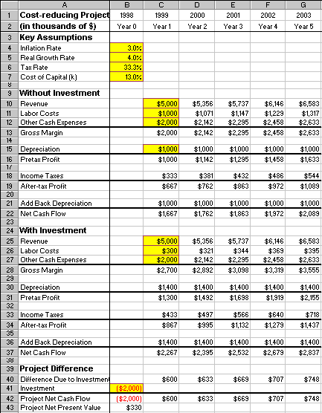
Using The Power Of Your Spreadsheet Model.

Labor cost savings may difficult to predict in the context of a major restructuring. You can test the financial significance of this prediction difficulty by checking the sensitivity of the product NPV to the With Investment Labor Costs.

- Create A List of Input Values and An Output Formula. Create a list of input values for the “With Investment Labor Costs” ($100, $200, $300, etc.) in the range C46:H46. Create an output formula that references the product NPV by entering the formula =B43 in cell B47.

- Data Table. Select the range B46:H47for the Data Table. This range includes both the list of input values at the top of the data table and the output formula on the side of the data table. Then choose Data Table from the main menu and a Table dialog box pops up. Enter the cell address C26 ( “With Investment Labor Costs”) in the Row Input Cell and click on OK.

- Graph the Sensitivity Analysis. Highlight the data table C47:H48 and then choose Insert Chart from the main menu. Select an XY(Scatter) chart type and make other selections to complete the Chart Wizard.

The sensitivity analysis shows that the Project NPV is highly sensitive to With Investment Labor Costs. Great care should be made in implementing the project to make sure that forecasted labor cost savings are actually realized and, hence, the project’s realizes a positive NPV.

6.7.2 Spreadsheet for Sensitivity of Project Net Present Value to “With Investment Labor Costs.”

