Section 5.1 Life-Cycle Financial Planning

Problem. Develop a financial plan for investment and consumption over your life-cycle (from the present ‘til your death). Suppose you face the following market and tax variables in the environment: inflation rate is 3.00%, real return on the riskfree asset is 2.00%, real growth rate in salary is 2.00%, federal tax rate on taxable income = 28.00%, state tax rate on taxable income = 3.00%, and federal FICA tax rate on salary is 7.45%. Suppose your first year salary is $70,000. Explore the investment and consumption impacts over the life-cycle of the following choice variables: whether to use a retirement fund that is taxable or tax deferred, what base level of real consumption (in the first working year), what growth rate of real consumption over working years, what retirement real consumption as a percent of last working year real consumption, what retirement age, and what life expectancy at retirement (that is, given that you have survived to your retirement age).

FIGURE 5.1.1 Spreadsheet for Life-Cycle Financial Planning.
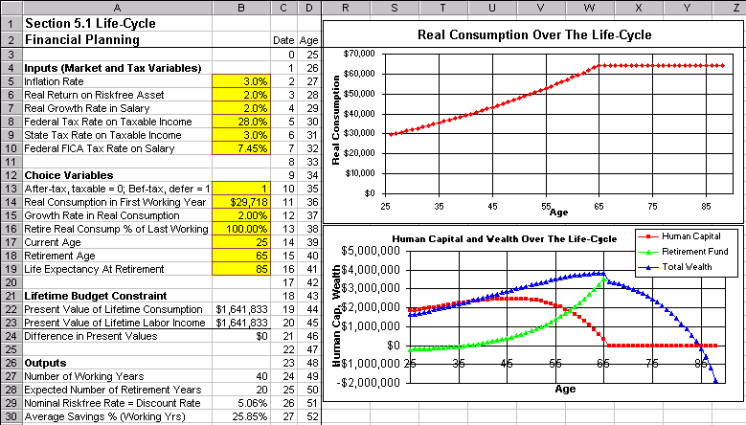

Solution Strategy. Develop a spreadsheet model of investment and consumption on a year-by-year basis over an entire lifetime. Each year you pay taxes on your taxable income. You need to choose how to divide your after-tax income between consumption now vs. savings (to provide for consumption in the future). Your savings are put in a retirement account and grow at the riskfree rate. Upon retirement, it is assumed that all funds accumulated in the retirement account are converted into a graduated annuity with a life insurance feature. Annuity means that it will provide a fixed payment each year. Graduated means that the payment grows through time. In particular, the payment is assumed to grow at the inflation rate, thus providing a constant level of real consumption in retirement. A life insurance feature means that the graduated payment is paid for the rest of your life, no matter how long or short that may be. The size of your payment is based on the number of the expected number of retirement years. Essentially, you are making a bet with the insurance company on how long you will live. You are betting that you will live longer than your life expectancy and the insurance company is betting that you will live shorter.

How To Build Your Own Spreadsheet Model.

- Inputs. Enter the market and tax variables described in the problem into the Inputs range B5:B10, first year salary in cell E4, and starting values for the choice variables (such as the starting values shown in Figure 5.1.1) into the Choice Variables range B13:B19. Note that Life Expectancy At Retirement is what age you expect to live to given that you have survived to your retirement age.

- Outputs. Calculate some useful outputs as follows:
- Number of Working Years = Retirement Age – Current Age. Enter =B18-B17 in cell B27.
- Expected Number of Retirement Years = Life Expectancy At Retirement – Retirement Age.
Enter =B19-B18 in cell B28
Nominal Riskfree Rate = Discount Rate = (1 + Inflation Rate) * (1 + Real Riskfree Rate) – 1.
Enter =(1+B5)*(1+B6)-1 in cell B29.

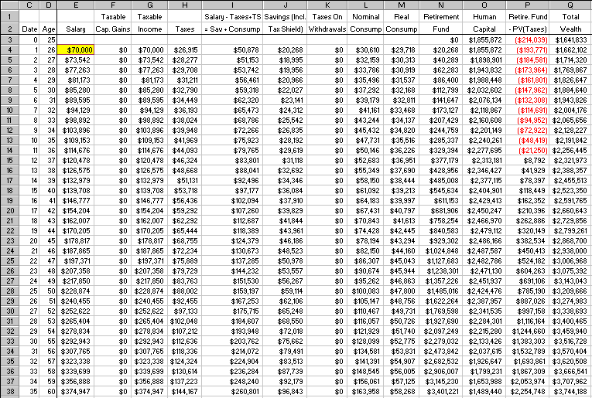
FIGURE 5.1.2 Spreadsheet for Working Years of Life-Cycle Financial Planning.

- Titles Setup. Create the column and row titles as follows:
- Enter the column titles in the range C1:Q2
- In the Date column, enter 0, 1, 2, …,63 in the range C3:C66. The easy way to do this is enter 0 in cell C3, 1 in cell C4, highlight the range C3:C4, put the cursor over the lower right corner of cell C4 until it becomes a “plus” icon, and drag the cursor all the way down to cell C66.
- In the Age column, enter =B20 in cell D3. Then, enter =D3+1 in cell D4 and copy the cell D4 down the range D5:D66
- With cell A1 showing on the screen, put the cursor in cell E3 and click on Windows Freeze Panes to lock in the column and row titles.

- Enter The Formula For Each Column. The calculations in Figure 5.1.2 may appear to be complex given the large mass of numbers. However, it is simpler than appears because each column is generated by a single formula, which is entered at the top and copied all the way down. Most of the column formulas make no distinctions by row. However, five of the column formulas (Salary, Taxes on Withdrawals, Real Consumption, Human Capital, and Retirement Fund) do distinguish between working years vs. retirements years. This is accomplished in each case with an IF statement. The IF statement checks if the age for that row (in column D) is less than or equal to the Retirement Age in cell $B$18, then uses the Working Year formula when true and the Retirement Year formula when not true. Here are the formulas:

- Salary = Last Year’s Salary * (1 + Inflation Rate) * (1 + Salary Growth Rate) in working years
= $0 in retirement years
Enter =IF(D5<=$B$18,E4*(1+$B$5)*(1+$B$7),0) in cell E5.

- Taxable Capital Gains = Last Year’s Retirement Fund * ((1+Inflation Rate)
* (1+Real Riskfree Rate)) * (1 – Tax Deferred Dummy Variable)
Enter =N3*((1+$B$5)*(1+$B$6)-1)*(1-$B$13) in cell F4.

- Taxable Income = Salary + Taxable Capital Gains
Enter =E4+F4 in cell G4.

- Taxes = (Federal Income Tax Rate + State Income Tax Rate) * Taxable Income
+ Federal FICA Tax Rate * Salary
Enter =($B$8+$B$9)*G4+$B$10*E4 in cell H4.

- Salary –Taxes + Tax Shield = Savings + Nominal Consumption. This is the annual budget
constraint. For convenience, it is calculated as = Savings + Nominal Consumption
Enter =J4+L4 in cell I4.

- Savings (Including Tax Shield From Saving Money on a Before Tax Basis)
= (Salary Less Taxes – Nominal Consumption) / (1 - Tax Deferred Dummy Variable
* (Federal Income Tax Rate + State Income Tax Rate))
Enter =(E4-H4-L4)/(1-$B$13*($B$8+$B$9+$B$10)) in cell J4.

- Taxes on Withdrawals = (Money Withdrawn)* (Tax Deferred Dummy Variable)
* (Federal Tax Rate + State Tax Rate) When Money is Withdrawn = When Savings < 0
Enter =IF(J4<0,-J4*$B$13*($B$8+$B$9),0) in cell K4.

- Nominal Consumption = (Real Consumption) * ((1 + Inflation Rate) ^ Number of periods)
Enter =M4*((1+$B$5)^C4) in cell L4.

- Real Consumption (RC) =(First Year RC)*((1 + RC Growth Rate)^(Date – 1)) in working years
=(First Year RC)*(Retirement RC % of Last Working RC)*
((1 + RC Growth Rate)^(Retire Age – Current Age – 1)) in retirement years
Enter =IF(D4<=$B$18,$B$14*((1+$B$15)^(C4-1)),
$B$14*$B$16*((1+$B$15)^($B$18-$B$17-1))) in cell M4.

- Retirement Fund = (Retirement Fund Last Year) * (1 + Nominal Riskfree Rate)
+ (Savings This Year)
Enter 0 in cell N3 and =N3*(1+$B$29)+J4 in cell N4.

- Human Capital = Net Present Value of Stream of Future Labor Income (Salary) through the end
of your working years (row 43) discounted at the Nominal Riskfree Rate
Enter =IF(D3<=$B$18,NPV($B$29,I3:$I$43),0) in cell O3.

- Retirement Fund – PV(Taxes) = (Retirement Fund This Year) - Net Present Value of the
stream of Taxes on Withdrawals up to Life Expectancy (row 63) discounted at the
Nominal Riskfree Rate
Enter =N3-IF(D3<=$B$19,NPV($B$29,K3:$K$63),0) in cell P3.

- Total Wealth = (Retirement Fund – PV(Taxes)) + Human Capital
Enter =O3+P3 in cell Q3.

Copy these formulas all the way down to row 66.

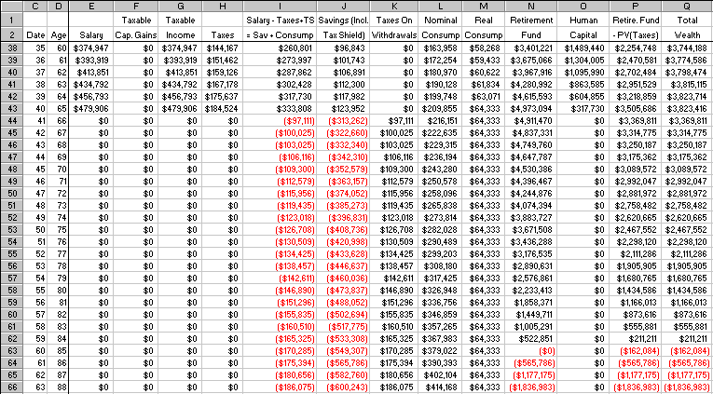
FIGURE 5.1.3 Spreadsheet for Remaining Working Years and for Retirement Years.

Figure 5.1.3 shows that row 66 corresponds to an age of 88. Essentially, we are considering what happens if you turn out to live three years past your life expectancy of 85. At age 65, you turned your retirement fund (then worth $4,973,094) over to the insurance company and the insurance company used this fund to pay for your taxes on withdrawals and nominal consumption since then. Since you lived three years past your life expectancy, you won your bet with the insurance company. Looking at the last row of the retirement fund column, the insurance company lost $1,836,983 on this bet.

- Lifetime Budget Constraint. In order for the complete Life-Cycle Plan to work, it is critical for the Present Value of Lifetime Consumption (Outflows in column L) = Present Value of Lifetime Labor Income, Net of Tax Effects (Inflows in column I). This section captures the variables needed to implement the lifetime budget constraint. Here are the steps:
- Present Value of Lifetime Consumption. Calculate this using NPV(Riskfree Rate, Nominal Consumption range). Enter =NPV(B29,L4:L63) in cell B22.
- Present Value of Lifetime Labor Income (Net of Tax Effects). Calculate this using NPV(Riskfree Rate, Salary – Taxes + Tax Shield range). Enter =NPV(B29,I4:I63) in cell B23.
- Difference in Present Values = Present Value of Lifetime Consumption – Present Value of Lifetime Labor Income (Net of Tax Effects). Enter =B23-B22 in cell B24.

Solver

Excel’s solver function can be used to implement the Lifetime Budget Constraint. Specifically, determine the level of Real Consumption in the First Working Year (B14) which sets the Difference in Present Values (B24) to zero.

- Call Up Excel Solver. From Excel’s main menu, click on Tools and then Solver. (If Solver does not appear on the Tools menu, then click on Add-Ins, check Solver Add-In, and click on OK.)

- Change Solver’s Set-up and Run It. In the Solver dialog box, change the Set Target Cell to cell B24 and change the By Changing Cell to cell B14. See figure 5.1.4 below. Click on the Solve button. When a solution is found, click on OK to accept it.

FIGURE 5.1.4 Solver Dialog Box.

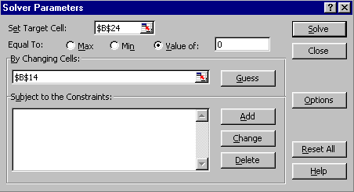
- Graph Real Consumption Over The Life-Cycle. Highlight the range D4:D66, then hold down the Control button and (while still holding it down) select the range M4:M66. Next choose Insert Chart from the main menu. Select an XY(Scatter) chart type and make other selections to complete the Chart Wizard. Place the graph in the range R1:Z15.

- Graph Human Capital and Wealth Over The Life-Cycle. Highlight the range D3:D66, then hold down the Control button and (while still holding it down) select the range O3:Q66. Next choose Insert Chart from the main menu. Select an XY(Scatter) chart type and make other selections to complete the Chart Wizard. Place the graph in the range R16:Z28.

Here are some interesting questions to explore:
- What impact does investing After-tax income in a retirement fund with Taxable capital gains vs. investing Before-tax income in a retirement fund with Tax-deferred capital gains have on the level of Real Consumption over a lifetime?
- What impact does decreasing the Growth Rate in Real Consumption have on the level of Real Consumption in First Working Year and have on the level of Real Consumption during Retirement Years?
- What impact does lowering Retirement Real Consumption % of Last Working have on the level of Real Consumption in First Working Year? How would you implement this in real life?
- What impact does lowering the Retirement Age have on the level of Real Consumption over a lifetime?
- What impact does increasing the Life Expectancy At Retirement have on the level of Real Consumption over a lifetime? What can you do to increase your Life Expectancy?

Using The Power Of Your Spreadsheet Model.

Let’s consider one of the questions above: What impact does investing After-tax and Taxable vs. investing Before-tax and Tax-deferred have on the level of Real Consumption over a lifetime? This can be determined by entering either 0 or 1 for the Tax Status variable in cell B13. A 0 means investing Before-tax money and Tax-deferred capital gains. Whereas, a 1 means investing After-tax money and Taxable capital gains.

- Cycle Over Different Input Values. Repeat the following cycle twice:
- Enter a particular value (say, 0) for the Tax Status variable in cell B13.
- Run Solver to implement the lifetime budget constraint. Click on Tools and then Solver. If the solver dialog box (see figure 5.1.4 above) still shows cell B24 as the Set Target Cell and cell B14 as the By Changing Cell, then click on the Solve button. When a solution is found, click on OK to accept it.
- Copy the resulting real consumption in the range M4:M66 and paste the values to the cell AC4 by clicking on Edit Paste Special Paste Values OK.
- Repeat this cycle for the other input value (1) and copy the resulting range of real consumption using the paste values to the adjacent cell AD4.

- Graph Real Consumption Over The Life-Cycle By Tax Status. Highlight the range D4:D66, then hold down the Control button and (while still holding it down) select the saved real consumption values in the range AC4:AD66. Next choose Insert Chart from the main menu. Select an XY(Scatter) chart type and make other selections to complete the Chart Wizard.

FIGURE 5.1.5 Graph of Real Consumption Over The Life-Cycle By Tax Status.

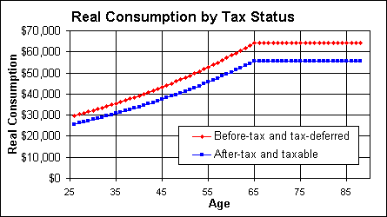

Figure 5.1.5 shows that investment Tax Status has a huge impact on Real Consumption over the life-cycle. Focusing on real consumption in retirement years, investing Before-tax and Tax-deferred yields $64,333 per year, whereas investing After-tax and Taxable yields $55,605 (14% less). There are two reasons why you are better off. First, investing After-tax money means that you are paying more taxes than investing Before-tax money and so there is less of your paycheck leftover for you to consume. Second, deferring taxes to the future means that you can earn a positive rate of return on money that you would otherwise pay immediately to the tax collector. Said differently, paying taxes in the future means you are paying less in present value terms than paying the same amount of taxes now. Another way to see the difference is to look at the Present Value of Lifetime Labor Income (Net of Tax Effects) in cell B23. Investing Before-tax and Tax-deferred yields a Lifetime Present Value of $1,641,833. Whereas, investing After-tax and Taxable yields a Lifetime Present Value of $1,419,086. Hence, you can realize a $222,747 increase just by investing in a tax-advantaged manner!

Here are some interesting ways in which the Life-Cycle Financial Planning model can be extended for you to consider doing yourself:
- Refine the treatment of Federal Income Taxes to include tax brackets and the corresponding tax rates. This can be done with a nested If statement of the form:
=IF(Taxable income < Bracket 1 Cutoff, Tax Rate 1 * Taxable Income, IF(Taxable income < Bracket 2 Cutoff, Tax Rate 1 * Bracket 1 Cutoff + (Taxable Income – Bracket 1 Cutoff) * (Tax Rate 2), and so on.
Be sure to index the Bracket Cutoffs on a year-by-year basis for inflation. Similarly, you may wish
to implement a salary cap on FICA, since that is what we observe in the real world.
- Add the possibility of spliting your investment between a Risky Diversified Fund and the Riskfree Asset. This Risky Diversified Fund would provide a much higher real return on average, but also add a great deal of risk to your retirement portfolio – see Chapter 12 for details.
- Extend the item above by allowing the percent allocation to the Risky Diversified Fund to vary by year. This will allow you to implement the sensible strategy of putting a higher percentage in the Risky Diversified Fund when you are young and a lower percentage as you approach retirement.
- Modify the Salary formula in retirement years to allow some amount of positive income. This implements the increasingly popular approach of working part-time in retirement years (typically 2 or 3 days per week) or pursuing a second career which might pay less, but be more fun.
- Allow the Growth Rate in Real Consumption to vary year by year. Typically people consume a higher percent of income in early years (higher first year income and a higher growth rate) and consume a lower percent of income in later years (lower growth rate in later years).
- Make the spreadsheet interactive by adding up-arrow & down-arrow combination buttons (“spinners”) to drive the inputs. See the Interactive Spreadsheet Model of the Black-Scholes model for details on how to implement spinners. After the spinners are used to change the inputs, then Solver is run to implement the lifetime budget constraint.

