Section 4.10 Inflation and DCF Calculations

Problem. Part A. The nominal interest rate is 7.30% and the inflation rate is 2.64%. What is the real interest rate?

Part B. You would like to buy a home whose current market price is $150,000. In order to qualify for a conventional mortgage loan, you need to provide a 20% downpayment. You have no savings now and would like to save money over the next 5 periods in order to have a full downpayment. What is your savings plan?

Solution Strategy. Directly calculate the real interest rate. Do parallel real and nominal calculations for the rest. Use the annuity function PMT to calculate the real savings amount each year to reach the target downpayment. Grow the real savings amount by the inflation rate each year to obtain the nominal savings amount.

FIGURE 4.10.1 Spreadsheet for Inflation and DCF Calculations.

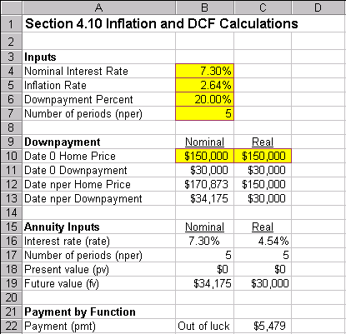
How To Build Your Own Spreadsheet Model.

- Inputs. Enter the inputs into the range B4:B7 and the current market value of the home in cells B10 and C10.

- Date 5 Downpayment. It is important to realize that the downpayment is a moving target. The nominal home price will be higher on date 5 than it is today due to inflation. Here are the steps:
- Calculate the Date 0 Downpayment = (Date 0 Home Price) * (Downpayment Percent). Enter =$B$6*B10 in cell B11 and copy it to cell C11.
- Determine the Date 5 Home Price = (Date 0 Home Price) * (1 + Inflation Rate)^nper. Enter =B10*(1+B5)^B7 in cell B12.
- By definition, the Real Date 5 Home Price is not effected by inflation. Enter =C10 in cell C12.
- Calculate the Date nper Downpayment = (Date nper Home Price) * (Downpayment Percent). Copy the range B11:C11 to the range B13:C13.

- Annuity Inputs. Calculate the needed inputs for the annuity Payment function as follows:
- The Nominal Interest Rate is given above. Enter =B4 in cell B16.
- The formula for the Real Interest Rate = (1 + Nominal Interest Rate) / (1 + Inflation Rate) – 1. Enter =(1+B4)/(1+B5)-1 in cell C16. In this case, the Real Interest Rate = 4.54%, which solves the original Problem 1.
- The Number of Periods is given above. Enter =$B$7 in cell B17 and copy it to cell C17.
- There is no cash flow on date 0. Hence, the annuity input pmt = 0. Enter 0 in cells B18 and C18.
- The target Future Value = Date nper Downpayment. Enter =B13 in B19 and copy it to cell C19.

- Payment by Function. The Real Savings Amount is constant over time and can calculated using the annuity Payment function. The format is PMT(rate,nper,pv,fv). Enter =-PMT(C16,C17,C18,C19) in cell C22. The negative sign up front is simply a convenience to generate a positive payment value, rather than the default negative value. The Nominal Savings Amount grows at the rate of inflation each period. Unfortunately, Excel does not have built-in functions for a growing annuity. Hence, we are out of luck to calculate the Nominal Payment by Function.

Note that the Nominal Date nper Downpayment of $34,175 is equivalent to the Real Date nper Downpayment of $30,000. The Nominal Downpayment incorporates the inflation rate each period, whereas the Real Downpayment does not.

Using The Power Of Your Spreadsheet Model.

We calculated how much money to save each period in real terms, but how much money is this in nominal terms? Can we verify that it will have enough money for the downpayment in 5 years

FIGURE 4.10.2 Spreadsheet for the Nominal Calculation and the Real Calculation by Solver.

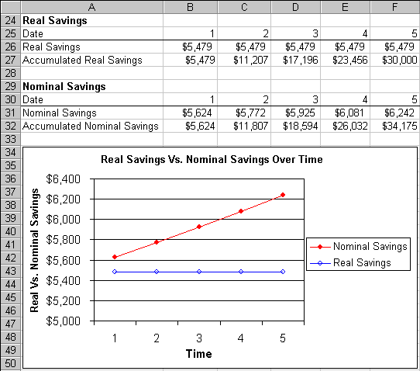
- Real Savings. This was calculated in cell C22 using the PMT function. Enter =$C$22 in cell B26 and copy across the range C26:F26.

- Accumulated Real Savings. The formula is Accumulated Real Savings (t) = (Accumulated Real Savings (t-1)) * (1 + Real Interest Rate) + Added Real Savings (t). Enter =B26 in cell B27 and then enter =B27*(1+$C$16)+C26 in cell C27 and copy it across the range D27:F27.

- Nominal Savings. The formula is Nominal Savings (t) = Real Savings (t) * ((1+Riskfree Rate) ^ t) Enter =B26*((1+$B$5)^B30) in cell B31 and copy it across the range C31:F31.

- Accumulated Nominal Savings. The formula is Accumulated Nominal Savings (t) = (Accumulated Nominal Savings (t-1)) * (1 + Nominal Interest Rate) + Added Nominal Savings (t). Enter =B31 in cell B32 and then enter =B32*(1+$B$4)+C31 in cell C32 and copy it across the range D32:F32.

- Graph Real Savings Vs. Nominal Savings Over Time. Highlight the range A26:F26, then hold down the Control button and (while still holding it down) select the range A31:F31. Next choose Insert Chart from the main menu. Select a Line chart type and make other selections to complete the Chart Wizard.

The Nominal Savings amount in Row 31 shows the actual nominal savings amount that one needs to save each period. Notice that the Accumulated Real Savings adds up to $30,000, which is the Date 5 Downpayment in Real Terms. Further, the Accumulated Nominal Savings adds up to $34,175, which is the Date 5 Downpayment in Nominal Terms. The graph shows that the Nominal Savings amount goes up each year reflecting inflation increases each year. By contrast, the Real Savings amount stays constant each year reflecting a constant level of real consumption that must be sacrificed in order to generate this level of savings.

