Section 3.8 Corporate Financial Planning

Problem. Given historical financial statements for XYZ, forecast the XYZ financial statements for the next three years.

Solution Strategy. Analyze the historical financial statements to determine which income statement and balance sheet items are close to being a constant percentage of sales and which items are not. Then, forecast sales as accurately as possible. Then, apply the average historical percentage of sales to generate most of the income statement and balance sheet items. Forecast other key assumptions to generate the rest.

FIGURE 3.8.1 Historical and Forecasted XYZ Financial Statements.

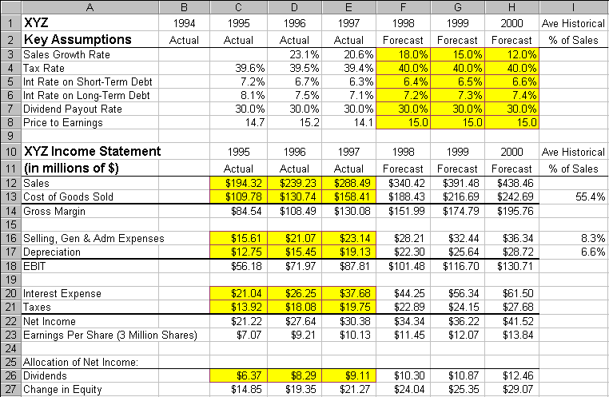
How To Build Your Own Spreadsheet Model.

- Set-up Row and Column Titles. Enter column titles, such as 1994, 1995, etc. in row 1 and “Actual” vs. “Forecast” in row 2. Then, place the cursor in cell B3 and click on Window Freeze Panes. This freezes the top two rows as column titles at the top and freezes Column A as a row title at the left. This step is essential to navigation in a large spreadsheet model.

- Historical Financials. Enter the historical XYZ Financial Statements into the input sections of the range B12:E58. Enter the observed market price / share into the range B61:E61. See Figures 3.8.1 and 3.8.2.

FIGURE 3.8.2 Historical and Forecasted XYZ Financial Statements – Continued.

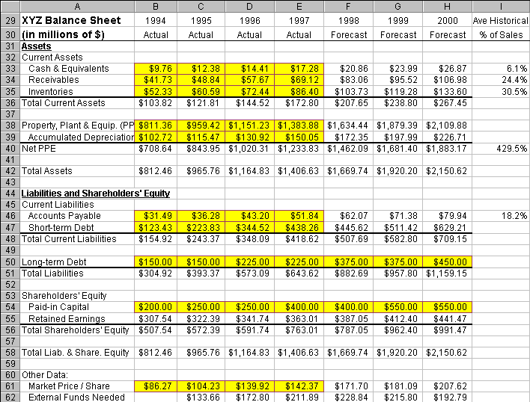
- Check Percent of Sales. For the historical financials, calculate each Income Statement item as a percentage of sales (see Figure 3.8.3, Rows 112 – 127) and calculate each Balance sheet item as a percentage of sales (see Figure 3.8.4, Rows 131 – 158). For example, 1995 Cost of Goods Sold as a Percent of Sales in cell C113 is calculated by entering

=C13/C$12

The $ sign in C$12 locks in row 12, which is XYZ Sales. Copy the formula in cell 113 across the
range D113:H113 for both historical and forecasted percent of sales. For XYZ, most of the Income
Statement and Balance Sheet items are nearly a constant percentage of sales. The main exceptions are
Interest Expense, Taxes, Accumulated Depreciation, Short-term Debt, Long-term Debt, and
Shareholders’ Equity.

- Average Historical Percent of Sales. In Figures 3.8.3 and 3.8.4, column I is the average historical percent of sales. This is simply the average of the percent of sales for the three historical years (1995 – 1997). For example, the average historical percent of sales for 1998 Cost of Goods Sold in cell I113 uses the formula:

=AVERAGE(C113:E113)

This is copied down the range I112:I158 for all Income Statement and Balance Sheet items. Average
historical percent of sales are used to forecast all financial items that are nearly constant as a
percentage of sales.

FIGURE 3.8.3 Actual, Forecasted, and Average Historical Income Statement as a Percent of Sales.

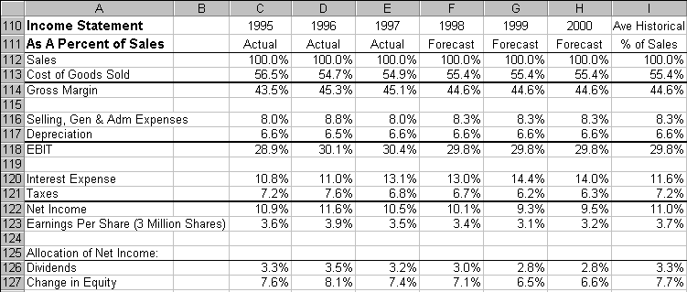
FIGURE 3.8.4 Actual, Forecasted, and Average Historical Balance Sheet as a Percent of Sales

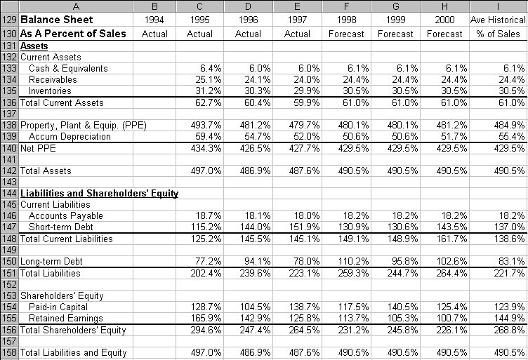
- Forecasting Sales and Other Key Assumptions. Looking at the historical sales growth rate, it is clear that the rate of growth is slowing down. This may reflect such factors as increasing competition or relative saturation of the market. It seems prudent to forecast a continued slowdown in the rate of growth. Hence, sales are forecast to grow at 18%, 15% and 12% over the next three years. Interest rates on short-term and long-term debt are forecasted based on their current levels with a slight rising trend. The rest of the key assumptions are forecasted at or near their average historical levels.

- Forecasting the Financials. A few financial statement items, such as Sales, are forecasted based on the Key Assumptions section (e.g., Sales Growth Rate). To forecast 1998 Sales in cell F12, enter

=E12*(1+F3)

To forecast 1999 and 2000 Sales, copy the formula in cell F12 to the range G12:H12. Most financial
statement items, such as Cost of Goods Sold, are forecasted based on the average historical percent of
sales. For convenience, reference the average historical percent of sales by entering =I113 in cell
I13. Then, forecast 1998 Cost of Goods Sold in cell F13 by entering

=$I13*F$12

The $ sign in $I13 locks in column I, which is the average historical percent of sales and the $ sign in
C$12 locks in row 12, which is XYZ Sales. To forecast 1999 and 2000 Cost of Goods Sold, copy the
formula in cell F13 to the range G13:H13. Some financial statement items, such as Gross Margin, are
based on simple addition or subtraction of lines above it. To forecast 1998 Gross Margin in cell F14,
enter

=F12-F13

To forecast 1999 and 2000 Gross Margin, copy the formula in cell F14 to the range G14:H14.
Continue using one of these three approaches for all Income Statement and Balance Sheet items.

- Interest Expense. Interest Expense is forecast as the (Interest Rate on Short-term Debt) * (Amount of Short-term Debt at the End of the Previous Year) plus the (Interest Rate on Long-term Debt) * (Amount of Short-term Debt at the End of the Previous Year). To forecast 1998 Interest Expense in cell F20, enter

=F5*E47+F6*E50

To forecast 1999 and 2000 Interest Expense, copy the formula in cell F20 to the range G20:H20.

- Plug Item. A Balance Sheet, by definition, must balance. Therefore, one line on the forecasted balance sheet must be a slack or plug item. In this case, the plug item is Short-term Debt. It is the residual item after everything else is forecast. Specifically, the Balance Sheet works as follows:
- All of the Asset items are forecasted individually and then summed up to get Total Assets.
- Total Liabilities and Shareholders Equity is set equal to Total Assets.
- Paid-in Capital is set directly, the increase in Retained Earnings is equal to the Change in Equity from the Income Statement, and they are summed to get Total Shareholders’ Equity
- Total Liabilities equals Total Liabilities and Shareholders Equity minus Total Shareholders’ Equity.
- Long-term Debt is set directly and Total Current Liabilities is equal to Total Liabilities minus Long-term Debt.
- Accounts Payable is forecasted based on the Percentage of Sales.
- Short-term Debt is plugged based on Total Current Liabilities minus Accounts Payable.
After one has done the rest of the forecasting, it is important to check Short-term Debt to make sure
that it isn’t growing explosively or dropping rapidly (perhaps going negative!). If it is going wild,
then backtrack to identify the source of sharp up or down movements and check for errors.

- Adjust Long-term Debt and Paid in Capital. The three sources of external capital are short-term debt, long-term debt, and equity. Most companies try to maintain a target proportion of these three sources of financing. Occasional adjustments of long-term debt and paid in capital (remember short-term debt is the plug item) will accomplish this.

The forecast for the next three years yields a steady increase in Earnings Per Share, but at a slower growth rate than during the last three years.

Using The Power Of Your Spreadsheet Model.

The amount of External Funds Needed by the firm is defined as the Increase in Total Assets minus the Increase in Retained Earnings minus the Increase in Accounts Payable. External Funds Needed is calculated in row 62 of the spreadsheet. How sensitive is the External Funds Needed to the forecasted Sales Growth Rate?

- Create A List of Input Values and An Output Formula. Create a list of input values for Sales Growth Rate (0%, 5%, 10%, etc.) in the range C162:I162 Create an output formula that references the External Funds Needed by entering the formula =F62 in cell B163.

- Data Table. Select the range B162:I163 for the Data Table. This range includes both the list of input values at the top of the data table and the output formula on the side of the data table. Then choose Data Table from the main menu and a Table dialog box pops up. Enter the cell address F3 (for Sales Growth Rate) in the Row Input Cell and click on OK.

- Graph the Sensitivity Analysis. Highlight the data table C162:I163 and then choose Insert Chart from the main menu. Select an XY(Scatter) chart type and make other selections to complete the Chart Wizard.

FIGURE 3.8.5 Sensitivity of External Funds Needed to the Sales Growth Rate.

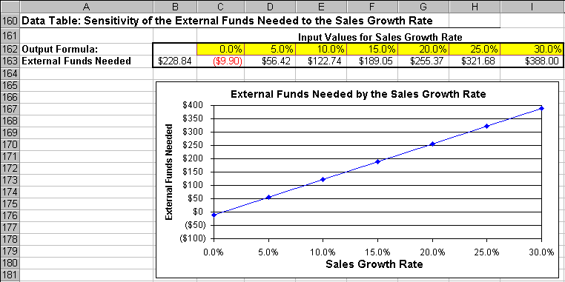
The sensitivity analysis shows that the amount of External Funds Needed is highly sensitive to the Sales Growth Rate. The relationship appears to be nearly linear.

