Section 16.10 Three Valuation Methods

Problem. A firm has the opportunity to do a one-shot project. It requires a date 0 initial outlay for new investment of $100,000. Over a five-year life-cycle, it will generate the following before-tax cash flows: Date 1 = $55,000. Date 2 = $80,000. Date 3 = $105,000. Date 4 = $75,000. Date 5 = $45,000. And nothing thereafter. The project’s tax rate is 34.0%, it’s unlevered cost of capital is 12.0%, and the riskfree rate (= cost of debt) is 4.0%. The company has precommitted to a particular quantity of debt on the following dates to support this project: Date 0 = $80,000. Date 1 = $65,000. Date 2 = $55,000. Date 3 = $35,000. Date 4 = $10,000. And nothing thereafter. What is the project’s NPV as calculated using: (1) the APV method, (2) the FTE method, and (3) the WACC method? Also verify that the present value of future cash flow under the three methods in the same on each date and equals the sum of debt plus equity.

Solution Strategy. Value this project under the APV method. Then use the project NPV result to calculate the amount of PV of Future Cash Flows for each date to calculate the amount of Equity and Cost of Equity Capital for each date. Using these results, value the project under the FTE method. Then, calculate the Weighted Average Cost of Capital (WACC) and value the project under the WACC method. For added generality, construct a two-stage valuation model that can handle projects with a particular series of Cash Flows and Debt amounts over an explicit forecast horizon and/or an infinite horizon.

FIGURE 16.10.1 Spreadsheet for Valuation Under The APV Method.

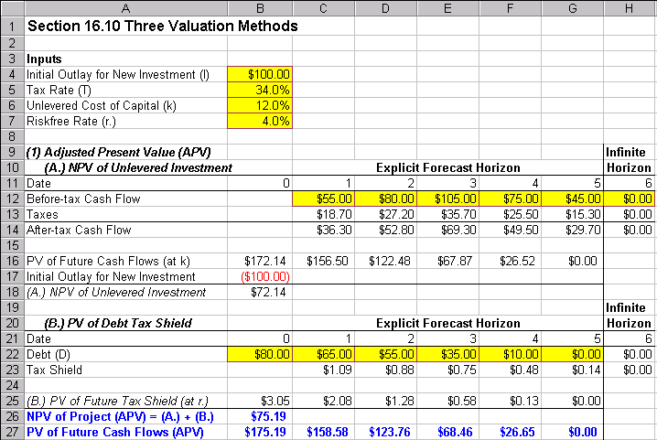

How To Build Your Own Spreadsheet Model.

The Adjusted Present Value (APV) Method

- Inputs. Enter the overall project inputs in the range B4:B7, the Before-Tax Cash flows in the range C12:H12, and the Debt amounts in the range B22:G22.

- Range Names. It simplifies entering and debugging formulas to create range names for the overall project input cells. Put the cursor in cell B4, click on Insert Name Define, enter the name “I” and click on OK. Repeat this procedure to give cell B5 the name “T”, give cell B6 the name “k”, and give cell B7 the name “r.” (Excel does not accept plain “r”).

- Taxes and After-Tax Cash Flow. Taxes paid is the (Before-tax Cash Flow) * (Tax Rate). Enter =C12*t C13 and copy it to the range D13:H13. After-tax Cash Flow is Before-tax Cash Flow less Taxes. Enter =C12-C13 in cell C14 and copy it to the range D14:H14.

- Present Value of Future Cash Flows (at k). Using the unlevered cost of capital k, discount an infinite series of constant cash flows using the infinite annuity formula: (After-tax Cash Flow) / k. Enter =H14/k in cell G16. Discount the explicitly forecast horizon cash flows using a recursive, one-period-at-a-time approach: PV of Future Cash Flow (t) = [After-tax Cash Flow (t+1) + PV of Future Cash Flow (t+1)] / (1+k). Enter =(G14+G16)/(1+k) in cell F15 and copy it leftwards to the range B16:E16.

- New Investment and NPV of Unlevered Investment. To get the NPV of the Unlevered Investment, subtract the Initial Outlay for New Investment. Enter =-I in cell B17 and =B16+B17 in cell B18.

- Tax Shield. We adopt the convention that interest to be paid on date t+1 based on debt which issued on date t. A tax shield is defined as the quantity of taxes avoided by deducing interest expense. It is calculated as Tax Shield (t+1) = Debt (t) * (Riskfree Rate) * (Tax Rate). Enter =B22*r.*t in cell C23 and copy it to the range D23:H23.

- PV of Future Tax Shield (at r.). Using the riskfree rate r., discount an infinite series of constant tax shields using the infinite annuity formula: (Tax Shield) / r. Enter =H23/r. in cell G25. Discount the explicitly forecast horizon tax shields using a recursive, one-period-at-a-time approach: PV of Future Tax Shield (t) = [Current Date Tax Shield (t+1) + PV of Future Tax Shield (t+1)] / (1+k). Enter =(G23+G25)/(1+r.) in cell G25 and copy it leftwards to the range B25:E25.

- NPV of the Project and PV of Future Cash Flows. The NPV of the Project is the sum of: (A.) NPV of the Unlevered Investment and (B.) PV of Debt Tax Shield. Enter =B18+B25 in cell B26. The PV of Future Cash Flows (APV) is the sum of the PV of Future Cash Flows (at k) and PV of Debt Tax Shield (at r.). Enter =B16+B25 in cell B27 and copy it across the range C27:G27.

We see that the NPV of the Project is $75.19

FIGURE 16.10.2 Spreadsheet for Valuation Under The FTE Method.

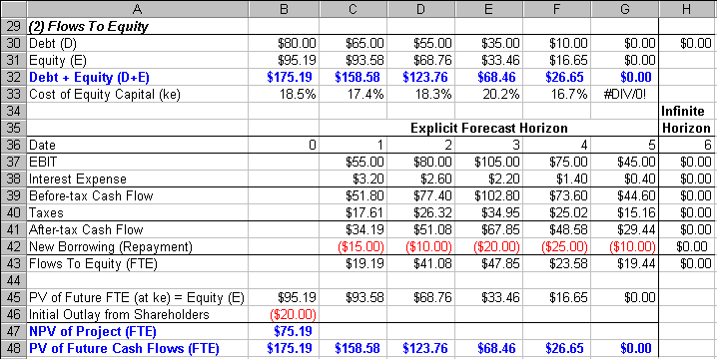

The Flows To Equity (FTE) Method

- Debt, Equity, and the Total. The Debt row is a repeat of the Debt input. Enter =B22 in cell B390 and copy it across the range C30:G30. Equity is the Present Value of Future Cash Flows (APV) less Debt. Enter =B27-B30 in cell B31 and copy it across the range C31:G31. Sum these two rows to get Debt + Equity. Enter =B30+B31 in cell B32 and copy it across the range C32:G32.

(10.) Cost of Equity Capital (ke). The infinite horizon formula for the Cost of Equity Capital is
$k_{e}=k+\left(1−t\right)\left(k−r\right)\left(D/E\right)$. Enter =k+(1-t)*(k-r.)*(G30/G31) in cell G33. The finite horizon formula
for the date t Cost of Equity Capital is $k_{e_{t}}=k+\left(k−r\right)\left\{D_{t}\left[1+r\left(1−T\right)\right]−\text{PVFTS}\left(t+1\right)\right\}/\left(E_{t}\left[1+r\right]\right)\text{.}$
Enter =k+((k-r.)*(B30*(1+r.*(1-t))-C25))/(B31*(1+r.)) in cell B33 and copy it across the C33:G33.
The term $\text{PVFTS}\left(t+1\right)$ is the present value of future tax shields as of date t+1. It is formally defined as $\text{PVFTS}\left(t+1\right)=\sum_{j=t+2}^{T}{\frac{\text{Tax}{\text{Shield}}_{j}}{{\left(1+r\right)}^{j−\left(t+1\right)}}+\frac{\text{Tax}{\text{Shield}}_{T+1}/r}{{\left(1+r\right)}^{T−\left(t+1\right)}}}$, where date T is the last date of the explicit forecast horizon
(T=5 in this case). Fortunately, we can simply reference the identical calculation done under the APV
method. The PV of Future Tax Shields on date t+1 is in cell C25.

- Flows to Equity. Calculate the cash flows to the equityholders (net of the debtholders) as follows:
- EBIT repeats Before-Tax Cash Flows. Enter =C12 in cell C37.
- Interest Expense (t+1) is Debt (t) * r. Enter =B22*r. in cell C38.
- Before-Tax Cash Flow is the difference. Enter =C37-C38 in cell C39.
- Taxes is Before Tax Cash Flow * t. Enter =C39*t in cell C40.
- After-Tax Cash Flow is the difference. Enter =C39-C40 in cell C41.
- New Borrowing (Repayment) is Debt (t+1) – Debt (t). Enter =C30-B30 in cell C42.
- Flows to Equity is the sum. Enter =C41+C42 in cell C43.
- Copy the range C37:C43 across to the range D37:H43.

- Present Value of Future FTE (at ke). Using the cost of equity capital ke, discount an infinite series of constant cash flows using the infinite annuity formula: (Flows To Equity) / ke. Enter =IF(H43=0,0,H43/G33) in cell G48. The IF statement avoids a divide by zero error. This occurs when the Infinite Horizon Flow to Equity (H43) is zero causing the prior period sum of Debt and Equity to be zero and thus causing ke in cell G33 to be undefined. Discount the explicitly forecast horizon cash flows using a recursive, one-period-at-a-time approach: PV of Future Flows To Equity (t) = [Flows To Equity (t+1) + PV of Future Flows To Equity (t+1)] / (1+ke). Enter =IF(G43+G45=0,0,(G43+G45)/(1+F33)) in cell F45 and copy it leftwards to the range B45:E45. Again the IF statement avoids a divide by zero error. You can verify that this equals the Equity (E).

- Initial Outlay from Shareholders, NPV of the Project, and PV of Future Cash Flows. To get the NPV of the Project using the FTE method, subtract the Initial Outlay from Shareholders. Enter =-I+B30 in cell B46 and =B45+B46 in cell B47. The PV of Future Cash Flows (FTE) is the sum of Debt plus the Present Value of Future FTS (= Equity). Enter =B30+B45 in cell B48 and copy it across the range C48:G48.

We see that the NPV of the Project under FTE is $75.19, which is the same as the APV calculation. The PV of Future Cash Flows are also the same under FTE and APV.

FIGURE 16.10.3 Spreadsheet for Valuation Under The WACC Method.

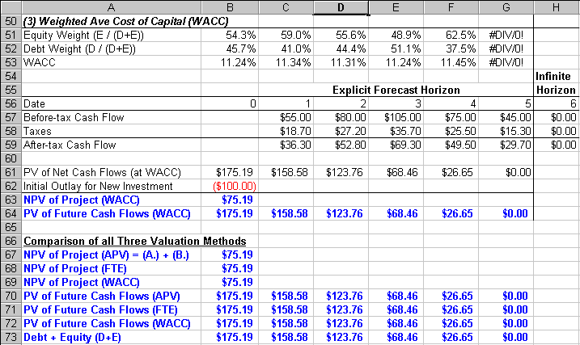
The Weighted Average Cost of Capital Method (WACC) Method

- Equity and Debt Weights. Using the Debt (D) calculated in row 30 and the Equity (E) calculated in row 31, determine Equity Weight = E / (D+E). Enter =B31/(B30+B31) in cell B51. Similarly, calculate the Debt Weight = D / (D+E). Enter =B30/(B30+B31) in cell B52.

- WACC. The formula for WACC = (Cost of Equity Capital) (Equity Weight) + (1 – Tax Rate) (r) (Debt Weight). Enter =B33*B51+(1-t)*r.*B52 in cell B53.

- WACC Method. Calculate the firm’s net cash flows and then discount them at WACC as follows:
- Before-Tax Cash Flows repeats row 12. Enter =C12 in cell C57.
- Taxes is Before Tax Cash Flow * t. Enter =C57*t in cell C58.
- After-Tax Cash Flow is the difference. Enter =C57-C58 in cell C59.
- Copy the range C57:C59 across to the range D57:H59.

- Present Value of Net Cash Flows (at WACC). Using the weighted average cost of capital (WACC), discount an infinite series of constant cash flows using the infinite annuity formula: (After-tax Cash Flow) / WACC. Enter =IF(H59=0,0,H59/G53) in cell G61. The IF statement avoids a divide by zero error. This occurs when the Infinite Horizon After-tax Cash Flow (H59) is zero causing the Equity Weight and Debt Weight to be undefined and thus causing WACC in cell G53 to be undefined. Discount the explicitly forecast horizon cash flows using a recursive, one-period-at-a-time approach: PV of Future Net Cash Flows (t) = [Net Cash Flow (t+1) + PV of Future Net Cash Flows (t+1)] / (1+WACC). Enter =IF(G59+G61=0,0,(G59+G61)/(1+F53)) in cell F61 and copy it leftwards to the range B61:E61. Again the IF statement avoids a divide by zero error.

- Initial Outlay from New Investment, NPV of the Project, and PV of Future Cash Flows. To get the NPV of the Project using the WACC method, subtract the Initial Outlay from New Investment. Enter =-I in cell B62 and =B61+B62 in cell B63. The PV of Future Cash Flows (WACC) is a repeat of row 61. Enter =B61 in cell B64 and copy it across the range C64:G64.

Comparison of all Three Valuation Methods

- Side-By-Side Results. To facilitate comparison of the three methods, place their key results side-by-side. Enter =B26 in cell B67, =B47 in cell B68, =B63 in cell B69, =B27 in cell B70, =B48 in cell B71, =B64 in cell B72, and =B32 in cell B73. Copy the range B70:B73 across to C70:G73.

The side-by-side comparison make clear that all three valuation methods, when properly calculated, yield the same project NPV and the same PV of Future Cash Flows as evaluated on any date. Further the PV of Future Cash Flows on any date equals the sum of Debt plus Equity on that date.

Using The Power Of Your Spreadsheet Model.

Suppose that the project above doesn’t stop producing cash flows after Date 5. Instead, suppose that it will produce a constant cash flow stream starting at Date 6 and carrying on forever. This is a so-called, two-stage project. The first stage consists of a specific set of cash flows over an explicit forecast horizon. The second stage is a constant annuity cash flow starting at Date 6 and extending over an infinite horizon. What is the s Let the Date 6 before-tax cash flow = constant annuity cash flow = $30,000 and let the Date 5 quantity of debt = infinite horizon quantity of debt = $5,000.

- Create A List of Input Values and An Output Formula. Create a list of input values for the Constant Cash Flow over an Infinite Horizon ($0.00, $10.00, $20.00, etc.) in the range C78:H78. Create an output formula that references the NPV of the Project under the three valuation methods. Enter =B26 in cell B79, =B47 in cell B80, and =B63 in cell B81.

- Data Table. Select the range B78:H81 for the Data Table. This range includes both the list of input values at the top of the data table and the three output formulas on the side of the data table. Then choose Data Table from the main menu and a Table dialog box pops up. Enter the cell address H12 ( Infinite Horizon Date 6 Before-tax Cash Flow) in the Row Input Cell and click on OK.

- Graph the Sensitivity Analysis. Highlight the data table C78:H81 and then choose Insert Chart from the main menu. Select an XY(Scatter) chart type and make other selections to complete the Chart Wizard.

FIGURE 16.10.4 Sensitivity of NPV of Project to Constant Cash Flow over Infinite Horizon

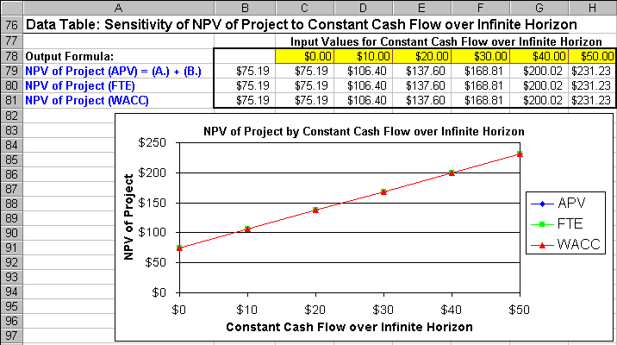

We learn two things from this analysis. First, the NPV of the Project is highly sensitive to the forecasted Constant Cash Flow over the Infinite Horizon. It is very important to forecast that Cash Flow as accurately as possible. Second, we see that the NPV of a Two-Stage Project is identical under all three valuation methods.

An interesting special case to the Two-Stage model is when the Cash Flows and Debt amounts in the first stage are identical to the Cash Flows and Debt amounts in the second stage. This allows the same spreadsheet model to be used for a single-stage, infinite horizon project. For example, the textbook example can be reproduced by setting I = $0.00, T = 0.0%, k = 10.0%, r. = 8.0%, all of the Before-tax Cash Flows in the range C12:H12 = $10.00, and all of the Debt (D) amounts in the range B22:G22 = $40.00.

Finally, all of the discussion so far has focused on valuing projects. However, the same Two-Stage spreadsheet model can be used value companies simply by zeroing out the Investment amount and entering the firm’s total Before-tax Cash Flows and the firm’s total Debt amount. Again, all three valuation methods will generate the same valuation of the firm.

