Section 15.8 Implied Volatility

Problem. On May 14, 1998, the S&P 500 index was at 1,1117.36. European call options on the S&P 500 index with the exercise prices show below traded for the following prices:

Exercise price | 1,1110 | 1,115 | 1,120 | 1,125 | 1,130
Call option price | $30.38 | $27.00 | $24.00 | $21.00 | $18.50

These call options mature on June 18th (the third Friday of June). Thus, the time to maturity is 36 days (0.0986 years). The S&P 500 portfolio pays a continuous dividend yield of 5.07% per year and the annual yield on a Treasury Bill which matures on June 18th is 4.82% per year. Using the first option and the continuous dividend yield version of the Black-Scholes model, what is the implied volatility of the stock?

Solution Strategy. Calculate the difference between the observed call price and the call price predicted by the continuous dividend yield version of the Black-Scholes model using a dummy value for the stock volatility. Have the Excel Solver tool adjust the stock volatility by trial and error until the difference between the observed price and the model price is equal to zero (within a very small error tolerance).

FIGURE 15.8.1 Spreadsheet for Implied Volatility

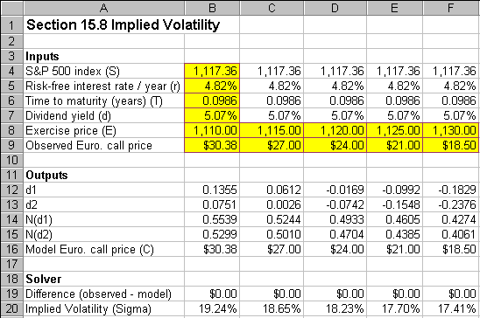
How To Build Your Own Spreadsheet Model.

- Inputs. Enter the inputs described in the problem into the range B4:B9 and enter a dummy value for the implied volatility (say 20%) in the cell B20.

- d1 and d2 Formulas. The formula is ${\left(\text{ln}\left(S/E\right)+\left(r−d+{σ^{2}}/2\right)T\right)}/{\left(σ\sqrt{T}\right)}$. In cell B12, enter

=(LN(B4/B8)+(B5-B7+B20^2/2)*B6)/(B20*SQRT(B6))

The formula is $d_{1}−σ\sqrt{T}$. In cell B13, enter

=B12-B20*SQRT(B6)

- Cumulative Normal Formulas. Enter $N\left(d_{1}\right)$ using the cumulative normal function in cell B14

=NORMSDIST(B12)

Copy the cell B14 to cell B15 or enter $N\left(d_{2}\right)$ using the cumulative normal function in cell B15

=NORMSDIST(B13)

- Model European Call Price. The continuous dividend version of the Black-Scholes call formula is $C=N\left(d_{1}\right){\text{Se}}^{−\text{dT}}−N\left(d_{2}\right){\text{Ee}}^{−\text{rT}}$. In cell B18, enter

=B14*B4*EXP(-B7*B6)-B15*B8*EXP(-B5*B6)

Solver

- Difference (Observed – Model). In cell B19, enter the difference between the observed call price and the model call price

=B9-B16

- Call Up Excel Solver. From Excel’s main menu, click on Tools and then Solver.

- Set-up Solver. In the Solver dialog box, enter cell B19 as the Set Target Cell. In the Equal to row, click on the option button for Value of and enter 0 in the adjacent box. Enter cell B20 as the By Changing Cell. See figure below.

FIGURE 15.8.2 Solver dialog box.

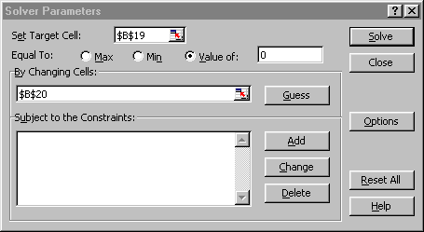
- Run Solver. Click on the Solve button.

By trial and error, the Solver adjusts the value of the Implied Volatility in cell B20 until the Difference (Observed – Model) in cell B19 equals zero (within a very small error tolerance). This results in an implied volatility of 19.24%.

Using The Power Of Your Spreadsheet Model.

Does the market’s beliefs about the distribution of returns of the S&P 500 Index match the theoretical distribution of returns that is assumed by the Black-Scholes model? You can answer this question by calculating the implied volatility for several different exercise prices.

- Inputs. Enter the exercise prices and call prices for the rest of the options into the range C8:F9.

- Copy The Inputs and Formulas. Enter the formula =B4 in the cell C4. Copy the formula in cell C4 down and across to the range C4:F7. Copy the formulas in the range B12:B20 across to the range C12:F20.

Solver

- Call Up Excel Solver. From Excel’s main menu, click on Tools and then Solver. (If Solver does not appear on the Tools menu, then click on Add-Ins, check Solver Add-In, and click on OK.)

- Change Solver’s Set-up. Change the Set Target Cell to cell C19 and change the By Changing Cell to cell C20.

- Run Solver. Click on the Solve button.

- Repeat. Repeat steps 4 and 5 to solve the problems in columns D, E, and F.

- Graph the Implied Volatilities Across Exercise Prices. Highlight the range B8:F8, then hold down the Control button and (while still holding it down) select the range B20:F20. Next choose Insert Chart from the main menu. Select an XY(Scatter) chart type and make other selections to complete the Chart Wizard.

FIGURE 15.8.3 Graph of the “Scowl” Pattern of Implied Volatilities.

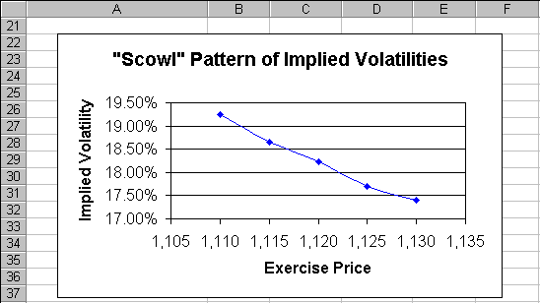
The implied volatility pattern declines sharply with the exercise price. In the ‘70s and ‘80s, the typical implied volatility pattern was a U-shaped, “Smile” pattern. In the ‘90s, it is more typical to see a downward-sloping, “Scowl” pattern. Clearly this implies that the market’s beliefs about the distribution of returns of the S&P 500 Index does not match the theoretical distribution of returns that is assumed by the Black-Scholes model.

