Section 15.7 Black-Scholes

Problem. The current stock price of SoftwareCo is $30, the exercise price of an European call option on SoftwareCo is $25, the annual risk-free interest rate is 4.0% per year, the call option’s time to maturity is nine months (0.75 years), the standard deviation of SoftwareCo’s stock is 40%, and the stock pays a continuous dividend yield of 2.0% per year. What this the current price of the European call option?

FIGURE 15.7.1 Spreadsheet for the continuous dividend version of the Black-Scholes model.

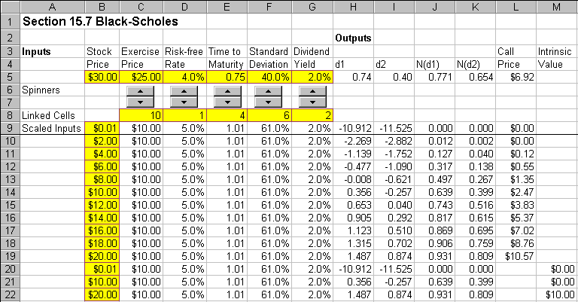
How To Build Your Own Spreadsheet Model.

- Inputs. Enter the inputs described above into the range B5:G5.

- d1 and d2 Formulas. The formula is ${\left(\text{ln}\left(S/E\right)+\left(r−d+{σ^{2}}/2\right)T\right)}/{\left(σ\sqrt{T}\right)}$. In cell H5, enter

=(LN(B5/C5)+(D5-G5+F5^2/2)*E5)/(F5*SQRT(E5))

The formula is $d_{1}−σ\sqrt{T}$. In cell I5, enter

=H5-F5*SQRT(E5)

- Cumulative Normal Formulas. Enter $N\left(d_{1}\right)$ using the cumulative normal function in cell J5

=NORMSDIST(H5)

Copy the cell J5 to cell K5 or enter $N\left(d_{2}\right)$ using the cumulative normal function in cell K5

=NORMSDIST(I5)

- European Call Price Formula. The continuous dividend version of the Black-Scholes call formula is $C=N\left(d_{1}\right){\text{Se}}^{−\text{dT}}−N\left(d_{2}\right){\text{Ee}}^{−\text{rT}}$. In cell L5, enter

=J5*B5*EXP(-G5*E5)-K5*C5*EXP(-D5*E5)

We see that the Black-Scholes model predicts an European call price of $6.92.

Using The Power Of Your Spreadsheet Model.

If you increased the standard deviation of the stock, what would happen to the price of the call option? If you increased the time to maturity, what would happen to the price of the call? You can answer these questions and more by creating an interactive spreadsheet model using “spinners.” Spinners are up-arrow / down-arrow buttons that allow you to easily change the inputs to the model with the click of a mouse. Then the spreadsheet recalculates the model and instantly redraws the model outputs on the graph.

FIGURE 15.7.2 An interactive Black-Scholes model with spinners.

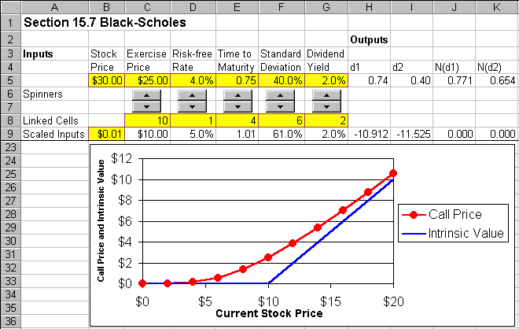
- Display the Forms Toolbar. Select View Toolbars Forms from the main menu.

- Create the Spinners. Look for the up-arrow / down-arrow button on the Forms toolbar (which will display the word “Spinner” if you hover the cursor over it) and click on it. Then draw the box for a spinner from the upper left corner of cell C6 down to the lower right corner of cell C7. Then a spinner appears in the range C6:C7. Right click on the spinner (press the right mouse button while the cursor is above the spinner) and a small menu pops up. Click on Copy. Then select the cell D6 and click on Paste. This creates an identical spinner in the range D6:D7. Repeat three more times. Select E6 and click on Paste. Select F6 and click on Paste. Select G6 and click on Paste. You now have five spinners in a row.

- Create The Cell Links. Right click on the first spinner in the range C6:C7 and a small menu pops up. Click on Format Control and a dialog box pops up. Enter the cell link “C8” in the Cell link edit box and click on OK. Repeat this procedure for the other four spinners. Link the spinner in D6:D7 to cell D8, link the spinner in E6:E7 to cell E8, etc. Click on the up-arrows and down-arrows of the spinners to see how they change the values in the linked cells.

- Create Scaled Inputs. The values in the linked cells are always integers, but they can be scaled appropriately to the problem at hand. In cell C9, enter =C8. In cell D9, enter =D8/20. In cell E9, enter =E8/4+0.01. In cell F9, enter =F8/10+0.01. In cell G9, enter =G8/100. Adding 0.01 to the standard deviation and time variables avoids having the formulas fail when those inputs equal zero.

- Create Stock Price Inputs. In the range B9:B19, enter the values 0.01, 2, 4, 6, …, 20. In cell B20, enter 0.01. In cell B21, enter =C9. In cell B22, enter 20.

- Copy The Other Inputs. In cell C10, enter =C9. Copy the formula in cell C10 across and down the range C10:G22.

- Copy The Formulas. Select the fomulas in the range H5:L5 and copy them to the range H9:L22.

- Add The Intrinsic Value. If the call option was maturing today, rather than later, the option payoff would be equal to: Max (S - X, 0). This is the so-called “Intrinsic Value” of the call option. In cell M20, enter the formula

=MAX(B20-C20,0)

Then copy this formula from the cell M20 to the range M21:M22. For convenience in graphing,
select the range L20:L22 and press delete to eliminate the values in those cells.

- Graph the Call Price and Intrinsic Value. Highlight the range B9:B22, then hold down the Control button and (while still holding it down) select the range L9:M22. Next choose Insert Chart from the main menu. Select an XY(Scatter) chart type and make other selections to complete the Chart Wizard. Place the graph in the range B23:K36.

- Freeze Panes. Put the cursor in cell A10 and select Window Freeze Panes from the main menu. Move the cursor down to cell A36. This moves the graph into view.

Your interactive spreadsheet model allows you to change Black-Scholes inputs and instantly see the impact on a graph of the call price and intrinsic value. This allows you to perform instant experiments on the Black-Scholes model. Below is a list of experiments that you might want to perform:

- What happens when the standard deviation is increased?
- What happens when the time to maturity is increased?
- What happens when the exercise price is increased?
- What happens when the riskfree rate is increased?
- What happens when the dividend yield is increased?
- What happens when the standard deviation is really close to zero?
- What happens when the time to maturity is really close to zero?

Notice that the Black-Scholes call price is usually greater than the payoff you would obtain if the call was maturing today (the “intrinsic value”). This extra value is called the “Time Value” of the option. Given your result in the last experiment above, can you explain why the extra value is called the “Time Value”?

