Section 14.7 Financial Futures

Problem. Suppose we observed the monthly spot price of the S&P 500 index and corresponding futures price for a stock index futures contract maturing in month 7. Here are the observed prices:

Month | 1 | 2 | 3 | 4 | 5 | 6 | 7
Spot price | 1117.36 | 1126.37 | 1136.73 | 1146.86 | 1155.14 | 1165.69 | 1178.23
Futures price | 1144.38 | 1149.94 | 1155.05 | 1162.00 | 1167.24 | 1170.23 | 1178.23

Suppose that the riskfree rate is 0.42% per month. Analyze what happens over time to the spread and to the price difference between the model futures price implied by Spot-Futures Price-Parity Relation versus the actual futures price.

Solution Strategy. First calculate the spread. Then substitute the spot price into the Spot-Futures Price-Parity Relation to determine the model futures price. Then calculate the price difference between the model futures price and the actual futures price.

FIGURE 14.7.1 Spreadsheet for Financial Futures.
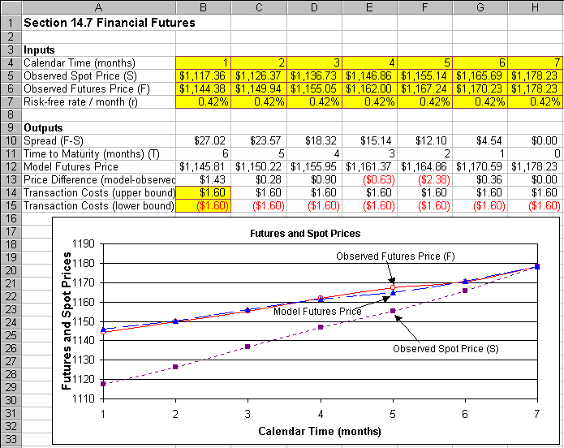
How To Build Your Own Spreadsheet Model.

- Inputs. Enter the monthly observations into the range B4:H6 and the monthly riskfree rate into the range B7:H7.

- Spread. Calculate the Futures Price minus the Spot Price (F-S) by entering =B6-B5 in cell B10.

- Time To Maturity. In month t, the formula for Time To Maturity is: Time To Maturity (t) = Maturity Date – Current Date (t). Hence, enter the formula =7-B4 in cell B11.

- Model Futures Price. In cell B12, enter the Spot-Futures Price-Parity formula

=B5*(1+B7)^B11

- Price Difference. In cell B13, calculate the price difference between the model futures price and the actual futures price

=B12-B6

- Copy Across. Copy the formulas in the range B10:B13 across the range C10:H13.

- Graph the Futures and Spot Prices Over Time. Highlight the range B4:H6, then hold down the Control button and (while still holding it down) select the range B12:H12. Next choose Insert Chart from the main menu. Select an XY(Scatter) chart type and make other selections to complete the Chart Wizard.

Notice that the spread is a substantial positive value and steadily declines over time before finally reaching zero when the futures contract matures. By contrast, the price difference is very small value and fluctuates between positive and negative values before going to zero when the futures contract matures.

Using The Power Of Your Spreadsheet Model.

Given that there is a (nonzero) price difference between the two markets, is it possible to make an arbitrage profit? Suppose that the round trip transaction cost for doing an arbitrage trade is $1.60. Analyze the monthly data to determine if was possible to have made an arbitrage profit.

- Transaction Cost Bounds. Transaction costs create an upper bound and a lower bound on the price difference, within which it is not possible to make an arbitrage profit. Specify the upper bound by entering 1.60 in cell B14 and the lower bound by entering –1.60 in cell B15. Copy these values from the range B14:B15 across the range C14:H15.

- Graph the Price Difference and Transaction Costs. Highlight the range B4:H4, then hold down the Control button and (while still holding it down) select the range B13:H15. Next choose Insert Chart from the main menu. Select an XY(Scatter) chart type and make other selections to complete the Chart Wizard.

FIGURE 14.7.2 Graph of Price Difference and Transaction Costs.

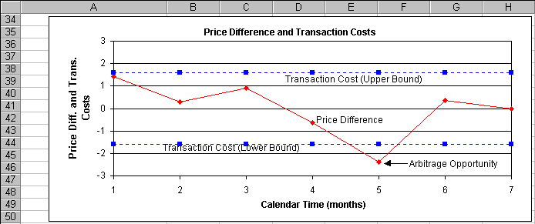
Most of the time the price difference was inside the transaction cost boundaries, so there wasn’t an arbitrage opportunity. However in month 5, the price difference went outside the boundaries by dropping below the lower bound. Thus, an arbitrage profit could made in month 5 by borrowing money at the riskfree rate to finance buying in the spot market and selling (going short) in the futures market.

