For Students: Spreadsheet Modeling is a Core Skill of Real-World Finance

My first job upon graduating with an a M.B.A. was working as a Financial Analyst in the corporate headquarters of a top 500 firm. Typical duties included forecasting the financial statements of company (to be used eventually by the President and Board of Directors), tracking short-term cash flows, analyzing our competition, and doing a variety of special projects, including at one point valuing a potential takeover target. In a typical month, 70% of my time was spent constructing and updating spreadsheet models.

My experience is typical of the real-world of finance. Whether you eventually work in a finance position (e.g., loan officer, broker, financial analyst, investment banker, etc.) or just do a little bit of financial work as part of a nonfinance position, the dominate vehicle for implementing your financial knowledge will be spreadsheet models.

Excel is merely a tool to build financial models, but it is an incredibly powerful and flexible tool. Calculators allow you to build toy models. Excel allows you to build real-world applications. For example, the Corporate Financial Planning Model in Section 3.8 is essentially the same as the model that I used in my financial analyst job. The only difference is that the later broke out more details about sales and inventories of our underlying products. The Life-Cycle Financial Planning Model in Section 5.1 can be used throughout your life to plan your lifetime savings and consumption. The Black-Scholes Option Pricing Model in Section 15. 7 can be used for such diverse applications as pricing listed call options, valuing equity when the shareholders can declare bankruptcy, valuing real options to develop land or close a mine, etc. The Portfolio Optimization Model in Section 12.3 can be used to allocate your investment funds between major asset categories, such as U.S. stocks, U.S. bonds, real estate, international stocks, international bonds, etc. And on it goes. The bottom line: these spreadsheet models should become a permanent part of your professional life and a permanent part of your personal financial decision-making.

Spreadsheet Modeling Exercises is based on a hands-on, active-learning paradigm. You start with a blank spreadsheet, follow complete user-friendly instructions, and build the financial models yourself. That way:
- you will really understand what is going on,
- you will be able to modify and extend the models to tackle related problems, and
- you will generate an understood model that will become a permanent part of your repertoire.
Your effort and hard work will be repaid many times over.

All you need to use Spreadsheet Modeling Exercises is an elementary knowledge of Excel, such as how to enter a formula in a spreadsheet cell and how to copy the contents of one spreadsheet cell to another. Everything else is fully explained. Each exercise is a self-contained, fully-worked-out example. The standard format is: (1) a problem is defined, (2) a solution strategy is sketched, (3) Excel screen shots show what the completed spreadsheet will look like, (4) step-by-step instructions explain exactly how to build the spreadsheet, and (5) key results are discussed. Each exercise contains two levels:
- “How To Build Your Own Spreadsheet Model” is the easier, more basic level to get started.
- “Using The Power Of Your Spreadsheet Model” extends the model to an advanced level.

Since this is an Electronic Book, you can have Spreadsheet Modeling Exercises open in one window and Excel open in another window. You can:
- Tile Horizontally between the two windows,
- Title Vertically between the two windows, or
- Run both applications in full-screen mode and switch back and forth between them using the Taskbar.
To tile the windows, right-click on the Taskbar (the gray bar at the bottom of the screen). This will bring-up a pop-up menu where you can select Tile Windows Horizontally or Tile Windows Vertically.

Title Windows Horizontally, | Title Windows Vertically, or
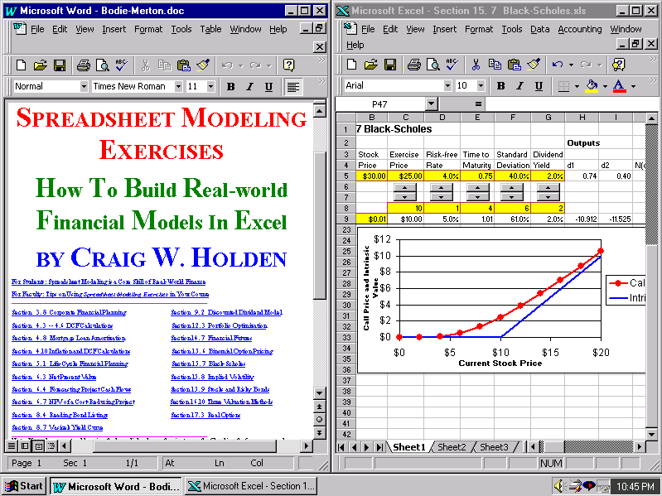 | 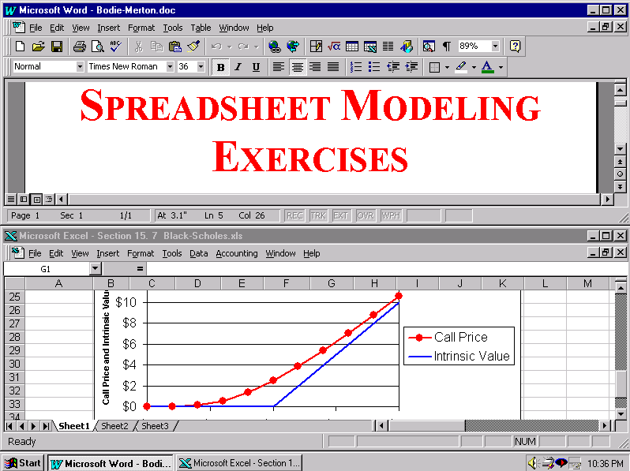
Switch Back and Forth Between Them Using the Taskbar.
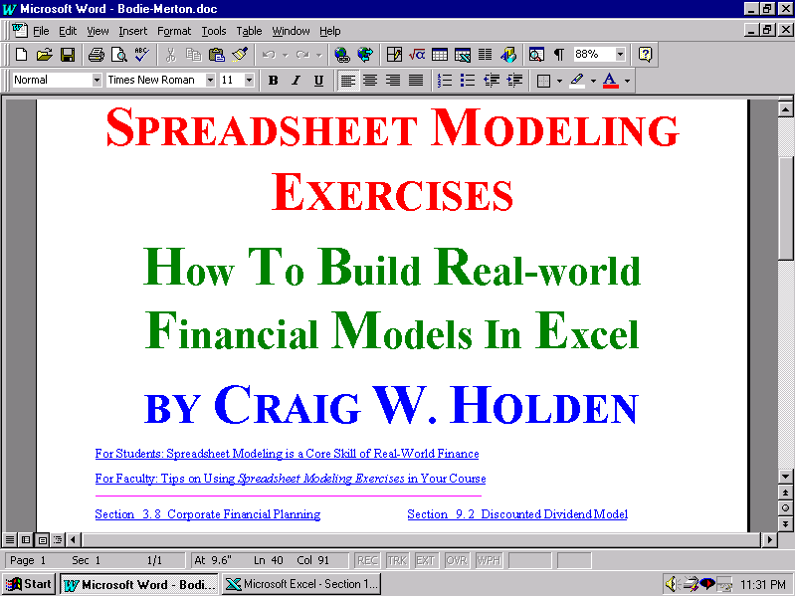 | 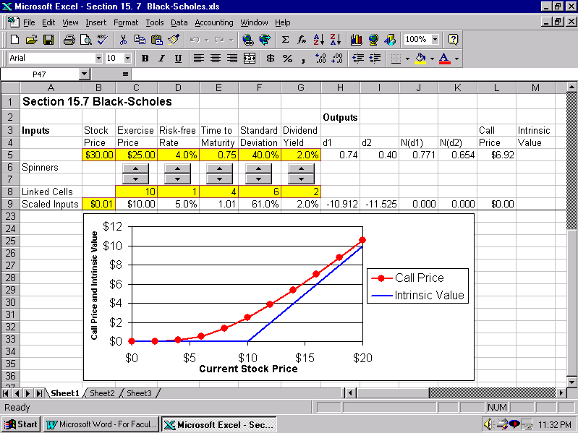

Please send you feedback or suggestions to my e-mail address: cholden@indiana.edu. Good luck!

Craig
________________________________________________________________________

Craig’s Challenge. Don’t click on this hyperlink unless you are willing to consider an important challenge that goes beyond the minimum effort needed for your class.

