Option Adjusted Spread Analysis:

A Tutorial

John F. Marshall, Ph.D.
St. John’s University, New York

Marshall, Tucker & Associates, LLC

and

Alan L. Tucker, Ph.D.

Pace University, New York

Marshall, Tucker & Associates, LLC

631-331-8024 (tel)
631-331-8044 (fax)
marshall@mtaglobal.com

Published January 2000 by Warren, Gorham & Lamont

John Marshall is Professor of Finance at St. John’s University. He was the Founding Executive Director of the International Association of Financial Engineers and he is the author of numerous books and articles on a variety of financial topics. Alan Tucker is Associate Professor of Finance at Pace University. He was the Founding Editor of the Journal of Financial Engineering and has also penned numerous books and articles. Drs. Marshall and Tucker are principals of Marshall, Tucker & Associates, LLC, and have served as consulting or testifying experts in important cases involving complex financial transactions.

Option Adjusted Spread Analysis:

A Tutorial

1. Introduction

An increasing amount of securities litigation involves complex financial transactions in which a portion of the testimony has involved option adjusted spread analysis. Option adjusted spread, or OAS, analysis is a relatively new tool for assessing the incremental return on a bond or other fixed income security for purpose of ascertaining whether said incremental return is sufficient compensation for the added risk occasioned by an option or options embedded in the security.

OAS analysis is decidedly superior to more traditional methods of measuring incremental return and risk when a security contains embedded options. Examples of instruments that contain embedded options include callable bonds, puttable bonds, convertible bonds, most structured securities, mortgages, and mortgage-backed securities such as collateralized-mortgage obligations (CMOs) and passthrough certificates. Indeed, the pre-payment options embedded in traditional fixed-rate mortgages are one of the most difficult types of options to understand, making the valuation of mortgage-backed securities problematic at best. This is one of the reasons that mortgage-backed securities (MBS) have been at the center of many large losses reported by financial institutions and fixed income portfolio managers over the last decade. It is also the reason that OAS analysis initially became popular among buyers and sellers of MBS.
In order to appreciate the benefits of OAS analysis as a way to measure incremental return, one should first understand the difficulties associated with the traditional approach to analyzing fixed income securities having embedded options (called embedded optionality). For this reason we begin our tutorial by reviewing basic concepts associated with measuring incremental return and interest rate risk. These concepts are initially applied to straight bonds, i.e., bonds having no embedded optionality, and then reapplied to bonds having embedded optionality. This exercise will reveal the inherent shortcomings of applying traditional approaches to valuing fixed income securities with embedded optionality. We then introduce the necessary concepts for understanding OAS analysis including spot zero rates, forward rates, and short rates. Finally, we combine these concepts with techniques developed to value options. What emerges is OAS analysis.
OAS analysis can be used to measure the incremental return and to assess the interest rate risk associated with a bond that does not contain embedded options. In this case, however, the results are not meaningfully different from more traditional measures. Nevertheless, the fact that OAS is always applicable - while more traditional methodologies are only truly applicable in the absence of embedded options - suggests that OAS is destined to become the standard method for assessing incremental return and interest rate risk.
All terms used in this paper will be defined as simply and clearly as possible. The authors apologize for the somewhat pedantic result. Throughout this article we will refer to the fixed income security as a “bond” and we will use a callable bond to illustrate the OAS analysis. One of the most widely employed analytic resources for calculating OAS for bonds is Bloomberg. For this reason the terminology employed in this paper and the analytical process described are drawn largely from Bloomberg publications. We will illustrate the process making use of rather simple assumptions. The reader is forewarned that actual OAS models often invoke considerably more complex assumptions than are employed in this paper.

2. Advantages of OAS Analysis

There are at least three advantages of OAS analysis:

Relative to other approaches, OAS provides a more comprehensive and more reliable measure of the risk premium associated with risky non-bullet bonds – bonds that are not scheduled to return all of their principal in a single lump sum at maturity but instead return principal periodically throughout the bond’s life, e.g., a bond with amortizing principal;

OAS provides a rational basis for valuing the options embedded in many bonds;

OAS leads to more stable and more reliable measures of interest rate risk associated with bonds having embedded options, relative to traditional methods. At the same time, these measures are analogous to and consistent with more traditional measures of interest rate risk applicable to bullet bonds – bonds that pay their full principal at maturity.

3. The Evolution of Bond Valuation Methodologies

To fully appreciate the OAS approach we first need to review the evolution of bond valuation. The evolution of bond valuation has had three major stages: yield-to-workout methodology, spot rate methodology, and option adjusted spread methodology. The first two stages are reviewed here in section 3, while OAS analysis is tackled in section 4. Initially, however, an understanding of the different types of bonds is required.

3.1. Types of bonds:

Bullet bond: A conventional bond paying a fixed periodic coupon and having no embedded optionality. Such bonds are nonamortizing, i.e., the principal remains the same throughout the life of the bond and is repaid in its entirety at maturity. Bullet bonds are also called straight bonds. In the United States such bonds usually pay a semiannual coupon. The coupon rate (CR) is stated as an annual rate (usually with semiannual compounding) and paid on the bond’s par value (Par). Thus, a single coupon payment is equal to ½ × CR × Par.

Benchmark bullet bond: A bullet bond issued by the sovereign government and assumed to have no credit risk (e.g., Treasury bond).

Non-benchmark bullet bond: A bullet bond issued by an entity other than the sovereign and which, therefore, has some credit risk.

Callable bond: A bond where the issuer has the right, but not the obligation, to call back/repurchase the bond at one or more specified points over the bond’s life. If called, the issuer pays the investor the pre-specified call price. The call price is usually higher than the bond’s par value. The difference between the call price and par value is called the call premium.

Zero coupon bonds: Zero coupon bonds do not pay periodic coupons. These bonds generate one and only one cash flow at some point in the future. This sum is received when the bond is redeemed at maturity. For example, a six-month zero produces one cash flow when the bond matures six months from today. Because they do not pay periodic coupons, zero coupon bonds always trade at a discount from their par value. The discount rate that equates the redemption value of the zero coupon bond to its current market price is called the bond’s spot zero rate. This rate is often called the zero rate or spot rate. Spot zero rates must be distinguished from forward zero rates, which are rates expected to prevail on zero coupon bonds at various points in the future.

Pure discount bonds: These are zero coupon bonds that are free of credit risk. They are zeros that are issued by the sovereign (e.g., zero coupon Treasury bonds).

3.2 Yield-to-Workout Methodology

This is the traditional methodology for valuing bonds. Essentially, all cash flows are discounted at the same rate. This rate is called the yield-to-workout (or simply the yield). In the case of a bond paying a semiannual coupon, and assuming that today is a coupon payment date, the present value of the bond is given by:

½×CR×Par ½×CR×Par ½×CR×Par Redemption
PV_{bond} = −⎯⎯⎯⎯ + −⎯⎯⎯⎯ + . . . + −⎯⎯⎯⎯ + −⎯⎯⎯⎯ (Eq. 1)
(1 + y/2)¹ (1 + y/2)² (1 + y/2)^{2T} (1 + y/2)^{2T}

Where y denotes the bond’s yield-to-workout

CR denotes the coupon rate (annual rate)

Par denotes the par value of the bond (we will assume throughout that this is $100)

Redemption is the bond’s par amount if the bond is held to maturity, or it is the

relevant call price if the bond is called

T denotes the number of years to the bond’s workout date.

This valuation equation is applicable if today is one of the bond’s coupon payment dates. This is an assumption we will make throughout because it simplifies the illustrations. Note that if we know the bond’s yield we can calculate the bond’s present value. The price of the bond should be equal to its present value. Equivalently, if we know the bond’s price we can work backwards (in an iterative fashion) to obtain the bond’s yield. Thus price and yield are interchangeable concepts.

The yield-to-workout method for valuing a bond clearly assumes that each cash flow (i.e., the coupon payments and the redemption amount) should be discounted at the same rate. This rate, called the bond’s yield-to-workout, is stated as an annual rate but with semiannual compounding (s.a.). If we assume that the bond will not be called, then T will be the years to maturity and the redemption amount is par. Here the yield-to-workout is called a yield-to-maturity.

If we assume that the bond will be called on a particular call date, then T is the number of years to the call date and the redemption amount represents the call price associated with that call date. In this case the yield-to-workout is known as a yield-to-call.

It cannot be known in advance whether a callable bond will be called and, if so, on which of its call dates it will be called. The traditional practice therefore, is to use the bond’s current market price to calculate all of its yields-to-workout and then to make the conservative assumption that the return on the bond is the lowest of all the yields-to-workout. The lowest of all the yields-to-workout is called the bond’s yield-to-worst or its promised yield. For example, suppose that a callable corporate bond matures at par in 20 years and pays a 9.00% s.a. coupon. The bond is currently priced at $108.25. It has three call dates. One is 5 years from today, the second is 10 years from today, and the last is 15 years from today. If not called on one of its three call dates, the bond would be redeemed for par at maturity. We have the following information:

When Redeemable Redemption Amount Implied Yield-to-Workout

5 years $107.50 (call price) yield to first call

10 years 103.50 (call price) yield to second call

15 years 100.50 (call price) yield to third call

20 years 100.00 (par) yield to maturity

To calculate the yield-to-worst, we use equation 1 and enter the current price of the bond, $108.25, for its present value (PV_{bond}). We then input the coupon rate of 9.00%, the relevant number of years to call or redemption T (e.g., 5 for the first call date), and the relevant redemption amount corresponding to that call or redemption date (e.g., $107.50 for the first call date). We then iterate to solve for y, which we interpret as the yield to the first call. We then repeat this process while using the information for the second call date and so forth. This produces the information below:

Redemption

When Redeemable Amount __Implied Yield-to-Workout at a Price of $108.25

5 years $107.50 yield to first call = 8.1992%

10 years 103.50 yield to second call = 8.0197% = yield to worst

15 years 100.50 yield to third call = 8.0601%

20 years 100.00 yield to maturity = 8.1566%

It may be prudent to employ the yield-to-workout methodology in order to measure the incremental return associated with bonds having credit risk, but not embedded options. Anything other than a benchmark bond, such as a corporate bond, will have at least some credit risk.

Essentially, when an investor purchases a corporate bond the investor is assuming some credit risk relative to the credit risk-free benchmark bond. Because such bonds expose the investor to additional credit risk, they should provide additional return. This additional return is usually called the credit spread. Credit spreads represent a type of risk premium.

Credit spreads are measured as the difference between the yield on a risky bond and the yield on a comparable-maturity benchmark bond. These credit spreads are measured in basis points. For example, suppose that the yield on a 10-year A-rated corporate bullet bond is 8.23%, while the yield on a 10-year Treasury bullet bond is 7.50%. The difference between these two yields is 73 basis points (bps). Thus the credit spread on the corporate is 73 bps and may be interpreted (albeit cautiously) as the risk premium earned for bearing the bond’s incremental credit risk.

While this is a reasonable way to measure the risk premium for a non-callable corporate bullet bond (i.e., direct comparison to a non-callable bullet benchmark bond), it is not judicious to apply this method to a callable corporate bond. The problem of course is that there can be many yields-to-workout associated with a callable bond (or other security with embedded optionality). Which of the yields-to-workout is the “right” yield to use to determine the credit spread? There is no good answer to this question in the yield-to-workout methodology. The standard approach is to take the yield-to-workout that represents the bond’s yield-to-worst and to treat the bond as though it has a maturity corresponding to the call date associated with the yield-to-worst. Then the yield on a benchmark bullet bond having a comparable maturity is deducted from the yield-to-worst on the callable bond. The difference between these two yields is the credit spread. While this approach seems reasonable at first blush, it is not. The yield-to-workout representing the yield-to-worst can suddenly change as a result of even a small change in the bond’s price. For example, in the corporate bond discussed above the yield-to-second-call represents the yield-to-worst and we would treat the bond as though it had a maturity of 10 years. The credit spread would be found by taking the difference between the corporate bond yield-to-worst and the yield on the comparable-maturity ten-year benchmark bond. But if the price of the corporate bond were to fall to $106, then the yield-to-worst would shift to the yield-to-third-call and the credit spread would be found by taking the difference between the bond’s yield-to-worst and the yield on the fifteen-year benchmark bond:

Redemption

When Redeemable Amount ________Implied Yield-to Workout__________

5 years $107.50 yield to first call = 8.7230%

10 years 103.50 yield to second call = 8.3350%

15 years 100.50 yield to third call = 8.3100% yield-to-worst

20 years 100.00 yield to maturity = 8.3760%

The yield-to-workout methodology has a number of other weaknesses and inconsistencies. First, the method assumes that all cash flows should be discounted at the same rate. This is inconsistent with anything other than a completely flat spot rate curve. That is, an upward sloping spot rate curve implies that cash flows to be received later should be discounted at a higher rate than cash flows to be received sooner. The interpretation we give this is that a yield-to-workout is not really the right rate at which to discount any of the cash flows that the bond will generate. Rather it is a weighted-average of the rates at which the individual cash flows should be discounted. In other words, we accept the idea that we are discounting all the individual cash flows at the wrong rate, because it is “right on average.” For some purposes this is an acceptable treatment. For other purposes it can be critically flawed.

Second, the yield-to-workout methodology implicitly assumes that cash flows generated by the instrument can be reinvested to return the same yield-to-workout. Again, this is not likely to be a reasonable assumption unless the spot rate curve is flat.

Third, as we have already demonstrated the yield-to-workout can be unstable when bonds are callable with the result that if the bond price changes, sometimes by only a little, the call date corresponding to the yield-to-worst can change abruptly. This has at least two serious implications: It can cause an abrupt and misleading change in the credit spread, and it causes the bond’s duration - a traditional measure of interest rate risk - to be quite unreliable.

Fourth and finally, it can be demonstrated that the yield-to-workout methodology is incapable of addressing, in a precise manner, the volatility of interest rates.

3.3. The Spot Rate Methodology

An important insight of Caks is that conventional bonds are simply portfolios of zero coupon bonds. That is, each coupon payment and the final redemption payment may be viewed as separate instruments. Each of these separate instruments may be viewed as a zero coupon bond.

While this argument seems obvious today, it was a revolutionary idea at the time. It was this realization that led Merrill Lynch to begin breaking up bullet Treasury bonds into zero coupon bonds. Merrill discovered that investors were willing to pay more for the zeros than it cost Merrill to create them from bullet Treasury bonds, giving rise, at least for a time, to an arbitrage opportunity.

When viewed as a portfolio of zeros, it becomes obvious that the proper way to value a bullet bond is to value each component zero separately by discounting it at the appropriate spot zero rate. The value of the bond is then the sum of these individual present values. Assuming semiannual coupon payments and that today is a coupon payment date, the valuation equation would look as follows:

½×CR×Par ½×CR×Par ½×CR×Par Redemption

PV_{bond} = −⎯⎯⎯⎯ + −⎯⎯⎯⎯ + . . . + −⎯⎯⎯⎯ + −⎯⎯⎯⎯ (Eq. 2)

(1 + ₀z₁/2)¹ (1 + ₀z₂/2)² (1 + ₀z_{2T}/2)^{2T} (1 + ₀z_{2T}/2)^{2T}

Where ₀z_{t} denote the spot zero rates that are applicable for discounting zero coupon bonds at time 0 (now) that will mature t periods from now. Here we assume that a period is six months in length and that the spot rate is stated as an annual rate with semiannual compounding.

The spot rate methodology is theoretically superior to the yield-to-workout methodology because it uses a correct, though different, discount rate for each cash flow. Thus if each cash flow is discounted at the correct rate, the sum of the present values is the correct value of the bond.

The spot rate methodology corrects for the first and second weaknesses of the yield-to-workout methodology, but it does not, by itself, address the third and fourth weaknesses. This is where OAS analysis picks up. First, however, we need to briefly introduce the concept of short rates.

3.4. Short Rates

Short rates are zero coupon rates that are limited to zero coupon bonds having a maturity of just one period. A “period” is defined by the context. For our purposes a period is six months. As each new period begins, a short rate for that period is realized. For example, suppose that we are measuring time in six-month intervals starting from today. Suppose that today is January 1, 1999. Then the current short rate is the six-month zero coupon rate applicable to a zero coupon bond maturing on July 1, 1999. The next short rate, i.e., the one associated with the six-month zero coupon bond that will exist on July 1 and mature on January 1, 2000 is not yet realized but will be realized on July 1, 1999.
4. Option Adjusted Spreads Analysis

OAS analysis makes use of forward rates of interest. This requires some explanation and some notation. Before beginning, keep in mind that time is divided into six-month intervals throughout this discussion. Thus a “period” is six months in length.

4.1. Forward Rates

The term forward rate is used by different people to mean different things, so great care should be taken when using it. In general, a forward rate refers to an expectation of a rate of interest that will prevail at some point in the future.

One type of forward rate is the forward yield-to-maturity on a coupon-bearing bond. These types of forward rates are often called coupon forwards. For example, we might be interested in the yield-to-maturity on a five-year coupon-bearing bond two years from today. This could be described as a two-year forward five-year coupon yield.

Most frequently, however, the term forward rate is used to refer to a forward zero rate. This rate could be any number of periods forward and applicable to any maturity zero coupon bond. Here a forward zero rate will be denoted _{j}z_{t}. This is interpreted as the t-period zero rate expected to prevail j periods from today (i.e., t periods from period j). For instance, the notation ₃z₄ would imply the zero rate expected to prevail on four-period zero coupon bonds three periods from today.

Recall that ₀z_{t} denotes the rate of discount applicable now (time 0) to a zero coupon bond that matures t periods later. We earlier called this a spot zero rate. It should be clear that a spot zero rate is just a special case of a forward zero rate where j = 0.

4.2. Forward Short Rates

There is one special set of forward zero rates that is critical to OAS analysis, namely, forward short rates. Forward short rates, most often just called forward rates, are forward rates on zero coupon bonds where each zero coupon bond has a maturity of just one period. Forward short rates may be viewed as forecasts of the future short rates. It is important to appreciate that a forecast is just that, a forecast. The actual short rate that is realized for a particular period will almost certainly differ from the forward short rate. Indeed, the forward short rate is continuously changing to reflect new information until such time as the future becomes the present - at which time the forward short rate becomes the realized short rate.

The full set of forward short rates is given by ₀z₁, ₁z₁, ₂z₁, ₃z₁, ₄z₁, ... Notice that the first forward short rate is simply the one-period spot zero rate, otherwise known as the current short rate.

Using a time line, these forward rates can be visualized as follows:

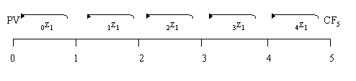

4.3. Obtaining Spot Rates and Forward Short Rates

Under a widely employed theory of term structure, called the expectations theory, forward short rates can be derived from a series of spot zero rates. Essentially, the expectations theory holds that spot zero rates are the geometric average of successive forward short rates. That is:

(1 + ₀z_{t}/2)^{t} = (1 + ₀z₁/2)×(1 + ₁z₁/2)× (1 + ₂z₁/2)× ... ×(1 + _{t-1}z₁/2)

Thus, if one knows the spot zero rates, one can sequentially derive the forward short rates. The spot zero rates can either be observed from Treasury zero coupon bonds (called STRIPS) or derived from the current term structure (yield curve) through a process commonly known as bootstrapping.
If we accept the expectations theory of term structure, the following will be true:

½×CR×Par ½×CR×Par ½×CR×Par Redemption
PV_{bond} = ⎯⎯⎯⎯ + ⎯⎯⎯⎯ + …+ ⎯⎯⎯⎯⎯ + ⎯⎯⎯⎯⎯
(1 + ₀z₁/2)¹ (1 + ₀z₂/2)² (1 + ₀z_{2T}/2)^{2T} (1 + ₀z_{2T}/2)^{2T}

[(1 + ₀z₁/2)×(1 + ₁z₁/2)]

[(1 + ₀z₁/2)×(1 + ₁z₁/2) ×...× (1 + _{2T-1}z₁/2)]

This allows us to express the value of a bond in terms of forward short rates rather than in terms of spot zero rates.
Notice that this formulation implies that the discounting of cash flows is a process by which each future cash flow is sequentially discounted period-by-period at each single period’s applicable short rate until we obtain its present value.
Now notice that the first short rate (i.e., the one-period spot zero rate ₀z₁) is known with certainty. However, the next period short rate is uncertain and will remain uncertain until one period has elapsed. Thus the short rate that will be realized one period from today is likely to be different from the current one-period forward short rate (₁z₁). Similarly, the short rate that will be realized two periods from today is likely to be different from the current two-period forward short rate (₂z₁). Notice also that the short rate to be realized two periods from now is more uncertain than the short rate to be realized one period from now, and so on. Indeed, the further out we project the short rates, the greater the likelihood that the realized rate will deviate from the current estimate (i.e., the forward short rate). This is where OAS analysis becomes important. OAS analysis provides a systematic framework for factoring in the uncertainty (i.e., volatility) of the forward short rates.

4.4. The Eight Steps of OAS Analysis

There are eight steps associated with OAS analysis. We assume that we are applying the method to a callable bond:

Derive the set of risk-free spot zero rates (via bootstrapping) from the benchmark yield curve. (We will assume that this has already been done.)

Derive the risk-free forward short rates from the benchmark spot zero rates by exploiting the expectations theory of term structure. (We will assume that this too has already been done.)

Build a binomial tree depicting the possible future values of the short rates and also determine their probabilities.

Apply the binomial tree to value the cash flows on a benchmark bullet bond.

Calibrate the model by adjusting the binomial tree values until the model’s predicted price matches the actual market price of the bond.

Apply the same set of calibrated rates to value a callable bond by adding the same number of basis points (the spread factor) to all short rates in the tree. Adjust this spread factor until the model’s predicted price equals the actual market price. The result is the bond’s OAS.

Apply the same OAS to value a bullet bond with terms identical to the callable bond (except that the bullet bond is not callable).

Take the difference between the value obtained for the callable bond and the value obtained for the non-callable bullet bond. This difference is the value of the embedded call option.

4.5. Building a Binomial Tree of Short Rates

We begin at step 3, building a binomial tree of forward short rates. We make a number of simplifying assumptions to illustrate the process. The more important of these assumptions are that the annual volatility of forward short rates is the same for all forward short rates and that this annual volatility is constant. We also assume that forward rates evolve via a random walk process.
In order to have a set of rates with which to illustrate the process, assume that we have the following four forward short rates, all expressed with semiannual compounding:

₀z₁ = 6.000%
₁z₁ = 7.200%
₂z₁ = 8.150%
₃z₁ = 8.836%

Assume that annual volatility of the forward short rates is 15%. We need to describe how, over time, the estimates of future short rates might evolve from the current estimates of those future short rates (the current estimates of the future short rates are the forward rates). Under a standard binomial approach, we assume that with each passing time period, the estimate of a future short rate can go either up to one and only one higher level or down to one and only one lower level.

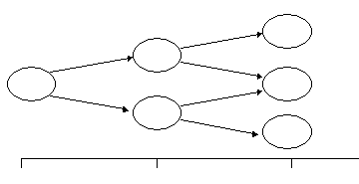

As noted earlier, we are denoting the t-period forward short rate by _{t}z₁. Suppose we are interested in where this forward rate will be j periods from now. Denote this by _{t}^{j}z₁. Thus one period from now the estimate of the t-period short rate (currently _{t}z₁) will be _{t}¹z₁. There would be 2 such values (one higher than _{t}z₁ and one lower than _{t}z₁). Similarly, two periods from now the estimate of the t-period short rate (currently _{t}z₁) will be _{t}²z₁. There will be 3 such values. Note that when j = t the forward short rate has become the realized short rate. We need to know all possible short rates that might be realized for each period.

For example, suppose that time is divided into six-month intervals, today is January 1, 1999, and I ask “what is the current estimate of the short rate that will prevail on July 1, 2000?” What I am asking for is ₃z₁.

And now suppose that I ask “what will be the estimate of the July 1, 2000 short rate on July 1, 1999?” The answer would be ₃¹z₁. Similarly, if I ask “what will be the estimate of the July 1, 2000 short rate on January 1, 2000?” then I am asking for ₃²z₁.

We will assume that the probability of the forward short rate rising each period and the probability of the forward short rate declining each period are the same.

Denote the higher possible value of the future t-period short rate one period from now by _{t}¹z^{H}₁ and the lower possible value of the future t-period short rate one period from now by _{t}¹z^{L}₁.

The following relationship between the higher and lower rates will hold:

_{t}¹z^{H}₁ = exp(2 × σ × √τ ) × _{t}¹z^{L}₁ (Eq 3)

Where exp(•) is the exponential function, and τ denotes the fraction of a year covered by each single period (this is 0.5 in this case as we have assumed six-month intervals).

Substituting the given values for σ (.15) and τ (.5), Equation 3 becomes:

_{t}¹z^{H}₁ = exp(2 × .15 × √.5 ) × _{t}¹z^{L}₁

= 1.23631 × _{t}¹z^{L}₁ (Result 1)

Intuitively, it would be expected that the statistical expectation of the next period value of the forward short rate should be equal to the current forward rate. This relationship is given by Equation 4:

(.5 × _{t}¹z^{H}₁) + (.5 × _{t}¹z^{L}₁ ) = _{t}z₁ (Eq 4)

Substituting Result 1 into Equation 4 allows us to solve for _{t}¹z^{H}₁ and _{t}¹z^{L}₁ in terms of

_{t}z₁ :

_{t}¹z^{H}₁ = 1.10567 × _{t}z₁

and

_{t}¹z^{L}₁ = 0.89433 × _{t}z₁

These results allow us to express each subsequent evolution of a forward rate in terms of its value in the prior period.

Consider the value ₁z₁ (7.200%). What might its realized values be one period from now (₁¹z₁)?

_{t}¹z^{H}₁ = 1.10567 × 7.200% = 7.961%

and

_{t}¹z^{L}₁ = 0.89433 × 7.200% = 6.439%

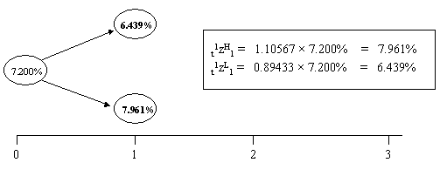

Now consider what the realized values of the short rate two periods from now (i.e., ₂²z₁) might be:

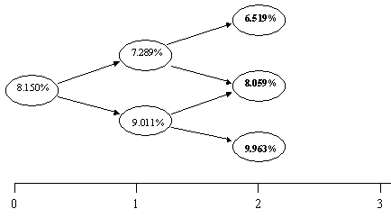

Finally, consider what the realized value of the short rate three periods from now (i.e., ₃³z₁) might be:

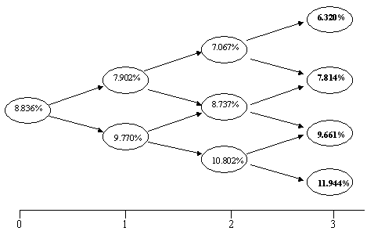

We are not interested in the intermediate values associated with arriving at the set of possible realizable values of each short rate, but rather just the realizable values per se. We now gather all of the realizable values and place them on the appropriate nodes of a binomial tree. This is called the binomial tree of risk-free short rates. It is depicted in Exhibit 6.

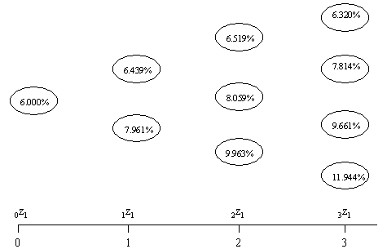

We are now ready to employ the range of possible values the various short rates might take on to value a bond. We begin with a benchmark bullet bond (recall that it is credit risk free and non-callable). Suppose that the bond pays a 7.50% annual coupon in two semiannual installments of $3.75 (per $100 of par) and that the bond currently has 24 months (4 periods) to maturity. Given the forward short rates we have assumed, this bond should be priced exactly at par (100.0000), which we will assume it is.

The first coupon of $3.75 will be received in exactly 1 period, i.e., six months. What is the value now (present value) of this future payment? We obtain this by building a “price tree” for this payment. Because this payment is only one period away and the short rate associated with this one period is known with certainty, this is a trivial matter.

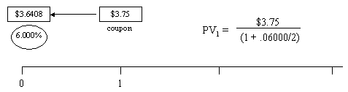

Next, we use the short rates to determine the value of the $3.75 coupon payment that will be received 2 periods (twelve months) from now by building a price tree for the second cash flow. This requires that we discount sequentially backward through every possible path of potentially realizable short rates.

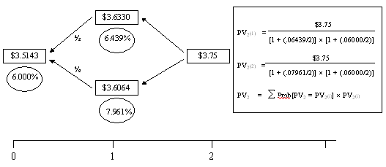

Next, we use the short rates to determine the value of the $3.75 coupon payment that will be received 3 periods from now by building a price tree for the third cash flow. Again, this requires that we discount sequentially backward through every possible path of potentially realizable short rates.

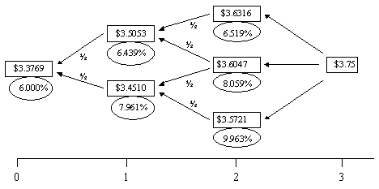

Finally, we use the binomial tree of short rates in the same manner to calculate the expected present value of the final cash flow. This final cash flow, which occurs two years from today, includes the final coupon payment of $3.75 and the bond’s par value of $100. Thus, the final cash flow is $103.75.

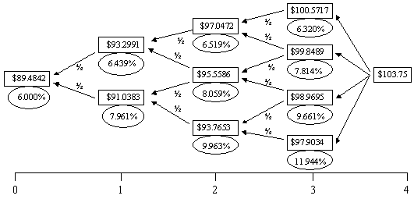

4.6. Valuing the Bond from its Cash Flows

We have calculated the present values of the individual cash flows by way of the price trees. We now sum these present values to obtain the value of the bond (representing step 4 in the eight-step OAS process):

Period Cash Flow Present Value

1 $3.75 $3.6408

2 $3.75 $3.5143

3 $3.75 $3.3769

4 $103.75 $89.4842

$100.0161

Notice that the actual market price of the bond is par ($100.0000). The value we obtained above for the bond is greater than par. Thus our model contains an error. What is the source of this error and how can we correct it?
The error is caused by a combination of two factors. The first is the convexity of present value functions and the second is the volatility of the forward rates that leads to multiple realizable values for the short rates. To understand the convexity problem we need to illustrate the relationship between the present value of a cash flow and the rate at which that cash flow is discounted. This is illustrated in Exhibit 11.

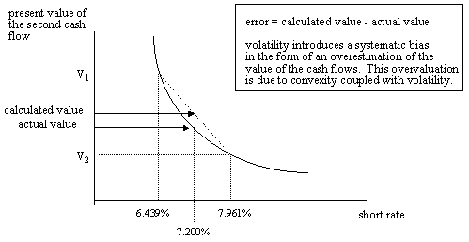

Notice that the present value curve depicted in Exhibit 11 is not linear. That is, it has some curvature to it. This curvature is called convexity and it, together with the volatility of interest rates, is the source of the error. To see this, consider the second cash flow on the bond above. This cash flow is a coupon payment of $3.75. If this cash flow is discounted for one period at the one-period forward short rate, ₁z₁, which is 7.200%, and then again at the spot short rate (₀z₁) of 6.000%, we get the actual value depicted in Exhibit 11. (Note that the exhibit illustrates only the first discounting but both sequential discountings are implied.) Instead, if the cash flow is discounted at the two different short rates that might be realized in one period (6.439% and 7.961%), and then the resulting values are discounted again at the spot short rate of 6.000%, we obtain the two values labeled V₁ and V₂ in Exhibit 11. The value of the cash flow, labeled the “calculated value” in the Exhibit, is an average of these two values. Note that this average is higher than the actual value.

4.7. Calibrating the Binomial Tree of Short Rates

Correcting the error in the valuation of cash flows requires a sequential process called calibrating the binomial tree of short rates (step 5). The calibration process involves raising the estimates of the future short rates by an amount just sufficient so that the average of the calculated present value for the cash flow exactly equals the actual value of the cash flow. As this is done, we must simultaneously preserve the relationship between the different values that the short rates might take on, as given by equation 3.

This calibration process is an iterative sequential process. First we calibrate the values at the first node in the binomial tree of short rates. Once this is finished, we calibrate the second set of nodes in the binomial tree of short rates, and so forth.
The solution to the first set of nodes is illustrated in Exhibit 12.

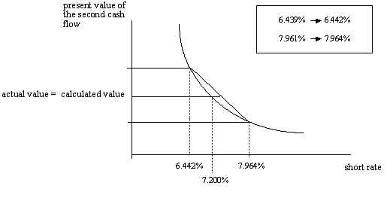

The fully calibrated binomial tree of risk-free short rates that correspond to our data is illustrated in Exhibit 13. Here the calibrated rates appear in the ellipses while the non-calibrated rates appear in brackets below the ellipses for comparison.

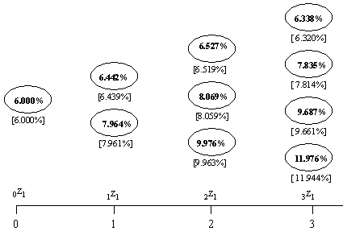

When the cash flows associated with the benchmark bond are obtained by discounting through this calibrated tree of risk-free short rates, the sum of present values is precisely the value of the bond. This is depicted below:

Period Cash Flow Present Value

1 $3.75 $3.6408

2 $3.75 $3.5143

3 $3.75 $3.3767

4 $103.75 $89.4683

$100.0000

4.8. Calculating a Bond’s Option Adjusted Spread

The calibrated binomial tree of short rates we have just derived is applicable to valuing a benchmark bullet bond. Now we consider how this same calibrated binomial tree could be adapted to value a non-benchmark callable bond (step 6). A callable corporate bond is an example of such a bond. To simplify the analysis, we assume that a corporation incurs no transactions costs either when it calls a bond or when it issues a new bond and that it will always call a bond if it is rational to do so.

Suppose that we have a 24-month corporate bond paying an annual coupon of 10.50% in two semiannual installments. Thus each coupon is $5.25. The bond is callable in 18 months (3 periods) at $101.00. Suppose that the bond’s offer price is $103.75. This is the price at which you could buy this bond. Our goal is to come up with this same value by way of our model. We begin by developing the price tree for each of this bond’s cash flows using the previously derived calibrated binomial tree of short rates.

The price trees for the first, second, and third cash flows are illustrated in Exhibits 14, 15, and 16, respectively.

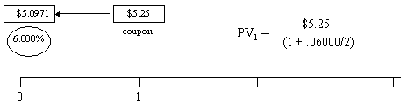

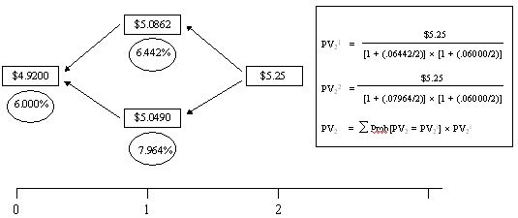

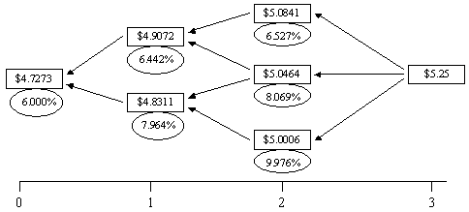

Now consider the price tree for the final cash flow on this bond. This is depicted in Exhibit 17.

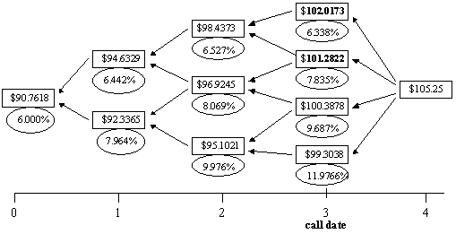

Now notice that the value of the fourth cash flow on the bond’s call date may be any one of four different values: $102.0173, $101.2822, $100.3878, or $99.3038. As the bond is callable on this date at $101 and we have assumed that the issuer incurs no transaction costs when calling or issuing a bond, the rational thing for this issuer to do is to call the bond if the value on the call date is above $101. This condition is satisfied if the value on the call date is either $102.0173 or $101.2822, but not satisfied if the value is either $100.3878 or $99.3038. To see why this is so, consider the issuer’s behavior if the bond’s value is $102.0173: Because the bond is a liability to the issuer, the issuer is able to eliminate a liability worth $102.0173 at a cost of $101.
At all short rates that give rise to values that would cause the issuer to call the bond, the investor must assume that the bond would be called and the value would then be only the call price, in this case $101.
Thus, we must substitute the call price for the value of the cash flow on the call date in any case in which the value of the cash flow exceeds the call price. This is depicted in Exhibit 18.

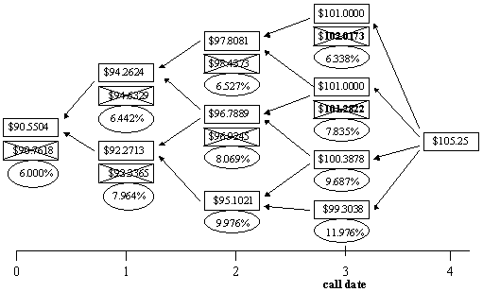

We can now sum the present values obtained from the price trees for the four individual cash flows, using the call-adjusted replacement tree for the fourth cash flow, to obtain the model’s predicted price (MPP). This value is $105.2947.

Period Cash Flow Present Value

1 $5.25 $5.0971

2 $5.25 $4.9200

3 $5.25 $4.7273

3 $105.25 $90.5504

$105.2947

Notice that the MPP of $105.2947 is higher than the actual market price of $103.75. Our model has clearly overestimated the value of the bond. The explanation for this is simple. The calibrated binomial tree of short rates that was used to value the bond was for risk-free bonds (e.g., recall that it was derived for valuing credit risk-free Treasury bonds). The rates at which bonds with credit risk should be discounted must clearly be higher than these risk-free rates. To deal with this, we go back to the calibrated binomial tree of risk-free short rates and add the same number of basis points to each short rate in the tree.

The number of basis points we add is called a spread factor. Spread factors are measured in basis points. This number is obtained in an iterative fashion. Suppose, for example, we add 50 basis points to each short rate in the calibrated tree and re-value the cash flows. We have:

Period Cash Flow Present Value

1 $5.25 $5.0874

2 $5.25 $4.8962

3 $5.25 $4.6933

4 $105.25 $89.7921

$104.4664

Because the MPP is still higher than the observed market price of $103.75, the spread factor we used is too low. So we try a higher spread factor. Suppose that we try 100 basis points. In this case, the MPP is $103.5791. This, of course, is lower than the observed market price of $103.7500. Thus the 100 basis points is too high a spread factor. This process is repeated until the MPP price matches (to a nearly exact amount) the observed market price. In our case this occurs with a spread factor of 90.465 basis points:

Period Cash Flow Present Value

1 $5.25 $5.0748

2 $5.25 $4.8772

3 $5.25 $4.6659

4 $105.25 $89.1321

$103.7500

The solution of 90.465 basis points is called the bond’s option adjusted spread. Essentially, we interpret the OAS as the number of basis points that must be added to each and every rate in the calibrated binomial tree of risk-free short rates to obtain a MPP that precisely equals the observed market value of the bond. These basis points represent the risk premium for bearing the credit risk associated with the bond. The same sort of analysis could have been performed if the bond had contained an embedded put option.

4.9. Using OAS Analysis to Value the Embedded Option

We can use the OAS to determine the value of the option that is embedded in a callable bond (steps 7 and 8). To accomplish this task we ask “what would the value of the bond be at the same OAS if the bond had not been callable. In this case, the answer is $103.8143.

A callable bond may be viewed as a portfolio consisting of a long position in a bullet bond and a short position in a call option on a bullet bond that begins on the option’s call date. Therefore,

B_{callable} = B_{bullet} – C_{bullet}

103.7500 = 103.8143 – C_{bullet}

implying that C_{bullet} = 0.0643

Thus the option is worth $0.0643 for every $100 of par.

4.10. Effective Duration:

As mentioned earlier in this paper, when a bond contains embedded options modified duration is a poor indicator of the interest rate risk associated with holding the bond. The OAS approach, by specifically taking the optionality of the bond into consideration as well as taking the sources of an option’s value into consideration (i.e., volatility), makes it possible to derive a better measure of interest rate risk. This measure is called the bond’s effective duration or option-adjusted duration.

The most intuitive way to calculate an effective duration is to first calculate the callable bond’s fair value using the OAS approach., as we did above. Next, we assume that the benchmark yield curve shifts upward by exactly 1 basis point. We then re-derive the benchmark spot rates, re-derive the forward rates, and re-derive the calibrated binomial tree of risk-free short rates.

Next, using the same OAS previously derived we calculate what the value of the callable bond would be. The new value is deducted from the original value of the bond to obtain the bond’s option-adjusted dollar value of a basis point or DV01.

For a non-callable bond, the following relationship holds between a bond’s modified duration (D_{M}) and its DV01:

DV01 = D_{M} × Price_{$100 par} × 0.0001

implying that

DV01
D_{M} = ⎯⎯⎯⎯⎯⎯⎯⎯
Price_{$100 par} × 0.0001

A similar relationship will hold for effective duration (D_{E}), whether the bond is callable or not, provided that the DV01 is derived via OAS analysis in the manner described above:

DV01_{option adjusted}
D_{E} = ⎯⎯⎯⎯⎯⎯⎯⎯ (Eq. 5)
Price_{$100 par} × 0.0001

It should be clear that for a non-callable bond, the bond’s modified duration and the bond’s effective duration are identical. But they are not identical for a callable bond (or any bond with embedded optionality for that matter).
In the case of the corporate bond for which we calculated an OAS of 90.465 basis points, we add one basis point to all maturities on the benchmark yield curve. We then re-derive the spot rates, re-derive the forward rates, and then re-derive the calibrated binomial tree of risk-free short rates. Finally, using the same OAS previously derived (90.465 basis points), we calculate the value of the bond and find it to be 103.73190. Thus, the option-adjusted DV01 is found to be:

DV01_{option adjusted} = 103.7500 − 103.7319

= $0.0181.

That is, a one basis point parallel upward shift in the benchmark yield curve will cause this corporate bond to decline in value by $0.0181 for every $100 of par value.
We can now obtain this bond’s effective duration from Equation 5. The effective duration is found to be 1.745.
For comparison to the traditional yield-to-workout methodology described earlier in this article, this bond’s yield-to-maturity is 8.4235% and its yield-to-call is 8.4258%. Clearly, the yield-to-maturity is this bond’s yield-to-worst. Based on this yield-to-worst and the fact that it corresponds to a redemption date 24 months out, this bond would have a modified duration of 1.7829. Notice the difference between this bond’s unreliable modified duration and its far-more reliable effective duration. While this difference may not seem significant, it has to be remembered that this bond has a very short maturity. For bonds with longer maturities, the difference can be very significant.

4.11. Portfolio Properties of Effective Duration

Effective duration has the same basic portfolio properties as does modified duration. Specifically, the effective duration of a bond portfolio is a weighted-average of the effective durations of the individual components of the portfolio, where the weights are the ratios of the present values of the individual components to the total present value of the portfolio.

5. Summary

This paper has presented the basics of OAS analysis. It has described the necessary steps to compute the credit spread, adjusted for embedded optionality, of a risky debt instrument such as a callable corporate bond. Still, OAS analysis can be significantly more complicated in practice than was illustrated here.
OAS analysis is an important valuation tool that can be used to determine if option-embedded securities are transacted at arms-length prices. For instance, in ACM v. Commissioner (commonly known as the “Colgate case” and cited in footnote 1 of this paper), the government argued that certain transactions undertaken by the partnership were sham transactions conducted at off-market prices as part of a complicated scheme to shield former capital gain income. Some of the securities transacted contained embedded options. In order to determine, therefore, whether or not said securities were traded at-market, OAS analysis was used to transform the securities to straight debt. The option-adjusted yields on these securities were then compared to the yields of straight-debt instruments of a similar risk class and maturity that were trading in the market at the time. If the option-adjusted yields and the yields of comparable straight-debt instruments were not substantially different, then one could conclude that the transactions in question were at-market. Otherwise, the conclusion would be that the transactions were not arms-length. In its ruling the Court found that certain transactions undertaken by ACM were not at-market. The ultimate effect of this finding was to preclude the taxpayer from shielding past gains.

Cf. ACM Partnership, Southampton-Hamilton Company, Tax Matters Partner, Petitioner, v. Commissioner of Internal Revenue, Respondent, United States Tax Court Docket No. 10472-93.
The credit spread is not necessarily entirely explained by additional credit risk. There are other factors as well. These include the liquidity of the bond issue, any unusual covenants the bond indenture might contain, and tax factors. The latter are particularly important. The interest on risk-free Treasury bonds is exempt from state and local income taxes but the interest on corporate bonds is generally not exempt from these taxes. Also, the coupon interest on municipal securities can be exempt from federal, state, and local income taxes and this will significantly affect their yields.
John Caks. “The Coupon Effect on Yield to Maturity,” Journal of Finance, v32(1), 103-115.
For a discussion of bootstrapping see John F. Marshall and Vipul K. Bansal, Financial Engineering: A Complete Guide to Financial Innovation, New York Institute of Finance, 1992, pp 430-433.
It is at this stage that the option analytics approach enters the methodology. Binomial models to value options are widely used. They constitute one of the “numeric approaches” to option valuation. Other numeric approaches could be used in lieu of a binomial approach and sometimes are used. Examples of other numeric approaches are simulation and finite difference methods.
Annual volatility is defined as the standard deviation of the annual percentage change in the forward rate, when that percentage change is continuously compounded. This is the usual way to measure volatility in applications involving option valuation.
For this particular bond, this is simply a matter of not substituting the call price of $101 for the value of the fourth period cash flow at the third node when that value exceeds $101.
The dollar value of a basis point is also called the price value of a basis point or the present value of a basis point. It is defined as the dollar amount by which the price of a $100 par value bond will decline if the yield curve shifts up by 1 basis point.
This assumes that corporate bond yields shift in the same direction and by the same number of basis points as the bonds that make up the benchmark yield curve.

