MT1370
Numerical methods with MATLAB
Anatoliy Malyarenko

$Θ$

$λ$

$Ρ$

$Δ$

$Γ$

Weiss Amani
Toma Boyacioglu
Antti Laine

INDEX

1 INtroduction 3
2 THEORY 4
3 INTRODUCING THE GREEKS 5
3.1 Delta$Δ$ 5
3.2 Gamma $Γ$ 6
3.3 Theta$Θ$ 7
3.4 Vega$υ$ 7
3.5 Lambda $λ$ 8
3.6 Rho 9
4 Hedging: The General Philosophy 10
5 Constructing Greek Neutral Portfolio 11
5.1 The Delta Neutral Portfolio 11
5.2 The Delta, Gamma, and Vega Neutral portfolio 13
6 Conclusions 15
7 References 16
8 The Matlab program for the Greeks neutral portfolios 17

INtroduction

Any financial institution operating in the over-the-counter markets, when selling an option or any other derivative to its clients will face with the challenge and problems of managing its risks.

If the option happens to be the same as one that is traded with on an exchange, the financial institution can neutralize its risks by buying on the exchange the same option it has sold.

In this report we will try to explain one of the main methods in use in the financial field for managing and neutralizing risks. We will cover what is commonly referred to as Greeks (Delta, Gamma, Lambda, Roh, Theta and Vega).

Each of them measures a different proportion of the risk in an option position and the goal of working with these Greeks is to manage them in a way so that all risks are acceptable.

THEORY

Now before we go on with the explanation and characteristics of each of these Greek letters we would like to give you as the reader some more information about upon what assumptions and models these sensitivities measures and based.

First of all it is of great importance to say that these sensitivity measures are based upon that the option is priced using the Black-scholes Model which it in it self entails several assumptions…

• The prices of the underlying asset follow an Ito process.

• The option can be exercised only on its expiration date (European Option so to say)

• Short selling is permitted (Short selling is the selling of a stock that the seller doesn't own. More specifically, a short sale is the sale of a security that isn't owned by the seller, but that is promised to be delivered. That may sound confusing, but it's actually a simple concept).

• There are no transaction costs.

• All securities are divisible and pay no dividends.

• There is no risk less arbitrage.

• Trading is a continuous process.

• The risk-free interest rate is constant and remains the same for all maturities.

If any of these assumptions are violated then the Black-scholes may not be an appropriate model.
The model was by the way the first complete mathematical model for pricing options and first developed by Fisher Black and Myron Scholes.

It examines the current stock price, strike price, volatility, time to expiration, and the interest rates.
To understand the model we must understand how the models value change when the input parameters change.
As we mentioned before the black-scholes option value depends on the relation of stock price, time to maturity, the volatility, and the interest rate.

All these parameters can change over the life time of the option therefore it is of importance to determine the sensitivity of the option value to the changes in each of these mentioned variables.
Each of these sensitivities can be determined by taking partial derivatives.

Now hopping that we have presented some background about the Black-scholes model we will not waste any more of your time and directly go to explanation of the “Greeks”.

We will collectively refer to the financial measures Delta, Gamma, Lambda, Roh, Theta, and Vega simply as the Greeks.

INTRODUCING THE GREEKS

Delta$Δ$

The delta of a stock option is the ratio of the change in the price of the stock option to the change in the price of the underlying stock.

$\text{Delta}=\frac{∂c}{∂S}$ (the change in the value of the option divided by the change in the value of the underlying asset).

It can be referred to as the slope of the curve that relates the option price to the underlying asset price.
An example might clarify things even more; suppose that the delta of a call option on a stock is 0.7.

This means that when the stock price changes by a small amount the option price changes by about 70% of that amount.
The delta of an option is also referred to as the hedge ratio of the option position were one simply shifts its position in the portfolio by either going long or short and hedging it all the time.
The delta is our first and most important Greek.

In matlab the function blsdelta have the purpose what we just described about the delta of an option this function in the program matlab calculates deltas for both call and put options the syntax of this function is as it follows,

[CallDelta, PutDelta] = blsdelta (Price, Strike, Rate, Time, Volatility, DividendRate).

The arguments that this matlab function takes are the following:

Price Current stock price.
Strike Exercise price.
Rate Risk-free interest rate. Enter as a decimal fraction.
Time Time to maturity of the option, in years.
Volatility Standard deviation of the annualized continuously
compounded rate of return of the stock, also known as volatility.
DividendRate (Optional) Dividend rate or foreign interest rate where
applicable enter as a decimal fraction. Default = 0.

Gamma $Γ$

The gamma of a portfolio of derivatives on an underlying asset is the rate of change of the portfolios delta with respect to the price of the underlying asset. Mathematically it is the second partial derivative of the portfolio value with respect to the asset price.
$\text{Gamma}=\frac{∂^{2}c}{∂S^{2}}$ (the change in the value of the options delta divided by the change of the
underlying asset).

If the gamma is small, delta changes slowly and adjustments to keep a portfolio delta neutral needs to be done more infrequently. So given this definition of the gamma we can state that the gamma is the delta of the delta with respect to the change of the underlying asset.
The gamma is important when examining the higher-order behavior of a contract.

In matlab the function blsgamma have the purpose what we just described about the gamma of an option; however the matlab function blsgamma function have only one output in contrast to the delta function syntax of this function is as it follows,

Gamma = blsgamma (Price, Strike, Rate, Time, Volatility, DividendRate)

And the arguments that this matlab function takes are

Price Current stock price.
Strike Exercise price.
Rate Risk-free interest rate. Enter as a decimal fraction.
Time Time to maturity of the option in years.
Volatility Standard deviation of the annualized continuously compounded rate of return of the stock (also known as volatility).
DividendRate (Optional) Enter as a decimal fraction. Default = 0.

Theta$Θ$

The theta of a portfolio consisting of derivatives can be regarded as the rate of change of the portfolio value with respect to the passage of the time when all other parameters are kept the same.

Therefore it is correct to express it as the rate of change of the portfolio value with respect to a decrease in the times to maturity of the derivatives in the portfolio. We can write it in mathematatical terms like

$\text{Theta}=\frac{∂c}{∂t}$ (the change in value of the option divided by the change in the time to
expiration).

Theta is also referred to as the time decay of the portfolio. The indication of the theta value we can express to be that if the asset doesn’t move, the option will change by the theta with time theta in this case of course being a value either positive or negative.

In the program matlab there is a function for this sensitivity measure blstheta which as the same purpose as described, to measure the Black-Scholes sensitivity to time until maturity change.

This function as the blsdelta returns two outputs a more general description is the following:

[CallTheta, PutTheta] = blstheta (Price, Strike, Rate, Time, Volatility, DividendRate).

This matlab function returns the call option theta CallTheta, and the Put option theta PutTheta.

The arguments that this matlab function takes are the following:

Price Current stock price.
Strike Exercise price.
Rate Risk-free interest rate. Enter as a decimal fraction.
Time Time to maturity of the option in years.
Volatility Standard deviation of the annualized continuously
compounded rate of return of the stock (volatility).
DividendRate (Optional) Enter as a decimal fraction. Default = 0.

Vega$υ$

In most theoretically constructed financial problems we implicitly assume that the volatility of an asset underlying a derivative is constant.

However in practice volatilities change over time. Which means that the value of the derivative is dependent to the change because of the movements in the volatility as well as of the changes in the asset price and the passage of time that we have discussed earlier?

The Vega of a portfolio of derivatives is the rate of change of the value of the portfolio with respect to the volatility of the underlying asset.
$\text{Vega}=\frac{∂c}{∂σ}$ (the change in the value of the option divided by the change in the volatility).

In matlab we have the function blsvega which as at its purpose to calculate the Black-Scholes sensitivity to the underlying price volatility, the syntax of this function can be described as the following:

Vega = blsvega(Price, Strike, Rate, Time, Volatility, DividendRate)

This function takes several arguments to be more specific we can state that the arguments that this function takes are the following:

Price Current stock price.
Strike Exercise price.
Rate Risk-free interest rate. Enter as a decimal fraction.
Time Time to maturity of the option in years.
Volatility Standard deviation of the annualized continuously
compounded rate of return of the stock (volatility).
DividendRate (Optional) Enter as a decimal fraction. Default = 0.

The function returns one output the rate of the change of the option value with respect to the volatility of the underlying asset.

Lambda $λ$

Lambda can also be referred to as the elasticity of a derivative.
It represents the percentage change in the price of an option relative to a one percent change in the price of the underlying asset.

The function blslambda satisfies this purpose in matlab. The syntax of this function is;

[CallEl, PutEl] = blslambda(Price, Strike, Rate, Time, Volatility, DividendRate),

this function takes several arguments such as,

Price Current stock price.
Strike Exercise price.
Rate Risk-free interest rate. Enter as a decimal fraction.
Time Time to maturity of the option in years.
Volatility Standard deviation of the annualized continuously
compounded rate of return of the stock (volatility).
DividendRate(Optional) Dividend rate. Enter as a decimal fraction. Default = 0.

A more general and comprehensive description of the function blslambda can be given as,

[CallEl, PutEl] = blslambda(Price, Strike, Rate, Time, Volatility, DividendRate)
returns the elasticity of an option. CallEl is the call option and PutE1 the put option.

Elasticity or leverage factor and PutEl is the put option elasticity or leverage factor. Elasticity (the leverage of an option position) measures the percent change in an option price per one percent change in the underlying stock price.

Rho

The roh of a portfolio of derivatives is the indication of the change of the portfolio value with respect to the interest rate.

The sensitivity measure roh that we are going to investigate can be reoffered to be belonging to the same group of Greeks as Vega.

This is in contrast to Theta, Delta, and Gamma that can be considered as sensitivity measures with respect to state variables.
The price of the stock and the time to expiration are state variables they denote the state of nature and keep changing.
$\text{Roh}=\frac{∂c}{∂r}$ (the change in the value of the option divided with the change in the value of the
interest rate).

In matlab we have a function called blsrho which has the same purpose that we have described to measure the Black-Scholes sensitivity to interest rate change.

The syntax of this function is the following:

[CallRho, PutRho] = blsrho (Price, Strike, Rate, Time, Volatility, DividendRate).

And the arguments that this function takes are…

Price Current stock price.
Strike Exercise or strike price.
Rate Interest rate. Enter as a decimal fraction.
Time Time to maturity of the option in years.
Volatility Standard deviation of the annualized continuously
compounded rate of return of the stock (volatility).
DividendRate(Optional) Dividend rate. Enter as a decimal fraction. Default = 0.

This matlab function returns two outputs the call option rho CallRho, and the put option rho PutRho.

Now having introduced the main and most important variables of hedging we would like to incorporate the concept of hedging by constructing some hedging related problems and present you some solutions programmed in matlab. But before we go on with the actual problems and the matlab solutions of these problems we would like to give some detailed explanation of the hedging.

We think however that it is of great importance that we should in this stage, after having developed the sensitivity measures mention that these sensitivity measures are accurate only for infinitesimal changes that occur over an instant of time.

Hedging: The General Philosophy

As mentioned before these sensitivity measures are accurate only over a small time interval.
The explanation of this can be given purely mathematically, and this is because they are derived or induced so to say by a first-order Taylor approximation for those of you who might not be acquainted with this approximation I will try to give a brief explanation here below.

Consider that a linear approximation to a function is obtained with a first-order Taylor approximation for example the function,
$f(x)=f(x_{0})+D(f)(x_{0})(x×x_{0})$

The intuitive explanation for this approximation is based on the interpretation of the first-order derivative D(f) as the increase in the function value, per an infinitesimal increase in the variable.

Hence an increase in the variable from $x_{0}$ to $x×x_{0}$, generates an increase of $D(f)(x_{0})(x×x_{0})$ in the function value resulting in a function value of $f(x_{0})+D(f)(x_{0})(x×x_{0})$.

The main idea of hedging is to utilize these changes to compose portfolios that over the next instant of time will be hedged against particular changes.

The use of these strategies over a time interval longer then say from $x$ to $x+1$ should be executed with some care.
For a larger change or for hedging over longer time intervals better approximations can be obtained by employing and utilizing a higher order of Taylor approximation.

This however will require in its turn the use of higher order calculus and derivatives which I am not that good acquainted with and unfortunately give an explanation for.

So therefore at least for my own account I can say that if I ever would face such an challenge in the lack of knowledge about higher order Taylor approximations I would instead keep on reshuffling the portfolio as often as possible and in this manner maintain its insensitivity to changes in certain parameters, since the sensitivity measures are effective only over a small interval of time.

Constructing Greek Neutral Portfolio

In this part of our report we are going to point our efforts entirely to the program matlab and construct two different types of portfolios the first portfolio that we are going to construct will be Delta neutral.

Which means that this portfolio will be constructed in such way that it will have its sensitivity measure or Greek letter if you whish to call it equal to zero.
This will be done to so we can be able to insulate the value of the option portfolio from small changes in the price of the underlying asset.

The Delta Neutral Portfolio

Now consider a portfolio consisting of two different options one call option named Pepsi and one put option named Coca-cola and a total amount of cash lets say $1500 to spend on these two options.
Our objective is to find $x_{1}$, $x_{2}$ such that satisfies the linear equation

$$P={\text{Pepsix}}_{1}+{\text{CocaColax}}_{2}$$

Such that the

Cost (P) = 1000, and $\frac{∂P}{∂S}$=0

This problem we can solve in 3 steps.
In matlab we will write a program that will provide us with the value, and deltas of these two options.

Step 1: Obtain V1 and V2, the prices of option 1 and 2 by using the matlab function blsprice ().

This function is used to calculate the Black-Scholes price of the underlying, the function returns two outputs one for the CallPrice, and one for the PutPrice.

Step 2: Obtain D1, D2, the Deltas for the options by using the matlab function blsdelta ().

Step 3: Solve the linear equation system,
What is a linear equation system and how is this solved in matlab?

A linear equation is any equation of the form

$$a_{1}x+a_{2}x=b$$

For example, to solve for x and y in the system of linear equations

$$2x+y=\text{13}$$
$$x−3y=−\text{18}$$

there must be two equations, which there are.

Matrix algebra represents this system as an equation involving three matrices: A for the left-side constants, X for the variables, and B for the right-side constants

$A=\left[\begin{matrix}2 & 1 \\ 1 & −3\end{matrix}\right]$ $X=\left[\begin{matrix}x \\ y\end{matrix}\right]$ $B=\left[\begin{matrix}\text{13} \\ −\text{18}\end{matrix}\right]$

where $A∗X=B$.

Solving the system simultaneously simply means solving for X. Using MATLAB,

A = [2 1
1 -3];

B = [13
-18];

X = A \ B

solves for X in A * X = B.

X = [3
7]

So x = 3 and y = 7 in this example. In general, you can use matrix algebra to solve any system of linear equations such as
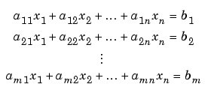
by representing them as matrices
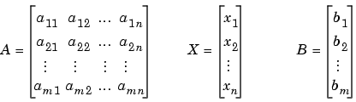
and solving for X in A*X = B.

So for our example of Pepsi and Coca-Cola options the solution simply follows,

x = A \ b; where

$A=\left[\begin{matrix}D_{1} & D_{2} \\ V_{1} & V_{2}\end{matrix}\right]$, and A = [D1 D2; V1 V2];

$b=\left[\begin{matrix}0 \\ \text{1500}\end{matrix}\right]$ b = [0; 1500];

having performed these steps in matlab we will obtain the result of how much dollars we should spend on $x_{1}V_{1}$ for the option Pepsi and how much we should spend on $x_{2}V_{2}$ for the option Coca-cola.

For a more detailed content of the solution and the matlab program see the detailed description of the program attached at the end of this report.

The Delta, Gamma, and Vega Neutral portfolio

Constructing a portfolio with delta, gamma and Vega neutral means that all the above mentioned Greeks would be set equal to zero.

Suck a portfolio is needed to be constructed if the purpose of the holder is to neutralize its risk exposure to small changes of the underlying and in the changes of the volatility.

Now for this portfolio problem, hence that we have a system of four options, Pepsi, Coca-Cola, Fanta, and Zingo.

We are at the most allowed to spend $45000 on this portfolio consisting of these above mentioned options.
Now the challenge is to create such an portfolio and that the portfolio is simultaneously hedged against Delta, Gamma and Vega exposure. They should be neutralized.

In more mathematical terms there partial derivatives with respect to the underlying asset in the case of movements in the stock option (Delta), in the change in the value of the options delta divided by the change of the underlying asset (Gamma) and finally in the movements of the change in the value of the option divided by the change in the volatility (Vega) should all be equal to zero.

The solution of this problem is no more difficult then the solution of the first portfolio and just for the simplicity of the problem I will try to give a more generalized solution of this problem.
Were the number of sensitivity measures calculated can be so many we wish them to be but no more then six.

Again the 3 step procedure:

Step 1: Obtain the prices $V_{1}$ for all the options in our case its four by using the matlab function
blsprice ().

Step 2: Obtain the vectors of Deltas, Gammas and Vegas using the matlab functions blsdelta (), blsgamma () and blsvega ().

Step 3: Create and solve the linear equation system of $\text{Ax}=b$ given by

$A=\left[\begin{matrix}Δ_{1} & … & … & Δ_{4} \\ γ_{1} & … & … & γ_{4} \\ κ_{1} & … & … & κ_{4} \\ V_{1} & … & … & V_{4}\end{matrix}\right]$ $b=\left[\begin{matrix}0 \\ 0 \\ 0 \\ \text{45000}\end{matrix}\right]$

Matrix A is consisting of the Deltas, Gammas, Vegas and the Values (Prices) of the portfolio. Make note that this matrix is the weighted average of the all Deltas, Gammas and Vegas of all four options traded.

Matrix b is consisting of the desired values that we want our portfoilio to have for each of our Greek, and the total value of the portfolio in this case Delta equal to zero same with the Gamma and Vega, and a total value of $45000 for the portfolio.

For a more detailed and coperhensive explanation and solution of the problem please chek the Matlab program written for this problem in the end of this report.

Conclusions

Working with Matlab and constructing different financial portfolios has been a real pain and when executed in correct manner a great pleasure at the same time.
We enjoyed working with Matlab because of its ability to solve almost any kind of financial problems.

Moreover this seminar helped us to understand and know the program Matlab a little bit more than what we did during the course, because of the effort and time put down on investigating and understanding the commands related to our seminar challenge.

One thing we can say as the outcome of this seminar is that in the future we will try to perform most of our tasks related to financial problems employing the program Matlab and financial toolbox because of its user-friendlyness and vivid explanations and graphics.

References

Literature:

- Eliezer Z. Prisman. Pricing Derivative Securities. (2000). Academic Press. (p.271-301, 323-327).

- John C. Hull. Options, Futures, & Other Derivatives. (2000). Fourth Edition. Prentice-Hall, Inc. (p.307-329)

- Jarrow & Turnbull. Derivative Securities. (2000). Second Edition. South-Western College Publishing a division of Thomson Learning. (p.224-225).

Internet:

- www.mathworks.com/access/helpdesk/help/toolbox/finance/samples5.shtml
- www.mathworks.com/access/helpdesk/help/toolbox/finance/fintu27a.shtml
- www.mathworks.com/access/helpdesk/help/toolbox/finance/fintu28a.shtml
- www.ndsu.nodak.edu/ndsu/jelder/f02/derivatives/Lect_ppt/T15_Greek_Letters1_ho.pdf
- www.cs.cornell.edu/Info/Courses/Spring-98/CS522/content/lab3.pdf

Program:

- Matlab 6.0
- Financial toolbox (p.2-32,33 – 3-12,13,14,15 – 4-34,35,38,39,41,42,43)

The Matlab program for the Greeks neutral portfolios

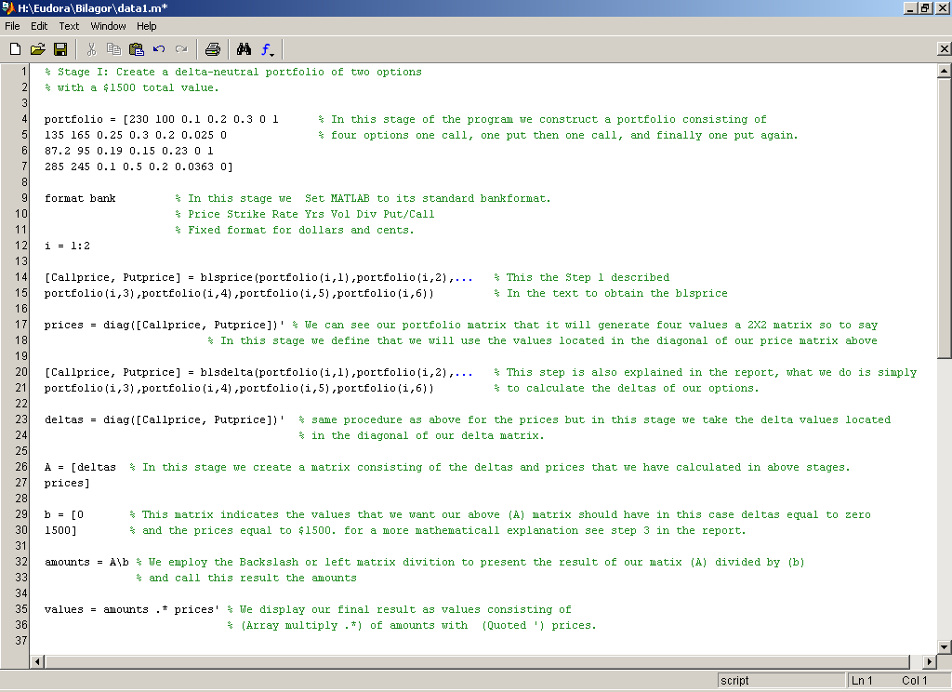

Executing this program in matlab will hopfully give you the follwing result…

portfolio =

Columns 1 through 5

230.00 100.00 0.10 0.20 0.30
135.00 165.00 0.25 0.30 0.20
87.20 95.00 0.19 0.15 0.23
285.00 245.00 0.10 0.50 0.20

Columns 6 through 7

0 1.00
0.03 0
0 1.00
0.04 0

i =

1.00 2.00

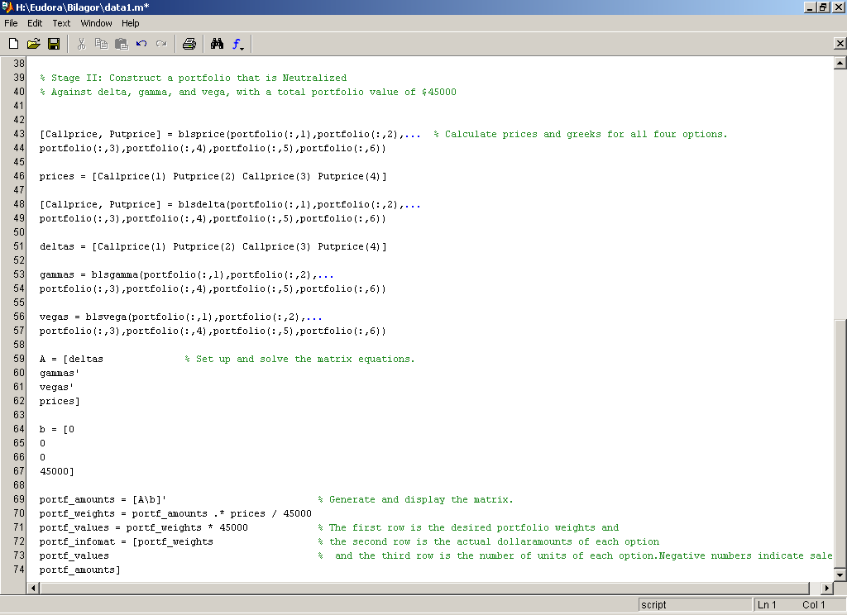

Callprice =

131.98
0.85

Putprice =

0.00
19.94

prices =

131.98 19.94

Callprice =

1.00
0.12

Putprice =

-0.00
-0.87

deltas =

1.00 -0.87

A =

1.00 -0.87
131.98 19.94

b =

0
1500.00

amounts =

9.68
11.12

values =

1278.21
221.79

Callprice =

131.98
0.85
1.26
48.48

Putprice =

0.00
19.94
6.39
1.66

prices =

131.98 19.94 1.26 1.66

Callprice =

1.00
0.12
0.28
0.90

Putprice =

-0.00
-0.87
-0.72
-0.08

deltas =

1.00 -0.87 0.28 -0.08

gammas =

0.00
0.01
0.04
0.00

vegas =

0.00
14.92
11.27
31.09

A =

1.00 -0.87 0.28 -0.08
0.00 0.01 0.04 0.00
0.00 14.92 11.27 31.09
131.98 19.94 1.26 1.66

b =

0
0
0
45000.00

portf_amounts =

294.79 321.51 -91.32 -121.23

portf_weights =

0.86 0.14 -0.00 -0.00

portf_values =

38906.05 6410.16 -114.90 -201.32

portf_infomat =

0.86 0.14 -0.00 -0.00
38906.05 6410.16 -114.90 -201.32
294.79 321.51 -91.32 -121.23

