Mälardalens Högskola
Analytical Finance Program
Numerical methods with MATLAB
Course Code: MT1370
Teacher: Anatoliy Malyarenko

Producing Graphics with the MATLAB Financial Toolbox

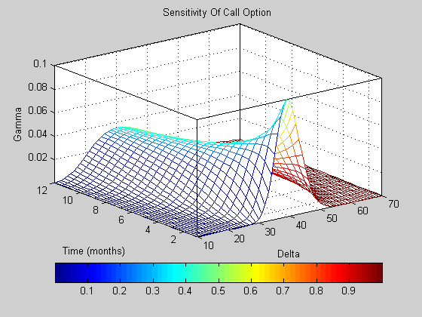

‘
Group 2B: PengPeng Ni
Cindy Ying Hong
Grace Anderson
Mahsima Ranjbar
CONTENT

- Abstract

- Introduction

- Case study
  - Sensitivity of Bond Prices to Parallel Shifts in the Yield Curve
    - Problem description
    - Solution
    - Results

  - Plotting an Efficient Frontier
    - Problem description
    - Solution
    - Results

  - Plotting Sensitivities of an Option
    - Problem description
    - Solution
    - Results

  - Plotting Sensitivities of a Portfolio of Options
    - Problem description
    - Solution
    - Results

- Summary and Conclusion

- Reference

1. Abstract

The MATLAB and Financial toolbox is a software program that enables the economists to easily complete their financial analysis tasks, as well as demonstrate their results by high quality graphs. In this report, we have studied in details some common cases with financial use, aiming to show how to use Matlab to produce the wanted graphs. We finally give our conclusion according to the experiences of those case studies.

Introduction

MATLAB is a powerful program. It is widely used for scientific computation such as financial and engineering analysis. Focusing on financial problems, MATLAB provides us a set of useful functions which is called the Financial Toolbox. With MATLAB and the Financial Toolbox, we can almost find everything we need to perform mathematical and statistical analysis of financial data.

More remarkably, the MATLAB Financial Toolbox has the ability of producing presentation-quality graphics, which can illustrate the results of financial analysis in a pleasant and straightforward manner. This is especially useful for a company to solve different financial problems. An economist or a portfolio manager needs not only deal with plenty of financial computation, but also needs demonstrate the solution clearly and effectively to the customer. In this report we aim to introduce MATLAB and Financial Toolbox as the ideal assistant, which help us to solve those tasks.

In the next section, several concrete examples will be studied and solved with the help of MATLAB functions. Through those exemplas, we study how to produce graphics in MATLAB and we demonstrate the final results followed by each problem.

Case Study

Sensitivity of Bond Prices to Parallel Shifts in the Yield Curve

3.1.1 Problem description

Bond portfolio managers usually are interested in the sensitivity of a bond’s price to the variation of long investment period, as well as to the values of yield, which varies in a wide range. To evaluate the impact of time-to-maturity and yield variation on the price of a bond portfolio, a 3D graph is desired, which plots the portfolio value and shows the behavior of bond prices as yield and time vary. In other words, the portfolio value need to be showed mathematically in space co-ordinate system as the function of two factors (yield and time).

Using the Financial Toolbox bond pricing functions, we can easily evaluate the impact of time-to-maturity and yield variation on the price of a bond portfolio and plot the wanted graph. To demonstrate how to use Matlab solving this kind of problem, we study a concrete case.

Suppose we have a portfolio consisting of four bonds (see table 1 for detailed information). We use the end-of-month payment rule (rule in effect) and day-count basis (actual/actual). Also, synchronize the coupon payment structure to the maturity date (no odd first or last coupon dates). Assume the portfolio value is $100,000, and the value of each bond is $25,000. The settlement date for those bonds is the 15th January 1995, and the evaluation dates occur annually on the same datum, January 15, beginning on 15-Jan-1995 (settlement) and extending out to 15-Jan-2018.

Given those series of settlement dates, we want to compute the price of the portfolio over a range of yields.
Table 1
 | Bond1 | Bond2 | Bond3 | Bond4
Maturity date | 03-Apr-2020 | 14-May-2025 | 09-Jun-2019 | 25-Feb-2019
Coupon rate | 0 | 0.05 | 0 | 0.055
Yield | 0.078 | 0.09 | 0.075 | 0.085
Period | 0 | 2 | 0 | 2
Face value | 1000 | 1000 | 1000 | 1000

3.1.2 M-File Solution

Firstly, we specify the values for the settlement date, maturity date, face value, coupon rate, and coupon payment periodicity as follows:

Settle = '15-Jan-2003';
Maturity = datenum(['03-Apr-2020'; '14-May-2025'; ...
'09-Jun-2019'; '25-Feb-2019']);
Face = [1000; 1000; 1000; 1000];
CouponRate = [0; 0.05; 0; 0.055];
Periods = [0; 2; 0; 2];
Yields = [0.078; 0.09; 0.075; 0.085];

Based on the specified value, we want to calculate the true bond prices which are the sum of the quoted price plus accrued interest. The Financial Toolbox provides us a function bondprice (), whose purpose is to price a fixed income security from yield to maturity. The syntax of the function has two forms. Given the available arguments showed in Table 1, we write the function as follows. Any inputs for which defaults are accepted are set to empty matrices ([]) as placeholders.

[CleanPrice, AccruedInterest] = bndprice (Yields, …
CouponRate, Settle, Maturity, Periods,...
[ ], [ ], [ ], [ ], [ ], [ ], Face);
Prices = CleanPrice + AccruedInterest;

We determine the quantity of each bond by

BondAmounts = 25000 ./ Prices;

Secondly, the next step is to create the grid of time of progression (dT) and yield (dY). The code is written as follows. We use datevec function get the vector of a given date, the vector (D) has three elements which are used to save separately the value of year, month and day. Function datenum is used to evaluate a date variable. After having created the vectors of dy and dt, we create the grid using matlab function meshgrid for the use of 3d graph drawing.

dy = -0.05:0.005:0.05; % Yield changes
D = datevec(Settle); % Get date components
dt = datenum(D(1):2018, D(2), D(3)); % Get evaluation dates
[dT, dY] = meshgrid(dt, dy); % Create grid

The following code creates and initializes the price vector.

NumTimes = length(dt); % Number of time steps
NumYields = length(dy); % Number of yield changes
NumBonds = length(Maturity); % Number of bonds
% Preallocate vector
Prices = zeros(NumTimes*NumYields, NumBonds);

Then we compute the price of each bond in the portfolio on the grid one bond at a time. Note here in each loop, the two vectors CleanPrice and AccruedInterest are calculated and their have the same length which is equal to NumTimes*NumYields.

for i = 1:NumBonds
[CleanPrice, AccruedInterest] = bndprice(Yields(i)+...
dY(:), CouponRate(i), dT(:), Maturity(i), Periods(i),...
[], [], [], [], [], [], Face(i));
Prices(:,i) = CleanPrice + AccruedInterest;
End

We scale the bond prices by the quantity of bonds which we have calculated before.
This operation is done by a simple matrix multiplication. We use the reshape function to conform the bond values to the underlying evaluation grid. The Reshape(X,M,N) function returns the M-by-N matrix whose elements are taken column wise from X.

Prices = Prices * BondAmounts;
Prices = reshape(Prices, NumYields, NumTimes);

Now we are ready to plot the price of the portfolio as a function of settlement date and a range of yields, and as a function of the change in yield (dy). This plot illustrates the interest rate sensitivity of the portfolio as time progresses (dT), under a range of interest rate scenarios. By the figure visualize the three-dimensional surface relative to the current portfolio value (i.e., $100,000).

figure % Open a new figure window
surf(dt, dy, Prices) % Draw the surface

Finally the following code adds axis labels.

dateaxis('x', 11);
figure.
xlabel('Evaluation Date (YY Format)');
ylabel('Change in Yield');
zlabel('Portfolio Price');
hold off
view(-25,25);

3.1.3 Results

The following diagram illustrates the result.

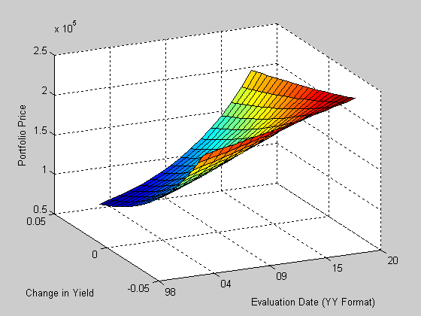

3.2 Plotting an Efficient Frontier

3.2.1 Problem description

The graph of the efficient frontier is very useful and efficient for real-world financial problems. It illustrates :
how to specify the expected returns, standard deviations and correlations of a portfolio of assets;
how to convert standard deviations and correlations into a covariance matrix;
how to compute and plot the efficient frontier from the returns and covariance matrix;
how to randomly generate a set of portfolio weights;
how to add the random portfolios to an existing plot for comparison with the efficient frontier.

To demonstrate how to use Matlab to solve this kind of real-world financial problems, we study a concrete case.
Here we hypothetic three different assets with returns of 0.1, 0.15 and 0.12 respectively;
standard deviation of 0.2, 0.25 and 0.18. Plots the efficient frontier of a hypothetical portfolio of three assets.

3.2.2 M-File Solution

First of all, specify the expected returns, standard deviations and correlation matrix for a hypothetical portfolio of three assets.

Returns = [0.1 0.15 0.12];
STDs = [0.2 0.25 0.18];
Correlations = [1 0.8 0.4
0.8 1 0.3
0.4 0.3 1 ];

Then using Financial Toolbox function corr2cov to convert the standard deviations and correlation matrix into a variance-covariance matrix.

Covariances = corr2cov(STDs, Correlations);

Using the Financial Toolbox function portopt and the expected returns and corresponding covariance matrix to plot the efficient frontier at 20 points along the frontier.

portopt(Returns, Covariances, 20)

Now the efficient frontier is displayed as blue line.

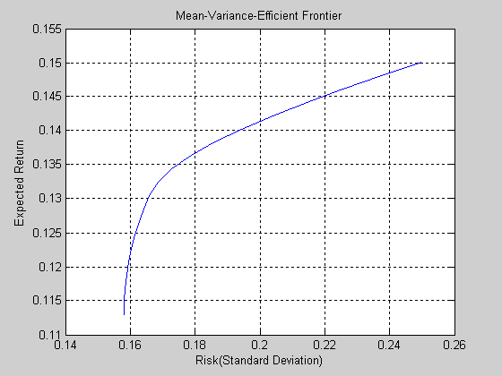

Randomly generate the asset weights for 1000 portfolios starting from the MATLAB initial state.

rand('state', 0)
Weights = rand (1000, 3);

It generates three columns of uniformly distributed random weights, but does not guarantee they sum to 1. Therefore we need to normalize the weights of each portfolio so that the total of the three weights represent a valid portfolio.

Total = sum(Weights, 2); % Add the weights
Total = Total(:, ones(3,1)); % Make size-compatible matrix
Weights = Weights./Total; % Normalize so sum=1

Given the 1000 random portfolios created compute the expected return and risk of each portfolio associated with the weights.

[PortRisk, PortReturn] = portstats(Returns, Covariances, ...
Weights);

Finally, annotate the graph with a title and plot.

hold on
plot (PortRisk, PortReturn, '.r')
title ('Mean-Variance Efficient Frontier and Random Portfolios')
hold off

1000 random portfolios are displayed as red dots.

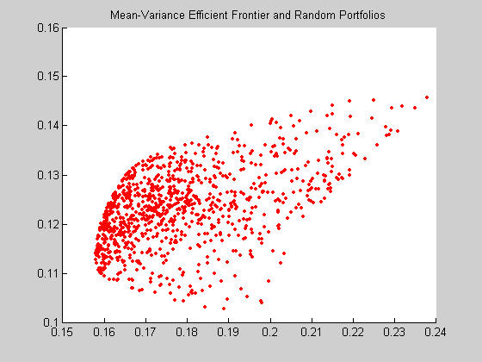

3.2.3 Results

Put everything together, the efficient frontier and the random portfolio, the following diagram illustrates the result of the efficient frontier.

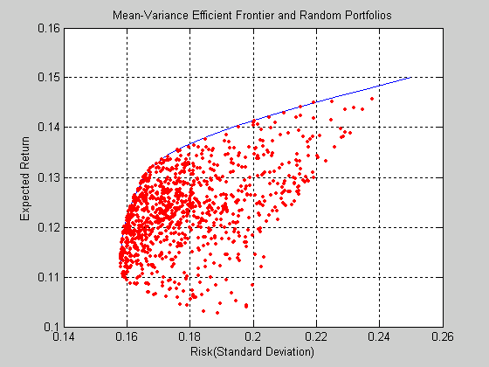

3.3 Plotting Sensitivities of an Option

3.3.1 Problem description
This example creates a three-dimensional plot showing how to value a Black-Scholes option.

Basics:

We all know that an option is a right to buy or sell specific securities or commodities at a stated price (exercise or strike price) within a specified time. An option is a type of derivative.

By sensitivity we mean the relationship between variables---one changing variable causes changes in another variable. In the following example of a three-dimensional plot giving us an overview of how gamma changes caused by change in price for a Black-Scholes option.

The Black-Scholes Option Valuation
The Black-Scholes Model is the standard basic model for pricing options, derived by Black and Scholes and Merton. Scholes and Merton shared the 1997 Nobel Price in Economics for their accomplishment.
The assumptions of the Black-Scholes option are: the risk-free interest rate and stock price volatility are constant over the life of the option.
The Black-Scholes pricing formula for a call option is
C₀ = S₀N(d₁) - Xe^{-rT}N(d₂)

Where
d₁₌$\frac{\text{ln}(S_{0}/X)+(r+σ^{2}/2)T}{σ\sqrt{T}}$
d₂₌ d₁- σ$\sqrt{T}$
and where
C₀ = Current call option value.
S₀ = Current stock price.
N(d) = The probability that a random draw from a standard normal
distribution will be less than d.
X = Exercise price.
e =2.71828, the base of the natural log function.
r = Risk-free interest rate.
T = Time to maturity
ln = Natural logarithm function.
σ = Standard deviation of the stock.

3.3.2 Solution

In the following example of a three-dimensional plot giving us an overview of how the second derivative of the option price to security price, gamma, changes caused by change in price for a Black-Scholes option. We denote x-axis as option price and y-axis as the time range, by using gamma (z-value) and delta (the colour) sensitivity functions, creating a three-dimensional plot. Consider a half-month European put option its strike price is changed from $10to $70, exercise price is $40, the risk-free interest is 10%, and the volatility is 0,35 for all price and periods. Now we construct a three-dimensional plot showing how gamma changes as price and time vary.
We first set the price range and the time range of the option according to the data of the option, notice that one year is divided into 12 months with half-months a step.

Range = 10:70; %the price range
Span = length (Range);
j = 1:0.5: 12; % the time range
Newj = j (ones ( Span , 1) , : )’/12;
Next step is to create a vector of price range from 10 to 70 and create a matrix of all ones.

JSpan = ones ( length (j) , 1 ); % create a vector of prices from 10 to 70
NewRange = Range ( JSpan , : ); % create a matrix of all ones
Pad = ones ( size ( Newj));

By using the gamma and delta sensitivity functions, we add all the given data to z-axis and the color.

ZVal = blsgamma ( NewRange, 40*Pad, 0.1*Pad , Newj , 0.35*Pad ); %n Gamma is the z-axis
Color = blsdelta (NewRange, 40*Pad, 0.1*Pad, Newj , 0.35*Pad ); %delta is the color

Then we add axis labels and a title to the surface as a mesh.

Mesh ( Range , j , ZVal, Color);
Xlabel ( `stock Price ($]´);
Ylabel (` Time ( months ) ´);
Zlabel ( `Gamma´);
Title (` Sensitivity Of Call Option´ ) ;
Axis ([ 10 70 1 12 –inf inf ] );

Finally we annotate the colors with a bar and label the colorbar.

Set ( gca , ` box ´ , ` on´ );
Colorbar ( ` horiz ´ );
A = findobj ( gcf , ´type ´ , ` axes ´ );
Set ( get ( a ( 2 ) , ` xlabel ´ ) , ` String ´ , ` Delta ´ );

3.3.3 Results

The following diagram illustrates the result.

3.4 Plotting Sensitivities of a Portfolio of Options

3.4.1 Problem description
This example plots a function of price and time for a portfolio of 10 Black-Scholes options.

3.4.2 Solution

3.4.3 Results

4.Summary and Conclusion

MATLAB is a very good program to perform heavy computing tasks. It provides us a plenty of useful functions which can be combined to solve different financial problem in real world. This flexibility allows us to formulate solution oriented to individual situation.

The MATLAB is convenient and efficient. Many house-keeping works are automatically done by the program, such as variable declaration and etc. We only need to write simple and easy-understood script to specify our solution. The graphic produced by MATLAB and financial toolbox are with high quality. They satisfy our requirement of financial problem presentation.

However, to control such a powerful program with plenty of functions, some educations are required. People need time to practice and get familiar with those MATLAB functions in order to take full advantage of the program.

5. References

- Financial Toolbox for use with MATLAB
- Derivative Securities, Second Addition By Jarrow & Turnbull

