Mälardalens University
MT1370 Numerical methods with MATLAB
5 points, Applied Mathematics, autumn term 2003, Västerås
Seminar report, Mean-Variance Portfolio Optimization with MATLAB, 2 points

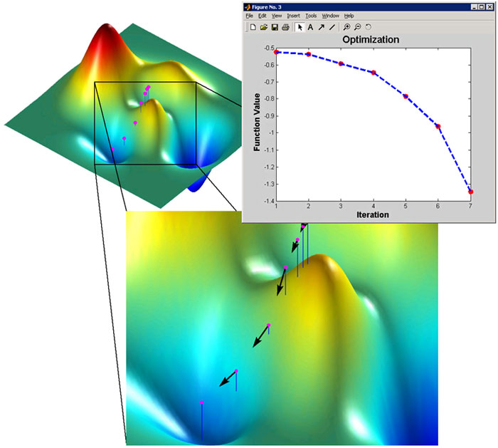
©http://www.mathworks.com/products/optimization/

Group B1
Christian Drapkin, Cecilia Flink, Tina Vedenpää, Terése Fridh

Table of contents
- Introduction 3
  - Purpose of Report 3
  - General Introduction 3
  - Introduction to Subject 3

- Portfolio Optimization 4

- Concepts of Portfolio Optimization 5

  - Risk-Aversion 5
  - Efficient Frontier 6
  - Capitalization-Weighted Portfolios 10
  - The Constrained and the Unconstrained Efficient Sets 10
    - Example of Constraint Specification 11
  - Linear Constraint Equations 13
  - Example of Linear Constraint Equations 14
  - Benefits of Portfolio Optimization 16
  - Optimal Risky Portfolios 16
    - Example of an Optimal Risky Portfolio 17

- Summary 19

- Conclusions 20

- References 21

- Introduction

  - Purpose of Report

The Markowitz Mean Variance Portfolio Optimization is an investment strategy which is used in various areas of investment, but its main use is in pension funds. The purposes of this report are to learn how to use MATLAB to solve financial and mathematical problems, and explain how MATLAB can be used to optimize portfolios. In the process we will describe the various financial topics to ease the understanding of our work.

  - General Introduction

We have written a seminar report about mean-variance optimization, using MATLAB. We have chosen firstly to explain the concepts of portfolio optimization and mean-variance optimization, and secondly how to use MATLAB to solve some financial and mathematical problems of optimization.

The Markowitz Mean Variance Portfolio Optimization is an investment strategy created by Harry Markowitz. The strategy has become a central theory in financial economics investors seeking to maximize return while minimizing risk. For this work Markowitz received a shared Nobel Prize in Economics in 1990. The investment strategy is used mostly by pension managers, rather than by individual investors and has the goal of optimally allocating the investments between different assets. The strategy may be considered a quantitative tool which will take the trade-off between risk and return into consideration when allocating the assets.

  - Method

We have chosen to use many examples of MATLAB commands when explaining how MATLAB could be used to solve problems of financial character. We have used one main source in the examples when using Matlab; http://www.mathworks.com/access/helpdesk_r12p1/help/pdf_doc/finance/finance.pdf, a website from which facts are taken from unless otherwise specified.

In addition in order to differentiate the illustrated M-files from the results given in the command window, the following lines have been added as to surround the text;

Command window M-file

Further more, in order to differentiate the actual MATLAB commands from the general text we have used the following notation; <command>.

- Portfolio Optimization

The theory of Mean-Variance Analysis was founded by Harry Markowitz in the early 1950’s. He evaluated stocks and securities, but not only according to their returns. He took in to account the variance and covariance, and this approach lead to maximizing of the portfolio return under a given restriction of the risk. The mean describes the return and the variance is a measure for the risk. Markowitz theory simply put a matter of efficient diversification; maximizing the return while minimizing the risk.
Portfolio optimization is a method for determining the investment program and asset weightings that give the maximum expected value for a given level of risk. An optimal portfolio is a portfolio that maximizes the return, given the risk, or minimizes the risk, given the return. The line that plots the maximum expected value against risk for possible combinations of a set of assets is known as the efficient frontier, which will be discussed further in section 3.2. The different investors all have different levels of risk tolerance, also referred to as risk aversion, which will be discussed further in section 3.1. It is therefore difficult to select adequate portfolios for each investor.
The portfolio manager can hedge the risk of the portfolio by partial investment in risk-free assets. This is done using the capital allocation line, which is the function of the risk-free rate, the borrowing rate, the risk/return profile of each asset and the degree of risk aversion characterizing an investor.
In either case, the portfolio optimization functions are very helpful to the investment managers when constructing portfolios that optimize the expected return and the risk. Before the mean-variance optimization theory was developed, portfolio management was limited to choosing the stock of best quality that had the best expected return. Markowitz pointed out that by concentrating the funds in a few assets with great expected return investment managers could use portfolio diversification, reducing risk and not having to sacrifice portfolio return. The modern portfolio theory clearly shows that the performance of an investment is manly dependent upon how the assets are allocated.

- Concepts of Portfolio Optimization

Before we start with the main part of our report we must introduce some important concepts which are relevant to portfolio optimization.

Expected Rate of Return;  The expected rate of return is defined as;  $$E\left(r\right)=\sum_{i−1}^{n}{h_{i}r_{i}}$$  where  h_{i} = the lowest possible return  r₁ = the prob. of occurrence in the next period? | Variance;  The variance can be defined as;  $$σ^{2}(r)=\sum_{i=1}^{n}{h_{i}[r_{i}−E(r)]^{2}}$$  where  h_{i} = the lowest possible return ???  r₁ = the prob. of occurrence in the next period?  E(r)= expected rate of return ???  σ²= the deviation
Standard Deviation (Volatility);  Standard deviation is a used to calculate the risk of a stock, called volatility. The volatility is a measure of how much a stocks return vary from its average return, if it’s a large difference between the average return and the actual return, then the volatility is high.  Standard Deviation may be defined as;  $$r={\left[\frac{1}{n}⋅\sum{{\left(r_{i}−r_{\text{ave}}\right)}^{2}}\right]}^{12}$$  Where  r = standard deviation  r_{i} = actual values of the stock’s yearly rate of return taken (over several years)  n = the number of values of r_{i} used  r_{ave} = the average value of the r_{i} | Portfolio Variance;  Portfolio variance may be expressed as;  $$σ^{2}\left(r_{p}\right)=β_{T,p}σ^{2}\left(r_{T}\right)+σ^{2}\left(ε_{p}\right)$$  where  σ²(r_{p}) = variance of portfolio returns  β_{T,p} = portfolio beta with respect to target  σ²(r_{T}) = variance of the target  σ²(ε_{p}) = variance of the portfolio return not associated with the target

  - Risk-Aversion;

Investors prefer portfolios with high expected returns and low risk but all investors have different degrees of risk aversions. The risk of a portfolio may be measured through its variance if its return is normally distributed, although it has been argues that in reality the portfolio returns are not normally distributed. If this is the case, then it is not appropriate to use the variance in order to estimate the risk.
To find a suitable portfolio one can define the investor’s indifference curve. This curve shows the trade-off between the expected 1Qreturn and the risk. The risk aversion coefficients lie between 2.0 and 4.0, where the lower value represents a higher tolerance to risk compared to the higher value. The formula used in the Financial Toolbox is the following;

$$U=E\left(r\right)−0\text{.}\text{05}⋅A⋅{\text{sig}}^{2}$$
where:
U = utility value.
E(r) = expected return.
A = index of investor’s aversion.
sig = standard deviation.
  - Efficient Frontier;

A portfolio can be said to be efficient when there is no portfolio with the same standard deviation and with a greater expected return and there is no portfolio having the same return with a lower standard deviation. The efficient frontier is a collection of all the efficient portfolios. The area below and to the right of the efficient frontier will contain various risky assets, for example stocks, bonds and real estate. The mean-variance efficient portfolios are all combinations of these risky assets.
In order to calculate efficient frontiers, we need information about the assets in the portfolio. The data is entered to the function through two matrices;
- Expected return vector – the average expected return for each asset in the portfolio.
- Covariance matrix – a square matrix representing the interrelationships between pairs of assets.
- Correlations – connections which occur more frequently than can be explained by chance or coincidence
Matlab can be used to explain the efficient frontier more closely.

Example of Efficient Frontier 1
Assuming we have three different assets with different expected returns of 10%, 20% and 15% respectively, and in addition we assume an expected covariance matrix (as expressed in the M-file below). To make the efficient frontier appear more clearly, it is important that we also assume that we have 10 different evenly spaced portfolios. Having the above assumptions we can create an M-File such as:

% The returns of the assets are as specified 10%, 20% and % 15%. We can then write the expected return as:

ExpReturn = [0.1 0.2 0.15];

% The expected covariance matrix could for example look as % follows:

ExpCovariance = [0.005 -0.010 0.004;
-0.010 0.040 -0.002;
0.004 -0.004 0.023];

% The number of portfolios is as specified 10.

NumPorts = 10;

portopt(ExpReturn, ExpCovariance, NumPorts);

<Portopt> is a command which gives the mean-variance efficient frontier when given asset properties and portfolio constraints which may be user specified. In this case there are no constraints to the example and by adding the following part to the M-file, we will receive a graph of the efficient frontier:

If we run the M-File we will get a graph of the efficient frontier that looks as follows:
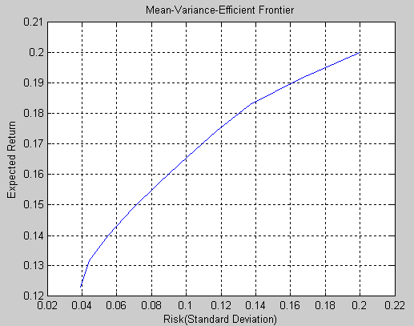

Another possibility with this example is to specify the output arguments. We can get the corresponding vectors and arrays showing the return, risk and the weights of the 10 different portfolios by again using the <portopt> command:

% Finding expected return, risk and weights of the portfolios:

[PortRisk, PortReturn, PortWts] = portopt(ExpReturn,...
ExpCovariance, NumPorts)

Now, by running the M-File, we find the following values for the risk, return and weights of each portfolio, expressed in the command window:

PortRisk =

0.0392
0.0443
0.0552
0.0690
0.0844
0.1007
0.1174
0.1366
0.1653
0.2000

PortReturn =

0.1231
0.1316
0.1402
0.1487
0.1573
0.1658
0.1744
0.1829
0.1915
0.2000

PortWts =
0.7692 0.2308 0
0.6617 0.2942 0.0442
0.5391 0.3426 0.1183
0.4166 0.3910 0.1924
0.2941 0.4394 0.2665
0.1715 0.4878 0.3407
0.0490 0.5362 0.4148
0 0.6581 0.3419
0 0.8291 0.1709
0 1.0000 0

If we for example look at portfolio 5, we can see that the expected return is 0.1573, the risk is 0.0844 and the weights are 0.2941 (29.41%) for the first asset, 0.4394 (43.94%) for the second asset and 0.2665 (26.65%) for the third asset.

Example of Efficient Frontier 2

We can use another example of another possible way to produce an efficient frontier. Assuming we have three different assets with different expected returns, say 8%, 16% and 11% respectively, in addition we have information of the standard deviations of the assets and the correlations between them. The difference here is that in this example we have no expected covariance. Instead we have the correlations between the assets and the standard deviations. These two can be converted into expected covariance using the Matlab command <corr2cov>, a command that simply converts standard deviation and correlation to expected covariance. Thus, the problem may be solved as follows;

% The expected returns of the three assets are specified as:

ExpReturn = [0.08 0.16 0.11];

% The standard deviations of the three assets are specified as:

StandDev = [0.21 0.26 0.19];

% The correlations are expressed as:

Correlations = [ 1 0.6 0.8
0.6 1 0.4
0.8 0.4 1 ];

% We convert the standard deviations and correlations to
% expected covariance.

ExpCovariance = corr2cov(StandDev, Correlations);

% As in previous examples we can now use the command <portopt> in % order to plot the efficient frontier. Assuming that we are % interested in 20 points along the frontier, the <portopt> can % be used as follows:

portopt(ExpReturn, ExpCovariance, 20)

At this time you can choose to execute the M-File. If you run the M-File at this point, you will receive an efficient frontier looking as follows:

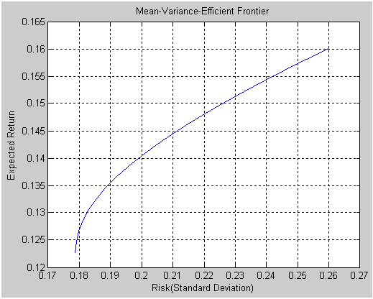

If you wish you can instead have a more detailed efficient frontier. Firstly weights can be randomly generated so that there are many more portfolios, say 1000, starting from the Matlab initial state. So the M-file may be continued;

% The command <Weights = rand(1000, 3)> will generate 1000 % portfolios and three columns of weights, together with the % <Rand(‘state’, 0)> command, which reset the generator to its
% initial state, it is assured they will be random.

Rand('state', 0)
Weights = rand(1000, 3);

The matrixes need to be compatible size-wise and therefore the sum of the weights must equal to 1. In order to guarantee that the weights are equal to the one we must therefore add the following entry to the m-file;

Total = sum(Weights, 2);
Total = Total(:,ones(3,1));
Weights = Weights./Total;

As we have now created 1000 portfolios, we can compute the portfolio risk and return associated with the weights:

[PortRisk, PortReturn] = portstats(Returns, Covariances, Weights);

We can now hold the current graph and plot our new efficient frontier based on our new information.

hold on
plot (PortRisk, PortReturn, '.r')
title('Mean-Variance Efficient Frontier and Random Portfolios')
hold off
The blue line represents the efficient frontier; red dots represent the 1000 different portfolios.

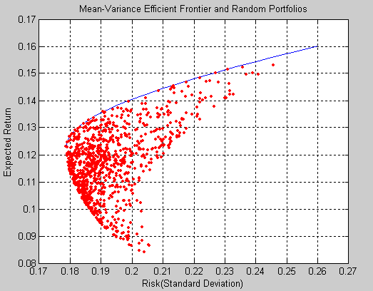

  - Capitalization-Weighted Portfolios;

The broad capitalization-weighted index (cap-weighted), Wilshire 5000 is one of the largest indexes in the US. It represents the pooled holdings of the member stocks of all investors who have taken a position in the stocks in the index. It is possible to see the separate holdings for every investor owning stock in the index, and to combine them, the combination being the Wilshire 5000. The performance of a capitalization-weighted portfolio will presumably not be as efficient in relative comparison to an efficiently constructed portfolio. In order for the cap-weighted index to be efficient the following requirements must be fulfilled;

- The investment opportunities are restricted to the securities of the cap-weighted index for all investors who hold any securities in the index.
- All of the investors must agree about the risk and expected return for all securities.
- There is no restriction for investors’ short-selling all securities in the index.
- Federal and or state income tax liability currently in effect, is not exercised on the investors’ return.

Cap-weighted portfolios are efficient when all the stocks in the index are met by the same unconstrained efficient set, thus the four requirements above must hold true. When two or more efficient portfolios are combined, the new combination is also efficient. When the requirements do not hold true, e.g. there is some restriction on short-selling; the efficient set is considered constrained.

  - The Constrained and the Unconstrained Efficient Sets
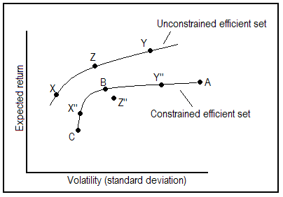
Graph 2;
The constrained vs. the unconstrained efficient set

Assuming a three-stock portfolio, the positions taken by investors on their unconstrained frontier is represented by the points X, Y and Z. A combination of X and Y might yield Z.

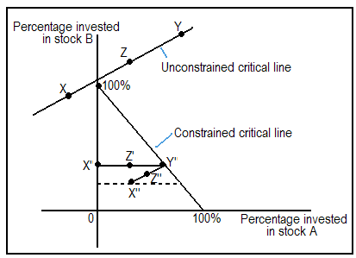

Graph 3;
The critical lines of the constrained and the unconstrained efficient set

A combination of two or more efficient portfolios will also be efficient. This property is represented by A, B and C in the triangle, where percentage invested in stock A is plotted on the horizontal axis, percentage invested in stock B is potted on the vertical axis, and percentage in C is implied such that at the origin there is a 100% investment in C and 0% in A and B.

In order to take a position outside the triangle in graph 3 at least one of the three stocks must be short-sold. Any of the portfolios represented in the graph 3 will also be represented in graph 2 on or within the unconstrained efficient frontier. If there is no possibility to sell short, the position must be taken on or within the borders of the triangle. The property which allows combinations of efficient portfolios are themselves efficient will be lost.
The existence of income tax on the investment returns are also illustrated on the graphs, although investors are differently exposed to federal taxes. As an example, if an investor who is exposed to tax invests in stock C, the investor might have a critical line with positive positions on the stock. The broken line in graph 3 is the critical line after tax. The investor will then be taking a position at X’’. As a further example, if this portfolio will be combined with Y’ the position could be further more inefficient at point Z’’.
There are also other factors which contribute to the ineffectiveness of the major market indexes. Alternative investments is one example, foreign investors is another. A rational foreign investor will not invest effectively relative to the United States opportunity set, but invest in securities which will be combined with foreign investments and with their investments in other countries.

3.4.1 Example of Constraint Specification

If we consider the same example as earlier with the same three assets, we can name them Aa, Bb and Cc with expected returns 10%, 20% and 15% respectively. Also consider 10 different portfolios. We will then have the same <ExpReturn>, <ExpCovariance> and <NumPorts> as used in earlier examples:

ExpReturn = [0.1 0.2 0.15];

ExpCovariance = [0.005 -0.010 0.004;
-0.010 0.040 -0.002;
0.004 -0.002 0.023];
NumPorts = 10;

We can now consider two different constraints:

- Constraint 1. Allow short selling up to 15% of the portfolio value in any asset but limit the investment in any one asset to 105% of the portfolio value.
- Constraint 2. Consider two different sectors, electricity and Real-Estate, with the table below indicating the sector each asset belongs to.

Asset | Aa | Bb | Cc
Sector | Electricity | Real-Estate | Real-Estate

Now we can constrain the investment in the electricity sector by 60% and in the Real-Estate sector by 80%.
If we start by introducing the information in Constraint 1 and create a matrix called <AssetBounds>, we will have a matrix where each column represents one asset and the upper row represents the lower bound, while the lower row represents the upper bound, in the M-file the information would be expressed as;

% Constraint 1

AssetBounds = [-0.15 –0.15 –0.15;
1.05 1.05 1.05];

The information in Constraint 2 needs to be divided into two different parts. The first part defines the groups. The matrix for the <Groups> contains 1s and 0s depending on whether the assets belong to the groups or not. Each column in the matrix represents an asset and each row represents one of the groups. In this case, the upper row represents Real-Estate and the lower row represents electricity.

% Constraint 2 part 1

Groups = [0 1 1;
1 0 0];

The second part of the second constraint defines the constraints for each group. This part of the constraint specifies the upper and lower bound for each of the sector groups. The rows represent the two groups and the left column represents the minimum allocation, which is 0, while the right column represents the maximum allocation. As mentioned earlier, investment in the electricity sector is constrained by 60% and in the Real-Estate sector is constrained by 80% which can be represented in the M-file as follows;

% Constraint 2 part 2

GroupBounds = [0 0.60;
0 0.80];

Now we can use the command <frontcon> to receive the risk, return and weights vectors and arrays for the 10 portfolios. <Frontcon> is a command which is similar to <portopt>, and will for the given group of assets compute the portfolios along the efficient frontier. The difference being that the portfolios are computed based on a set of constraints which maximize or minimize weights for each asset or total weight for a specified group of assets. Thus, by adding <frontcon> to the M-file:

[PortRisk, PortReturn, PortWts] = frontcon(ExpReturn,...
ExpCovariance, NumPorts, [], AssetBounds, Groups, GroupBounds)

Now, if we run this M-File, we will find the following values:

PortRisk =

0.0385
0.0406
0.0451
0.0515
0.0592
0.0676
0.0773
0.0925
0.1117
0.1334
PortReturn =

0.1221
0.1271
0.1322
0.1372
0.1423
0.1473
0.1524
0.1574
0.1625
0.1675

PortWts =

0.8000 0.2418 -0.0418
0.7309 0.2736 -0.0045
0.6587 0.3023 0.0390
0.5865 0.3310 0.0825
0.5143 0.3597 0.1260
0.4421 0.3884 0.1695
0.4000 0.4473 0.1527
0.4000 0.5482 0.0518
0.4000 0.6491 -0.0491
0.4000 0.7500 -0.1500

Now we can look at e.g. portfolio 6 and see that the risk is 0.0676, the return is 0.1473 and the weights for asset Aa is 0.4421 (44.21%), asset Bb 0.3884 (38.84%) and asset Cc is 0.1695 (16.95%).

  - Linear Constraint Equations

The <frontcon> command enables the entry of a fixed set of constraints with minimum and maximum values for groups and individual assets. However, sometimes a larger and more general set of constraint needs to be used when finding the optimized risky portfolio. This is enabled by the command <portopt>.
We can also use the command for the auxiliary function <portcons> to create a matrix of constraints and in which all rows represent an inequality that is written in the following form:

A*Wts’ <= b

Where;
A = the matrix
b = the vector
Wts = row vector of asset allocations

It is also important to remember that the number of columns in A and the length of <Wts> represent the number of assets. And in the same way, the number of rows in A and the length of b represents the number of constraints. This information allows the specification of any number of linear inequalities to the command <portopt>.

  - Example of Linear Constraint Equations

Assume that there are four different assets in the portfolio; Aa, Bb, Cc and Dd. These assets are allocated differently depending on which country you look at. Assume that we are interested in looking at the countries Sweden, France, Germany, Spain and Austria. The assets are related to the countries as shown in the table below:

Table 1
 | Aa | Bb | Cc | Dd
Sweden |  | X |  | X
France | X |  | X | X
Germany | X | X
Spain |  | X | X
Austria | X |  |  | X

The five different countries can minimally and maximally invest in the specified assets according to the table below:

Table 2
 | Minimum Investment | Maximum Investment
Sweden | 0.20 | 0.65
France | 0.15 | 0.70
Germany | 0.30 | 0.55
Spain | 0.40 | 0.40
Austria | 0.25 | 0.50

With the help of the information in the two tables, we can present this information mathematically. We can assume that the vector Wts (weights) represents the investment of each asset in a portfolio looking as follows:

Wts = [W1 W2 W3 W4]

We now want to present the information in the form A*Wts <= b. Table 1 represents the matrix A as it is written above. At this point we wish to present it as A*Wts, meaning that we must multiply the matrix A with the vector Wts as shown below:

1. W2 + W4
2. W1 + W3 + W4
3. W1 + W2
4. W2 + W3
5. W1 + W4

Now we can put A*Wts <= b by adding the information in table 2.

1. W2 + W4 >= 0.20
2. W2 + W4 <= 0.65
3. W1 + W3 + W4 >= 0.15
4. W1 + W3 + W4 <= 0.70
5. W1 + W2 >= 0.30
6. W1 + W2 <= 0.55
7. W2 + W3 >= 0.40
8. W2 + W3 <= 0.40
8. W1 + W4 >= 0.25
9. W1 + W4 <= 0.50

Since the information should be represented in the form A*Wts <= b, we need to multiply functions 1, 3, 5 and 8 with -1 to get the <= sign so that the form is completed.

1. -W2 - W4 <= -0.20
2. W2 + W4 <= 0.65
3. -W1 - W3 - W4 <= -0.15
4. W1 + W3 + W4 <= 0.70
5. -W1 - W2 <= -0.30
6. W1 + W2 <= 0.55
7. W2 + W3 <= 0.40
8. –W2 – W3 <= -0.40
9. -W1 - W4 <= -0.25
10. W1 + W4 <= 0.50

We now have the information presented in the form A*Wts <= b as we wanted and it can now be transferred into Matlab commands:

A = [0 –1 0 -1;
0 1 0 1;
-1 0 –1 -1;
- 0 1 1;
-1 –1 0 0;
- 1 0 0;
- 1 1 0;
0 –1 –1 0;
-1 0 0 -1;
1 0 0 1];

b = [-0.20;
0.65;
-0.15;
0.70;
-0.30;
0.55;
0.40;
-0.40;
-0.25;
0.50];

% We can link matrix A to vector b by the <ConSet> command:
ConSet = [A, b]

If we run the M-File, the constraint matrix <ConSet>, looks as follows:

ConSet =

0 -1.0000 0 -1.0000 -0.2000
0 1.0000 0 1.0000 0.6500
-1.0000 0 -1.0000 -1.0000 -0.1500
1.0000 0 1.0000 1.0000 0.7000
-1.0000 -1.0000 0 0 -0.3000
1.0000 1.0000 0 0 0.5500
0 1.0000 1.0000 0 0.4000
0 -1.0000 -1.0000 0 -0.4000
-1.0000 0 0 -1.0000 -0.2500
1.0000 0 0 1.0000 0.5000
  - Benefits of Portfolio Optimization;

There are alternative portfolios with lower volatility and same expected return as the cap-weighed indexes available on the market. The reality is that the investors, who try to match the market, must carry an uncompensated risk. Investing efficiently has substantial benefits.
A common area of use is the pension funds. A typical investment for a pension fund would combine e.g. sixty percent domestic equity investments with e.g. forty percent fixed-income investments. The benefits of portfolio optimization can be expressed in the following graph.
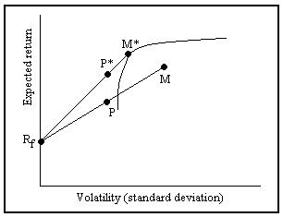
Graph 4;
The benefits of efficient investments

Here we let R_{f} represent the fixed income investment assumed risk-less. Combining the 60/40 split with point M gives us P. However if we instead combine the efficient portfolio M* with a 70/30 split, we get P*. The gap which is evident between P and P* represents the benefit of investing efficiently in the market.

  - Optimal Risky Portfolios

The general objective with finding the optimal risky portfolio is to maximize the reward to risk ratio, a ratio also known as the Sharpe ratio.
One way to find the optimal risky portfolio is to use the Markowitz portfolio selection model and choose an efficient portfolio. The model will help determine the best possible combination of a certain number or risky assets available to an investor, the choices can be made using the efficient frontier, which will illustrate whether or not a portfolio is efficient.
Borrowing and lending possibilities need to be taken in to consideration. Given the borrowing and lending possibilities, the investor must then decide on a final portfolio based on preference.
The first key to finding an optimal risky portfolio is diversification; an investor holding a well diversified portfolio faces only market risk. A diversifiable risk is unique and firm specific. Thus risk can be reduced by diversification. However, due to diversification the variance of the portfolio will be lower than the variance of the component assets. As long as the correlation between the assets in a portfolio is not one, there are diversification benefits.

    - Example of an Optimal Risky Portfolio

We can use Matlab to illustrate how to contrast an optimal risky portfolio.
This example assumes we have three different assets with expected returns of 9%, 19% and 14% respectively. This time, we choose to have 30 portfolios, in comparison to the 10 we previously used. In this example we also need to add the risk-free rate of 7%, the borrowing rate of 11% and the investor’s degree of risk aversion of 3.

ExpReturn = [0.09 0.19 0.14];

ExpCovariance = [0.004 -0.009 0.003;
-0.009 0.039 -0.001;
0.003 -0.001 0.022];
NumPorts = 30;

portopt(ExpReturn, ExpCovariance, NumPorts);

[PortRisk, PortReturn, PortWts] = portopt(ExpReturn,
ExpCovariance, NumPorts)

% Add the risk-free rate, borrowing rate and risk aversion:

RisklessRate = 0.07
BorrowRate = 0.11
RiskAversion = 3

When using the command <portalloc>, meaning capital allocation to efficient portfolio, without specifying the output arguments it will result in a graph illustrating the critical points:

portalloc (PortRisk, PortReturn, PortWts, RisklessRate,...
BorrowRate, RiskAversion);

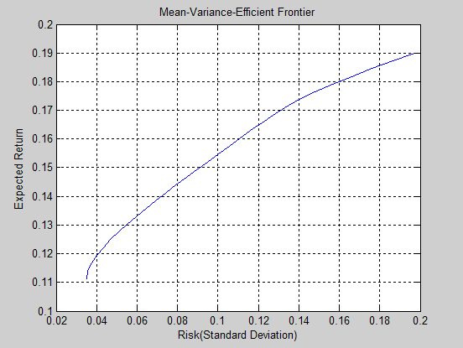

If we run this M-File, we will obtain two graphs, the first being an efficient frontier…

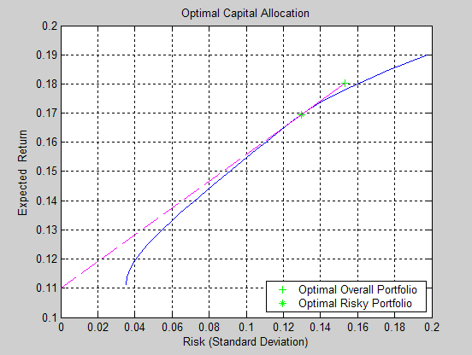
…the second illustrating optimal capital allocating with points that shows the optimal overall portfolio and the optimal risky portfolio.

If we instead choose to specify the output arguments, we would write the following command:

[RiskyRisk, RiskyReturn, RiskyWts, RiskyFraction,...
OverallRisk, OverallReturn] = portalloc (PortRisk,...
PortReturn, PortWts, RisklessRate, BorrowRate, RiskAversion)

Where;
- <RiskyRisk> = risk
- <RiskyReturn> = expected return risky portfolio
- <RiskyWts> = weights
- <RiskyFraction> = the fraction of the complete portfolio allocated to the risky portfolio.
- <OverallRisk> = risk
- <OverallReturn> = expected return overall portfolio

By running the M-File, we obtain the following set of information:

RiskyRisk = 0.1296
RiskyReturn = 0.1695
RiskyWts = 0.0007 0.5904 0.4089
RiskyFraction = 1.1809
OverallRisk = 0.1530
OverallReturn = 0.1802

The fraction of the complete portfolio allocated to the risky portfolio, <RiskyFraction>, exceeds 100% in our example, meaning that we are allowed to borrow money and invest in the risky portfolio and that no money will be invested in the risk-free interest asset. Customers will allow borrowing 18.09% of the capital amount, according to our example.
- Summary
Investors who are tying to match the market must carry an uncompensated risk. Therefore investing efficiently will have substantial benefits. Financial concepts such as expected rate of return, variance and standard deviation, also called volatility, are used to help compute the expected risk and possible return of an investment. Special attention must be paid to the existence of tax and other factors of ineffectiveness which influence the major market indexes.
The portfolio managers are concentrating on trying to get the best possible trade-off between risk and return. An optimal portfolio is a portfolio that maximizes the return, given the risk, or minimizes the risk, given the return.
The advanced program MATLAB includes the optimization toolbox and the financial toolbox which can both be used to solve problems of investment theory. Using Portfolio optimization gives the investor an advantage in comparison to other investors, but it is important to acknowledge that no model works for all occasions.

- Conclusions

In conclusion, using the theory of optimization one can easily find the values that minimize or maximize functions. It is used to solve complex design problems to improve cost, reliability, and performance in a wide range of applications.
MATLAB is an advanced program, which will help to calculate find the optimized portfolio can be very beneficial for investors. The most common area of use for the mean-variance optimization theory is however, the pension funds.
Using the methods described in our report, an investor will be able to maximize the return, given the risk, or minimize the risk, given the return, thus creating efficient portfolios.

- References

Literature

- Haugen, Robert A., Modern Investment Theory, 4th edition, 1997. Prentice Hall Inc., A Simon & Schuster Company, New Jersey.
- Jarrow, Robert and Turnbull, Stuart, Derivative Securities, 2nd edition, 2000. South-Western College Publishing, USA.
- Ross, Sheldon M., An Introduction to Mathematical Finance, 1st edition, 1999. Cambridge University Press.

Web sites

We have used the following websites as sources. The sources were visited for the last time on the following dates;

2003-11-22

- http://www.mathfinance.wagner.com/PRODUCTS/MVOPT/mvopt.html http://www.fpai.net/markowitz%202.htm
- http://www.effisols.com/basics/MVO.htm
- http://www.opttek.com/publications/asset_paper.html
- http://www.mathworks.com/access/helpdesk_r12p1/help/pdf_doc/finance/finance.pdf (p.82)

2003-11-28

- http://www.bykeyword.com/pages/detail9/download-9414.html
- http://davidmlane.com/hyperstat/A40397.html
- http://www.moneychimp.com/glossary/standard_deviation.htm
- http://www.nag.com/doc/TechRep/Pdf/tr2_00.pdf
- http://www.mathworks.com/cgi-bin/ble_process.pl
- https://tagteamdbserver.mathworks.com/ttserverroot/Download/236_8513v03_optim_ds.pdf

2003-12-06

- http://www-fp.mcs.anl.gov/otc/Guide/CaseStudies/port/efrontier.html
- http://www.cbe.wwu.edu/Hall/FMDS440/chapter8.pdf
- http://www.uno.edu/~nmaroney/Course/F6302/LectureNotes/18
- http://www.uno.edu/~nmaroney/Course/F6302/LectureNotes

2004-01-12

- http://www.pertrac2000.com/optimization.asp
- http://www.mathworks.com/access/helpdesk/help/toolbox/finance/samples7.shtm

http://www.mathfinance.wagner.com/PRODUCTS/MVOPT/mvopt.html
http://www.fpai.net/markowitz%202.htm
http://www.effisols.com/basics/MVO.htm
http://www.pertrac2000.com/optimization.asp
Jarrow and Turnbull, 2000, Derivative Securities, p. 100 - 101
Ibid.
http://davidmlane.com/hyperstat/A40397.html
http://www.moneychimp.com/glossary/standard_deviation.htm
Ibid.
Haugen, R. A, 1997, Modern Investment Theory, p. 294-295
http://www.mathworks.com/access/helpdesk_r12p1/help/pdf_doc/finance/finance.pdf p.82
http://www-fp.mcs.anl.gov/otc/Guide/CaseStudies/port/efrontier.html
http://www.opttek.com/publications/asset_paper.html
http://www.mathworks.com/access/helpdesk/help/toolbox/finance/samples7.shtml
Haugen, R. A, 1997, Modern Investment Theory, p. 282
Ibid.
Ibid. p. 283
Haugen, R. A, 1997, Modern Investment Theory, p. 286-287
Ibid, p. 287
Haugen, R. A, 1997, Modern Investment Theory, p. 287.
Ibid. p. 286
Ibid. p. 287
http://www.uno.edu/~nmaroney/Course/F6302/LectureNotes
http://www.uno.edu/~nmaroney/Course/F6302/LectureNotes/1
http://www.cbe.wwu.edu/Hall/FMDS440/chapter8.pdf
http://www.uno.edu/~nmaroney/Course/F6302/LectureNotes

