The Mean-Variance Portfolio Optimisation



Group A₂:
Hervé Fandom Tchomgouo
Bartlomiej Bartoszewicz
Francisco J. Gil
Llamas, Javier

Västerås 2004

Table of contents

Table of contents……………………………………………………………………………...1

Abstract………………………………………………………………………………………..2

Introduction……………………………………………………………………………….3

Characteristics of portfolios……………………………………………………………...3

Diversification and portfolio risk………………………………………………………...6

Systematic and unsystematic risk……………………………………………………..6

Markowitz Diversification…………………………………………………………….7
  - Graphical Illustration of Markowitz Diversification………………………………….8
    - Feasible set of portfolios in mean-standard deviation diagram………………..8
    - Minimum variance frontier and efficient frontier……………………………...9
- Markowitz Diversification with Risk-free Asset………………………………………10
  - Two risky stocks and a risk-free asset……………………………………………….10
  - Efficient diversification with many risky assets and a risk-free asset……………….10
  - Two fund separation with risk-free asset…………………………………………….11

Asset Allocation with two Risky Assets………………………………………………...12

Perfect positive correlation…………………………………………………………..12

Perfect negative correlation………………………………………………………….13

Minimum risk portfolio………………………………………………………………13

The efficient frontier with riskless lending…………………………………………..15
- Matlab …………………………………………………………………………………...17
  - Introduction…………………………………………………………………………..17
  - Financial toolbox…………………………………………………………………….17
  - Our scripts……………………………………………………………………………17
  - A real life example…………………………………………………………………...25

Summary………….……………………………………………………………………...28

Conclusion……………………………………………………………………………..…28
References……………………………………………………………………………………29
Internet links……………………………………………………………………………...…29
List of figures………………………………………………………………………………...29
List of tables………………………………………………………………………………….29

Abstract
The purpose of this report is to investigate the mean-variance portfolio optimisation theory, which is commonly used within the financial area. The first half of the report brings primarily focus on the pure theoretical explanations of constructing an optimal portfolio. The second part is the most crucial one, giving the reader examples on how to apply the financial theory, constructed by the mathematical programming tools of Matlab.
The author’s main idea with this report is to introduce reader to a mean-variance portfolio optimisation theory in a simple and understandable way with examples form real life. The disposition is constructed by a pedagogical text, combined with graphs and tables, which facilitates the reading.

Introduction
In the 1950's, Dr. Harry Markowitz pioneered a Nobel Prize-winning mathematical approach to asset allocation based on a technique called mean-variance optimisation. Over the years, his original approach has been perfected and improved upon, but some fundamental concepts, such as diversification (selecting assets that complement one another in order to mitigate risk), remain at the heart of asset management. Mean-variance optimisation accomplishes this by characterizing each asset by its expected return and volatility. The interaction between each pair of assets is characterized by the correlation between their respective returns. Under these assumptions, a mathematically optimal answer to the asset allocation problem can be generated.
Pushing the mean-variance approach beyond its original simplified, theoretical framework, risk quantification is now done through complex factor models and measured relative to benchmark indices. Risk can be constrained not only globally, but also by sector or industry, or using other limited diversification constraints. On the trading side, transaction costs can be incorporated, minimum and maximum trades or holdings can be specified, and a trade's tax implications can be taken into account.
From an optimisation perspective, many of these features significantly increase the complexity of the underlying asset allocation problem. Consequently, with most portfolio optimisation software, the portfolio manager must choose between solving the real problem inaccurately and solving a crude representation of the problem accurately. Not anymore Portfolio Precision brings you the best of both worlds: great speed and exceptional versatility.

Characteristics of Portfolios
Let us assume that we have a portfolio of N assets given by
$$P=\sum_{i=1}^{N}{x_{i}A_{i}}$$
where $x_{i}$ is the weight of each asset. The return on this portfolio is simply a weighted average of the return on the individual assets:
$$R_{p}=\sum_{i=1}^{N}{x_{i}R_{i}}$$

The expected return is also a weighted average of the expected returns on the individual assets:
$$E\left(R_{p}\right)={\bar{R}}_{p}=E\left(\sum_{i=1}^{N}{x_{i}R_{i}}\right)=\sum_{i=1}^{N}{x_{i}E\left(R_{i}\right)}=\sum_{i=1}^{N}{x_{i}{\bar{R}}_{i}}$$

Now let us assume that we have a portfolio of two assets only. The variance of the portfolio is given by

$$\begin{aligned}σ_{p}^{2}=E{\left(R_{p}−{\bar{R}}_{p}\right)}^{2}=E{\left[x_{1}R_{1}+x_{2}R_{2}−\left(x_{1}{\bar{R}}_{1}+x_{2}R_{2}\right)\right]}^{2}=E{\left[x_{1}\left(R_{1}−{\bar{R}}_{1}\right)+x_{2}\left(R_{2}−{\bar{R}}_{2}\right)\right]}^{2} \\ \\ =x_{1}^{2}E{\left(R_{1}−{\bar{R}}_{1}\right)}^{2}+x_{2}^{2}E{\left(R_{2}−{\bar{R}}_{2}\right)}^{2}+2x_{1}x_{2}E\left(R_{1}−{\bar{R}}_{1}\right)\left(R_{2}−{\bar{R}}_{2}\right) \\ \\ =x_{1}^{2}σ_{1}^{2}+x_{2}^{2}σ_{2}^{2}+2x_{1}x_{2}σ_{12}=x_{1}^{2}σ_{1}^{2}+x_{2}^{2}σ_{2}^{2}+2x_{1}x_{2}ρ_{12}σ_{1}σ_{2}\end{aligned}$$

where $σ_{12}=E\left(R_{1}−{\bar{R}}_{1}\right)\left(R_{2}−{\bar{R}}_{2}\right)$ is the covariance between the two assets. It is the product of two different deviations. As such, it can be positive or negative. It will be large when the good outcomes for each asset occur together and when the bad outcomes for each asset occur together.
In contrast, if good outcomes for one asset are associated with bad outcomes of the other, the covariance is negative. The covariance is a measure of how returns on assets move together.
For many purposes, it is useful to standardize the covariance. Dividing the covariance between two assets by the product of the standard deviation of each asset produces a variable with the same properties as the covariance but with range -1, +1. The measure is called the correlation coefficient:
$$ρ_{12}=\frac{σ_{12}}{σ_{1}σ_{2}}$$

The formula for variance of a portfolio can be generalized to more than two assets. The first part of the expression for the variance of a portfolio is the sum of the variances on the individual assets times the square of the proportion invested in each asset:
$$\sum_{i=1}^{N}{x_{i}^{2}σ_{i}^{2}}$$
The second set of terms in the expression for the variance of a portfolio is covariance terms. Note that the covariance between each pair of assets in the portfolio enters the expression for the variance of a portfolio. Further, note that each covariance term is multiplied by two times the product of the proportions invested in each asset. The following double summation captures the covariance terms:
$$\underset{N}{\sum^{N}{}}$$
Putting together the variance and covariance parts of the general expression for the variance of a portfolio yields

$$\underset{N}{σ_{p}^{2}=\sum_{j=1}^{N}{x_{j}^{2}σ_{j}^{2}}+\sum^{N}{}}$$
First consider the case where all assets are independent and, therefore the covariance between them is zero:
$$σ_{p}^{2}=\sum_{j=1}^{N}{x_{j}^{2}σ_{j}^{2}}$$
Furthermore, assume equal amounts are invested in each asset. With N assets the proportion invested in each asset is$\frac{1}{N}$. Applying our formula yields
$$σ_{p}^{2}=\sum_{j=1}^{N}{{\left(\frac{1}{N}\right)}^{2}σ_{j}^{2}}=\frac{1}{N}\left[\sum_{j=1}^{N}{\frac{σ_{j}^{2}}{N}}\right]=\frac{1}{N}{\bar{σ}}_{j}^{2}$$
where${\bar{σ}}_{j}^{2}$ represents the average variance of the assets in the portfolio. As N gets larger and larger, the variance of the portfolio gets smaller and smaller. As N becomes extremely large, the variance of the portfolio approaches zero. This is a general result. If we have enough independent assets, the variance of a portfolio of these assets approaches zero.
In general we are not so fortunate. In most markets the correlation coefficient and the covariance between assets is positive. In these markets, the risk on the portfolio cannot be made to go to zero but can be much less than the variance of an individual asset.

Once again, consider equal investment in N assets. With equal investment the proportion invested in any asset $x_{j}$ is $\frac{1}{N}$ and the formula for the variance of a portfolio becomes
$$\underset{N}{σ_{p}^{2}=\sum_{j=1}^{N}{{\left(\frac{1}{N}\right)}^{2}σ_{j}^{2}}+\sum^{N}{}}$$
Factoring out $\frac{1}{N}$ from the first summation and $\frac{N−1}{N}$ from the second yields
$$\underset{N}{σ_{p}^{2}=\frac{1}{N}\sum_{j=1}^{N}{\left(\frac{σ_{j}^{2}}{N}\right)}+\frac{\left(N−1\right)}{N}\sum^{N}{}}$$
Both of the terms in the brackets are averages. Replacing the summations by averages, we have
$$σ_{p}^{2}=\frac{1}{N}{\bar{σ}}_{j}^{2}+\frac{\left(N−1\right)}{N}{\bar{σ}}_{jk}$$
This expression is a much more realistic representation of what occurs when we invest in a portfolio of assets. The contribution to the portfolio variance of variance of the individual securities goes to zero as N gets very large. However, the contribution of the covariance terms approaches the average covariance as N gets large. The individual risk of securities can be diversified away, but the contribution to the total risk caused by the covariance terms cannot be diversified away.
Rearranging the previous equation clarifies this relationship even further
$$σ_{p}^{2}=\frac{1}{N}\left({\bar{σ}}_{j}^{2}−{\bar{σ}}_{jk}\right) + {\bar{σ}}_{jk}$$
This relationship clarifies the effect of diversification on portfolio risk. The minimum variance is obtained for very large portfolios and is equal to the average covariance between all stocks in the population. As securities are added to the portfolio, the effect of the difference between the average risk on a security and the average covariance is reduced.

Diversification and portfolio risk

Systematic and unsystematic risk
Systematic Risk, market risk, can be defined as a risk, which is attributable to market-wide sources.
Non-systematic risk, also called firm specific or unique risk, can be virtually eliminated through diversification (exposure to any one specific risk is reduced). This is the risk which is eliminated through diversification.

Number of Securities
St. Deviation
Market Risk
Unique Risk

Figure 1. Different types of risks.

Markowitz Diversification
Diversification is intended to assemble a portfolio of assets in order to reduce risk. Systematic or market risk cannot be diversified away (markets will go up and down). However, unsystematic risk (between investments) is capable of being reduced by diversification.
There are basically two diversification strategies to lessen portfolio risk: naive and Markowitz. The naive strategy ranges from seat-of-the-pants to what many refer to as the interior decorator approach. The seat-of-the-pants approach combines investments because "one is supposed to combine investments". There is a guessed at basis for their combination in the portfolio. The interior decorator approach "designs" portfolios for individuals (such as widows with high current income needs) that concentrate investments in single asset categories that "fit" the individual (such as bonds). These approaches invite the very risk that the asset manager is attempting to avoid.
Markowitz diversification combines assets with returns that are less than perfectly correlated in order to lower overall risk without sacrificing overall return. Concentrations in single asset categories are avoided. The magic of Markowitz diversification is the degree of correlation between expected asset returns. Portfolio returns may be maintained while obtaining lower risk through assets with low to negative correlations.
Unlike naive diversification, which selects a large number of stocks randomly, Markowitz diversification improves the process by finding the portfolios, which have the following characteristics:
- For a given level of expected return, the portfolio has the lowest standard deviation;
- For a given level of standard deviation, the portfolio has the largest expected return.
Markowitz diversification is based on the assumption that investors care only about the means and variances of the returns of their portfolios over a particular period:
- Investors prefer higher wealth;
- Investors are risk-averse, and prefer lower risk;
- The return risk can be summarized by the variance (e.g. the return is normally distributed).
How restrictive are the assumptions?
- Stock returns are not normally distributed;
- Investors are concerned also about how portfolio returns relates to overall economy. For example, they might prefer a portfolio that tends to have a high return during a recession.

Graphical Illustration of Markowitz Diversification

Feasible set of portfolios in mean-standard deviation diagram
- Feasible set of portfolios is formed by different portfolio weights for stocks within the portfolios.
- When there are only two stocks, the feasible set of portfolios are depicted by the line linking up the two stocks, and the curvature of the line is determined by the correlation between the two stocks.
- When there are more than two stocks, the feasible set of portfolios will expand, moving to the left and to the right, due to additional diversification by including more stocks in the portfolios.

E (r)
σ
• Stock 3
• Stock 2
• Stock 1

Figure 2. Efficient frontier made of three stocks.

Minimum variance frontier and efficient frontier
- If there are many stocks, the feasible set of portfolios keeps expanding.
- Minimum variance frontier: portfolio with the lowest variance for a given expected return level.
- Efficient frontier: portfolio with the highest expected return for a given standard deviation level.
- Since investors prefer higher expected returns, holding risk constant, they should hold only efficient portfolios.

Fig. 3. Minimum variance frontier and efficient frontier.

Markowitz Diversification with Risk-free Asset

Two risky stocks and a risk-free asset
- By adding a risk-free asset to the portfolio, the risk of the portfolio could be reduced further. An investor could achieve a higher expected return for a given standard deviation, or a lower standard deviation for a given expected return level.
- Suppose there are only two risky stocks and one risk-free asset.

Efficient diversification with many risky assets and a risk-free asset
When we have a portfolio of many risky assets, we could still combine them with the risk-free asset to improve diversification.
Fig. 4. Efficient diversification with many risky assets and a risk-free asset.
We will first trace the efficient frontier of the risky assets, and among the efficient portfolios, find out the one that maximize the reward-to-variability ratio. This will be the portfolio where their capital allocation line is tangent to the efficient frontier. We call this optimal portfolio the tangency portfolio.

Two fund separation with risk-free asset
All portfolios preferred by the investors can be formed as a weighted average of two funds again. But this time, there is a natural choice for the two funds: the tangency portfolio and the risk-free asset.
The portfolio choice problem may be separated into two sequential tasks:
- Determine the tangency portfolio;
- To allocate the investment between the tangency portfolio and the risk-free asset to achieve the desired expected return level or desired risk level.
If investors have the same beliefs about the expected returns, variances and covariances, they will choose the same tangency portfolio.
The choice of tangency portfolio is independent of the risk-aversion. However, for a less risk-averse investor, he will put a smaller portfolio weight into the risk-free asset (or negative portfolio weight, i.e. borrowing money), and a larger portfolio weight into the tangency portfolio, while a more risk-averse investor will put a larger portfolio weight into the risk-free asset and a smaller weight into tangency portfolio.

Asset allocation with two risky assets.
Let us assume that we have a portfolio of 2 assets A and B with weights $x_{A}$ and $1−x_{A}$ respectively. The expected return and the standard deviation of the portfolio are given by
$$\begin{aligned}{\bar{R}}_{p}=x_{A}{\bar{R}}_{A}+\left(1−x_{A}\right){\bar{R}}_{B}=x_{A}\left({\bar{R}}_{A}−{\bar{R}}_{B}\right)+{\bar{R}}_{B} \\ \\ σ_{p}=\sqrt{x_{A}^{2}σ_{A}^{2}+{\left(1−x_{A}\right)}^{2}σ_{B}^{2}+2x_{A}\left(1−x_{A}\right)ρ_{A B}σ_{A}σ_{B}}\end{aligned}$$

  - Perfect Positive Correlation $ρ\text{=+}1$.
If the correlation coefficient is +1 then the equation for the risk on the portfolio simplifies to

$$\begin{aligned}σ_{p}=\sqrt{x_{A}^{2}σ_{A}^{2}+{\left(1−x_{A}\right)}^{2}σ_{B}^{2}+2x_{A}\left(1−x_{A}\right)σ_{A}σ_{B}} \\ \\ =\sqrt{{\left[x_{A}σ_{A}+\left(1−x_{A}\right)σ_{B}\right]}^{2}} \\ \\ =x_{A}σ_{A}+\left(1−x_{A}\right)σ_{B}\end{aligned}$$

Thus with correlation coefficient equal to +1, both risk and return of the portfolio are simply linear combinations of the risk and the return of each security.
Solving for $x_{A}$ in the expression for standard deviation yields
$$x_{A}=\frac{σ_{p}−σ_{B}}{σ_{A}−σ_{B}}$$

Substituting this into the expression for expected return yields
$${\bar{R}}_{p}=\frac{{\bar{R}}_{A}−{\bar{R}}_{B}}{σ_{A}−σ_{B}}σ_{p}+{\bar{R}}_{B}−σ_{B}\frac{{\bar{R}}_{A}−{\bar{R}}_{B}}{σ_{A}−σ_{B}}$$
In the case of perfectly correlated assets, the return and risk on the portfolio of the two assets is a weighted average of the return and risk on the individual assets. There is no reduction in risk from purchasing both assets.

  - Perfect Negative Correlation $ρ=−1$
We now examine the other extreme: two assets that move perfectly together but in exactly opposite directions. In this case the standard deviation of the portfolio is
$$\begin{aligned}σ_{p}=\sqrt{{\left(−x_{A}σ_{A}+\left(1−x_{A}\right)σ_{B}\right)}^{2}} \\ \end{aligned}$$
Thus $σ_{p}$ is either
$$\begin{aligned}x_{A}σ_{A}−\left(1−x_{A}\right)σ_{B} \\ \end{aligned}$$
or
$$−x_{A}σ_{A}+\left(1−x_{A}\right)σ_{B}$$
Thus, each equation is valid when the right hand side is positive. Since one is always positive when the other is negative (except when both equations equal zero), there is a unique solution for the return and risk of any combination of securities A and B.
The value of $σ_{p}$ when $ρ=−1$ is always smaller than the value of $σ_{p}$ when $ρ\text{=+}1$.
We can go one step further. If two securities are perfectly negative correlated, it should always be possible to find some combination of these two securities that has zero risk.
By setting either of the two preceding equations equal to zero we find that a portfolio with
$x_{A}=\frac{σ_{B}}{σ_{A}−σ_{B}}<1$ will have zero risk.
We have once again demonstrated the most powerful result of diversification: the ability of combinations of securities to reduce risk. In fact, it is not uncommon for combinations of two securities to have less risk than either of the two assets in the combination.

  - Minimum Risk Portfolio
The portfolio that has minimum risk can be found in general by looking at the equation for risk:

$$σ_{p}=\sqrt{x_{A}^{2}σ_{A}^{2}+{\left(1−x_{A}\right)}^{2}σ_{B}^{2}+2x_{A}\left(1−x_{A}\right)ρ_{A B}σ_{A}σ_{B}}=\sqrt{C}$$

To find the value that minimizes this equation, we take the derivative with respect to $x_{A}$, set the derivative equal to zero, and solve for $x_{A}$.
The derivative is

$$\begin{aligned}d\frac{\left(σ_{p}\right)}{{\text{dx}}_{A}}=\frac{1}{2}⋅\frac{2x_{A}σ_{A}^{2}−2σ_{B}^{2}+2x_{A}σ_{B}^{2}+2ρ_{A B}σ_{A}σ_{B}−4x_{A}ρ_{A B}σ_{A}σ_{B}}{\sqrt{C}}=0 ⇒ \\ \\ x_{A}=\frac{σ_{B}^{2}+ρ_{A B}σ_{A}σ_{B}}{σ_{A}^{2}+σ_{B}^{2}−2ρ_{A B}σ_{A}σ_{B}}\end{aligned}$$

When $ρ_{A B}=0$ this reduces to

$$x_{A}=\frac{σ_{B}^{2}}{σ_{A}^{2}+σ_{B}^{2}−2ρ_{A B}σ_{A}σ_{B}}$$

We have developed some insights into combinations of two securities or portfolios from the analysis performed to this point.

ρ = 1
13%
8%
E(r)
St. Dev
12%
20%
ρ =.3
ρ = -1
ρ = -1

Fig. 5. Efficient frontiers constructed with different correlation coefficients.
First, we noted that the lower (the closer to -1) the correlation coefficient between assets, all other attributes held constant, the higher the payoff from diversification.
Second, we have seen that combinations of two assets can never have more risk than that found on a straight line connecting the two assets in expected return standard deviation space.
Finally, we have produced a simple expression for finding the minimum variance portfolio when two assets are combined in a portfolio.

  - The Efficient Frontier with Riskless Lending
Up to this point, we have been dealing with portfolios of risky assets. The introduction of a riskless asset into our portfolio possibility set considerably simplifies the analysis. We call the certain rate of return on the riskless asset$R_{F}$. Since the return is certain, the standard deviation of the return on the riskless asset must be zero.
Initially assume that the investor is interested in placing part of the funds in some portfolio A and either lending or borrowing. Call x the fraction of original funds that the investor places in portfolio A. Remember that x can be greater than one because we are assuming that the investor can borrow at the riskless rate and invest more than his initial funds in portfolio A.

The expected return and the risk on the combination of riskless asset and risky portfolio is given by: $\begin{aligned}{\bar{R}}_{p}=\left(1−x\right)R_{F}+x{\bar{R}}_{A} \\ \\ σ_{p}={xσ}_{A}\end{aligned}$
Solving this expression for x yields
$$x=\frac{σ_{p}}{σ_{A}}$$
Substituting this expression for x into the expression for expected return on the combination yields ${\bar{R}}_{p}=R_{F}+\frac{{\bar{R}}_{A}−R_{F}}{σ_{A}}σ_{p}$
Note that this is the equation of a straight line. All combinations of riskless lending or borrowing with portfolio A lie on a straight line in expected return standard deviation space. The intercept of the line (on the return axis) is $R_{F}$ and the slope is $\frac{{\bar{R}}_{A}−R_{F}}{σ_{A}}$.
We have a construction of an efficient frontier made of a combination of the weights of two assets.

Table1. Data computation of A-two-asset portfolio.

Fig. 6. Graphical representation of a-two-asset portfolio.

- Matlab

  - Introduction
Quantitative methods have become fundamental tools in the analysis and planning of financial operations. There are many reasons for this development: the emergence of a whole range of new and complex financial instruments, innovations in securitization, the volatility of fixed-income markets since interest rate deregulation, the increased globalisation of the financial markets, the proliferation of information technology, and so on.
In this paper, mean-variance portfolio optimisation is discussed. The model typically requires the tools of statistics, optimisation, and/or simulation, and they will be implemented in a high-level modelling environment, MATLAB

  - Financial Toolbox
This section of the report presents Matlab implementation of mean-variance portfolio optimisation. Financial Toolbox contains several useful functions that do all the hard work for the user. In our report we used:
- tick2ret
- ewstats
- cov2corr
- portopt
- The function ‘tick2ret’ calculates returns from equity prices; an input argument is a matrix containing asset prices in columns sorted from the oldest to the latest; it is also possible to use optional argument ‘TickTimes’ that enables to choose some rows from the matrix containing prices and calculate for instance weekly returns from a matrix containing daily prices. In out report this argument was omitted and daily returns were computed.
The function returns two matrices: the first contains (one or more) series (in one or more columns) of returns on asset prices calculated using the formula:
${\text{Return}}_{i}=\frac{\text{Asset} {\text{price}}_{i+1}}{\text{Asset} {\text{price}}_{i}}−1$.
The second matrix is usually a vector that contains interval times between observations. In our example, the interval is equal to one day.

- The function ‘ewstats’ computes expected returns and covariance matrix from a matrix of equally spaced incremental returns (obtained for instance from the function ‘tick2ret’). There is one obligatory input argument and two optional arguments. The obligatory argument is a matrix of returns. The other arguments are: a vector of weights to control how much each observation contributes to the expected return and covariance matrix and the number of observations to be used in calculations. In our example all the observations were equally weighted and all of them were used.
The function returns a vector of expected returns (one expected return for each asset), the covariance matrix (that contains variances on the main diagonal and covariances between asset returns elsewhere) and the number of effective observations (that depends on weights). Further we use the vector of expected returns and covariance matrix.

- The function ‘cov2corr’ computes standard deviations and a matrix of correlation coefficients. The one and only input argument is the covariance matrix (obtained for example from the function ‘ewstats’).
The function returns a vector of standard deviations and a matrix of correlation coefficients.

- The function ‘portopt’ is the most important because that function computes the efficient frontier. There are two obligatory input arguments: the vector of expected returns and the covariance matrix. The optional input arguments are:
- The number of portfolio generated along the efficient frontier (if the argument is omitted the function generates 10 portfolios); in our example we generate 100 portfolios to obtain as smooth efficient frontier as possible.
- The returns of portfolios to be computed by the function; if omitted, the portfolios are equally spaced along the frontier;
- The last argument is a matrix of constrains for portfolios (the matrix is generated by the function ‘portcons’); in our example the argument was omitted and default constrains were used: all weights are non-negative (no short selling is allowed) and sum up to 1.
The function ‘portopt’ can be used in two different manners:
‘portopt(arguments);’ – in this case the function computes the portfolios on the efficient frontier according to the input arguments and creates a plot of the frontier;
‘[PortRisk, PortReturn, PortWts]=portopt(arguments);’ – the function returns the volatilities (‘PortRisk’), expected returns (‘PortReturn’) and weights (‘PortWts’) of portfolios on the efficient frontier computed according to the input arguments, but no plot is created; this way of using the function enables the user to create the plot himself.

  - Our scripts.

1 | % File: Stocks_1.m
2 | % Description: seminar in the course Numerical methods with MATLAB.
3 | % Author: Bartek Bartoszewicz
4 | % e-mail: bbartoszewicz@tlen.pl
5
6 | [Ret, RetInt]=tick2ret(S);
7 | [ExpRet, ExpCov, NumEffObs]=ewstats(Ret);
8 | [ExpSigma, ExpCorrC]=cov2corr(ExpCov);
9 | ExpSigma=ExpSigma.*250^0.5;
10 | covariances = corr2cov(ExpSigma , ExpCorrC);
11
12 | % calculate the efficient frontier
13 | [PortRisk, PortReturn, PortWts]=portopt(ExpRet, covariances,100);
14
15 | % plot the results
16 | figure;
17 | plot(PortRisk,PortReturn,'-k','LineWidth',2);
18 | hold on;
19 | plot(ExpSigma,ExpRet,'xk','MarkerSize',8);
20 | axis([0 (max(ExpSigma)*1.1) (min(ExpRet)*1.1) (max(ExpRet)*1.1)]);
21 | grid on;
22 | xlabel('\it{Annualised Volatility}');
23 | ylabel('\it{Expected daily return}');
24 | title('\bf{Efficient Frontier for a Portfolio of Stocks}');

The script ‘Stocks_1.m’ computes the efficient frontier. It assumes that there is a matrix ‘S’ in the workspace that contains the asset prices. The script does not assume anything about how many assets there are and how many observation of prices are available. In the line 6, the daily returns are computed (matrix ‘Ret’; information in the matrix ‘RetInt’ is not used). In the line 7, the expected returns (‘ExpRet’) and expected covariance matrix (‘ExpCov’) are calculated (the information on the variable ‘NumEffObs’ is not used). Line 8 converts the covariance matrix into vector of volatilities (‘ExpSigma’) and a matrix of correlation coefficients (‘ExpCorrC’). In the line 9 the volatilities are annualised. The line 10 computes the new covariance matrix using annualised volatilities. In the line 13, the efficient frontier is computed. Lines 16 to 24 contain code for creating and formatting the figure.

1 | % File: Stocks_3.m
2 | % Description: seminar in the course Numerical methods with MATLAB.
3 | % Author: Bartek Bartoszewicz
4 | % e-mail: bbartoszewicz@tlen.pl
5
6 | dom_num=0;
7 | [Ret, RetInt]=tick2ret(S);
8 | [ExpRet, ExpCov, NumEffObs]=ewstats(Ret);
9 | [ExpSigma, ExpCorrC]=cov2corr(ExpCov);
10 | ExpSigma=ExpSigma.*250^0.5;
11 | chosen_stocks=choose_2([ExpSigma',ExpRet'],dom_num);
12 | chosen_stocks_num=choose_num_2([ExpSigma',ExpRet'],dom_num);
13 | covariances = corr2cov(ExpSigma , ExpCorrC);
14
15 | % calculate the efficient frontier
16 | [PortRisk, PortReturn, PortWts]=portopt(ExpRet, covariances,100);
17
18 | % plot the results
19 | figure;
20 | plot(PortRisk,PortReturn,'-k','LineWidth',2);
21 | hold on;
22 | plot(ExpSigma,ExpRet,'xk','MarkerSize',8);
23 | axis([0 (max(ExpSigma)*1.1) (min(ExpRet)*1.1) (max(ExpRet)*1.1)]);
24 | grid on;
25 | xlabel('\it{Annualised Volatility}');
26 | ylabel('\it{Expected daily return}');
27 | title('\bf{Efficient Frontier for a Portfolio of Stocks}');
28 | hold on;
29 | plot(chosen_stocks(:,1),chosen_stocks(:,2),'ok');
30 | hold on;
31
32 | % calculate the efficient frontier for chosen stocks
33 | % choose returns of chosen stocks
34 | for k=1:size(chosen_stocks_num,2)
35 | Ret_new(:,k)=Ret(:,chosen_stocks_num(1,k));
36 | end
37
38 | % calculate expected return and covariance for chosen stocks
39 | [ExpRet, ExpCov, NumEffObs]=ewstats(Ret_new);
40 | [ExpSigma, ExpCorrC]=cov2corr(ExpCov);
41 | ExpSigma=ExpSigma.*250^0.5;
42 | covariances = corr2cov(ExpSigma , ExpCorrC);
43
44 | % calculate efficient frontier for chosen stocks
45 | [PortRisk, PortReturn, PortWts]=portopt(ExpRet, covariances,100);
46 | plot(PortRisk,PortReturn,'--k','LineWidth',2);

The script ‘Stocks_3.m’ computes the efficient frontier for all stocks as well as for a subset of stocks chosen in a special manner in order to reduce the computation effort. At the beginning of the script there are the same calculations as in the script ‘Stocks_1.m’, but there are three additional lines: a variable ‘dom_num’ is defined and it’s value is set to 0; in lines 11 and 12 the subset of stocks is chosen using functions ‘choose_2’ and ‘choose_num_2’. The former function returns a matrix of volatilities and expected returns for chosen stocks. The latter function chooses stocks in the same manner, but returns the numbers of stocks only. The stocks are chosen so that there are only ‘dom_num’ (0 in this case) stocks that have lower volatility and higher expected return than chosen stocks. If the variable ‘dom_num’ is set to 0, chosen stocks are the best in some sense (for each of them there is no stock that has lower volatility AND higher expected return at the same time, but of course there are stocks that have lower volatility OR higher expected return). The subset of chosen stocks is used to calculate a new efficient frontier, but first the efficient frontier for all the stocks is computed (line 16) and a plot is created and formatted (lines 19 to 30). Then the series of daily returns are chosen from the matrix ‘Ret’ and kept in the matrix ‘Ret_new’ (lines 34 to 36). Next the expected returns, covariance matrix, volatilities and correlation coefficients are computed (lines 39 to 42) and finally the new efficient frontier is calculated (line 45) and added to the plot (line 46).

1 | function F=choose_2(stocks,dom_num)
2 | % Function can be used to preselct stocks.
3 | % Input argument:
4 | % a matrix containing volatilities and expected returns for stocks.
5 | % Function returns a matrix of chosen stocks.
6 | % File: choose_2.m
7 | % Description: seminar in the course Numerical methods with MATLAB.
8 | % Author: Bartek Bartoszewicz
9 | % e-mail: bbartoszewicz@tlen.pl
10 | F=[];
11 | n=0;
12 | N=size(stocks,1);
13 | for k=1:N
14 | count=0;
15 | if k==1  % skip comparing a stock with itself for the first stock
16 | m=2;
17 | else
18 | m=1;
19 | end
20 | while (m<=N)
21 | if ((stocks(m,1)<=stocks(k,1))&(stocks(m,2)>=stocks(k,2)))
22 | count=count+1;
23 | end
24 | m=m+1;
25 | if m==k % skip comparing a stock with itself
26 | m=m+1;
27 | end
28 | end
29 | if count<=dom_num
30 | n=n+1;
31 | F(n,:)=stocks(k,:);
32 | end
33 | end

1 | function F=choose_num_2(stocks,dom_num)
2 | % Function can be used to preselct stocks.
3 | % Input argument:
4 | % a matrix containing volatilities and expected returns for stocks.
5 | % Function returns a row vector of numbers of chosen stocks.
6 | % File: choose_num_2.m
7 | % Description: seminar in the course Numerical methods with MATLAB.
8 | % Author: Bartek Bartoszewicz
9 | % e-mail: bbartoszewicz@tlen.pl
10 | F=[];
11 | n=0;
12 | N=size(stocks,1);
13 | for k=1:N
14 | count=0;
15 | if k==1  % skip comparing a stock with itself for the first stock
16 | m=2;
17 | else
18 | m=1;
19 | end
20 | while (m<=N)
21 | if ((stocks(m,1)<=stocks(k,1))&(stocks(m,2)>=stocks(k,2)))
22 | count=count+1;
23 | end
24 | m=m+1;
25 | if m==k % skip comparing a stock with itself
26 | m=m+1;
27 | end
28 | end
29 | if count<=dom_num
30 | n=n+1;
31 | F(1,n)=k;
32 | end
33 | end

The two functions presented above are used to pre-select stocks. Both functions use as input arguments a matrix of volatilities and expected returns and a number of stocks that we allow to be better than any chosen stocks. If zero is used as an input argument, we obtain the best stocks in the sense explained above, but is it also possible and it makes sense to allow one, two or three stocks to be better than stocks that are chosen since the procedure of comparing stocks does not investigate the correlations between stocks.
- Real life example
In this section a real life example of mean-variance portfolio optimisation will be shown. The example is based on closing prices of 20 stocks traded at Stockholm Stock Exchange. These are:

1 | ABB | ABB Ltd.
2 | ALIV | Autoliv Inc. SDB.
3 | TLSN | TeliaSonera AB
4 | SWMA | Swedish Match AB
5 | STE R | Stora Enso Oyj ser. R
6 | SSAB A | SSAB Svenskt Stal AB ser. A
7 | SECU B | Securitas AB ser. B
8 | SEB A | Skandinaviska Enskilda Banken ser. A
9 | NOKI | Nokia Abp, SDB
10 | INVE B | Investor AB ser. B
11 | INDU C | Industrivärden, AB ser. C
12 | HOLM B | Holmen AB ser. B
13 | GAMB A | Gambro AB ser. B
14 | FSPA A | FöreningsSparbanken AB ser. A
15 | ERIC B | Ericsson, Telefonab. L M ser. B
16 | ELUX B | Electrolux, AB ser. B
17 | AZN | AstraZeneca PLC
18 | ATCO A | Atlas Copco AB ser. A
19 | VOLV B | Volvo, AB ser. B
20 | SCA B | Svenska Cellulosa AB SCA ser. B

There were 249 closing prices for all the stocks from 17/12/2002 to 16/12/2003. Using script ‘Stocks_1.m’ shown in the previous section the efficient frontier was computed for all of the stocks as shown in the figure 7. Then using script ‘Stocks_3.m’ the efficient frontier for chosen stocks was also calculated (the variable ‘dom_num’ was set to 0) as shown in the figure 8. Next the script ‘Stocks_3.m’ was used to create figures 9 and 10 with variable ‘dom_num’ set to 1 and 2, respectively. The example shows that not all of the stocks (shown in the figures as crosses) contribute to efficient frontier (solid black line). If only 4 stocks are selected (shown as circles in the figure), the new efficient frontier based on these stocks is far worse (higher volatility for every expected return). If we choose more stocks (‘dom_num’ set to 1 or 2), we obtain the new efficient frontier much closer to the initial one and at the same time the computation effort is highly reduced.
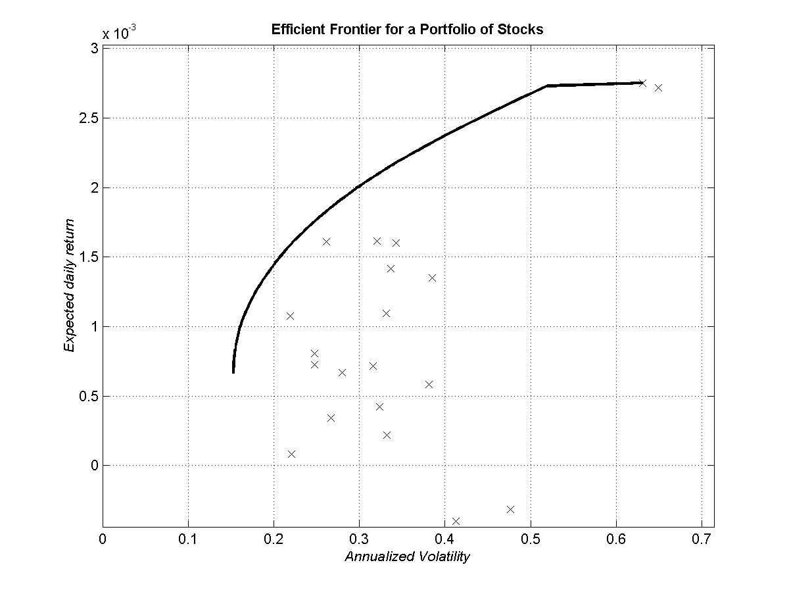
Figure 7. Efficient frontier for a portfolio of stocks.
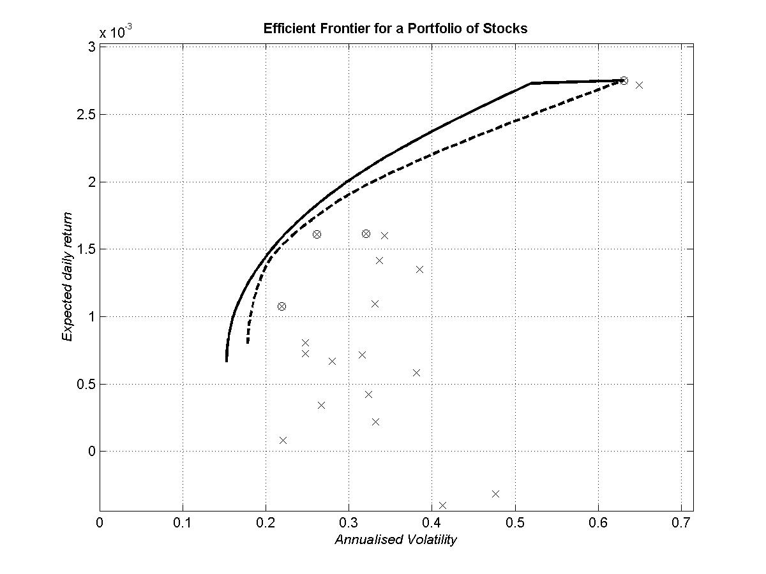
Figure 8. Efficient frontier for a portfolio of pre-selected stocks, dom_num=0.
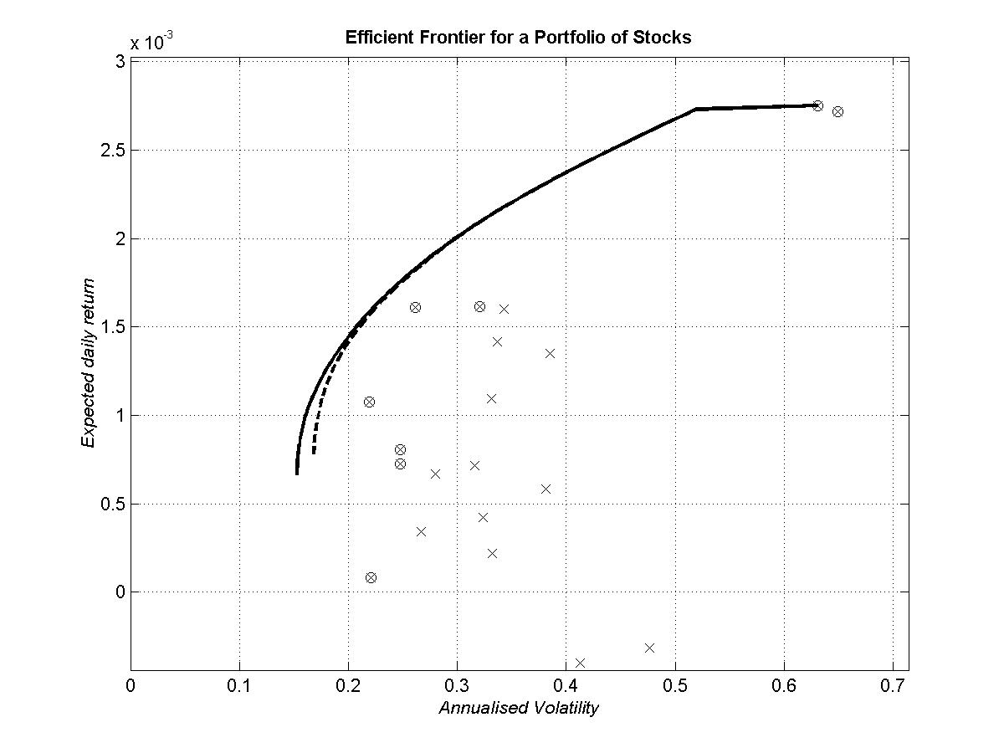
Figure 9. Efficient frontier for a portfolio of pre-selected stocks, dom_num=1.

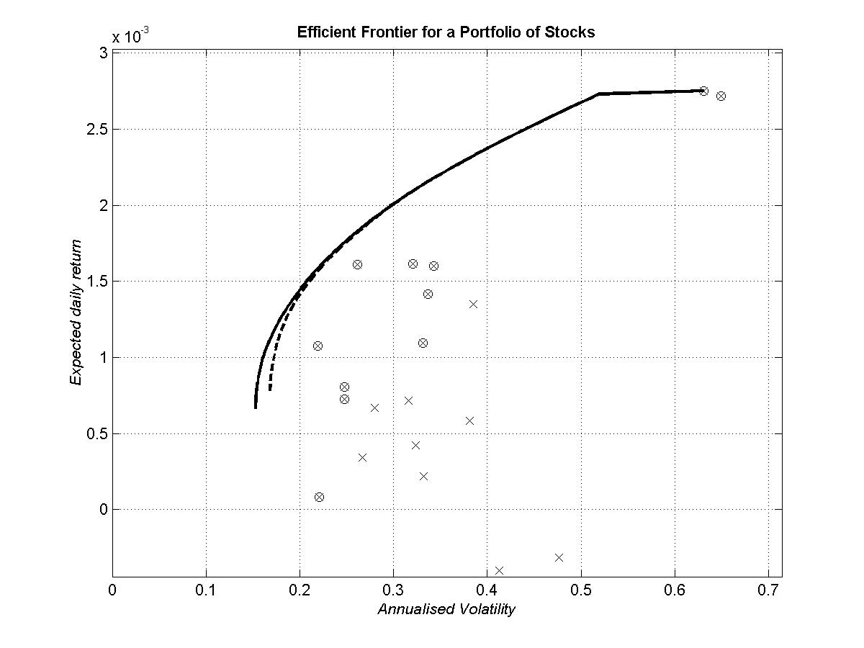
Figure 10. Efficient frontier for a portfolio of pre-selected stocks, dom_num=2.

- Summary
Selection of portfolio investments is not just limited to the size of returns. Usually the greater the return, the greater the risk. The objective of portfolio management is to balance expected gain and risk, consistent with gain expectations and risk tolerances of each specific individual.
Prior to the work of Harry Markowitz (1990 Nobel Prize Winner), portfolio management theory was limited to picking the highest quality stocks with the best expected returns. Markowitz revolutionized portfolio management by pointing out that the "best stock" theory was contrary to portfolio diversification, since it would logically concentrate funds in a few assets with the greatest expected returns. Portfolio diversification, Markowitz asserted, expressed investor concern with risk. His "mean-variance" theory quantifies risk as the variance from each security's expected return; then combines securities having opposing market movement characteristics to reduce overall portfolio risk.
By combining, assets in a portfolio with returns that increase or decrease differently (are less than perfectly correlated) portfolio risk can be reduced without sacrificing portfolio return. As the correlation (covariance) between asset returns combined in a portfolio decreases, the volatility (standard deviation) of the return on the entire portfolio decreases.

- Conclusion
In the real market, there are tremendous unexpected factors affecting the price of stocks. Matlab, as a strong calculator and graphic generator, can help us to understand the mathematical module of the stock market well, but it is only a mathematical tool and it cannot predict the market from other aspects. Therefore, we can try to get help from Matlab, but the result shown by Matlab is not the best solution to invest. Matlab can accurately restore the history and make us understand the market situations. Our Matlab scripts can help you decide the investment portfolio and show you the utility function graphically. If such predicted values are far from the actual market value, our example codes can only be a reference. In our opinion, Matlab is the best mathematical tool we can get for complex calculation. Matlab also provides some functions based on some general accepted formulas and methods, but those functions are only used to make the calculations faster and easier. If we want Matlab to help us to implement some special task, we have to write our own functions based on our own theories to make the calculation result more accurately.
Because Matlab is not designed for solving any special problem, it is very flexible for use in the field of complex value calculations.
References
Ross, Westerfield, Jaffe. (1996) Corporate Finance, McGraw-Hill
Radcliffe, Robert C. (1997) Investment: Concepts, Analysis, Strategy, Addison-Wesley

Internet links
http://www.mathworks.com
http://www.mathworks.com/access/helpdesk/help/techdoc/matlab_prog/ch14_o53.shtml
www.stockholmsborsen.se

List of figures
Figure 1. Different types of risks.....................................................................................……...7
Figure 2. Efficient frontier made of three stocks...............................................................…….9
Figure 3. Minimum variance frontier and efficient frontier.....................................................10
Figure 4. Efficient diversification with many risky assets and a risk-free asset……………..11
Figure 5. Efficient frontiers constructed with different correlation coefficients..................…14
Figure 6. Graphical representation of a-two-asset portfolio................................................….16
Figure 7. Efficient frontier for a portfolio of stocks………………………………………….26
Figure 8. Efficient frontier for a portfolio of pre-selected stocks, dom_num=0……………...26
Figure 9. Efficient frontier for a portfolio of pre-selected stocks, dom_num=1……………...27
Figure 10. Efficient frontier for a portfolio of pre-selected stocks, dom_num=2…………….27

List of tables
Table1. Data computation of A-two-asset portfolio. .......................................................….16

