Mälardalens University
MT1370 Numerical Methods
With Matlab, 5points
Seminar 2points
Tutor: Anatoliy Malyarenko Ima
Västerås 2004-01-14

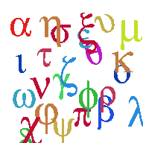

Authors:
Ikran Abdi
Stephanie Luong
Katya Vasileva
Andreas Gull

