List of Contents

- Introduction……………………………………………………………….. 1

- Constructing Greek-Neutral Portfolios of European Stock Options….. 2

  - Creating Portfolios with MATLAB…………………………….. 2

  - Delta Neutral Portfolio……………………………………………. 5

Problem 1…………………………………………………………. 6

  - Gamma Neutral Portfolio……………………………………….. 8

Problem 2………………………………………………………… 9

  - Delta-Gamma Neutral Portfolio ………………………………. . 11

Problem 3………………………………………………………… 11

- Conclusion……………………………………………………………….. 14

- Summary………………………………………………………………… 15

- References……………………………………………………………….. 16

1.0 Introduction

Matlab as a tool for doing numerical computations in matrices and vectors helps us to solve problems in many areas. One of those is the financial market which endorses our topic on constructing greek-neutral portfolios of European stock options. Here we intend to investigate how these greeks which measure the sensitivities of an option affects the option’s value in a financial market. In a financial market, the trader’s goal is to neutralize risk exposures entailed by the changes of the greeks, hence aiming to hedge. This is the topic of our report where we intend to construct different greek-neutral portfolios. Here, we plan to set up a game where 3 of us play the roles of traders and the fourth plays the role of a manager. Both the traders and the manager have to persuade the teacher, who is playing the role of a boss, that it is best for the company to use Matlab when doing financial computations to manage the portfolios.

- Constructing Greek-Neutral Portfolios of European Stock Options

Collectively, "greeks" refer to the financial measures delta, gamma, lambda, rho, theta, and vega, which are sensitivity measures used in evaluating derivatives. Each Greek letter measures a different dimension to the risk in an option position. To construct a greek-neutral portfolio for European stock option involves maintaining one or more of the sensitivity measures zero. A portfolio contains two or more options. In our report, on this matter of constructing greek-neutral portfolios on European Stock Options, we will be limiting ourselves to two of these parameters (delta and gamma) to see the role they play in an option’s value determination. Thus, we will create and construct portfolios which are delta neutral, gamma neutral and both delta-and-gamma neutral.

2.1 Creating Portfolios with MATLAB

In constructing a portfolio when using Matlab a trader follows four steps:

STEP 1:

We create an input data where each row contains the standard input of the Black-Scholes suite of the function.

Black-Scholes is a model used to calculate the value of an option, by considering the stock price, strike price and expiration date, risk-free return, and the standard deviation of the stock's return.

The Black-Scholes formula for calculating the price of a call option is:

$c=\text{SN}(d_{1})−{\text{Xe}}^{−\text{rT}}\text{SN}(d_{2})$
where
c = price of the call option
S = price of the underlying stock
X = option exercise price
r = risk-free interest rate
T = current time until expiration
N =cumulative standard normal distribution
d₁ =${\left[\text{ln}(S/X)+(r+{σ^{2}}/2)T\right]}/{{σT}^{1/2}}$
d₂=${\left[\text{ln}(S/X)+(r−{σ^{2}}/2)T\right]}/{{σT}^{1/2}}=d_{1}−{σT}^{1/2}$

For the put option we deduce a similar formula through the put-call parity relationship. The put-call parity links the value of a put option to that of a call option:

$p=c−S+{\text{Xe}}^{−\text{rT}}$

Hence by substitution we get the value of a put option in relation to the Black-Scholes’ formula:

$p={\text{Xe}}^{−\text{rT}}N(−d_{2})−\text{SN}(−d_{1})$
Consequently, we create a data matrix where each option has five inputs and thus has five columns:
Column 1: contains the current price of the underlying asset (S).
2: contains the strike price of each option (X).
3: contains the time-to-expiry of each option in years (T).
4: contains the annualised stock price volatility (σ)
5: contains the annualised dividend rate of the underlying asset (r).

>DataMatrix[…………..
……………];

The trader assigns some data to the functions, creating a matrix:
>StockPrice = DataMatrix(:,1);
>StrikePrice = DataMatrix(:,2);
>ExpiryTime = DataMatrix(:,3);
>Volatility = DataMatrix(:,4);
>DividendRate = DataMatrix(:,5);

By design the matrix should take the form:

Option StockPrice(S) StrikePrice(X) ExpiryTime(T) Volatility(σ) DividendRate(r)

If there is an n number of options in a given portfolio there will be an n number of rows and hence the matrix would be nx5 matrix. For example let portfolio Y contain 5 options. The martix data will be 5x5.

STEP 2:

Compute the prices, as well as the sensitivity of the greeks of each option using the Black-Scholes model. Here the trader uses functions such as ¨blsprice¨, ¨blsdelta¨, ¨blsgamma¨.

blsprice = Black-Scholes put and call pricing.
[callPrices,putPrices] = blsprice(S,X,r,T,σ,Q) returns the value of call and put options using the Black-Scholes pricing formula.

blsdelta = Black-Scholes sensitivity to underlying price change.
[callDeltas, putDeltas] = blsdelta(S,X,r,T,σ, Q) returns sensitivity in option value to change in the underlying security price. Delta is also known as the hedge ratio.

Blsgamma = Black-Scholes sensitivity to underlying delta change.
G = blsgamma(S,X,r,T,σ) returns sensitivity of delta to change in the
underlying security price.

One important point is that the functions blsprice and blsdelta have two outputs, while blsgamma have only one. This is because, the price and delta of a call option will differ from the price and delta of a put option whereas for gamma the type of the option is not important. In other words it is the same for both call or put options. The commands that are used for Matlab are:
> [callPrices, putPrices] = blsprice(stockPrice, strikePrice, riskFreeRate,…
expiryTime, volatility, dividendRate);

> [callDeltas, putDeltas] = delta(stockPrice, strikePrice, riskFreeRate,…
expiryTime, volatility, dividendRate);
Also, the trader extracts the prices and deltas of interest to account for the distinction between call and put options.

> prices = [call/putPrices(n)];
> deltas = [call/putDeltas(n)];

If there is a greek letter different from delta, then we should define it in following manner. For example:

> gammas = blsgamma(stockPrice, strikePrice, riskFreeRate, expiryTime,…
volatility, dividendRate)';

Again note that gamma is the same for both call and put options.

STEP 3:

Assuming an arbitrage portfolio value(Y), as a trader, we sets up a linear system of equations where we intends to solve for the parameters of the overall option portfolio – i.e. in our case delta and gamma. The solutions makes use of the fact that the value of a particular greek of a portfolio of options is a weighed average of the corresponding greek of each individual option in the portfolio. The weight applied to each greek is simply the quantity of each option included in the portfolio.

> A = [deltas ; gamma ; prices]
> b = [ 0 ; 0 ; Y ]

As:
> optionQuantities = A\b;

If the portfolio consists of a quantity w_{i} of option i$\left(1≤i≥n\right)$, the delta/gamma of the portfolio can be calculated from the deltas/gammas of the individual options in the portfolio. For example for delta neutrality the formula is:

$Δ=\sum_{i=1}^{n}{w_{i}Δ_{i}}$

STEP 4:

Summarising the sensitivity information and making sure that the portfolio value is actually Y, we expect the option portfolio to be neutral, i.e., depending on what our chosen parameter(s) were:

> portfolioValue = prices * OptionQuantities;
> portfolioDelta = deltas * OptionQuantities;
> portfolioGamma = gammas * OptionQuantities;

> disp (' ')
> disp (' ')
> disp (' Option Price Delta Gamma Quantity')
> fprintf('%8d %8.4f %8.4f %8.4f %8.4f %12.4f\n' , [[1:n]' prices' deltas' > gammas' optionQuantities]')
> disp (' ')
> fprintf(' Portfolio Value: $%8.2f\n' , portfolioValue)
> fprintf(' Portfolio Delta: %8.2f\n' , portfolioDelta)
> fprintf(' Portfolio Gamma: %8.2f\n' , portfolioGamma)

bar( [ ……..' …….']');
Title('….');
Legend('…….','…….',…);
XLABEL('……….');

2.2 Delta Neutral Porfolio

Delta is the price sensitivity of an option with respect to changes in the price of the underlying asset. It represents the first-order sensitivity measure analogous to duration in fixed income markets. In terms of calculus, delta can be expressed as the rate of change of the option price with respect to the price of the underlying asset. Hence, it is the slope of the curve that relates the option price to the underlying asset price.

$$Δ=\frac{δc}{δS}$$
=(change in the value of the option) /(change in the value of the underlying asset)

Where c is the price of the option and S is the stock price.

As delta is an important parameter in the pricing and hedging of options, it is positive for a call option and negative for a put option.

$Δ_{\text{call}}=\frac{{δc}_{\text{call}}}{δS}=N(d_{1})$ and $Δ_{\text{put}}=\frac{{δc}_{\text{put}}}{δS}=N(−d_{1})−1$

The delta of a call option tends to approach 1.0 when the call option is deep-in-the-money whereas it approaches 0 when it is out deep-out-of-the-money. The delta of a put option tend to –1.0 when it is deep-in-the-money and 0 when it’s deep-out-of-the-money. Hence:

Δ_{call}>= 0 whereas, Δ_{put}<0

When the stock price is near to the exercise price (i.e. S→X), take a call option for example, the delta of a call option is most sensitive to the change in the stock price. This creates a problem for us, the traders, and is the reason why we need to hedge against these risks. Hedging against delta means creating a delta-neutrality. This means that we protect the value of the option portfolio(two or more options) from small changes in the price of the underlying asset. The concept is to shape the risk characteristics of the investment to our particular purpose by rebalancing. Rebalancing is the process of adjusting to counteract the fact that different option have performed differently and contain different percentages of the portfolio than they were intended. This is because since the changes of delta makes the investor’s position to remain delta neutral for a short period of time, delta has to be adjusted periodically – hence rebalancing.
Problem 1: Construct a portfolio that is hedge locally against delta and has a total value of $25,000. The portfolio consists of one call option with S= 200, X=250, T=0.2 years, σ=0.5, Q=0.01 and a put option with S= 134.1, X=150, T=0.1 years, σ=0.3, Q=0.025. The risk free interest rate of the portfolio is 15%.

% STEP 1.
riskFreeRate = 0.15;

dataMatrix = [200.000 250 0.2 0.5 0.01 % Call
134.100 150 0.1 0.3 0.025 ]; % Put

stockPrice = dataMatrix(:,1);
strikePrice = dataMatrix(:,2);
expiryTime = dataMatrix(:,3);
volatility = dataMatrix(:,4);
dividendRate = dataMatrix(:,5);

% STEP 2.

[callPrices, putPrices] = blsprice(stockPrice, strikePrice, riskFreeRate, ...
expiryTime, volatility , dividendRate);

[callDeltas, putDeltas] = blsdelta(stockPrice, strikePrice, riskFreeRate, ...
expiryTime, volatility , dividendRate);

prices = [callPrices(1) putPrices(2) ];
deltas = [callDeltas(1) putDeltas(2) ];

% STEP 3.

A = [deltas ; prices];
b = [ 0 ; 25000];

optionQuantities = A\b;

% STEP 4.

portfolioValue = prices * optionQuantities;
portfolioDelta = deltas * optionQuantities;

disp (' ')
disp (' ')
disp (' Option Price Delta Quantity')
fprintf('%8d %8.4f %8.4f %12.4f\n' , [[1:2]' prices' deltas' optionQuantities]')
disp (' ')
fprintf(' Portfolio Value: $%8.2f\n' , portfolioValue)
fprintf(' Portfolio Delta: %8.2f\n' , portfolioDelta);
bar( [ prices' deltas']');
Title('Delta Neutral Portfolio of a European Stock Option');
Legend('opion1','option2');
XLABEL('prices deltas');

%And

bar( [ optionQuantities']');
Title('Option Quantities of Delta Neutral Portfolio of a European Stock Option');
XLABEL(' option1 option2');

Result:

Option Price Delta Quantity
1 5.1743 0.2229 2729.4652
2 15.0116 -0.8397 724.5724

Portfolio Value: $25000.00
Portfolio Delta: 0.00

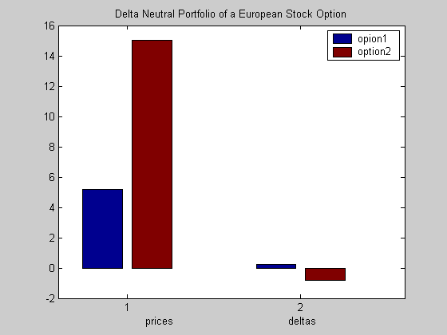

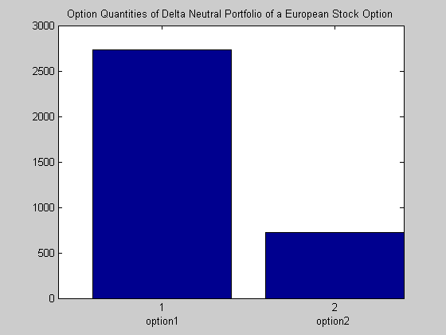

2.3 Gamma Neutral Portfolio

The gamma of a portfolio is defined as the sensitivity of delta when the stock price changes, that is the rate of change of delta with respect to price of the underlying asset, and the gammas of calls and puts are always non-negative.

Gamma is the second partial derivative of the portfolio with respect to the asset price:

$$Γ=\frac{∂^{2}Δ}{∂S}$$
= Change in Delta / Change in Underlying Asset

An option that is bought has positive gamma while sold options have negative gamma. A portfolio's gamma will be the weighted sum of its option's gammas and the resulting gamma will be determined by the dominant options in the portfolio.

A trader finds gamma to be attractive when it is positive and off-putting when it’s negative because as gamma tends to be negative the rate of losses increases as losses are sustained and the rate of profit falls. Gamma is useful when delta portfolio is neutral. If Gamma is negative, the portfolio profits as long as the current rate remains stable. If Gamma is positive, the portfolio will only profit from large movements in the current rates in either direction. To change the Gamma of a portfolio a trader must buy or sell additional option contracts.

Why we make the portfolio gamma neutral is because we want to protect against large movements in stock prices. Gamma of the portfolio must be close to zero. We have already analysed how a portfolio can be made delta neutral, by taking a position in the underlying asset. In order to achieve gamma neutrality, suppose we want to buy $W_{T}$units of the option, the traded options’ gamma is $Γ_{T}$ and that gamma of the delta portfolio is $Γ$. Gamma of the portfolio will be:

$$W_{T}Γ_{T}+Γ$$

To hedge against this gamma, traded options :

$\begin{aligned}W_{T}Γ_{T}+Γ=0 \\ W_{T}=−\frac{Γ}{Γ_{T}}\end{aligned}$

Gamma is neutral for just a short period. It requires${−Γ}/{Γ_{T}}$ options to keep the portfolio gamma neutral. After this change in the portfolio, it will not be delta neutral anymore.

Problem 2: Using the same information given in problem 1, construct a gamma neutral portfolio.

% STEP 1.

riskFreeRate = 0.15;

dataMatrix = [200.000 250 0.2 0.5 0.01 % Call
134.100 150 0.1 0.3 0.025]; % Put

stockPrice = dataMatrix(:,1);
strikePrice = dataMatrix(:,2);
expiryTime = dataMatrix(:,3);
volatility = dataMatrix(:,4);
dividendRate = dataMatrix(:,5);

% STEP 2.

[callPrices, putPrices] = blsprice(stockPrice, strikePrice, riskFreeRate, ...
expiryTime, volatility , dividendRate);

[callDeltas, putDeltas] = blsdelta(stockPrice, strikePrice, riskFreeRate, ...
expiryTime, volatility , dividendRate);

gammas = blsgamma(stockPrice, strikePrice, riskFreeRate, ...
expiryTime, volatility , dividendRate)';

prices = [callPrices(1) putPrices(2) ];
deltas = [callDeltas(1) putDeltas(2) ];
% STEP 3.

A = [gammas ; prices];
b = [ 0 ; 25000];

optionQuantities = A\b;

% STEP 4.

portfolioValue = prices * optionQuantities;
portfolioDelta = deltas * optionQuantities;
portfolioGamma = gammas * optionQuantities;

disp (' ')
disp (' ')
disp (' Option Price Delta Gamma Quantity')
fprintf('%8d %8.4f %8.4f %8.4f %12.4f\n' , [[1:2]' prices' deltas' gammas' optionQuantities]')
disp (' ')
fprintf(' Portfolio Value: $%8.2f\n' , portfolioValue)
fprintf(' Portfolio Delta: %8.2f\n' , portfolioDelta)
fprintf(' Portfolio Gamma: %8.2f\n' , portfolioGamma)

bar( [ prices' gammas']');
Title('Gamma Neutral Portfolio of a European Stock Option');
Legend('opion1','option2');
XLABEL('prices gammas');

% And

bar( [ optionQuantities']');
Title('Option Quantities of Gamma Neutral Portfolio of a European Stock Option');
XLABEL(' option1 option2');

Result:

Option Price Delta Gamma Quantity
1 5.1743 0.2229 0.0067 -228623.6565
2 15.0116 -0.8397 0.0189 80468.8155

Portfolio Value: $25000.00
Portfolio Delta: -118532.67
Portfolio Gamma: 0.00

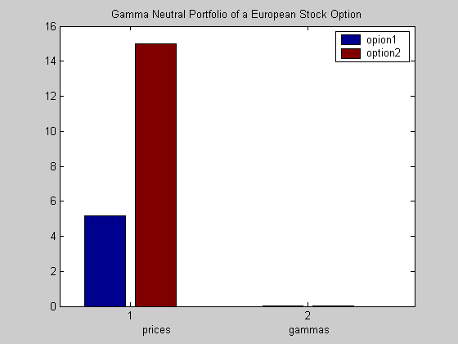

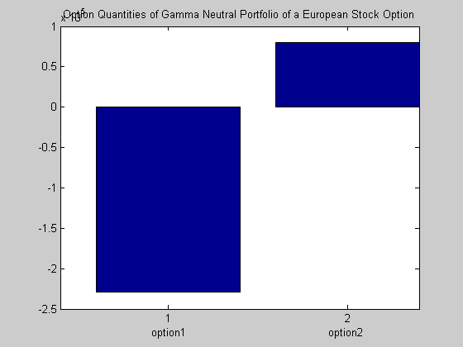

2.4 Delta-Gamma Neutral Portfolio

Let’s now discuss delta and gamma hedging a portfolio. If a delta-neutral portfolio, has a negative gamma, large changes in the stock price can cause the portfolio to decrease in value. Recall from what we said above that gamma is a measure of the change of delta in respect to a change in the price of the underlying stock. The larger the absolute value of gamma, the larger will be the change in delta, and this can cause problems with delta hedging in a market characterized by rapid price changes. Since gamma depends on the changes of delta (and vice versa) and delta fluctuates inconsistently over time, to avoid such a problem we need to construct a portfolio such that both delta and gamma are neutral. In designing a portfolio to be delta neutral, we need two assets, but if we add the requirement that the hedged portfolio must also be gamma neutral, then we need a third asset.

Problem 3: Using with the previously given call and put option, the third asset is a call option with stock price $307.125, strike price $330, time to expiration 0.5 year, volatility 0.2 and dividend rate 0.0333, create a delta-gamma neutral portfolio.

% STEP 1

riskFreeRate = 0.15;

dataMatrix = [200.000 250 0.2 0.5 0.01 % Call
134.100 150 0.1 0.3 0.025 % Put
307.125 330 0.5 0.2 0.0333]; % Call

stockPrice = dataMatrix(:,1);
strikePrice = dataMatrix(:,2);
expiryTime = dataMatrix(:,3);
volatility = dataMatrix(:,4);
dividendRate = dataMatrix(:,5);

% STEP 2.

[callPrices, putPrices] = blsprice(stockPrice, strikePrice, riskFreeRate, ...
expiryTime, volatility , dividendRate);

[callDeltas, putDeltas] = blsdelta(stockPrice, strikePrice, riskFreeRate, ...
expiryTime, volatility , dividendRate);

gammas = blsgamma(stockPrice, strikePrice, riskFreeRate, ...
expiryTime, volatility , dividendRate)';

prices = [callPrices(1) putPrices(2) callPrices(3) ];
deltas = [callDeltas(1) putDeltas(2) callDeltas(3) ];

% STEP 3.

A = [deltas ; gammas ; prices];
b = [ 0 ; 0 ; 25000];

optionQuantities = A\b;

% STEP 4.

portfolioValue = prices * optionQuantities;
portfolioDelta = deltas * optionQuantities;
portfolioGamma = gammas * optionQuantities;

disp (' ')
disp (' ')
disp (' Option Price Delta Gamma Quantity')
fprintf('%8d %8.4f %8.4f %8.4f %12.4f\n' , [[1:3]' prices' deltas' gammas' optionQuantities]')
disp (' ')
fprintf(' Portfolio Value: $%8.2f\n' , portfolioValue)
fprintf(' Portfolio Delta: %8.2f\n' , portfolioDelta)
fprintf(' Portfolio Gamma: %8.2f\n' , portfolioGamma)

bar( [ prices' deltas' gammas']');
Title('Delta-Gamma-Neutral Portfolio of a European Stock Option');
Legend('opion1','option2','option3');
XLABEL(' prices deltas gammas');

% And

bar( [ optionQuantities']');
Title('Option Quantities of Delta-Gamma Neutral Portfolio of a European Stock Option');
XLABEL(' option1 option2 option3');

Result:

Option Price Delta Gamma Quantity
1 5.1743 0.2229 0.0067 -5191.3761
2 15.0116 -0.8397 0.0189 372.7700
3 15.1699 0.4821 0.0090 3049.8358

Portfolio Value: $25000.00
Portfolio Delta: 0.00
Portfolio Gamma: -0.00

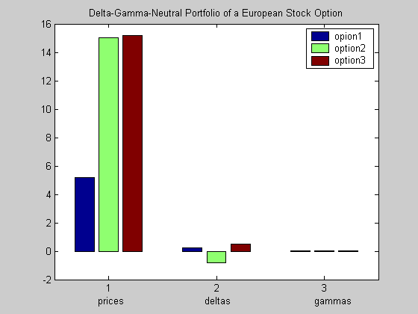

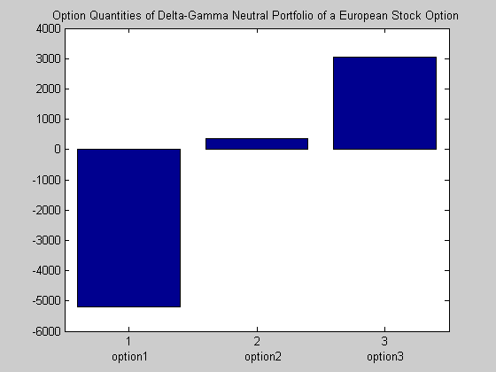
3.0 Conclusion

After solving the problems with the help of Matlab, we concluded that Matlab is very useful device when working in the field of financial mathematics. The program makes it possible to construct, e.g. in our case, any desired greek neutral portfolio without any complicated mathematical calculations, and to get the result illustrated visually in a fast and convenient way. As we know, in the world of the stock market, taking fast decisions is extremely important and one of the factors which contributes to this fast decision-making is the possibility to convert the given information into a strategy for the shortest possible time. Matlab plays a significant role in this process and that’s why when referring back to our financial game, convincing the boss of Matlab’s usefulness for the business, is our main objective. This is exactly what we did in our report and the results were as clear and fast to get as we anticipated to be. We are optimistic that our boss will come to agree with us.

4.0 Summary:

Our objective was to introduce, investigate and present the idea of the greeks and their neutrality in a clear and consistency manner. Here, we gave a detailed explanation of two of the greeks (delta and gamma) and their functions in an European option. Furthermore, with the help of Matlab, we constructed three greek neural portfolios consisting options on different positions – delta neutral, gamma neutral and delta-gamma neutral. To see our results graphically, we made some bar graphs with Matlab showing the new portfolios’ option quantities, prices, and the chosen greeks.

- References

J. C. Hull, Options, futures and other derivatives, 5th edition, Prentice Hall, 2002

Financial toolbox user’s guide, The Mathworks, Inc., 2003, version 2

Robert W. Kolb, Futures, Options, & Swaps, 3rd edition, Blackwell, 2000

Jarrow & Turnbull, Derivative Securities, 2nd edition, South-Western Thomson Learning, 2000

http://www.quantnotes.com/fundamentals/options/thegreeks-gamma.htm

http://www.in-the-money.com/glossarynet/port0039.htm

http://www.investorwords.com/4074/rebalancing.html

http://www.investorwords.com/4074/rebalancing.html
http://www.in-the-money.com/glossarynet/port0039.htm
http://www.quantnotes.com/fundamentals/options/thegreeks-gamma.htm
Jarrow & Turnbull – Derivative Securities 2nd edition South-Western Thomson Learning 2000 p. 286

