Mälardalen University
Institution of Mathematics and Physics
MT 1370 Numerical Methods with MATLAB, 5 points
Seminar, 2 points
Tutor: Anatoliy Malyarenko
Västerås 2004-01-07

Term Structure Analysis of Interest Rates

& Interest Rate Swap Pricing

An Matlab-based Introduction

Group A1:
Krasimira Kirova
Ying Ni
Lei Zhang

Table of Contents

Summary 2
Introduction 3
Part One Term Structure Analysis of Interest Rates 4
1.1 Term structure of interest rates 4
1.3 The Bootstrapping Process 8
1.4 Curve Fitting 9
Part Two Interest Rate Swap Pricing 10
2.1 Interest Rate Swap 10
2.2 Finding the Correct Fixed Interest Rate (Swap Rate) 10
2.3 Example 2.1-Interest Rate Swap Pricing 11
Present Value of the Floating Side 12
Present Value of the Fixed Side 15
Part Three A sample application 18
Conclusion 21
List of Sources 22

Summary

Term structure analysis bootstraps the theoretical spot rate curves, zero curve or forward curve, from the observed market data. In practice, such analysis is difficult to carry due to the characteristics of the market data. MATLAB functions tbl2bond, tr2bonds can solve the problem. Functions zbtprice, and zbtyield, derives the desired zero curve. Functions zero2fwd and zero2disc can return an implied forward and a discount curve respectively. Both of them, together with zero curve, construct the term structure analysis of interest rates.

Interest rate swap is an agreement between two parties to exchange a series of future cash payments. At each exchange date, one party pays the other a fixed rate in return for a floating interest payment. To price an interest rate swap involves finding the correct fixed rate, the swap rate, that equates the present values of the two sides. Term structure analysis is used to analyze both sides of the swap. And a simple algorithm in MATLAB can do the job for equating the present values of the two sides, and hence find the swap rate.

One can apply MATLAB and its Financial Toolbox to apply term structure analysis and then price an interest rate swap. The whole process consists of 6 steps: 1 specify values for the market instruments, 2 use zbtprice or zbtyield to derive the zero rates, 3 derive the forward rates from zero rates by zero2fwd, 4 derive the discount rates by zero2disc, 5 calculate the present value of floating side, 6 find the correct fixed rate that makes the present value of the floating side and fixed side equal.
Introduction

Discussing the structure and valuation of interest rate swap would be unrealistic without analyzing the interest rates first. Term structure analysis of interest rate is the choice. It finds out the theoretical spot interest rates consisting of zero rates and forward rates, which are consistent with the prices of market instruments. It is therefore considered to be the market expectation of interest rates.

Techniques of term structure analysis, including for example Bootstrapping and Curve Fitting, are introduced in part one. In part two, interest rate swap is analyzed and valuated guiding by no-arbitrage policy. None of term structure analysis and interest rate swap pricing is a easy job without the help of a programming language. User-friendly spread-sheets or other softwares do have the advantages of being easy to use. However, few of them can handle non-standardized or too sophisticated problems. MATLAB and its Financial Toolbox is one of the best high-level computer languages that facilitate a powerful tool for analyzing financial problems. An sample application of MATLAB in both Term structure analysis and interest rate swap pricing is given in the end of the paper.

Part One Term Structure Analysis of Interest Rates

1.1 Term structure of interest rates

Term Structure of interest rates looks at why interest rates on bonds with the same risk (e.g. T-bills) will vary due to differences in term to maturity. Another factor besides risk that influences interest rates is the term to maturity. Special interest rate curves are created in order to visualize the term structure of interest rates. These curves are created using the market data by two processes, bootstrapping and curve fitting. Analysts who build and use these curves often face incomplete data, differing market conditions, misalignment of cash flows in time, and other issues. There are few software packages which make it easy to carry out the sophisticated term structure analysis. In this paper MATLAB and the Financial Toolbox are used to help overcome many of the obstacles to effective term structure.

Several activities are involved in creating effective term structure, but the most important of them is bootstrapping the theoretical spot rate curve from observed market data. Bootstrapping is a process where there are known data points and it is solved for unknown data points using an underlying arbitrage theory. Every coupon bond can be valued as a package of zero-coupon bonds which have the same cash flow and risk characteristics. Then a theoretical yield for every component of every bond in the market place can be derived. This collection of theoretical yields along with their corresponding maturities is known as the theoretical spot curve, the zero curve, or sometimes also called the yield curve.

A set of bonds with identical risk, features, tax treatment, etc. but different maturities will be examined in order to focus on maturity alone. In reality, only Treasury bonds satisfy these criteria. Municipal and private issuers do not issue enough different maturities to allow useful comparison. Treasury securities range in maturity from 3 months to 30 years.

The yield curve is practically a plot of Treasury bond maturities versus their yields. The shape of the yield tells us the relationship between short-term and long-term interest rates. Consider the sample yield curves below:
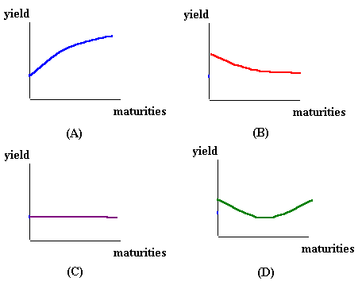
In curve (A), the yield curve is upward-sloping, so yields rise as maturity increases.
In curve (B), the yield curve is downward-sloping, or inverted, so yields fall as maturity increases.
In curve (C), the yield curve is flat, so yields are identical across all maturities.
In curve (D), the yield curve changes direction, so the short and long-term bonds have the highest yields, but intermediate-term bonds have lower yields.

The yield curve changes shape over time, depending on financial market conditions. However, in looking at historical data on Treasury yields, there are 3 important facts about the yield curve:

- Interest rates on bonds of different maturities generally move together.
- When short-term interest rates are low relative to historical averages, the yield curve usually slopes up. When short-term interest rates are high, the yield curve usually slopes down.
- The yield curve usually slopes up.

In addition to describing the current relationship between short and long-term interest rates, the yield curve may also contain valuable information about investor expectations about future interest rates.

1.2 Matlab Application of Term Structure Analysis

In theory, bootstrapping a zero curve from U.S. Treasury data should be a relatively straightforward process. In practice, however, it is much more difficult due to the characteristics of the market data reported for these instruments. When bootstrapping from Treasury bills, notes and bonds, analysts are confronted with three data-related issues:

- Direct data incomparability between Treasury bill and bond data due to differing market conventions.
- Noise in the data caused by price-yield distortion in both near-term and longer-term securities.
- Sparseness in the data due to the fact that Treasury coupon bonds are callable in the maturity region between about 7 and 14 years.

The first issue is actually a major problem in analyzing the term structure of interest rates. It arises because data is often reported in different formats. For example, Treasury bills are quoted with bid and asked bank-discount rates, while Treasury notes and bonds are quoted with bid and asked prices based on $100 face value. Therefore, to study all Treasury securities analysts must convert data to a single format. The Financial Toolbox contains several functions to derive and analyze interest rate curves, as well as data conversion and interest-rate curve conversion functions. The following example 1 illustrates this.

First, the Treasury bill quotes are presented in the way they are reported.

% Maturity Days Bid Ask AskYield
TBill = [datenum('12/26/2000') 53 0.0503 0.0499 0.0510];

Then the Treasury bond quotes are also presented in the way in which they are reported.

% Coupon Maturity Bid Ask AskYield
TBond = [0.08875 datenum(2001,11,5) 103+4/32 103+6/32 0.0564];

In this example only one security each is used, however, in reality analysts use much more of each. Then they construct TbillMatrix and TbondMatrix which are both n-by-5 matrices. For Treasury bills each row of the matrix describes a Treasury bill; n is the number of Treasury bills and the columns are [Maturity Days Bid Ask AskYield]. For treasury bonds each row of the matrix describes an equivalent Treasury (zero-coupon) bond and the columns are [CouponRate Maturity Bid Ask AskYield].

It should be noted that both quotes are based on a settlement date – November 3, 2000.
Settle = datenum('3-Nov-2000');

Next we use the toolbox function tbl2bond to convert the Treasury bill data to Treasury bond format. The general form of the function is
[TBondMatrix, Settle] = tbl2bond(TBillMatrix), but since we use just one of each security the function can be written in the form

TBTBond = tbl2bond(TBill)

TBTBond =
0 730846 99.26 99.27 0.05

The second element of TBTBond is the serial date number for December 26, 2000.
To combine short-term (Treasury bill) with long-term (Treasury bond) data the overall term structure is set up.

TBondsAll = [TBTBond; TBond]

TBondsAll =
0 730846 99.26 99.27 0.05
0.09 731160 103.13 103.19 0.06

The Financial Toolbox contains also a second data-preparation function, tr2bonds, to convert the bond data into a format ready for bootstrapping functions. This function creates a matrix of bond information sorted by maturity date, as well as vectors of prices and yields. Applied to our previous example the function will look like
[Bonds, Prices, Yields] = tr2bonds(TBondsAll);

Generally the function will be written as

[Bonds, Prices, Yields] = tr2bonds(TreasuryMatrix, Settle)

where TreasuryMatrix refers to a n-by-5 matrix, for which each row describes a Treasury bond and the columns are [CouponRate Maturity Bid Ask AskYield]. Settle refers to the date string or serial date number of the settlement date for the analysis and this input is optional. Bonds gives coupon bond information. It is a n-by-6 matrix where each row describes a bond and has columns [Maturity CouponRate Face Period Basis EndMonthRule]. Prices is a column vector containing the price of each bond in Bonds, respectively, and the number of rows (n) matches the number of rows in Bonds. Yields is also a column vector, which contains the yield to maturity of each bond, respectively, and the number of rows (n) matches the number of rows in Bonds. If Settle is an input, Yields is computed as a semiannual yield to maturity. If Settle is not an input, the quoted input yields will be used. There is a simple example 2 below.

Given published Treasury bond market parameters for December 22, 1997

Matrix =[0.0650 datenum('15-apr-1999') 101.03125 101.09375 0.0564
0.05125 datenum('17-dec-1998') 99.4375 99.5 0.0563
0.0625 datenum('30-jul-1998') 100.3125 100.375 0.0560
0.06125 datenum('26-mar-1998') 100.09375 100.15625 0.0546];

To execute the function

[Bonds, Prices, Yields] = tr2bonds(Matrix)
Bonds =

729840 0.06125 100 2 0 1
729966 0.0625 100 2 0 1
730106 0.05125 100 2 0 1
730225 0.065 100 2 0 1

Prices =
100.1563
100.3750
99.5000
101.0938
Yields =
0.0546
0.056
0.0563
0.0564

Given the Treasury bond parameters the function tr2bonds returns term-structure parameters (bond information, prices, and yields) sorted by ascending maturity date. The formats of the output matrix and vectors meet requirements for input to the zbtprice and zbtyield zero-curve bootstrapping functions.

zbtprice derives a zero curve from bond data and prices, and zbtyield derives a zero curve from bond data and yields. Their general forms are

[ZeroRates, CurveDates] = zbtprice(Bonds, Prices, Settle,
OutputCompounding)

[ZeroRates, CurveDates] = zbtyield(Bonds, Yields, Settle,
OutputCompounding)

Those two functions will be further studied in this work. Other toolbox functions that will be used later are zero2fwd, which returns an implied forward rate curve given a zero curve and its maturity dates; and zero2disc which returns a discount curve given a zero curve and its maturity dates.

[ForwardRates, CurveDates] = zero2fwd(ZeroRates, CurveDates,
Settle, OutputCompounding, OutputBasis, InputCompounding,
InputBasis)

[DiscRates, CurveDates] = zero2disc(ZeroRates, CurveDates, Settle,
InputCompounding, InputBasis)
1.3 The Bootstrapping Process

The phenomenon of noisy market data was mentioned above. To reduce this noise, analysts typically exclude the first six months of Treasury note and bond data. Here the first three months of the data will be excluded, replacing it with six months' of Treasury bill data, and then bootstrap from the resulting portfolio. Treasury bills are quoted using actual/360 basis, bank discount yield, and bond equivalent yield conventions, while Treasury notes and bonds are quoted using actual/actual basis, 32nds price, and bond equivalent yield conventions. To bootstrap from both bill and bond data, the bill data must be restated. The MATLAB Financial Toolbox contains a function for restating the Treasury bill data as showen in 1.2. And there are also two bootstrapping functions, one that allows you to bootstrap from prices, and another that allows you to bootstrap from quoted yields to maturity (zbtprice and zbtyield). The toolbox also contains functions for converting a bootstrapped zero curve to a discount curve, an implied forward curve (zero2fwd and zero2disk). Figure 1.1 contains a zero curve bootstrapped from 30 years of U.S. Treasury note and bond in combination with a half year's worth of Treasury bill data. Note how the region of callability appears as flat part of the curve. This is due to the fact that, in the absence of securities in this range, the bootstrapping algorithm linearly interpolates the zero rates across the gap.

Figure 1.1 Theoretical Spot Curve Bootstrapped from U.S. Treasury - Market Date November 3, 1997

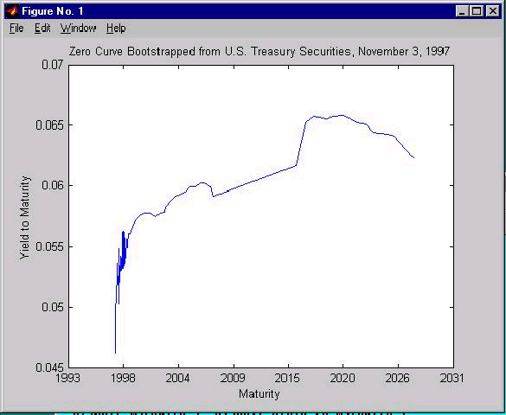

1.4 Curve Fitting

Curve fitting allows to remove the gap arising from the callable nature of some Treasury bonds by creating a curve whose shape reflects the underlying economic trend exhibited by the other parts of the curve. Besides that, if the zero curve is well fitted and smooth, it can then be converted to a well-formed implied forward curve. This forward curve shows the future path of short rates implied by a given zero curve, and these future short rates tell what future yield curves will look like if the expectations implied by the forward curve hold. If an implied forward curve is directly built from a bootstrapped zero curve (which by definition fits the data exactly), it is possible that there will be some negative forward rates (i.e. negative term interest rates at some point in the future) which are not a function of an economic trend in the yield curve, but rather are noise in the data. Building an implied forward curve from a fitted zero curve ensures that the forward curve reflects the economic trend presented by the underlying yield curve. The MATLAB Financial Toolbox contains a function for deriving implied forward rates from either bootstrapped zero rates or a fitted zero curve. Figure 1.2 depicts both the un-smoothed and smoothed implied forward curves. Note the existence of negative forward rates in the curve derived from the bootstrapped zero curve despite the fact that the economic trend in the zero curve is upward sloping.

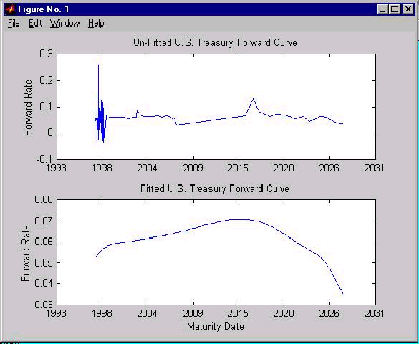
Figure 1.2 Implied Forward Curves Derived from Bootstrapped and Well Fitted Zero Curves

There is much more that can be said about the Term Structure of Interest Rates, but the major problems and issues have been mentioned. Some of them will further be discussed in this paper, it will be illustrated more in detail how to derive implied zero and forward curves from the observed market prices of coupon-bearing bonds and then the curves implied from the market data will be used to price an interest rate swap agreement.
.
Part Two Interest Rate Swap Pricing

2.1 Interest Rate Swap

A financial swap, as its name indicates, refers to an agreement between two parties, known as counterparties, to exchange a series of future cash flows. There are two basic kinds of swaps, currency swap and interest rate swap. In an interest rate swap, the counterparties exchange the interest payments periodically on a certain amount, the principal, for a given length of time.
At each exchange date, one party pays the other a fixed rate of interest payment in return for a floating interest payment, (Page 282, Wilmott, Howison, & Dewynne) as Figure 2.1 illustrates.

Figure 2.1 The parties to an interest rate swap

Party A

Pays fixed

Receives floating

Party B

Receives fixed

Pays floating

Floating interest rate
Fixed interest rate
Our task is to find the no-arbitrage fixed rate

The principal on an interest rate swap is only notional and will not be exchanged at the maturity.

2.2 Finding the Correct Fixed Interest Rate (Swap Rate)

There are two sides of a swap, the fixed rate payment side and the floating rate payment side. In the floating rate side, the floating payments stream is tied to some variable index rate. For example, the London Interbank Offer Rate (LIBOR) is the most commonly used floating rate. In the fixed side, the periodic sequence of fixed cash payments is determined by a prespecified fixed interest rate.

When a swap is first entered into, it is usual for the deal to have no value to either party. In other words, the present value of the fixed rate cash payments equals the present value of the floating rate cash payments, netting out to zero. (Page 279, Wilmott). This is done by a careful choice of fixed rate.

Pricing an interest rate swap is equivalent as finding the correct fixed rate for the swap. So our task in this section is to find the fixed rate that prevents arbitrage and does not disadvantage either party. In figure 2.1, A too high fixed rate makes the contract a high value and disadvantage the party A (thus arbitrage opportunity for party B) and vice versa.

To conclude, the principle of finding the correct fixed rate is straight-forward. We calculate the present value of the floating rate side and the fixed rate side and make them equal. Example 2.1 illustrates the process applying MATLAB Financial Toolbox.

2.3 Example 2.1-Interest Rate Swap Pricing

Find the fixed rate for a five year swap with semi-annual payments. The settlement date is today 7th Jan 2004. The annual floating rate is denoted as r * which is variable and tied to future spot interest rates, using treasury rate as the reference interest rate. The annual fixed rate is denoted as r which is a fixed number. The principal is one dollar (for simplicity). Use the term structure data in table 2.1.

Table 2.1 term structure of interest rates- zero rates

Maturity  1/2 Year  1 Year  3/2 Year  2 Year  5/2 Year  3 Year  7/2 Year  4 Year  9/2 Year  5 Year | Zero Rates  0.0614  0.0642  0.0660  0.0684  0.0702  0.0726  0.0754  0.0795  0.0827  0.0868

To find the right fixed rate for this swap, we first study the pattern of cash payments in the floating rate side and fixed rate side, as shown in figure 2.2.

Figure 2.2 Diagram of the cash payments in the interest rate swap in example 2.1
½ r
½ r
½ r
½ r
½ r
½ r
½ r
½ r
½ r
½ r * (today)
r *
(1 y)
½ r *
(½ y )
½ r *
(3/2 y)
½ r *
(2 y)
½ r *
(5/2 y)
½ r *
(3 y)
½ r *
(7/2 y)
½ r *
(4 y)

5 Years
½ r
½ r *
(9/2 y)
today
7th Jan 04

Present Value of the Floating Side

Look at Figure 2.2, the cash payments in the floating side are denoted by the curly lines. There are totally ten payments. Since we have principal of one dollar, the ten payments in dollar amount are:

½ r* ½ r* ½ r* … ½ r*
(today) (½ y) (1 y) …(9/2 y)

There are two important details here. First, r and r* are annualized interest rate, so each semi-annual interest payment is ½ r or ½ r *. Second, in the floating payments side, the first payment at ½ year from now (7th Jul 2004), equals to the 6-month floating interest rate quoted six month before (quoted today), which is ½ times today’s r*.

Similarly, the second floating rate payment at 1 year from now (7th Jan 2005 ) is ½ times
r* (½ y), which is the 6-month floating interest rate quoted ½ years from today, and so on.

Therefore, the floating rate payments stream can be replicated by a forward rates stream.
Forward rates are the time-dependent spot interest rates that are consistent with the market price instruments. They are often taken as a forecast of future expected spot interest rates.

The underlying arbitrage relationship here is: since the floating rate payments are consistent with forward rates, they are perfect substitutes of each other and therefore should be valued the same at the time zero. Thus the present value of floating payments stream is equivalent to the present value of the forward rates stream.
Forward rates can be calculated from zero rates which are given in this example. MATLAB function zero2fwd converts zero rates into corresponding forward rates.

We now create m-flile SwapRate.m.
______________________________________________________________________
% Filename: SwapRate.m
% Find the fixed swap rate for a 5-year interest rate swap
% with semi-annual payments.

% Converting Zero Rates to Forward Rates
ZeroRates = [0.0614
0.0642
0.0660
0.0684
0.0702
0.0726
0.0754
0.0795
0.0827
0.0868];

Maturity = [ '07-Jul-2004'
'07-Jan-2005'
'07-Jul-2005'
'07-Jan-2006'
'07-Jul-2006'
'07-Jan-2007'
'07-Jul-2007'
'07-Jan-2008'
'07-Jul-2008'
'07-Jan-2009'];

Maturity = datenum(strvcat(Maturity));
Settle = datenum ('07-Jan-2004');

ForwardRates = zero2fwd(ZeroRates, Maturity, Settle)

plot (Maturity,ZeroRates,'-',Maturity,ForwardRates, ':','Linewidth',2)
title ('Zero rates and forward rates','FontWeight','bold')
xlabel ('Maturity (years)')
ylabel ('Rate percentage per annum')
legend ('Zero Rates','Forward Rates')
_______________________________________________________________________

Figure2.4 The forward curve and zero curve

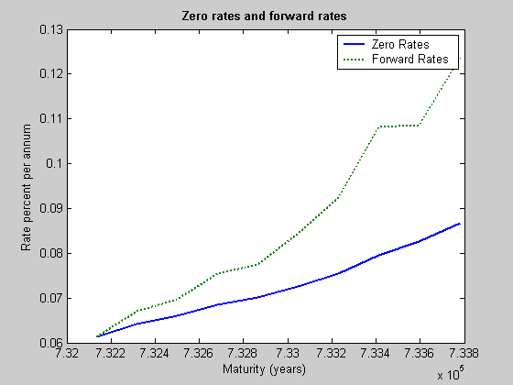

And the forward rates are,

Forward Rates

Today ½ y after 1 y after … 9/2 years after
0.0614 0.0670 0.0696 … 0.1238

The first forward rate 0.0614 is the annualized today’s (7th Jan 2004) spot interest rate for the interval between today and 7th Jul 2004 (1/2 years later). Therefore the first floating rate payments is replicated by 0.0614/2 = 0.0307, the second floating rate payments 0.0670 / 2 = 0.0335 etc. In general the floating side payments are replicated by the corresponding forward rates divided by 2.

The next step is to discount the floating rate payments into their present values and sum up, which is the present value of the floating side. Function zero2disc can convert zero rates into discount factors.

(continued SwapRate.m)
________________________________________________________________

% Convert Zero Rates into Discount Factors

DiscountFactors = zero2disc (ZeroRates, Maturity, Settle)
________________________________________________________________

If we denote B(0, ½) as the present value of a riskless zero-coupon bond with the face value
1 dollar and maturity ½ years. B (0, ½ ) refers to the present value of receiving 1 dollar for sure ½ years later. Therefore B(0, ½ ) is the discount factor for payment made ½ years from now. From the result of zero2disc, the discount factors are,

Discount Factors

B(0, ½ ) B(0, 1) B(0, 3/2) … B(0, 5)
0.9704 0.9388 0.9075 … 0.6543

We can verify the results using following relationship between discount factors and zero rates.

B (0, ½ ) = 1/(1+0.0614/2) = 0.9702
B (0, 1) = 1/(1+0.0642/2)² = 0.9388
…
B (0, 5) = 1/(1+0.0868/2)¹⁰ = 0.6539

So the present value of the floating side is calculated by:

(continued SwapRate.m)
_______________________________________________________________________

% Calculate the Present Value of the Floating Side

PresentValue1 = sum(ForwardRates/2 .* DiscountFactors);
________________________________________________________________

Present Value of the Fixed Side

For the fixed-rate side, all future payments are known in the beginning, in this example each equal to r/2 where r is the annualized fixed rate. Thus we simply discount the payments to present values and sum up.

An alternative way of thinking is to replicate the fixed payments by a portfolio of riskless zero-coupon bonds with face value r/2 and maturities ½ year, 1 year… and 5 years. Thus the present value of fixed payments should equal to the present value of the synthetic portfolio according to no-arbitrage principle.

Present value of fixed side = r/2 × (B(0, ½ )+B(0, 1)+…B(0, 5))
= r/2 × sum of discount factors

Set this equal to the present value of the floating side

r/2 × sum of discount factors = present value (floating side)

r = 2 × present value (floating side) / sum of discount factors.

Translate the algorithm into MATLAB codes.

(continued SwapRate.m)
________________________________________________________________________

% Swap Rate is the rate that equates the two sides

SwapFixedRate = 2 * PresentValue1 /sum(DiscountFactors)
________________________________________________________________________

The SwapFixedRate is 0.0845. To see the fixed rate pricing principle more clearly, we can plot the present value of the floating side and the fixed sides against different alternatives of fixed rates.

(continued SwapRate.m)
________________________________________________________________________
% Plot the two sides against different swap rate alternatives
FixedRates = (0.01:0.001:0.1);

PresentValue1 = ones(size(FixedRates))*PresentValue1;
PresentValue2 = FixedRates/2 * sum(DiscountFactors);

figure
plot(FixedRates,PresentValue1,'-',FixedRates,PresentValue2,':','LineWidth',2.5)
title ('The present value of the floating and fixed rate side','FontWeight','bold')

xlabel ('Fixed Rate Alternatives')
ylabel ('Present Value in Dollar')
legend ('The floating rate side', 'The fixed rate side')
_________________________________________________________________________

Figure 2.5 is the output graph, on which we can see the correct fixed rate 0.0845 makes the two sides’ present values equal.

Figure 2.5 The present value of the floating side and the fixed side

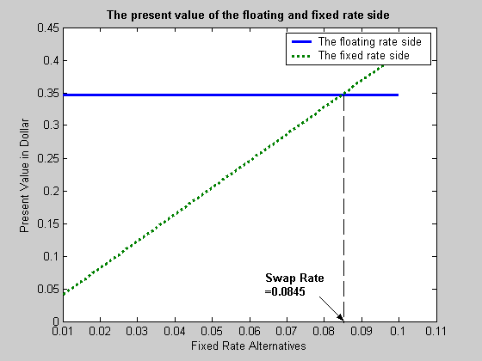

Now we complete the discussion of interest rate swap pricing. In the next part we will concentrate on a detailed MATLAB application of both term structure analysis and interest rate swap pricing.

Part Three A sample application

Our example consists of 6 steps. It illustrates some of the term-structure analysis functions found in the MATLAB Financial Toolbox. And shows how to derive implied zero and forward curves from the market prices of coupon-bearing bonds. The zero and forward curves implied from the market data are then used to price an interest rate swap agreement.

Step one

Specify values for the settlement date, maturity dates, coupon rates, and market prices for 10 U.S. Treasury Bonds. And we could price a five-year swap with net cash flow payments exchanged every six month payment. The payments apply end-of-month rule (rule in effect) and day-count basis (actual/actual). Also assume that all Treasury Bonds pay semiannual coupons and that settlement occurs on a coupon payment date.

Settle = datenum(‘15-Jan-1999’)
BondDate = {‘15-Jul-1999’ 0.06000 99.93
‘15-Jan-2000’ 0.06125 99.72
‘15-Jul-2000’ 0.06375 99.70
‘15-Jan-2001’ 0.06500 99.40
‘15-Jul-2001’ 0.06875 99.73
‘15-Jan-2002’ 0.07000 99.42
‘15-Jul-2002’ 0.07250 99.32
‘15-Jan-2003’ 0.07375 98.45
‘15-Jul-2003’ 0.07500 97.71
‘15-Jan-2004’ 0.08000 98.15};
Maturity = datenum( strvcat (BondData{:,1}));
CouponRate= [BondData{:,2}]’;
Prices = [BondData{:,3}]’;
Period = 2; % semiannual coupons

Settlement date is the date when money first changes hands; i.e., when a buyer actually pays for a security. It need not coincide with the issue date.
BondData is an instance of a MATLAB cell array, indicated by the curly braces({}).
CouponRate is the nominal interest rate that the issuer promises to pay the buyer of a bond.
Period is coupon or payment dates. The length of the first and last periods may differ from the regular period between coupons. And thus the bond owner is not entitled to the full value of the coupon for that period. Instead, the coupon is pro-rated according to how long the bond is held during that period.

Step two

Now we specified the data, use the term structure function zbtprice ( zero curve bootstrapping from coupon band data given price) to bootstrap the zero curve implied from the prices of the coupon-bearing bonds. This implied zero curve represents the series of zero-coupon Treasury rates consistent with the prices of the coupon-bearing bonds such that arbitrage opportunities will not exist.

ZeroRates = zbtprice([Maturity CouponRate], Prices, Settle);

Since we set a semiannual bond basis (the periodic, six-month, interest rate is simply doubled to annualize). The first element of ZeroRate is the annualized rate over the next six months, the second element is the annualized rate over the next 12 months, and so on.

Step three

From the implied zero curve, find the corresponding series of implied forward rates using the term structure function zero2fwd (forward curve given a zero curve).

Forward Rates = zero2fwd (ZeroRates, Maturity, Settle);

The forward curve is also quoted on a semiannual bond basis. The first element of ForwardRate is the annualized rate applied to the interval between settlement and six months after settlement, the second element is the annualized rate applied to the interval from six months to 12 months after settlement, and so on. Also the forward curve consistent with the market prices such that arbitrage activities will be unprofitable. Since the first forward rate is also a zero rate, the first element of ZeroRates and ForwardRates are the same.
ForwardRate is the future interest rate of a bond inferred from the term structure, especially from the yield curve of zero-coupon bonds. Calculated from the growth factor of an investment in a zero held until maturity.

Step four

Now we have derived the zero curve, convert it to a sequence of discount factors with the term structure function zero2disc (discount curve given a zero curve).

DiscountFactors = zero2disc (ZeroRates, Maturity, Settle);

Step five

From the discount factors, compute the present value of the variable cash flows derived from the implied forward rates.

PresentValue = sum((ForwardRates/Period) .* DiscountFactors);

PresentValue is today’s value of an investment that yields some future value when invested to earn compounded interest at a known interest rate; i.e., the future value at a known period in time discounted by the interest rate over that time period.

Step six

Compute the swap’s price (the fixed rate) by equating the present value of the fixed cash flow with the present value of the cash flow derived from the implied forward rates.

SwapFixedRate = Period * PresentValue / sum(DiscountFactors);

The example displays the output on the screen as below:

Zero Rates Forward Rates
0.0614 0.0614
0.0642 0.0670
0.0660 0.0695
0.0684 0.0758
0.0702 0.0774
0.0726 0.0846
0.0754 0.0925
0.0795 0.1077
0.0827 0.1089
0.0868 0.1239

Swap Price (Fixed Rate) = 0.0845

All rates are in decimal format. The swap price, 8.45%, would likely be the mid-point
Between a market-maker’s bid/ask quotes.

Interest rate swaps are priced from the forward curve such that the variable cash flows implied from the series of forward rates and the periodic sequence of fixed-rate cash flows have the same present value. Thus, interest rate swap pricing and term structure analysis are intimately related.
Conclusion

Term structure of interest rates is one of the most studied phenomena in the field of financial economics. In the area of fixed income finance, an analysis of the term structure of interest rates is a critical part of any investment strategy. In an effort to earn superior returns, money managers vary their portfolios along many dimensions, the most important of which is term to maturity. Given this, these managers must be able to assess how volatility in interest rates and shifts in the term structure, particularly non-parallel shifts, will affect the value of their portfolios.

Using the term structure of interest rates analysts can derive zero and forward curves implied from the market data and then use those curves to price an interest rate swap agreement. In such an agreement two parties agree to a periodic exchange of cash flows, one cash flow based on a fixed constant interest rate and the other cash flow is connected to some variable index rate. Interest rate swaps are generally priced from the forward curve such that those two cash flows have the same present value. Thus, it becomes more than clear that interest rate swap pricing and term structure analysis are intimately related. Finally, MATLAB and its Financial Toolbox has proved to be a very useful tool in the two subjects.

List of Sources

Financial Engineering News [On-line]. Available: http://www.fenews.com/1998/Issue4/059805.htm
[2004, January 5]

Wilmott. P. (2001). Introduces Quantitative Finance. Baffins Lane, Chichester, England: John Wiley & Sons Ltd.

Wilmott. P. Howison. S. & Dewynne J.(1999) The Mathematics of Financial Derivatives. New York, NY: Cambridge University Press

The MathWorks (2004). Term structure of interest rates. MatLab Financial Toolbox.
[On-line]. Available:
http://www.mathworks.com/access/helpdesk/help/toolbox/finance/finance.shtml
[2004, January 5]

The MathWorks (2004). Term structure analysis of interest rate and interest rate swap princing
MatLab Financial Toolbox. [On-line]. Available:
http://www.mathworks.com/access/helpdesk/help/toolbox/finance/finance.shtml
[2004, January 5]

The Risk and Term Structure of Interest Rates [On-line]. Available:
http://www.oswego.edu/~edunne/340chapter6_1.html
[2004, January 5]

This correct fixed interest rate is often called “swap rate”.
The interest rate for the shortest possible deposit is commonly called the spot interest rate.
A full discussion of forward rates is omitted here. Readers can refer to book Derivative Securities by Jarrow and Turnbull (page 397-400) for a good description of forward rates.

