mean-variance portfolio optimisation

Abstract

The purpose of this report is to investigate the mean-variance portfolio optimisation theory, which is commonly used within the financial area. The first half of the report brings primarily focus on the pure theoretical explanations of constructing an optimal portfolio. The second part is the most crucial one, giving the reader examples on how to apply the financial theory, constructed by the mathematical tool matlab.

The author’s main idea with this report is to introduce reader to a mean-variance portfolio optimisation theory in a simple and understandable way with examples form real life. The disposition is constructed by a pedagogical text, combined with graphs and tables, which facilitates the reading.

Table of Content

1. Introduction 1
2. The Characteristics of the Opportunity Set Under Risk 2
2.1 Average outcome and dispersion in one-asset situation 2
3. The Portfolio Selection Problem 3
4. Mean-variance portfolio theory 7
4.1 Variance of combinations of assets 7
4.2 Characteristics of portfolios in general 7
5. Realistic applications 10
5.1 Example 1 10
5.2 Matlab functions 12
5.3 Real life example 18
6. Conclusion 24
References 25

1. Introduction

Never before have people, worldwide, been so interested in the financial markets and financial assets (e.g. shares, bonds and options). Since the era of Information Technology (IT) started, more and more people paid their attention to invest money in these very promising assets, usually without any kind of expertise or knowledge of what they were doing. During March of 2000, the era for IT-shares came to a turning point, and it started to collapse. People began to lose huge amount of money. Many people were caught up in a panic and tried effortlessly to seek answers for why this happened. Nevertheless, some investors didn’t lose their last penny, just because the IT-business went down. In fact, many of these investors have even managed to increase their wealth, despite of the collapse of the IT. How, you may wonder? By spreading their risks among different number of shares and among different business sectors.
This is where the mean-variance portfolio optimisation comes into the picture. In this report we will address to the different key areas of a good portfolio optimisation and how you can start to build up your own good portfolio with minimal risks.

In section 2 we go through the characteristics of the opportunity set under risk, where terms like expected return, variance and standard deviation for single asset situation portfolio construction would be mentioned and explained in detail. Section 3 is a development of the theory obtained in section 2 and it brings an explanation of how to apply the theory in allocation in several asset situations. After that, we’re moving on to section 4, which brings up important aspects of utility function and how it is affecting an investor’s choice of portfolio construction, as well as risk aversion. Section 5 shows a real-life based example of how to apply all of the knowledge obtained from the previous chapters, and we show it by using matlab. Then we round off with some important conclusions about the whole project in section 6.

2. The Characteristics of the Opportunity Set Under Risk

The existence of risk means that the investor can no longer associate a payoff with investment in any asset. The payoff must be described by a set of outcomes each with a probability of incidence, called a return distribution.
We start by examine the two most used attributes of such a distribution, expected return and standard deviation.

2.1 Average outcome and dispersion in one-asset situation

It takes at least two measures to capture the relevant information about a return distribution: one to measure the average value and one to measure dispersion or spreading around the average value. In table 2.1 we have returns for various assets.

Table 2.1 Returns of Various Investments
Market condition Return
Asset 1 Asset 2 Asset 3 Asset 4
Good | 20 | 16 | 1 | 14
Average | 12 | 10 | 10 | 10
Poor | 4 | 4 | 19 | 6
Expected return | 12 | 10 | 10 | 10
Variance | 42.66 | 24 | 54 | 5.33
Standard deviation | 6.53 | 4.9 | 7.35 | 2.31

To calculate the expected return for the various assets, we have for the expected value of the N equally likely returns for asset i

$$\overline{r_{i}}=\sum_{j=1}^{n}{{r_{\text{ij}}}/n}$$
If outcomes are not equally likely and if $p_{\text{ij}}$ is the probability of the jth return on the ith asset, then expected return is

$$\overline{r_{i}}=\sum_{j=1}^{n}{p_{\text{ij}}r_{\text{ij}}}$$

It is not enough to have a measure of the average return; it is also useful to have some measure of how much the outcomes differ from the average. One can believe that a good measure of this is to examine the difference between the return of asset and its corresponding expected return, $r_{\text{ij}}$ - $\overline{r_{i}}$. Although this seems sensible there is a problem. Some of the differences will be positive and some will be negative and these will tend to cancel out. The result of such an operation will be misleading and mathematically erroneous.
A better solution to find how much the outcomes differ from the average is to square all differences before determining the average difference. The average squared deviation is called the variance; the square root of the variance is called the standard deviation. Formula for the variance of the return on the ith asset when each return is equally liked is
$$σ_{i}^{2}=\sum_{j=1}^{n}{(r_{\text{ij}}−\overline{r_{i}}}{)^{2}}/n$$
If observations are not equally likely, we multiply by the probability with they occur, then the formula for the variance of the return on the ith asset becomes

$$σ_{i}^{2}=\sum_{j=1}^{n}{p_{\text{ij}}(r_{\text{ij}}−\overline{r_{i}}})^{2}$$

An alternative measure of dispersion is called standard deviation and is the square root of the variance and is designated by $σ_{i}$.

3. The Portfolio Selection Problem

Suppose we are given an initial wealth W₀ to be invested among n different risky stocks. If the amount w₁ is invested in stock i (i = 1,…,n) then, after one period, that investment returns w₁r_{i}, (r_{i} = Q_{i}/P_{i}, where r is the return and a nonnegative random variable, Q selling price and P purchase price). In other words, if we let r_{i} denote the rate of return from the investment i, then

$w_{1}=\frac{w_{1}r_{i}}{1+r_{i}}$ or $r_{i}=\frac{Q_{i}−P_{i}}{P_{i}}=r_{i}−1\text{.}$

If w_{i} is invested in each stock i = 1,…, n, then the end-of-period wealth is

$$W=\sum_{i=1}^{n}{w_{i}r_{i\text{.}}}$$

The vector w₁,…,w_{n} is called a portfolio. The problem of determining the portfolio that maximizes the expected utility on one’s end-of-period wealth can be expressed mathematically as follows:

Choose w₁,…,w_{n} satisfying

$w_{i}≥0,$ $i=1,\text{.}\text{.}\text{.},n,$ $\sum_{i=1}^{n}{w_{i}=w,}$

maximize $E[U(W)],$ where U is the investor’s utility function for the end-of-period wealth.

Now assume that the rate of return ( r ), of a stock is normally distributed then we shall make the assumption that the end-of-period wealth W can be thought of as being a normal random variable. Provided that one invests in many securities that are not too highly correlated, this would appear to be, by the central limit theorem¹, a reasonable approximation.

Central Limit Theorem For large n, S_{n} will approximately be a normal random variable with expected value nμ and variance nσ². As a result, for any x we have $P\left\{\left.\frac{S_{n}−nμ}{σ\sqrt{n}}≤x\right\}≈Φ(x),\right.$ with the approximation becoming exact an n becomes larger and larger.

In this case, the rate of return ( r ), is fully characterized by two parameters, the expected return $\overline{r_{i}}$ and the standard deviation $σ_{i}$.
Now, suppose that we have two stock and that ${\overline{r}}_{1}>{\overline{r}}_{2}$ and $σ_{1}>σ_{2};$ in other words, stock 1 has better potential than stock 2, but it is riskier.
Since our utility function U(W), depends on wealth . It is reasonable to assume that U is an increasing function, since we prefer more wealth than less. Another reasonable assumption is that U is concave, $U(λx+(1−λ)y)≥λU(x)+(1−λ)U(y)$ $0≤λ≤1$ (1.1)

That a concave utility function implies some degree of risk aversion may be seen from the figure 4.1. As wealth increases you are less willing to take risks.

Figure 4.1
U(W)

W
w₁ w* w₂

Consider two wealth levels, w₁ and w₂, with $w_{1}<w_{2\text{.}}$ You are offered two choices. You may get a “lottery” whereby you may win one of the two wealth levels, each with probability 0.5; alternatively, you may simply get the wealth $w∗0\text{.}5w_{1}+0\text{.}5w_{2}\text{.}$
The expected utility of the lottery is then $0\text{.}5U(w_{1})+0\text{.}5U(w_{2}),$ whereas the expected utility of the alternative choice is $U(0\text{.}5w_{1}+0\text{.}5w_{2})\text{.}$
From condition (1.1), with $λ=0\text{.}5,$ we see that the expected utility of the safe offer will be larger than the expected utility of the lottery for any concave utility function, even if the expected values of the wins are equal.

Proof: if X is a random variable whose possible values are x₁, x₂,…,x_{n}, then the expected value of X, denoted by E[X], is defined by $E[x]=\sum_{j=1}^{n}{x_{j}P\left\{\left.X=x_{j}\right\}\text{.}\right.}$
In words, E[X] is a weighted average of the possible values of X, where the weight given to a value is equal to the probability that X assumes that value.
If we assume that w₁=2, w₂=6 and w*=4, then
$\begin{aligned}E[\text{lottery}]=2(0\text{.}5)+6(0\text{.}5)=4 \\ E[\text{safe}]=4(1)=4\end{aligned}$

We see that the expected values of the wins are equal but it is wiser to choose the safe alternative since the expectations are the same.

Typical utility functions are the logarithmic utility, $U(W)=\text{log}(W),$ (1.2)
And the quadratic utility, $U(W)=W−{\text{bW}}^{2}\text{.}$ (1.3)

Note that the quadratic function only makes sense in the domain over which it is increasing [i.e., $W≤1/(2b)],$ $b≥0$.
A person with a logarithmic utility function is risk aversive. As his wealth increases, his willingness to take risks decreases which can be seen in figure 4.1.
A person with a quadratic utility function takes risks until his wealth reaches, $W≤1/(2b)$, then he’s not willing to take any more risk and he is satisfied as implied in figure 4.2.

Figure 4.2
U(W )

W
1/(2b)

The portfolio optimisation can be stated as
max $E\left[U\left(\sum_{i=1}^{n}{θ_{i}Q_{i}}\right)\right]$

s.t. $\sum_{i=1}^{n}{θ_{i}P_{i}=W_{0,}}$
where the decision variables $θ_{i}$ are the number of shares of stock i purchased. Some assumptions are required to ensure that this problem has a solution and that we invest all of our initial wealth W₀.

Apart from the qualitative implication of the concavity, we may also measure the degree of risk aversion associated with a utility function. One such measure is the Arrow-Pratt absolute risk aversion coefficient, defined as

$$A(W)=−\frac{U\text{''}(W)}{U'(W)\text{.}}$$

The utility function is assumed increasing, hence we have $U'(W)≥0;$ furthermore, concavity implies that $U\text{''}(W)≤0\text{.}$ These facts imply that the coefficient A(W ) is nonnegative. Note that according to this definition, risk aversion may change, depending on the level of wealth. Indeed, some investors might tend to be less risk averse when wealth increases; whether or not this is really the case depends on the utility function. If we assume the logarithmic utility function (1.2), we have

$$A(W)=−\frac{U\text{''}(W)}{U'(W)}=−\frac{{−1}/{W^{2}}}{1/W}=1/W,$$

and risk aversion decreases with increasing wealth. For the quadratic utility (1.3) we have

$$A(W)=\frac{2b}{1−2\text{bW}},$$

showing that in this case risk aversion increases with increasing wealth. For simplicity I will show the change in risk aversion against wealth for logarithmic and quadratic utility function graphically. See figures below.

A(W ) A(W )

$A(W)=\frac{2b}{1−2\text{bW}},$
A(W ) = 1/W

1/(2b)

W W

Specifying a utility function may be a difficult task, since assessing the trade-off between risk and return is far from trivial. A relatively simple approach is based on the idea of restricting the choice to “reasonable” portfolios. If you fix the expected return you want to get from the investment, you would like to find the portfolio achieving that expected return with minimal risk. By the same token, if you fix the level of risk you are willing to take, you would like to select a portfolio maximizing the expected return. This approach leads to mean-variance portfolio theory.

4. Mean-variance portfolio theory

Our analysis in the previous section has been limited towards single asset situations. In real-life situations investors considers opportunities of allocating their money between several assets. This opportunity increases the number of options open to the investor and therefore our calculations will be a bit complexier leading us to portfolio theory.

4.1 Variance of combinations of assets

The risk of a combination of assets is very different from a simple average of the risk of individual assets. In table 3.1, there is a combination of asset 2 and asset 3 that is less risky than asset 2.

Table 3.1 Returns of asset 2 and asset 3
Combination of
Market condition Return asset 2 (60%)
Asset 2 Asset 3 and asset 3 (40%)
Good | $1.16 | $1.01 | $1.10
Average | 1.10 | 1.10 | 1.10
Poor | 1.04 | 1.19 | 1.10

Assume an investor has $1 to invest. If he selects asset 2 when the market condition is good, he will have $1.16. If the market condition is average he will obtain $1.10 and if the market is poor he will receive $1.04. In table 3.1 the reader can see the corresponding figures for asset 3. Now consider another allocation. If the investor allocates 60% of his dollar in asset 2 and the remaining 40% of his dollar to asset 3 he will obtain in an good market condition $1.10. In an average market condition he will receive $1.10 and in a poor market again $1.10.
From this example one can see that the risk on a portfolio of assets can differ from the risk of individual assets. The deviations on the combination of the assets was zero because the assets had their highest and lowest returns under opposite market conditions. This result is general and not only for this example.
When assets have their good and bad outcomes at different times, then investing in these assets can radically reduce the dispersion obtained by investing in one of the assets itself.

4.2 Characteristics of portfolios in general

The return on a portfolio of assets is simply a weighted average of the return on the individual assets. The weight applied to each return is the fraction of the portfolio invested in that asset. If $r_{\text{pj}}$ is the jth return on the portfolio and $w_{i}$ is the fraction of the investor’s fund invested in the ith asset, then
$$r_{\text{pj}}=\sum_{j=1}^{n}{w_{i}r_{\text{ij}}}$$

The expected return is also a weighted average of the expected returns on the individual assets. Taking the expected value of the expression just given for the return on a portfolio yields

$${\overline{r}}_{p}=E\left(\sum_{j=1}^{n}{w_{i}r_{\text{ij}}}\right)$$

Before we proceed we must know two certain properties of the expected value that are supportive in this situation.

- The expected value of the sum of two returns is equal to the sum of the expected value of each return, that is,

$E(r_{1j}+r_{2j})=$$\overline{r_{1}}+\overline{r_{2}}$ (1)

- The expected value of a constant C times a return is the constant times the expected return, that is,

$E\left[C\left(r_{1j}\right)\right]=C\overline{r_{1}}$ (2)

By support of these two properties we have

$${\overline{r}}_{p}=\sum_{i=1}^{n}{E(w_{i}r_{\text{ij}}})$$

Finally, the expected value of a constant times a return is a constant times the expected return, or

$${\overline{r}}_{p}=\sum_{i=1}^{n}{w_{i}{\overline{r}}_{\text{ij}}}$$

To find the variance on a portfolio of assets is slightly more difficult to determine than the expected return. We will first show it with a two-asset situation. The variance of a portfolio P, elected by $σ_{p}^{2}$, is simply the expected return on the portfolio, or $σ_{p}^{2}$= $E(r_{p}−{\overline{r}}_{p})^{2}$. Substituting in this expression the formulas for return on the portfolio and mean return yields in the two-asset case

$σ_{p}^{2}$=$E(r_{p}−{\overline{r}}_{p})^{2}$= $E{\left[w_{1}r_{1j}+w_{2}r_{2j}−\left(w_{1}{\overline{r}}_{\text{11}}+w_{2}{\overline{r}}_{\text{22}}\right)\right]}^{2}=E{\left[w_{1}\left(r_{1j}−{\overline{r}}_{1}\right)+w_{2}\left(r_{2j}−{\overline{r}}_{2}\right)\right]}^{2}$

where $r\overline{{}_{i}}$stands for the expected value of a asset i with respect to all possible outcomes.
We can open up the last expression more
$σ_{p}^{2}$= $E\left[w_{1}^{2}{\left(r_{1j}−{\overline{r}}_{1}\right)}^{2}+2w_{1}w_{2}\left(r_{1j}−{\overline{r}}_{1}\right)\left(r_{2j}−{\overline{r}}_{2}\right)+w_{2}^{2}{\left(r_{2j}−{\overline{r}}_{2}\right)}^{2}\right]$

Applying rule (1) and rule (2), we have

$σ_{p}^{2}$= $w_{1}^{2}E\left[{\left(w_{1j}−{\overline{r}}_{1}\right)}^{2}\right]+2w_{1}w_{2}E\left[\left(r_{1j}−{\overline{r}}_{1}\right)\left(r_{2j}−{\overline{r}}_{2}\right)\right]+w_{2}^{2}E\left[{\left(w_{2j}−{\overline{r}}_{2}\right)}^{2}\right]$
= $w_{1}^{2}σ_{1}^{2}+2w_{1}w_{2}E\left[\left(r_{1j}−{\overline{r}}_{1}\right)\left(r_{2j}−{\overline{r}}_{2}\right)\right]+w_{2}^{2}σ_{2}^{2}$
The segment $E\left[\left(r_{1j}−{\overline{r}}_{1}\right)\left(r_{2j}−{\overline{r}}_{2}\right)\right]$ is called the covariance and will be denoted as $σ_{\text{12}}$. Our formula for the variance for a two-asset situation is now

$σ_{p}^{2}$= $w_{1}^{2}σ_{1}^{2}\text{++}w_{2}^{2}σ_{2}^{2}+2w_{1}w_{2}σ_{\text{12}}$

The covariance is a measure of how returns on assets move together. Insofar as they have positive and negative deviations at similar times, the covariance is a large positive number. If they have the positive and negative deviations at dissimilar times, the covariance is negative. If the positive and negative deviations are unrelated, it tends to be zero.

The formula for variance of a portfolio can be generalized to more than two assets. Consider a three-asset portfolio case. Substituting the expression for return on a portfolio and expected return of a portfolio in the general formula for variance yields

$σ_{p}^{2}$=$E(r_{p}−{\overline{r}}_{p})^{2}$= $E{\left[w_{1}r_{1j}+w_{2}r_{2j}+w_{3}r_{3j}−\left(w_{1}{\overline{r}}_{\text{11}}+w_{2}{\overline{r}}_{\text{22}}+w_{3}{\overline{r}}_{3}\right)\right]}^{2}$

The reader can verify that the result, after rearranging, squaring and applying rule (1) and (2) yields

$$σ_{p}^{2}=w_{1}^{2}σ_{1}^{2}+w_{2}^{2}σ_{2}^{2}+w_{3}^{2}σ_{3}^{2}+2w_{1}w_{2}σ_{\text{12}}+2w_{1}w_{3}σ_{\text{13}}+2w_{2}w_{3}σalignl{\begin{aligned}\text{23}\end{aligned}}_{}$$
This formula applies for any number of assets. To see how we will examine the expression for the three assets case above and find a corresponding general expression for the variance of a portfolio. We see that the variance of each asset is multiplied by the square of the proportion invested in it. So the first part of the general expression of the variance of a portfolio is the sum of the variances of the individual assets times the square of the proportion invested in each, or

$$\sum_{i=1}^{n}{w_{i}^{2}}σ_{i}^{2}$$

Second segment in the expression for the variance of a portfolio is covariance segment. Each covariance term is multiplied by two times the product of the proportions invested in each asset. Putting together the variance and covariance parts of the general expression

$$k≠j\underset{n}{}w_{k}σ_{\text{jk}}$$
The reader can prove that this general expression hold for multi-asset situations.

5. Realistic applications

5.1 Example 1

To describe the Matlab functions better, an example is formed and history stock price data are retrieved from Stockholm Stock Exchange (www.stockholmborsen.se).
In table 5.1, the example data are listed.

Table 5.1 Example 1
Date | Monthly Revenue | NOKI | HM B | ERIC B | SAAB B
2001-01-15 | $$r_{1}$$ | (SEK 57.50) | SEK 11.00 | (SEK 3.00) | SEK 0.00
2001-02-15 | $$r_{2}$$ | (SEK 103.00) | SEK 41.50 | (SEK 18.00) | SEK 7.00
2001-03-15 | $$r_{3}$$ | (SEK 31.00) | (SEK 21.50) | (SEK 34.50) | (SEK 1.00)
2001-04-17 | $$r_{4}$$ | SEK 9.00 | (SEK 25.50) | (SEK 4.10) | SEK 0.50
2001-05-15 | $$r_{5}$$ | SEK 57.00 | SEK 24.00 | SEK 5.10 | SEK 7.50
2001-06-15 | $$r_{6}$$ | (SEK 80.00) | (SEK 21.50) | (SEK 7.50) | SEK 10.00
2001-07-16 | $$r_{7}$$ | (SEK 56.00) | SEK 37.00 | (SEK 3.00) | (SEK 1.50)
2001-08-15 | $$r_{8}$$ | SEK 7.50 | (SEK 2.50) | SEK 2.00 | SEK 0.50
2001-09-17 | $$r_{9}$$ | (SEK 33.00) | (SEK 17.50) | (SEK 15.70) | (SEK 6.00)
2001-10-15 | $$r_{\text{10}}$$ | SEK 35.50 | SEK 21.00 | SEK 3.90 | (SEK 2.00)
2001-11-15 | $$r_{\text{11}}$$ | SEK 66.00 | SEK 3.00 | SEK 14.30 | (SEK 3.50)
2001-12-17 | $$r_{\text{12}}$$ | SEK 6.00 | SEK 13.00 | SEK 2.00 | SEK 12.00
Expected Return $\overline{r}$ |  | (SEK 14.96) | SEK 5.17 | (SEK 4.88) | SEK 1.96
Variance $σ^{2}$ |  | 2,654.56 | 497.85 | 151.69 | 29.94
Standard deviation $σ$ |  | 51.52 | 22.31 | 12.32 | 5.47
Covariance:
NOKI |  |  | (SEK 78.86) | SEK 405.84 | (SEK 54.23)
HM B |  | (78.86) |  | SEK 80.15 | SEK 24.55
ERIC B |  | 405.84 | 80.15 |  | SEK 4.18
SAAB B |  | (54.23) | 24.55 | 4.18
Correlation coefficient:
NOKI |  |  | (0.07) | SEK 0.64 | (SEK 0.19)
HM B |  | (0.07) |  | SEK 0.29 | SEK 0.20
ERIC B |  | 0.64 | 0.29 |  | SEK 0.06
SAAB B |  | (0.19) | 0.20 | 0.06

Legend: *
NOKI, Nokia Abp, SDB
HM B, Hennes & Mauritz AB, H & M ser. B
ERIC B, Ericsson, Telefonab. L M ser. B
SAAB B, SAAB AB ser. B
*All the stock codes are from Stockholm Stock Exchange.

The closing prices of four companies, Nokia, H&M, Ericsson and SAAB are chosen to be our sample data. We choose them because they come from different sectors in the same stock market and we try to avoid those synchronous appreciation or synchronous depreciation factors as much as possible.In the example we selected the day closing price from Jan. 15th, 2001 to Dec. 17th, 2001 to calculate the monthly revenues by holding those stocks. We decided to form a 12 month long example because it is long enough to include everything that may happen in a single year such as holidays and disasters. The data listed in the form are calculated results of monthly revenues rather than the real day closing prices because we need the revenue data to calculate expected returns and variances.

The following formulas are used for calculations:
Expected Return: $\bar{R}=\sum_{j=1}^{\text{12}}{r_{j}}÷\text{12}$
Variance: $σ^{2}=\sum_{j=1}^{\text{12}}{(r_{j}−\overline{r})^{2}}÷\text{12}$
Covariance: $σ_{\text{12}}=\sum_{j=1}^{\text{12}}{(r_{1j}−{\overline{r}}_{1})(r_{2j}−{\overline{r}}_{2})}÷\text{12}$
Correlation coefficient of 1 and 2 = $σ_{\text{12}}÷(σ_{1}×σ_{2})$

Sample calculation: Calculation of covariance

Event | Return
Event | Share 1 | Share 2
1 | 15 | 16 |  | (15-9) | (16-10) | 36
2 | 9 | 10 |  | (9-9) | (10-10) | 0
3 | 3 | 4 |  | (3-9) | (4-10) | 36
 |  |  |  |  |  | 72/3
Expected Return | 9 | 10
Variance | 24 | 24 |  | Covariance: |  | 24
Standard deviation | 4.9 | 4.9

5.2 Matlab functions

Matlab provides functions in Financial toolbox to solve the investment portfolio problems. They can help us to draw utility functions of portfolios graphically or to show the result numerically. They can also calculate the weights of each stock in the same portfolio and the related risks, returns and mathematically choose the best combination for portfolios, given some risky stocks. First, we briefly introduce the Matlab functions for portfolio calculations.

- ewstats function
It is used to calculate the expected return and covariance from return time series.

We can try an H&M and Saab example in Matlab:
>> r = [11 0 % r denotes to expected return by time sequence
41.5 7
-21.5 -1
-25.5 0.5
24 7.5
-21.5 10
37 -1.5
-2.5 0.5
-17.5 -6
21 -2
3 -3.5
13 12];
>> [ExpReturn, ExpCovariance] = ewstats(r)

The result shown below is the same as what we manually calculated in example 1.

ExpReturn =
5.1667 1.9583

ExpCovariance =
497.8472 24.5486
24.5486 29.9358

- frontcon function

From Example 1, we have the expected return of Nokia is SEK -14.96 and Saab is SEK 1.96, the variance of Nokia is 2654.56 and Saab is 29.94 and the covariance for Nokia and Saab is -54.23.

By this figures we have in Matlab:
>> r = [-14.96 1.96]; % r denotes to expected return
>> s = [2654.56 -54.23;-54.23 29.94]; % s denotes to variance
>>frontcon(r,s,4)

Figure 5.2 shows us the utility function of including Nokia and Saab in the same investment portfolio.

Table 5.2
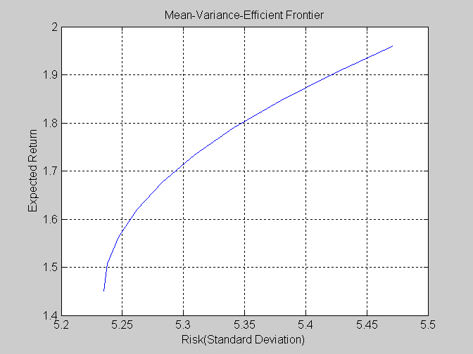

If we try the frontcon as following with parameters:
>>[PortRisk, PortReturn, PortWts] = frontcon(r,s,4)
%PortRisk denotes to the Risk of Portfolio
%PortReturn denotes to the Expected Return of Portfolio
%PortWts denotes to the Weight of stocks in the same Portfolio

We have the result:
PortRisk =
5.2348
5.2617
5.3414
5.4717

PortReturn =
1.4501
1.6201
1.7900
1.9600

PortWts =
0.0301 0.9699
0.0201 0.9799
0.0100 0.9900
0 1.0000
This is the numerical result of executing the function frontcon (for detail usage information, please refer to the Matlab help online at www.mathworks.com). From those figures we know that the function help us calculate the weights of stocks in the portfolio and the expected return and risks. Here we have a simplified version of the function frontcon with Matlab script as shown in script 5.2 and we will try to briefly explain the codes to make us understand the mechanism of this function.

When we describe the mechanism of the function, we try this example by putting H&M and Saab in the same portfolio:

>> r = [5.17 1.96]; % r denotes to expected return
>> s = [497.85 24.55; 24.55 29.94]; % s denotes to variance
>>[PortRisk, PortReturn, PortWts] = naiveMV(r,s,4)
Script 5.2
Line | Code
 | % naiveMV.m
1 | function [PRisk, PRoR, PWts] = naiveMV(ERet, ECov, NPts)
2 | ERet = ERet(:); % makes sure it is a column vector
3 | NASSETS = length(ERet); % get number of stocks
4 | V0 = zeros(1, NASSETS);
5 | V1 = ones(1, NASSETS);
 | % Find the maximum expected return
6 | MaxReturnWeights = linprog(-ERet, [], [], V1, 1, V0);
7 | MaxReturn = MaxReturnWeights'*ERet;
 | % Find the minimum variance return
8 | MinVarWeights = quadprog(ECov, V0, [], [], V1, 1, V0);
9 | MinVarReturn = MinVarWeights'*ERet;
10 | MinVarStd = sqrt(MinVarWeights' * ECov * MinVarWeights);
11 | if MaxReturn > MinVarReturn
12 | RTarget = linspace(MinVarReturn, MaxReturn, NPts);
13 | NumFrontPoints = NPts;
14 | else
15 | RTarget = MaxReturn;
16 | NumFrontPoints = 1;
17 | end
18 | PRoR = zeros(NumFrontPoints, 1);
19 | PRisk = zeros(NumFrontPoints, 1);
20 | PWts = zeros(NumFrontPoints, NASSETS);
21 | PRoR(1) = MinVarReturn;
22 | PRisk(1) = MinVarStd;
23 | PWts(1,:) = MinVarWeights(:)';
24 | VConstr = ERet';
25 | A = [V1 ; VConstr ];
26 | B = [1 ; 0];
27 | for point = 2:NumFrontPoints
28 | B(2) = RTarget(point);
29 | Weights = quadprog(ECov, V0, [], [], A, B, V0);
30 | PRoR(point) = dot(Weights, ERet);
31 | PRisk(point) = sqrt(Weights'*ECov*Weights);
32 | PWts(point, :) = Weights(:)';
33 | end

  - In line 1 to 5, it is the part to initial variances for function to use.
- In line 6 and line 7, it uses the Matlab function linprog to solve the weight each stock should take to maximize return for given portfolio. It calculates that if risk is ignored, how much the maximum return should be.

By using the example above, we should have:
MaxReturnWeights =
1.0000
0.0000
MaxReturn =
5.1700
It means that ignore the risk problem, we should buy H&M only to maximize our portfolio return and the value of the maximum return should be SEK 5.17.

- In line 8 to 10, it uses the Matlab function quadprog to solve the weight each stock should take to minimize risk for given portfolio. It calculates that if return is ignored, how much the risk should be.

By using the example above, we should have:
MinVarWeights =
0.0113
0.9887
MinVarReturn =
1.9961

It means that if to minimize is our only concern, we should buy 1.13% H&M and 98.87% Saab and if we follow such an investment portfolio, the expected return should be SEK 1.9961.

- In line 11 to 17, we have an if condition. Here we have to reemphasize the theory risk aversion again, it means that if the expected return are similar for some given portfolios, wise investors will take the one with lowest risk.

The codes here decide that if by taking the lowest risk we can make the maximized profit, the lowest risk point should be the unique investment combination we should take. But in real life, the actual should be that the higher the expected return, the higher the risk we have to take, in such a situation, the codes equally divide the interval between the lowest risk point and the highest expected return point into several subintervals and the codes try each subinterval borders on the utility function curve to calculate the portfolio weight and related expected return and risks.

- From line 18 to the end of the codes is the part to display the result.

- portalloc function

The function portalloc calculates the optimal risky portfolio on the efficient frontier
based upon some risk-free rate, some borrowing rate and the investor’s degree of risk aversion. The first step requiring the calculation of the optimal risky portfolio is the step of computing the efficient frontier, by using the function frontcon. Consider the following two financial assets from Exhibit 1: HM B and SAAB B. The expected return for HM B is 5.17 and variance 497.85. Expected return for SAAB B is 1.96 and variance 29.94. Covariance between those two assets is 24.55. By using these figures as input arguments in the frontcon function, we will have following:

ExpReturn = [5.17 1.96];
ExpCovariance = [497.85 24.55; 24.55 29.94];

This time, we can choose to have 5 different portfolio compositions:

NumPorts = 5;

Finally, we put all of these three input arguments to calculate the following output arguments: portfolio risk, portfolio return and portfolio weights:

[PortRisk, PortReturn, PortWts] = frontcon(ExpReturn, ExpCovariance, NumPorts);

Use the output arguments as the first three input arguments to the function portalloc.
Now, we have to find the optimal risky portfolio and the optimal allocation of funds between the risky portfolio and the risk-free asset by using some example figures for
risk-free rate, borrowing rate and the investor’s degree of risk aversion:

RiskFreeRate = 0.1;
BorrowRate = 0.15;
RiskAversion = 4;

By calling portalloc with no specification for output arguments gives you a graph with critical points:

portalloc(PortRisk, PortReturn, PortWts, RiskFreeRate, BorrowRate, RiskAversion);
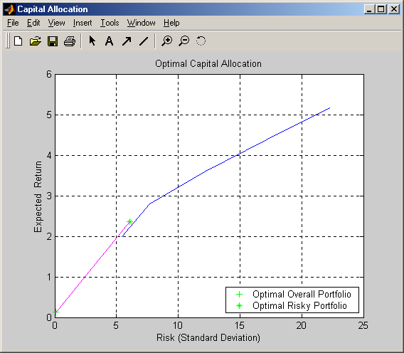
and the corresponding graph:

Here, you can see that the optimal risky portfolio combination, in this case, is given at the very upper-end of the shortest line, with a thick black dot on it.

If you call on portalloc again, but this time with output parameters, it will return a set of parameters of variance (RiskyRisk), the expected return (RiskyReturn), and the weights (RiskyWts) distributed to the optimal risky portfolio. It will also return a fraction (RiskyFraction) of the complete portfolio distributed to the risky portfolio, the overall variance (OverallRisk) and the overall expected return (OverallReturn) for the optimal overall portfolio.

[RiskyRisk, RiskyReturn, RiskyWts, RiskyFraction, OverallRisk, …
OverallReturn] = portalloc (PortRisk, PortReturn, PortWts, RiskFreeRate, …
BorrowRate, RiskAversion);

RiskyRisk = 6.0653
RiskyReturn = 2.3518
RiskyWts = 0.1221 0.8779
RiskyFraction = 0.0153
OverallRisk = 0.0928
OverallReturn = 0.1345

In this case, we can see more clearly what kind of figures we are interested in, if we are going to invest in HM B and SAAB B.

- portopt function

This function is similar to frontcon and it computes the number of portfolios along the so
called efficient frontier for a certain number groups of assets. This function will be used later in the Real-life problem section.

- portcons function

The portcons function will create for you some portfolio, consisting of a matrix of constraints for some portfolio of asset investments using linear inequalities. The inequalities should be of the type A*Wts' <= b, implying that Wts is a row vector of weights.

5.3 Real life example

After reviewing the Matlab functions, based on the example we formed in Example 1 we write the code in script 5.3 to test the usage of those functions together. The code shown in script 5.3 has a dual output function; it means that it can show the result of portfolio calculation graphically and numerically at the same time. From line 1 to line 8 we define the possible stocks for a portfolio, then input the monthly return of those stocks. From line 12 to 19, we differentiate the type of portfolio. If the portfolio is only a combination of single stocks and the weight of each stock can be ranged from 0% to 100%, we define it as ‘single’. Actually, we know that in stock market, we separate the market into sectors such as IT sector, manufacturing sector, financing sector and so on. So when we invest, we always consider the formation of portfolios by sectors. So we always pick up several different stocks from the same sectors to be a group and as a result of such a portfolio formation, we have to consider not only the weight of single stocks but the weight of each group in the portfolio, so here we have the option for you too form such a group investment plan. In the rest part of the M-file, we just use all the Matlab functions we introduced above and all the knowledge we got from the course ‘Numerical Methods with MATLAB’ to show the result graphically and numerically as convenience as possible.

Script 5.3
Line | Code
 | % Define the expected return by periods for each stocks
1 | quote1prices = [-57.5 -103 -31 9 57 -80 -56 7.5 -33 35.5 66 6];
2 | quote2prices = [11 41.5 -21.5 -25.5 24 -21.5 37 -2.5 -17.5 21 3 13];
3 | quote3prices = [-3 -18 -34.5 -4.1 5.1 -7.5 -3 2 -15.7 3.9 14.3 2];
4 | quote4prices = [0 7 -1 0.5 7.5 10 -1.5 0.5 -6 -2 -3.5 12];
5 | quotesprices = [quote1prices
6 | quote2prices
7 | quote3prices
8 | quote4prices];
9 | riskfreerate = 0.05; %Risk free deposit rate
10 | borrowrate = 0.07; %Borrow rate
11 | riskaversion = 3; %Risk aversion value, the default value is 3 by MATLAB
12 | porttype = 'group'; %Portfolio type  %porttype = 'group'; Group stocks in the portfolio  %porttype = 'single'; Combine stocks in the portfolio freely
13 | numofport = 10; %If your portfolio type is 'single' assign a value here
14 | numofstocks = size(quotesprices,1);
15 | stocksmin = [0 0 0 0]; %The minimum weights of each stock in the portfolio
16 | stocksmax = [1 1 1 1]; %The maximum weights of each stock in the portfolio
17 | combinations = [1 0 1 0; 0 1 0 1]; %How to group?
18 | combinmin = [0.1 0.5]; %The minimum weights of each group in the portfolio
19 | combinmax = [0.4 0.9]; %The minimum weights of each group in the portfolio
20 | clc
21 | %Calculate the expected return and covariance
22 | [ExpReturn, Covariance] = ewstats(quotesprices');
23 | … %Display Result of expected regurn and covariance, this part ignored
24 | switch porttype
25 | case 'single'
26 | [PortRisks, PortReturns, PortWts] = frontcon(ExpReturn,Covariance,numofport);
27 | frontcon(ExpReturn,Covariance,numofport);
28 | case ‘group’
29 | ConstrMatrix = portcons('AssetLims',stocksmin,stocksmax,numofstocks, …  'GroupLims',combinations,combinmin,combinmax);
30 | [PortRisks, PortReturns, PortWts] =  portopt(ExpReturn,Covariance,[],[],ConstrMatrix)
31 | portopt(ExpReturn,Covariance,[],[],ConstrMatrix); %drawing graph
32 | end; %Calculate portfolio risk, return and weight by portfolio type
33 | … %Display Result of portfolio combinations, this part igonred
 | %Find the optimized portofolio combination
34 | [RiskyRisk, RiskyReturn, RiskyWts, RiskyFraction, PortRisk, PortReturn] = portalloc(PortRisks, PortReturns, PortWts, riskfreerate, borrowrate, riskaversion);
35 | … %Display Result of portfolio optimization, this part igonred
36 | portalloc(PortRisks, PortReturns, PortWts, riskfreerate, borrowrate, riskaversion);

- First try:

We first set the value of constant ‘porttype’ at line 12 to ‘single’ and keep other constants and variance as it used to be. Then we got the following graphic and numerical result.

Figure 5.3
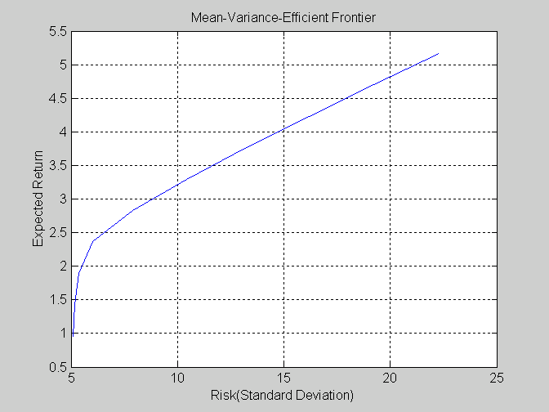
Figure 5.4
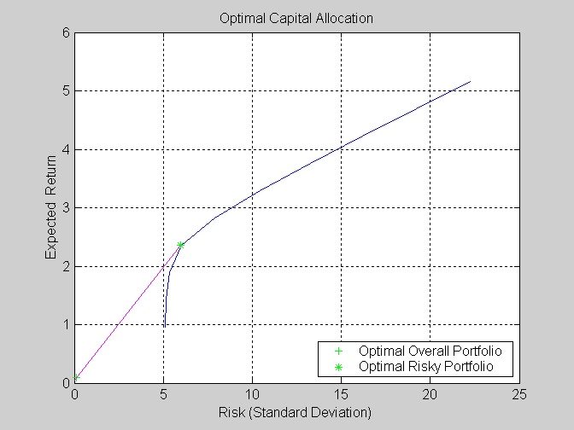

1. Expected Return(s) of the portfolio formed:

Stock1 Stock2 Stock3 Stock4
--------------------------------------------------------------------------------
-1.4958e+001 +5.1667e+000 -4.8750e+000 +1.9583e+000
--------------------------------------------------------------------------------

2. Covariance(s) of the portfolio formed:

Stock1 Stock2 Stock3 Stock4
--------------------------------------------------------------------------------------------
Stock1 +2.6546e+003 -7.8861e+001 +4.0584e+002 -5.4227e+001
Stock2 -7.8861e+001 +4.9785e+002 +8.0146e+001 +2.4549e+001
Stock3 +4.0584e+002 +8.0146e+001 +1.5169e+002 +4.1760e+000
Stock4 -5.4227e+001 +2.4549e+001 +4.1760e+000 +2.9936e+001
--------------------------------------------------------------------------------------------

3.1 The Risks(s), Return(s) of possible portfolio(s):

Risk Return
---------------------------
5.0997 +0.9612
5.1691 +1.4285
5.3562 +1.8957
6.0160 +2.3630
7.8972 +2.8303
10.4329 +3.2976
13.2527 +3.7648
16.2090 +4.2321
19.2389 +4.6994
22.3125 +5.1667
---------------------------

3.2 The weight(s) of stocks in each portfolio:

Stock1 Stock2 Stock3 Stock4
--------------------------------------------------------
Port1 +0.0083 +0.0000 +0.1253 +0.8664
Port2 +0.0127 +0.0123 +0.0520 +0.9230
Port3 +0.0102 +0.0340 +0.0000 +0.9558
Port4 +0.0000 +0.1261 +0.0000 +0.8739
Port5 +0.0000 +0.2718 +0.0000 +0.7282
Port6 +0.0000 +0.4174 +0.0000 +0.5826
Port7 +0.0000 +0.5631 +0.0000 +0.4369
Port8 +0.0000 +0.7087 +0.0000 +0.2913
Port9 +0.0000 +0.8544 +0.0000 +0.1456
Port10 -0.0000 +1.0000 +0.0000 +0.0000
--------------------------------------------------------

4.1 The Risky and Overall of Optimised Portfolio:
----------------------------------------------------------
Risk of the optimal risky portfolio: 5.989
Expected return of the optimal risky portfolio: 2.353
Risk of the optimal overall portfolio: 0.128
Expected return of the optimal overall portfolio: 0.099
----------------------------------------------------------

4.2 The weight of Optimised Risky Portfolio:

Stock1 Stock2 Stock3 Stock4
----------------------------------------
0.0002 0.1241 0.0000 0.8757
----------------------------------------

We can test the result of expected return and covariance with those figures listed in table 5.1. The numerical result 3.1 and 3.2 is shown by Matlab in Figure 5.3 and that is the utility function we discussed in the previous part of this paper. In this example we require 10 possible portfolio combinations. Matlab helps us get 10 possible weights of the stocks and according to the weights; it calculates the related risk and return of each portfolio combination. The last part of the codes is to calculate the optimised portfolio combination. And as a result of Matlab calculation, we choose the combination as shown in 4.1 and 4.2 of the numerical result as the best choice.

- Second try:

In our second try, we set the value of constant ‘porttype’ at line 12 in script 5.3 to ‘group’. We form Nokia and Ericsson a group and they both together can weight from 10% to 40% of the portfolio. We form H&M and SAAB the other group and they can take 50% to 90% of the portfolio. Then we get the following results.
Figure 5.5
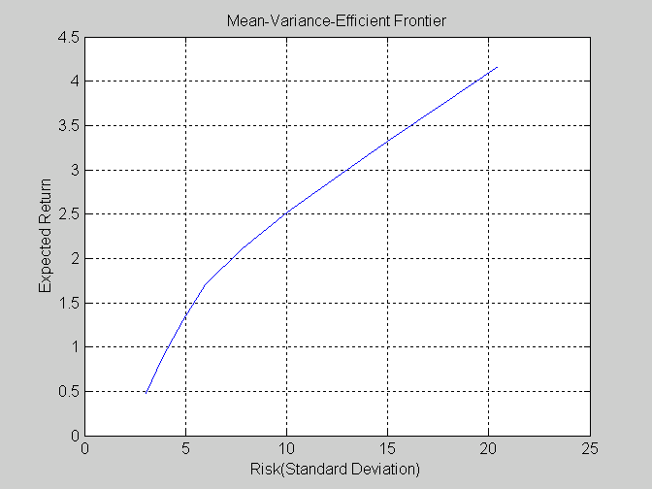

Figure 5.6
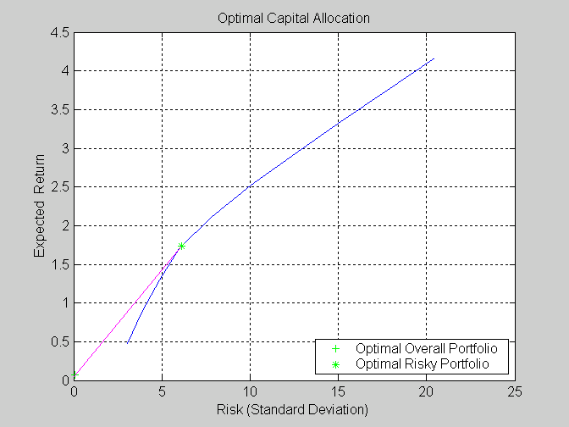

1. Expected Return(s) of the portfolio formed:

Stock1 Stock2 Stock3 Stock4
--------------------------------------------------------------------------------
-1.4958e+001 +5.1667e+000 -4.8750e+000 +1.9583e+000
-------------------------------------------------------------------------------

2. Covariance(s) of the portfolio formed:

Stock1 Stock2 Stock3 Stock4
--------------------------------------------------------------------------------------------
Stock1 +2.6546e+003 -7.8861e+001 +4.0584e+002 -5.4227e+001
Stock2 -7.8861e+001 +4.9785e+002 +8.0146e+001 +2.4549e+001
Stock3 +4.0584e+002 +8.0146e+001 +1.5169e+002 +4.1760e+000
Stock4 -5.4227e+001 +2.4549e+001 +4.1760e+000 +2.9936e+001
--------------------------------------------------------------------------------------------

3.1 The Risks(s), Return(s) of possilbe portfolio(s):

Risk Return
---------------------------
3.0678 +0.4725
3.8818 +0.8825
4.8854 +1.2925
5.9790 +1.7025
7.7827 +2.1125
10.0512 +2.5225
12.5347 +2.9325
15.1276 +3.3425
17.7821 +3.7525
20.4744 +4.1625
---------------------------

3.2 The weight(s) of stocks in each portfolio:

Stock1 Stock2 Stock3 Stock4
-------------------------------------------------------------
Port1 +0.0019 +0.0000 +0.0981 +0.5000
Port2 +0.0000 +0.0540 +0.1000 +0.5570
Port3 -0.0000 +0.0738 +0.1000 +0.7142
Port4 +0.0000 +0.1333 +0.1000 +0.7667
Port5 +0.0000 +0.2610 +0.1000 +0.6390
Port6 +0.0000 +0.3888 +0.1000 +0.5112
Port7 +0.0000 +0.5166 +0.1000 +0.3834
Port8 +0.0000 +0.6444 +0.1000 +0.2556
Port9 +0.0000 +0.7722 +0.1000 +0.1278
Port10 +0.0000 +0.9000 +0.1000 +0.0000
-------------------------------------------------------------

4.1 The Risky and Overall of Optimised Portfolio:
-------------------------------------------------------------------
Risk of the optimal risky portfolio: 6.097
Expected return of the optimal risky portfolio: 1.736
Risk of the optimal overall portfolio: 0.092
Expected return of the optimal overall portfolio: 0.075
-------------------------------------------------------------------

4.2 The weight of Optimised Risky Portfolio:

Stock1 Stock2 Stock3 Stock4
----------------------------------------
0.0000 0.1437 0.1000 0.7563

6. Conclusion

After we try ‘single’ and ‘group’, we found the result different. For each type of portfolio combination, Matlab gives us an optimised investment combination. However, in the real market, there are tremendous unexpected factors affecting the price of stocks. Matlab, as a strong calculator and graphic generator, can help us to understand the mathematical module of the stock market well, but it is only a mathematical tool and it cannot predict the market from other aspects. So we can try to get help from Matlab, but the result shown by Matlab is not the best solution to invest. As what we have shown in the example, Matlab can accurately restore the history and make us understand the market situations. With some mathematical tools we can use Matlab to predict the future market trend to a certain extent. How accurate can such a prediction be? We cannot say anything and Matlab gives us no guarantee. Actually the key point is how to get the expected return values for each period and allocate the most possible values and insert them into our example codes. Our Matlab function can help you decide the investment portfolio and show you the utility function graphically. If such predicted values are far from the actual market value, our example codes can only be a reference. In our opinion, Matlab is the best mathematical tool we can get for complex calculation. Matlab also provides some functions based on some general accepted formulas and methods, but those functions are only used to make the calculations faster and easier. If we want Matlab to help us to implement some special task, we have to write our own functions based on our own theories to make the calculation result more accurately.

Because Matlab is not designed for solving any special problem, it is very flexible for use in the field of complex value calculations.

References

Books
Edwin J. Elton & Martin J.Gruber (1995). Modern Portfolio Theory and Investment analysis. Fifth edition. John Wiley & Sons, Inc. USA.

Paolo Brandimarte (2002). Numerical Methods in Finance. Wiley series in probability and statistics. John Wiley & Sons, Inc. USA.

Sheldon M. Ross (1999). An introduction tom mathematical finance. Cambridge University press, USA.

Internet
www.mathworks.com
www.stockholmsborsen.se

Edwin J. Elton & Martin J.Gruber (1995). Modern Portfolio Theory and Investment analysis.
Sheldon M. Ross (1999). An introduction tom mathematical finance Paolo Brandimarte (2002). Numerical Methods in Finance
Edwin J. Elton & Martin J.Gruber (1995). Modern Portfolio Theory and Investment analysis
Paolo Brandimarte (2002). Numerical Methods in Finance Edwin J. Elton & Martin J.Gruber (1995). Modern Portfolio Theory and Investment analysis
Paolo Brandimarte (2002). Numerical Methods in Finance, page 34
www.mathworks.com
Paolo Brandimarte (2002). Numerical Methods in Finance, page 34

