Abstract

The aim of this report is to construct three different Greek-neutral option portfolios that are
protected from different risks. The first portfolio should be protected from small changes in the price of the underlying asset, the second from small and large changes in the price of the underlying asset and the third from all kinds of changes in the price of the underlying asset and small changes in the volatility. We explore the possibilities of the Financial toolbox in Matlab in constructing the portfolios.

Index

Introduction 1

Hedging 2

Delta 2
Making delta-neutral portfolio in Matlab 3
Gamma 8
Making a gamma-neutral portfolio 8
Making a gamma-neutral portfolio in Matlab 9
Plotting bars to show the gammas of the option portfolio 10
Plot of a three-dimensional graph showing the relation 11
between stock price, time and gammas

Vega 12
Making a portfolio delta-, gamma- and vega-neutral 14

Conclusions 18

References 19

Introduction

In this paper we are supposed to explain the techniques for keeping option portfolios neutral to changes in underlying assets. We use the software MATLAB which contains a Finanacial Toolbox from where we perform certain strategies depending on what kind of risk exposure we want to protect from. In the very beginning of the report we are giving a brief history of hedging techniques.

The first part of the paper involves delta hedging, that serves for insuring against small changes, used frequently perhaps on daily bases.

Next step is gamma, a greek that gives the sensitivity of the option ‘s delta to changes in the price of the underlying asset. Rebalancing position is preferable seldom compared to delta.
Gamma will be explained as well in words, graphically and in terms of Matlab.

The last technique we will evaluate, considering hedging options, is called vega. Vega is the hedge against changes in the volatility. In an easy way we can follow the way a portfolio of options can be protected against most of the threats that occur on the market, of course theoretically.
Hedging

When you buy and sell options you are always taking some risk of loosing money (assuming there is no arbitrage opportunities). An important issue for financial institutions that sell options is how to minimise this risk. A way of protecting itself from loosing money is to use so called hedging.

If an institution sells an option that is identical with options traded on the market, the risk can be neutralised by buying the same option on exchange as the one that has been sold. If, on the other hand, the option that the institution sells is tailor made for the customer, hedging the option is far more difficult. How should a financial institution, who has sold a European style call option, hedge it?

One strategy is to do nothing. This is referred to as adopting a naked position and it will work out fine as long as the call is not exercised. An alternative is to adopt a covered position, meaning that they will buy the corresponding amount of the shares from the market as soon as the option has been sold. In this case, the strategy works well if the option is being exercised, but otherwise it could lead to a significant loss on the stock bought. Neither of these two strategies provide a satisfactory hedge.

The stop-loss strategy’s basic idea for a European call option with strike price K, is to buy the stock as soon as its price rises above K, and to sell as soon as it falls below. This way a naked position is held when price of the security is less than K and a covered position when the stock price is larger than K. This strategy however, does not work satisfactory since the cash flows occur at different times and must be discounted and because the purchases and sales cannot be made at exactly the same time.

Most traders in the financial market use more sophisticated strategies for hedging than the above mentioned. These strategies include calculations with the so called Greeks.

Delta

Delta hedging is a technique that is used to minimize the exposure of a portfolio at small changes in the underlying asset. Delta is the first derivative of an option with respect to a change in the price of a stock,

[Dollar change in option / Dollar change in value of the underlying asset]

Since option prices are extremely dependent upon stock prices, and the price of the underlying stock is the key determinant of an options price, therefore, delta is one of the most important of all sensitivity measures.

The task for an investor is to keep the portfolio delta- neutral, that is, to having the right mixture of put-call options and parts of the underlying stock so that an increase or a decline in the price of the underlying asset has no or infinite small effect on the portfolio.

These hedge schemes are in discrete time, and it’s estimations, so it calls for continues rebalancing acts. Delta for a call option is always positive while delta for the put option is negative. The value of a call increases with a stock price increase, and the value of a put will decrease.

Consider a delta for a call option at 0.6, if the stock price rises by $ 1 the price of the call option will rise by approximately $ 0.6, and the put option will fall by 1-0.6 i.e. $ 0.4.

Delta changes when the stock price changes, other factors like standard deviation and time remaining until the option expires also has influences on the delta. Delta c tends to approach 1.0 when the call option is deep in the money, similarly when the call is deep out of the money it turns towards zero. When the stock price is near the exercise price of the option the sensitivity for changes in the price of the underlying stock is the greatest. Similar stands for the put delta, though its always less than zero, the put delta of an option deep in the money approaches –1, while the Delta of a deep out of the money put approaches zero.
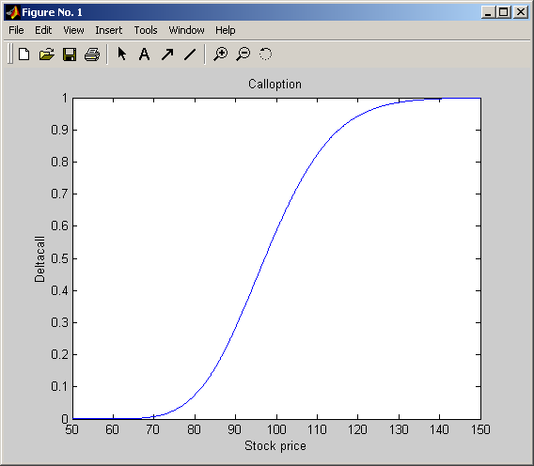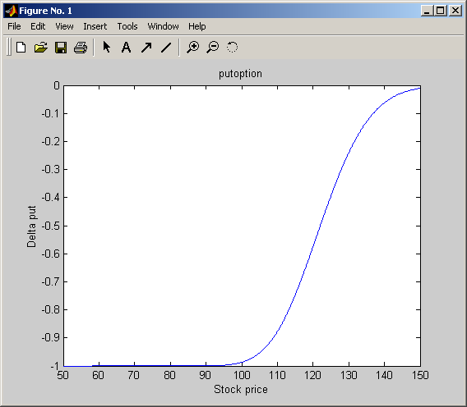

These graphs show the call and put deltas as a function of the stock price.

Making a delta- neutral portfolio in Matlab.

The portfolio consists of two options, one call and one put.
All data related to these two options are presented below.

Black-Scholes sensitivity to underlying delta change
Arguments

 | Price | Current stock price.
 | Strike | Exercise price.
 | Rate | Risk-free interest rate. Enter as a decimal fraction.
 | Time | Time to maturity of the option in years.
 | Volatility | Standard deviation of the annualized continuously compounded rate of return of the stock (also known as the volatility).
 | DividendRate | (Optional) Enter as a decimal fraction. Default = 0.

Description
[Calldelta,Putdelta] = blsdelta(Price, Strike, Rate, Time, Volatility, DividendRate)

 | Call Option | Put Option
Stock price | 100 | 119,1
Strike price | 100 | 125
Expirty time | 0.2 | 0.2
Volatility | 0.3 | 0.2
Dividend rate | 0 | 0.025

The first thing that Matlab requires is to get this inputs collected in a data matrix.

Datamatrix = [100.000,100,0.2,0.3,0 % call option
119.100,125,0.2,0.2,0.025];% put option

The first row (100.000, 100, 0.2, 0.3,0 ) assigns the inputs that refers to the Call option,
The second row (119.100, 125, 0.2, 0.2, 0.025 ) refers to inputs for the Put option.

Every column of the DataMatrix is assigned a column vector:

>> StockPrice = DataMatrix (:,1);
>> StrikePrice = DataMatrix (:,2);
>> ExpiryTime = DataMatrix (:,3);
>> Volatility = DataMatrix (:,4);
>> DividendRate = DataMatrix (:,5);

To be able to hedge the portfolio we also need to know the value of the annualized risk-free interest rate. The rate in our case is constant for all maturities and lies at 10%.

>> RiskFreeRate = 0.10;

Now we can calculate the prices and the delta sensitivity of the options using the Matlab functions bls price and bls delta

>> [CallPrices, PutPrices] = blsprice(StockPrice,Strikeprice,… RiskFreeRate, ExpiryTime, Volatility, DividendRate)

CallPrices =

6.3441
2.5846

PutPrices =

4.3640
6.6035

>> [CallDeltas, PutDeltas] = blsdelta(StockPrice, Strikeprice,… RiskFreeRate,ExpiryTime, Volatility, DividendRate)

CallDeltas =

0.5856
0.3695

PutDeltas =

-0.4144
-0.6255

There are two results for prices and deltas, that is as stated in the beginning of this paper due to the fact of call and put differences, there is an importance in keeping track on which one that is used at each occasion.

>> Prices = [CallPrices(1) PutPrices(2) ]

Prices =

6.3441 6.6035

>> Deltas = [CallDeltas(1) PutDeltas(2) ]

Deltas =

  - -0.6255

This data and the value of the portfolio that is set at $ 25 000 a linear system of equations can be set up and solved for the righteous portfolio mix to keep the delta-neutral investment.

>> A = [Deltas; Prices];
>> b = [0; 25000];
>> OptionQuantities = A\b

- where OptionQuantities is the quantity (or number) of each option.

OptionQuantities =

1.0e+003 *

1.9958
1.8685

Finally we want to compute the market value, and delta of the overall portfolio.

PortfolioValue = Prices * OptionQuantities
PortfolioDelta = Deltas * OptionQuantities

This generate the answer:

PortfolioValue =

25000

PortfolioDelta =

0

Now the investor has created a delta neutral portfolio out of those two options that are available. What happens to delta when the price of the underlying stock changes?
Lets take our call option as example. Assume that the stock price changes from $50 to $150 with step 0.1. We make the following script file:

S0=50:0.1:150;
x=100;
r=0.1;
t=0.2;
sig=0.3;
[calld,putd]=blsdelta(S0,x,r,t,sig);
plot(S0,calld)
title('Calloption');
xlabel('Stock price');
ylabel('Deltacall');

When the option is deep in the money call delta turns to 1, and when the option is out of the money it turns towards 0.

Now we make the same with our put option.

S0=50:0.1:150;
x=125;
r=0.1;
t=0.2;
sig=0.2;
[calld,putd]=blsdelta(S0,x,r,t,sig);
plot(S0,putd)
title('putoption')
xlabel('Stock price')
ylabel('Delta put')

Deep in the money put delta approaches –1, and out of the money it turns to 0.

To get a good overview of the relation between stock price, time and delta, we plot a three dimensional graph.

%Three dimensional plot
X = 100;
r = 0.1
sig= 0.3
[S0,T]=meshgrid(95:0.1:105,0.1:0.1:0.5);
[CallDeltas,PutDeltas]=blsdelta(S0,X,r,T,sig);
mesh(S0,T,CallDeltas);
xlabel('stock price');
ylabel('time to maturity');
zlabel('calldelta');
title('Delta neutral portfolio');

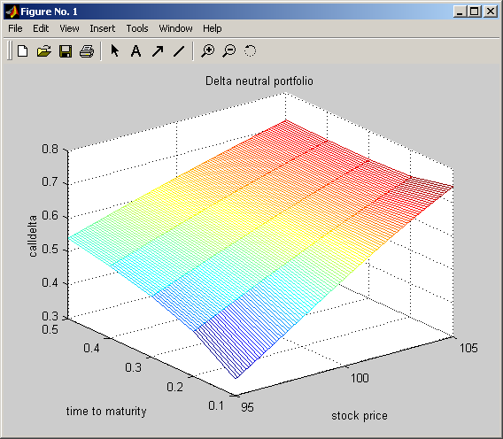

Gamma

The gamma $Γ$, of a portfolio of derivatives is the rate of change of the portfolio’s delta with respect to the price of the underlying asset.

$$Γ=∂Δ/∂S$$
$$Γ=∂^{2}Π/∂S^{2}$$

It is the second derivative of the portfolio value with respect to the asset price. Gamma is the sensitivity of an option's delta to changes in the price of the underlying asset.

Making a portfolio gamma- neutral
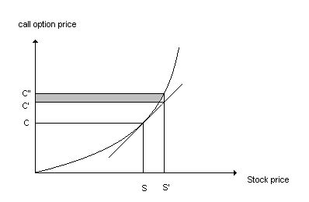

If the stock price change from S to S’, the delta- neutral portfolio assumes that the price is at C’. But in fact the option price move from C to C’’. This is a hedging error. To protect the portfolio from this error you make it gamma-neutral. That is by selling or purchasing parts of the underlying asset.

If gamma is small, delta changes slowly and adjustments to keep the portfolio delta-neutral need only to be made relatively infrequently. If gamma is large, then the delta is highly sensitive to the price of the underlying asset. At this point the portfolio can’t be left for a long time to keep it delta-neutral. Gamma neutrality provides protection against large movements in the stock price between hedge rebalancing.

To make adjustment to gamma in a portfolio we must take an option that is not linearly dependent to the underlying asset. If we have a delta-neutral portfolio with gamma equal to$Γ$ and traded option with gamma equal to $Γ_{T}$. The number of traded options added to the portfolio is $w_{T}$, the gamma of the portfolio becomes
$w_{T}Γ_{T}+Γ$
To make the portfolio gamma-neutral the position in the traded option must be -$Γ/{Γ_{T}}$.

Making a gamma- neutral portfolio in Matlab

Description

Gamma = blsgamma(Price, Strike, Rate, Time, Volatility, DividendRate)

returns gamma, the sensitivity of delta to change in the underlying security price. Blsgamma have only one output. Gamma sensitivities for call- and put options are the same.

Our portfolio contains three options, two call options and one put option. We have the stock price, strike price, expirytime, volatility and the dividend for all our options. Now we have to hedge the portfolio so it is delta- and gamma-neutral.

We are using Matlab as a tool to calculate the quantity of each option.

% Script File: Portfolio.m
% Calculate the optionquantities to obtain a gamma-neutral % portfolio
DataMatrix=[100.000 100 0.2 0.3 0 % Call option
119.100 125 0.2 0.2 0.025 % Put option
87.200 85 0.1 0.23 0] % Call option

RiskFreeRate = 0.10;
% For clarity, assign each column of DataMatrix to a column
% vector whose name reflects the type of financial data in the % column.
StockPrice = DataMatrix(:,1);
StrikePrice = DataMatrix(:,2);
ExpiryTime = DataMatrix(:,3);
Volatility = DataMatrix(:,4);
DividendRate = DataMatrix(:,5);

[CallPrices,PutPrices] = blsprice(StockPrice,StrikePrice,...
RiskFreeRate,ExpiryTime,Volatility,DividendRate);
[CallDeltas,PutDeltas] = blsdelta(StockPrice,StrikePrice,...
RiskFreeRate,ExpiryTime,Volatility,DividendRate);
Gammas = blsgamma(StockPrice,StrikePrice,...
RiskFreeRate,ExpiryTime,Volatility,DividendRate)';

% Extract the prices and deltas of inerest to account for the % distinction between call and put.
Prices = [CallPrices(1) PutPrices(2) CallPrices(3)];
Deltas = [CallDeltas(1) PutDeltas(2) CallDeltas(3)];

% Our portfolio value is $25,000. We will set up and solve the % linear system of equations such that the overall option % portfolio is delta- and gamma-neutral. The solution computes
% the value of a particular Greek of a portfolio of options as % a weight average of the corresponding Greek of each individual % option in the portfolio.
A = [Deltas; Gammas; Prices];
b = [0; 0; 25000];
OptionQuantities = A\b % Quantities of each option
PortfolioValue = Prices * OptionQuantities
PortfolioDelta = Deltas * OptionQuantities
PortfolioGamma = Gammas * OptionQuantities

DataMatrix =

100.0000 100.0000 0.2000 0.3000 0
119.1000 125.0000 0.2000 0.2000 0.0250
87.2000 85.0000 0.1000 0.2300 0

OptionQuantities =

1.0e+003 *

5.1780
1.0309
-3.4091

PortfolioValue =
2.5000e+004

PortfolioDelta =
9.0949e-013

PortfolioGamma =
-2.8422e-014

The quantity of our third option is negative. That means that we have to sell that option in short. Selling in short means that we must borrow this option from a broker and sell it. At a later date, we buy it back and return the option to the broker.

Plotting bars to show the gammas of the portfolio.

% Script File: bar.m
% Plotting bars to show that the portfolio is gamma-neutral
Gammas=[0.0290 0.0353 0.0548];
OptionQuantities=[5.1780 1.0309 -3.4091];
x=Gammas.*OptionQuantities;
sum(x)
bar(x)
title('Total gamma of the portfolio')
xlabel('Options')
ylabel('Gamma')

We call our script in the command window:
>> bar

ans =
-2.6591e-004

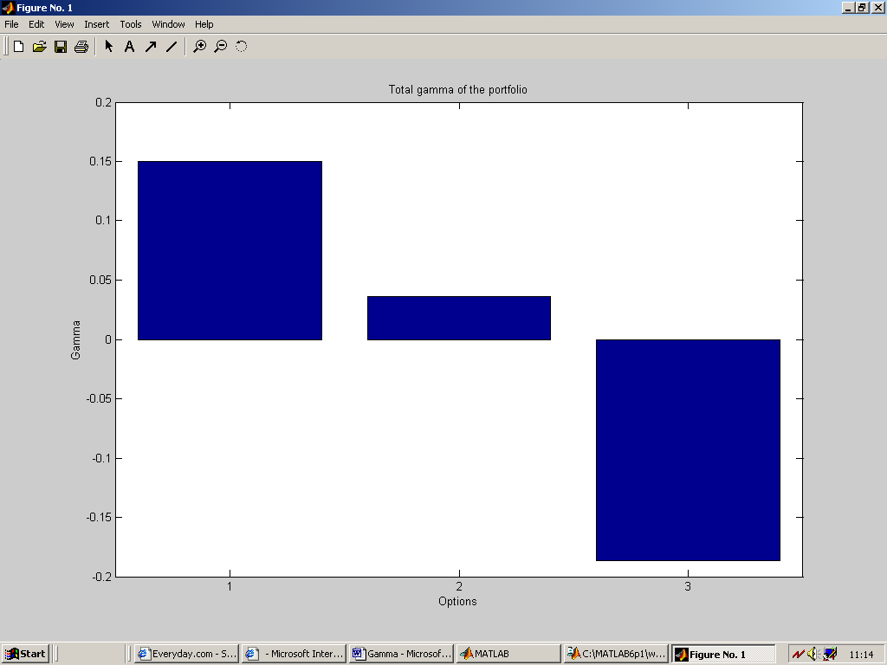

Plot of a three-dimensional graph showing the relation between stock price, time and gammas.

We want to look at one of the options and see that happens to the gamma during one year when the stock price changes with the time. We examine option no.1 and made a graph to show the relation with each other.

% Script File: bls.m
% Three-dimensional plot of the relation between stock price, % time and gammas
X=100;
r=0.1;
Sigma=0.3;
[S0,T]=meshgrid(95:0.5:105,0.1:0.01:1);
gammas=blsgamma(S0,X,r,T,Sigma);
mesh(S0,T,gammas)
xlabel('Stock price');
ylabel('Time to maturity');
zlabel('Gammas');
title('Option no.1');

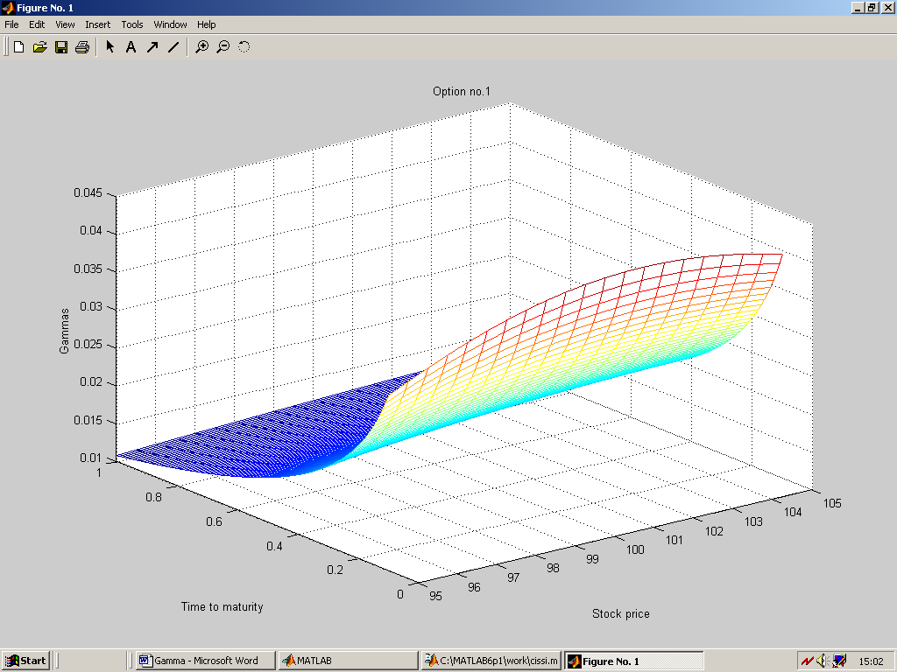

Vega

Up till now, when hedging delta and gamma parameters, we have implicitly assumed that the volatility of the asset underlying an option / derivative is constant.

In practice, however, volatilities do change which implies the value of a trader’s portfolio is exposed to change resulting from movements in volatility ( standard deviation) as well as because of changes in the portfolio’s value as time passes.

Using the so called vega, financial technique as such a sensitivity indices, enables financial managers to measure such changes. vega is actually the Black-Scholes price sensitivity measure of an option portfolio with respect to changes in the volatility of the underlying asset.

The vega of a portfolio of derivatives is the rate of change of the value of the portfolio with respect to the volatility of the underlying asset :

vega = ∂Π / ∂σ

where the symbol ∂ stands for change; Π is the value of the portfolio and σ is the standard deviation i.e. the price volatility.

The higher vega is in absolute terms, the more sensitive is the portfolio’s value to small changes in volatility. If vega is low in absolute terms , volatility changes have relatively little impact on the value of the portfolio.

The changes of the degree in sensitivity when vega increases its absolute equivalent exposes a trader’s portfolio of options to risk because of its value depreciation ( especially over time elapsing ).

Therefore a trader who wishes to protect or secure its portfolio against such volatility movements threat should hedge by making the position vega neutral.

Similarly to the constructing delta and gamma neutral portfolio neutrality, with vega this also involves an offsetting position in the traded options. For example, if vega= 2 and the trader wants to neutralize her portfolio against the threat of volatility movement, she should undertake a position equal to minus the value of the given vega parameter, that is her hedging action demands having vega = - 2; then vega = 0 is consistent with insulated or neutralized vega-portfolio.

Thus depending on a certain risk / threat traders ought to frequently adjust their portfolios, i.e. to construct their neutralization against potential risks.

Moreover important to note is that if a trader intends to achieve both gamma and vega neutrality, at least / usually two traded options are required.

Using the reliable software package MATLAB allows the computation of vega as follows:

Vega = blsvega(Price,Strike,Rate,Time,Volatility,DividendRate)

where the input arguments are current price, exercise price, rate, risk-free interest rate, maturity life of option in years, standard deviation or volatility and dividend rate, respectively.

Vega has only one output is the same for both put and call options.

How does vega change with the stock price? We can illustrate this change by creating a m-file in MATLAB, letting the stock price for a call option change from $100 to $500:

% Plot the changes in vega when the stock price changes from
% 100 to 500 with step 0.1.
S0=100:0.1:500;
X=315;
r=0.10;
t=0.5;
sig=0.25;
div=0.0333;
vega=blsvega(S0,X,r,t,sig,div);
plot(S0,vega);
title('Option no. 4');
xlabel('Stock price');
ylabel('Vega');

This gives the following figure:

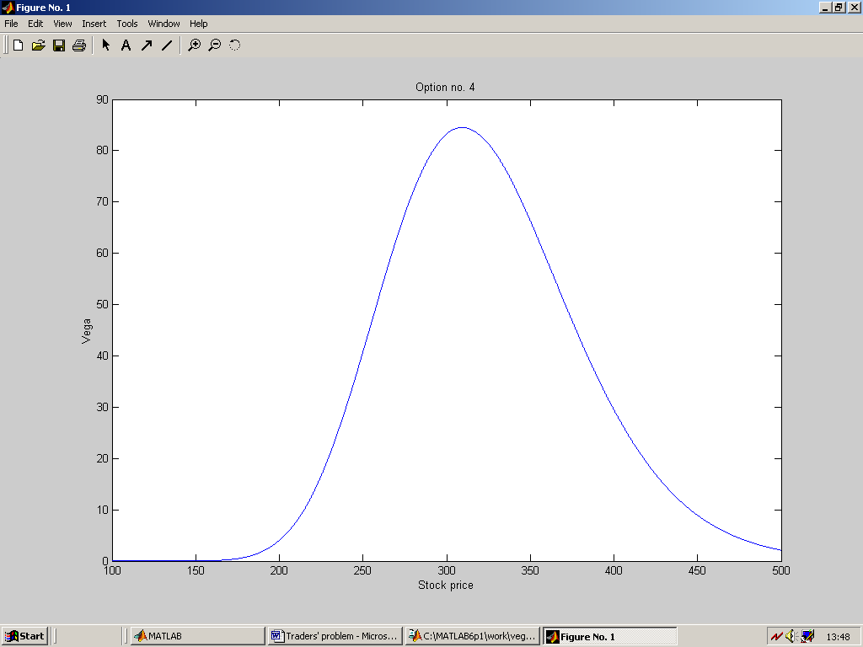

In fact this is the general relationship between the stock price and vega for options. The peak of the graph appears where x = strike price.

If the absolute value of vega is low, volatility changes have relatively little impact of the value of the portfolio. The higher the absolute value of vega, the more sensitive is the value of the portfolio to small changes in the volatility.

Making a portfolio delta, gamma and vega neutral:

The third portfolio consists of four stock options, two call options (1 and 3) and two put options (2 and 4), with the following data:

 | Option 1 | Option 2 | Option 3 | Option 4
Stock price | 100 | 119,1 | 87,2 | 301,125
Strike price | 100 | 125 | 85 | 315
Expirty time | 0.2 | 0.2 | 0.1 | 0.5
Volatility | 0.3 | 0.2 | 0.23 | 0.25
Dividend rate | 0 | 0.025 | 0 | 0.0333

Our first step in MATLAB is to collect the relative data of the options in a data matrix, where each row relates to one option.

>> DataMatrix = [100.000 100 0.2 0.3 0 % Call
119.100 125 0.2 0.2 0.025 % Put
87.200 85 0.1 0.23 0 % Call
301.125 315 0.5 0.25 0.0333] % Put

To get a clear picture we can assign each column of DataMatrix to a column vector.

>> StockPrice = DataMatrix (:,1);
>> StrikePrice = DataMatrix (:,2);
>> ExpiryTime = DataMatrix (:,3);
>> Volatility = DataMatrix (:,4);
>> DividendRate = DataMatrix (:,5);

Stating the risk free interest rate:

>> RiskFreeRate = 0.10;

We can now compute prices of each option as well as delta, gamma and vega sensitivities by using the functions blsprice, blsdelta, blsgamma and blsvega:

>> [CallPrices, PutPrices] = blsprice(StockPrice,Strikeprice,… RiskFreeRate, ExpiryTime, Volatility, DividendRate)

CallPrices =

6.3441
2.5846
4.2993
19.2849

PutPrices =

4.3640
6.6035
1.2536
22.7694

>> [CallDeltas, PutDeltas] = blsdelta(StockPrice, Strikeprice,… RiskFreeRate,ExpiryTime, Volatility, DividendRate)

CallDeltas =

0.5856
0.3695
0.7003
0.5005

PutDeltas =

-0.4144
-0.6255
-0.2997
-0.4830

>> Gammas = blsgamma(StockPrice, Strikeprice, RiskFreeRate,... ExpiryTime,Volatility, DividendRate)’

Gammas =

0.0290 0.0353 0.0548 0.0074

>> Vegas = blsvega(StockPrice, Strikeprice, RiskFreeRate,... ExpiryTime,Volatility, DividendRate)’

Vegas =

17.4293 20.0347 9.5837 83.5225

Note that we have placed an apostrophe after the blsgamma function and blsvega function, which takes its transpose. This is necessary for computations later on where we need vectors of the same size.

The blsprice function and blsdelta function have two outputs, one for call options and one for put options. It is necessary to state which ones to use.

>> Prices = [CallPrices(1) PutPrices(2) CallPrices(3)... PutPrices(4)]

Prices =

6.3441 6.6035 4.2993 22.7694

>> Deltas = [CallDeltas(1) PutDeltas(2) CallDeltas(3)... PutDeltas(4)]

Deltas =

0.5856 -0.6255 0.7003 -0.4830

With the data above and the fact that the value of the portfolio is $ 25000
we can now set up and solve a system of linear equations:

>> A = [Deltas; Gammas; Vegas; Prices];
>> b = [0; 0; 0; 25000];
>> OptionQuantities = A\b

- where OptionQuantities is the quantity (or number) of each option.

OptionQuantities =

1.0e+004 *

3.2842
1.0094
-2.3022
-0.6633
This indicates that we have to sell option no. 3 and 4 in short.

Finally we want to compute the market value, delta, gamma and vega of the overall portfolio.

PortfolioValue = Prices * OptionQuantities
PortfolioDelta = Deltas * OptionQuantities
PortfolioGamma = Gammas’ * OptionQuantities
PortfolioVega = Vegas’ * OptionQuantities

This generate the answer:

PortfolioValue =

2.5000e+004

PortfolioDelta =

-2.2737e-012

PortfolioGamma =

-2.9843e-013

PortfolioVega =

0

The portfolio delta and gamma are very close to zero, and we consider them to be neutral.
Conclusions

To protect our option portfolios against value changes we use the greeks. Delta is used to hedge against small changes in the price of the underlying asset, gamma against small and large changes in the price of the underlying asset and vega against changes in the volatility. Matlab has standard commands that makes it easy to construct greek-neutral portfolios. This means that we calculate different quantities of each option in our portfolios. Negative quantities of an option means that we have to sell that option in short.

References

Financial toolbox in Matlab. pp. 3-12—3-15.
Hull, Options, futures and other derivatives. pp. 307-341.

