MINICOURSE #8

MATHEMATICAL FINANCE

Walter Stromquist

Bryn Mawr College

walters@chesco.com

Alan Durfee

Mount Holyoke College

adurfee@mtholyoke.edu

Baltimore, MD
January 15 and 17, 2003

Notes for Part A

NOBEL PRIZES FOR MATHEMATICS

AND MATHEMATICAL FINANCE

1990 — William F. Sharpe, Merton Miller, Harry Markowitz
(Portfolio optimization)

1994 — Reinhard Selten, John C. Harsanyi, John Nash
(Game theory)

1996 — James A. Mirrlees, William Vickrey
(Auctions, etc.)

1997 — Myron S. Scholes, Robert C. Merton [Fisher Black]
(Option valuation)

Wednesday (Stromquist)

(1) Introduction
- Browsing through data: distributions of daily returns for
selected securities
- The “Standard Model” (Geometric Brownian Motion)
- Can we estimate the parameters of the standard model?

(2) Mean-Variance Optimization
- Basic model
- Extensions:
Add a risk-free asset
Capital Asset Pricing Model (CAPM)
- How is mean-variance optimization used?

Friday (1 pm, same room) (Durfee)

(3) Teaching a financial mathematics class
(4) Option Valuation: Black-Scholes formula

NOTATION

One security:

S(t) = Price (per share) of a security at time t ≥ 0
(t may be continuous or discrete)
L(t) = ln ( S(t) )
(log of price is easier to model than price itself)

Multiple securities:

S_{i} (t) = Price of security i at time t ( for i = 1, … , N )
L_{i} (t) = ln ( S_{i}(t) )
S (t) = column vector of prices, ( S₁(t), … , S_{N}(t) )^{T}

For each i and t, S_{i}(t) and L_{i}(t) are random variables.
For each t, S (t) is a vector-valued random variable.
For each i, the family S_{i}(t) (for all t ≥ 0) is a stochastic process.
The family S (t) (for all t ≥ 0) is a vector-valued stochastic process.

“DAILY RETURNS”

For now, measure t in days (with 252 days per year).
Measure daily returns in two ways:

Additive definition:
Logarithmic definition:

Both measures are commonly expressed as percentages.
The measures roughly agree when both are small.
( But R(t) is always smaller, since . )

For example, if a stock price goes from $100 to $110, the additively-defined daily return is A(t) = 10%, while the logarithmically-defined return is R(t) = 9.53%. Note that R(t) combines additively over time periods, while A(t) does not.

Additive definition vs. logarithmic definition of daily returns:

Each definitions has its place. The additive definition is assumed in everyday reporting. The logarithmic definition is more natural in a theoretical context, since we usually build models for the logarithm L(t) rather than for S(t) directly.

The additive definition has some weaknesses:

(1) It doesn’t add over time. If a stock goes up 10% on day 1 and 10% on day 2, the two-day return is 21%, not 20%.

(2) We can’t pretend that additive daily returns are drawn from a normal distribution (which would be a convenient assumption), since that would place a positive probability on returns below –100 %.

Logarithmically defined returns do combine additively over time, and it is plausible (at least, internally consistent) to assume that they are normally distributed. But the logarithmic definition has its troubles, too.

Suppose that each day, a security goes up 10% with 50% probability, and down 10% with 50% probability. Then the expected profit from holding this stock is exactly zero, whether you hold it for one day or a longer period. The average additively-defined daily return is also exactly zero. But the average logarithmically-defined daily return is smaller:

( ln(1.10) + ln(0.90) ) / 2 = –.005
which is a poor guide to expected profits. For estimating expected profit, the additive definition is better.

In practice, daily returns are usually small (-2% to +2%) and averages are hard to estimate accurately, so the numerical difference between A(t) and R(t) is unimportant.

The Half-Sigma-Squared Term

The additive and logarithmic definitions of return satisfy this relationship:
,
or, using the power series,
.
The higher-powered terms are small compared to typical values of A(t) and R(t). But if we take A and R as random variables, we find that their expected values are near zero and the squared term is more significant by comparison. We have:
.

Recall that the variance of R is given by
.
In practice, E(R) is negligible, so we can approximate Var(R) as just E(R²). Writing μ and σ² for the mean and variance of R, we have the approximation
.
At this level of approximation it doesn’t matter whether we regard σ² as the variance of A or of R. From either point of view, we see that the difference between average additive returns and average logarithmic returns is half the variance of returns. (The difference can matter. Estimated from Ford daily returns 1987-2002, and scaled to one year, the average logarithmic return was 8% but the average additive return was 14%. The latter is what matters to profits.)

This is the first appearance of the “half-sigma-squared” term that occurs throughout financial mathematics. In this context, at least, it is not at all mysterious.

STATISTICS OF RETURNS

We will use μ and σ for the mean and standard deviation of the (logarithmic) daily returns, R(t). Recall:

Mean: μ = E(R)

Variance: σ² = E(R²) – E(R)²

Standard deviation: σ =

For two securities:

Covariance: Cov ( R_{i}, R_{j}) = E(R_{i}R_{j}) – μ_{i}μ_{j}

Correlation: ρ_{ij} = Cov(R_{i}, R_{j}) / σ_{i}σ_{j}

( Covariance and Correlation )

Recall that the covariance of two random variables R_{i} and R_{j} is defined as
σ_{ij} = Covar ( R_{i}, R_{j} ) = E ( R_{i} R_{j} ) – E ( R_{i} ) E ( R_{j} ).

The covariance of R_{i} with itself is the same as its variance:

σ_{ii} = σ_{i}² = Var ( R_{i} ).

In this application the second term above is negligible (which is good, since we do not like to rely on our estimates of mean returns!). So, in practice, σ_{ij} can be estimated empirically as the average value over time of R_{i} times R_{j}:

σ_{ij} .

Recall also that the correlation coefficient is given by This value is always in [ –1, +1 ].
Also, ρ_{ii} = 1.

Since correlations are more intuitive than covariances, it is common to take as inputs the set of standard deviations and correlations, rather than the covariances themselves. Either set of inputs can be recovered easily from the other:

THE STANDARD MODEL
(GEOMETRIC BROWNIAN MOTION)

We model L(t) directly by assuming that its initial value L(0) (the log of the current price) is a known constant, and by assuming certain probability distributions for the changes in L(t) over time.

One security, discrete version:

Successive daily increments to L(t) are independent and have identical normal distributions with mean μ and variance σ².

( “daily increments to L(t)” = L(t+1) – L(t) = daily returns, logarithmically defined )

Multiple securities, discrete version:

Successive daily return vectors are independent and have
identical multivariate normal distributions with mean vector μ
and covariance matrix Σ.

LONGER-PERIOD RETURNS ARE NORMALLY DISTRIBUTED

In the logarithmic world, returns are additive. Therefore the return over a longer period is also normally distributed.

For example, the return over the first five days is

R ( [0, 5] ) = R(1) + R(2) + R(3) + R(4) + R(5).

As the sum of five independent normals, this is itself normal.

Its parameters are
mean = 5 μ,

variance = 5 σ².

There is nothing special in this model about a one-day time period. Means and variances of returns both grow in proportion to the length of the time interval.

THE STANDARD MODEL
(CONTINUOUS VERSION)

Here are the defining assumptions of the continuous version of Geometric Brownian Motion:

One security:

(1) The increment to L(t) over any interval [ t, t + Δt ]
is normally distributed with mean
Note that both mean
and variance are proportional
to the length of the time
interval.

(Δt) μ
and variance
(Δt) σ².

(2) Increments to L(t) over non-overlapping intervals are
independent.

Multiple securities:

(1) The (vector) increment to L(t) over any interval [ t, t + Δt ]
has a multivariate normal distribution with mean
(Δt) μ
and variance
(Δt) Σ.

(2) Increments to L(t) over non-overlapping intervals are
independent.

This model for L(t) is called Brownian Motion, or a Weiner Process,
or white noise. The resulting model for S(t) itself is called Geometric Brownian Motion (GBM).

μ and Σ are parameters of the process.

CONSEQUENCES OF THE STANDARD MODEL

The standard model assumes that during each time period,
L(t) is increased by a normally-distributed random variable.

Equivalently, during each time period, S(t) is multiplied by a
random variable which has a lognormal distribution.

If S(0) (the current security price) is known, then we can calculate the distributions of L(t) and S(t):

- L(t) is normal with mean L(0) + tμ and variance tσ².

- S(t) is lognormally distributed. Its mean is
.

Note that the continuously-compounded growth rate is μ + (1/2) σ²,
not just μ.

Normal and lognormal distributions

A random variable X is normally distributed if its density function is given by
Its mean is μ and its variance is σ².

A random variable Y has a lognormal distribution if its logarithm X = ln(Y) has a normal distribution. Its density function is
where μ and σ are the underlying parameters; that is, the parameters of the underlying distribution (the distribution of X).

Now Y = exp(X). But since the relationship is nonlinear, we would not expect that the mean of Y would equal exp(mean of X). In fact, the mean of Y is

exp ( μ + (1/2) σ² ).

Suppose you want to construct a standard price model in which the mean price grows at a continuous rate of m per year. Then you need to make the yearly multiplier have a mean of exp(m). If you have decided on a volatility of σ (= underlying standard deviation) then you need to choose

μ = m – (1/2) σ².

Thus, the linear growth rate of L(t) is lower than the continuously-compounded growth rate of S.

VOLATILITY

The parameter σ in the standard model is called the volatility of the security, and it is a standard measure of risk.

Since L(t) is dimensionless, so are its mean μt and variance σ²t.
That means that μ and σ² are in units of time⁻¹, and volatility itself is in units of time^{(-1/2)}.

μ is often stated in terms of percent per year, or percent per month, etc. (But note that it is the average growth rate of ln(S(t)), which is not
the same as the expected growth rate of the security.)

Volatility σ is also stated in terms of percent per year, but since its units are really time^{(-1/2)} it scales with the square root of time. Thus:
(Yearly volatility) = (Daily volatility).

Yearly volatilities of typical stocks are from 10% to 50%.
WHY THE STANDARD MODEL?

If you believe…

The stock price varies continuously as a function of time
(continuity)

Increments to L(t) over non-overlapping intervals are
independent (independence)

Like-sized intervals have identical increment distributions
(stationarity)

…then you must believe in the standard model.

ESTIMATING PARAMETERS OF THE STANDARD MODEL

If we accept the standard model, can we estimate the parameters μ and σ from the history of the stock price?

First consider μ.

Today we have 4045 observations of daily returns from F. According to the standard model, they represent independent draws from a single distribution. We calculate:

Sample mean = .000347
Sample standard deviation = .021209

Under these circumstances, .000347 is a reasonable estimate of the mean μ of this distribution. The standard error of estimate is

.021209 / = .000333.

Therefore a 95% confidence interval for the true value of μ is

μ = .000347 ± (1.96) (.000333) (daily)

= .000347 ± .000654 (daily)

or, scaled to yearly values,

μ = 8.74% ± 16.47% (yearly).

That is, we can infer from our data that the true value of μ is probably between –7.7% and +25.2%. This is useless information; we could have guessed this a priori from the nature of the stock market.

You can’t estimate the mean return of a security from its history.

ESTIMATING VOLATILITY

Today we have 4045 observations yielding a sample (daily) variance of
σ² = .000450. A standard confidence interval (based on chi-square or a normal approximation, with 95% confidence in either case) gives

0.000430 ≤ σ² ≤ .000470,

or, in terms of yearly volatility,

.329 ≤ σ ≤ .344,

which is good for any practical purpose.

If you accept the standard model, then you CAN estimate volatility (and covariance) from history.

Computing the confidence intervals…

For the mean I have used the 95 % confidence interval defined by

estimated mean ± ( estimated standard deviation )

where is the standard normal cumulative distribution function, so that

For the standard deviation I have used the confidence interval

where the denominators are critical points of a Chi-Squared distribution with n-1 degrees of freedom, and s² is the estimated variance. In this case n = 3785. When n is large (say, over 40) we can use the approximation
.

I have copied these formulas by rote from Jay L. Devore’s Probability and Statistics for Engineering and the Sciences. When n ≥ 1000 the formula can be simplified even further; the confidence interval is just

More on estimating μ from history…

Further subdividing the interval (say, using minutes instead of days) would not help. The accuracy of the estimator is determined almost entirely by the length of the sample period in years, not by how it is subdivided.

This is easiest to see if we are using logarithmically-defined returns. In this case, the estimator we are using for μ is given by
.
The accuracy of this estimate doesn’t depend on how we subdivide the time interval at all. So unless the subdivision changes our sample standard deviation—and according to the standard model, that would only occur by accident—the confidence interval is not affected at all by whether we count by days, months, or fortnights.

Using a longer sample period—say, going back to 1950 or 1900—would shrink the size of the confidence interval, but only in proportion to the square root of the time interval. We would then be relying much too heavily on the assumption that μ is constant over time.

On estimating σ² from history…

In principle, further dividing the interval would give us as accurate an estimate of σ² as we might like. For either Brownian Motion or Geometric Brownian Motion, if we are able to observe the entire continuous process over any interval of positive length, we can determine σ and σ² exactly.

In practice, we would be reluctant to use measured returns over periods of less than a day, so the interval given above is about the best we can do. Of course, if we are willing to use data further back into history, we can shorten the confidence interval a bit more.

MEAN-VARIANCE OPTIMIZATION

Statistics for Ford, Amazon:
Like 20%
returns!

 | Ford | Amazon
mean | .10 | .20
variance | .1124 | 1.0144
std. dev. (volatility) | .33 | 1.01  Don’t like  above - 100%  volatility!
covariance | .0652
correlation | .19

Can we do better by mixing Ford and Amazon?

Create a portfolio P by investing x (fraction) of fund in Ford, and y = 1-x in Amazon:

P = x ( Ford ) + y ( Amazon ) ( x + y = 1 )

Then we have:

Mean return (good):

E(P) = x E(Ford) + y E(Amazon)

Variance (bad):

Var(P) = x² Var(Ford) + y² Var(Amazon)
+ 2xy Covar(Ford, Amazon)

Var
Π
x=0 (all Amazon)
x=1 (all Ford)

x | mean | variance
0 | .20 | 1.0144
.5 | .15 | .3143
.7 | .13 | .1738
.95 | .105 | .1102
1 | .10 | .1124

MEAN-VARIANCE OPTIMIZATION

We want to invest B dollars in some mix of securities, in such a way as to maximize expected return and minimize risk.

( Competing Objectives! )

Start by defining the choices available to us. Let

x_{i} = number of dollars we invest in security i ( for i=1…N ).

We are free to choose values of x₁,…,x_{N} subject to a budget constraint,

x₁ + … + x_{N} = B,

and perhaps other linear constraints. For today, assume that the only other linear constraints are non-negativity constraints:

x_{i} ≥ 0 for i = 1, …, N.
A vector x = ( x₁ , … , x_{N} ) satisfying these constraints is called a portfolio, or a feasible portfolio. The feasible portfolios form a compact, convex subset of R^{N} called the feasible set.

Restating the problem: we want to choose a portfolio that, among feasible portfolios, maximizes expected return and minimizes risk.
INPUTS TO MEAN-VARIANCE OPTIMIZATION

We assume that the mean returns for the securities, and all covariances, are known. Some notation:

R_{i} = Return on i-th security (a random variable)

( Thus, our profit from investing x_{i} in the i-th security is
x_{i}R_{i} ,
which is also a random variable. )

μ_{i} = E ( R_{i} ) = expected return
σ_{i} = standard deviation of R_{i}
σ_{i}² = Var ( R_{i} ) = variance of R_{i}

σ_{ij} = covariance of R_{i} and R_{j} ( note that σ_{ii} is the same as σ_{i}². )

ρ_{ij} = correlation of R_{i} and R_{j}.

MEAN-VARIANCE OPTIMIZATION (continued)

With this notation, we can write the return from the portfolio x = ( x₁ , … , x_{N} ) as a random variable:

Π(x) = x₁R₁ + … + x_{N}R_{N} .

We want to maximize the mean of Π(x) and minimize its variance. Thus, our two objectives involve

π(x) = E(Π(x)) = x₁r₁ + … + x_{N}r_{N} (to be maximized)

and
Var (x) = Var(Π(x)) = (to be minimized).

(It would be just as good to minimize the standard deviation, σ(x)= . )
Let’s see which combinations of ( Var(x), π(x) ) are possible as x ranges over the set of feasible portfolios:

The yellow image of this map is compact, since it is a continuous image of a compact set. It isn’t usually convex.

We have seen that a segment on the left maps to a parabola on the right (opening to the right). This is true of all segments (barring degeneracies). Thus the left edge of the yellow image is convex (that is, the edge is concave to the right) and that’s all we need.
MEAN-VARIANCE OPTIMIZATION (continued)

The upper-left edge of the yellow image is called the efficient frontier. Each point on the frontier represents a portfolio that…

(a) Maximizes π for a given value of the variance Var, or

(b) Minimizes Var for a given expected return π.

We call these efficient portfolios.

Our model tells us that we should choose an efficient portfolio, but it offers no guidance as to which efficient portfolio we should choose. That depends on the investor’s taste for risk.

Therefore, a reasonable statement of our problem is to find portfolios corresponding to all points on the efficient frontier.

MATRIX FORMULATION

Introduce column vectors x = ( x₁ , … , x_{N} )^{T} and r = ( r₁ , … , r_{N} )^{T}, and the vector of all 1’s, e = ( 1 , … , 1 )^{T}. Also, write the covariance matrix as
.

Now the constraints can be written as
x^{T}e = B (budget constraint) and
x ≥ 0 (non-negativity).

The various objective functions become
Mean: π(x) = x^{T}r ;
Variance: Var(x) = x^{T}Σx ; and

Standard deviation: σ(x) = .

FORMAL STATEMENTS

We could state the problem formally in either of two ways.

For each K,

Maximize

π = x^{T}r

by choice of x subject to

x^{T}Σx ≤ K,

x^{T}e = B,

x ≥ 0.

For each L,

Minimize

Var = x^{T}Σx

by choice of x subject to

x^{T}r ≥ L,

x^{T}e = B,

x ≥ 0.

FORMAL STATEMENTS

But there’s a better way:

For each λ in [0, +∞]

Maximize

Φ = λ x^{T}r – (1/2) x^{T}Σx

by choice of x subject to

x^{T}e = B,

x ≥ 0.

Each value of λ corresponds to one point on the efficient frontier.

For each λ, this is a quadratic programming problem (“an instance of a quadratic program”). The only sense in which it is not entirely routine is that we are to solve the problem for a family of λ’s, and it is more efficient to solve the family together than to apply quadratic programming algorithms separately for different values of λ.

WHAT IF THERE IS CASH?

( At this point it is convenient to introduce a simplification.

( Since the entire problem scales with B, we might as well assume that B = 1. The budget constraint becomes

x₁ + … + x_{N} = 1,

and we can interpret x_{i} as the fraction of our portfolio invested in security i.

( Also, at this point we will make a sudden change: We will use σ(x) in place of Var(x) in our graphs of the efficient frontier. Clearly it makes no difference whether we minimize σ(x) or Var(x). Also, the graph of the efficient frontier looks the same: it is still strictly concave towards the right. )
WHAT IF THERE IS CASH? (continued)

Introduce a new asset, indexed by i=0, with a guaranteed return of r₀.
That is:
σ₀² = 0, and
σ_{i0} = 0 for each i = 1, …, N.
Call the new asset cash, and call r₀ the risk-free rate. The other assets are called risky assets.

Weu can borrow or lend as much cash as we want at the risk-free rate. That is, there is no non-negativity constraint for x₀ — the fraction of our portfolio that is in cash can be positive or negative.

What does this do to the efficient frontier?

First, we add the point ( 0, r₀ ) corresponding to the all-cash portfolio.

Suppose we keep a fraction x₀ of our portfolio in cash, and allocate the remaining fraction (1-x₀) to risky assets in proportion to M, where M was a feasible portfolio under the old formulation. Then:

π ( x ) = x₀r₀ + (1-x₀) π ( M )
σ ( x ) = (1-x₀) σ ( M ).

In a σ-π graph, this lies on a line joining the all-cash portfolio to the portfolio M. ( If x₀ < 0, it lies on the same line but beyond M.)

So the new set of possibilities ( σ, π ) is the cone connecting the all-cash point with the original image. The new efficient frontier is the ray from ( 0, r₀ ) through the point realized by a particular portfolio which we will call M*.

Note now that there is a unique optimal portfolio M* of risky assets. We exercise our risk preference only by deciding how much cash to hold, and how much of the optimal portfolio M*.

M* happens to be the portfolio that maximizes the Sharpe Ratio,

Sharpe Ratio = .

CAPITAL ASSET PRICING MODEL

Now assume that everyone agrees on the inputs r and Σ. Then everybody calculates the same M*. Everybody holds the same mix of non-cash securities. Investors differ only in how much cash they hold, and how much of M*.

M* must necessarily be a proportional share of all the securities that exist. We call it the market portfolio.

Since every security is in M*, it follows from the solution of the quadratic program above (and lots of algebra) that every security satisfies this equation:

r_{i} = r₀ + β_{i} (r_{M} – r₀) ,

where r_{M} = π(M*).

The coefficient β_{i} is the same as the regression coefficient in the equation

R_{i} = β_{i} R_{M*} + α.

That is,

.

This is a theory of what expected returns must necessarily be, if we accept all of the assumptions made so far.

WHO USES MEAN-VARIANCE OPTIMIZATION?

Hedge funds

Asset allocation (e.g., what fraction of our investment fund should we have in bonds vs. mutual funds? Here we deal with categories of securities, rather than individual securities.)

The theory of “implied views.”

Downloading historical returns from Yahoo:

(1) Go to http://finance.yahoo.com

(2) Enter your favorite stock symbol, select CHART, and click GET

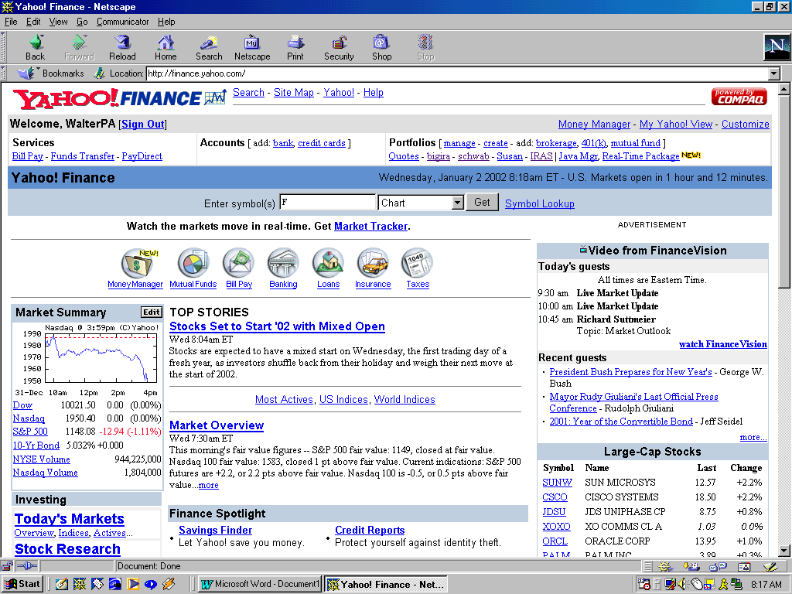
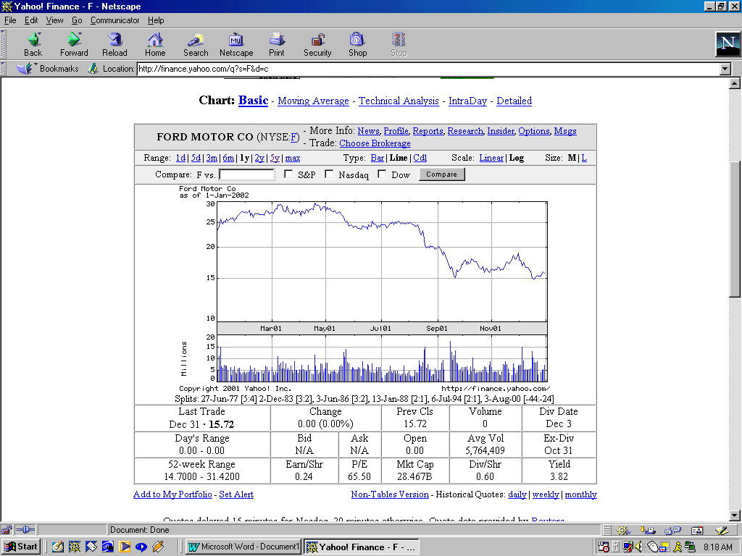

(3) Scroll to the bottom of the table and click on the link for “daily”, “weekly”, or “monthly” historical data.

(4) Enter the dates you want, and change other selections if you like
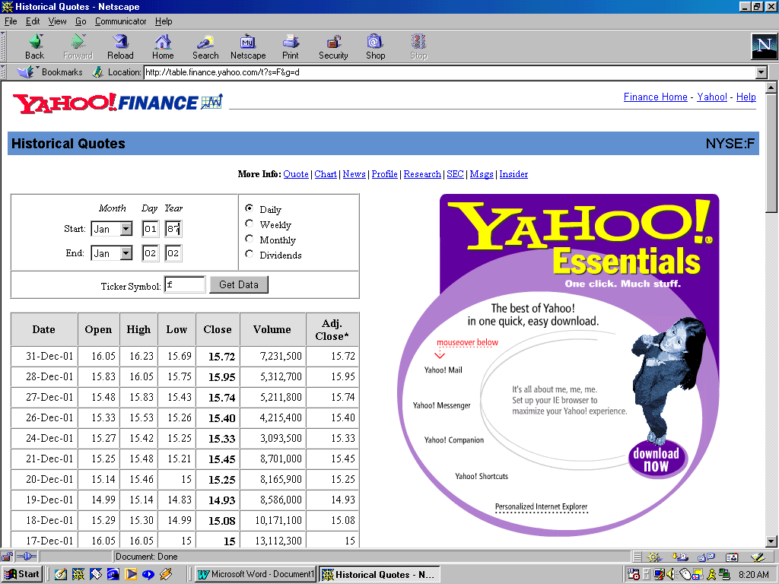
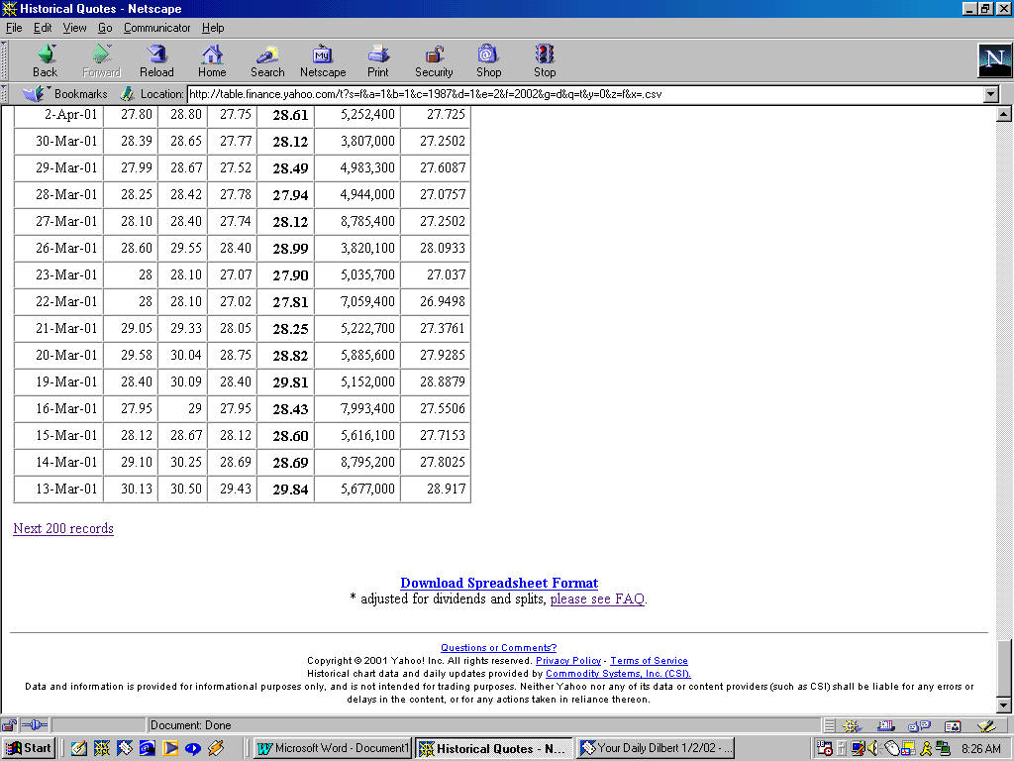

(5) Scroll to the bottom and select “Download Spreadsheet Format.”

The spreadsheet is in .csv format and can be read with Excel. It may not be perfect, so check the dates for gaps and duplications. The spreadsheet shows “adjusted prices” only. If you want the actual historical prices or the dividend events, you may need to get them directly from the displayed tables (shown above) which list only 200 lines at a time.

A book reference:

Brealey and Myers, Principles of Corporate Finance, 5th Ed., McGraw Hill, 1996 (ISBN 0-07-007417-8). Standard textbook for a graduate-level corporate finance course.

Some web sites:

www.chesco.com/~marys/ ( follow the link for the minicourse )

www.stanford.edu/~wfsharpe/home.htm (Prof. William F. Sharpe’s home page)

www.ibbotson.com (free and expensive research; their Yearbook—classic edition, mainly—is a standard source)

www.efficientfrontier.com/ (an intelligent newsletter for investors, not necessarily an authority)

www.bus.indiana.edu/finweb/holden.htm (maybe start with dynamic chart – port. opt. — docu.)

www.wagner.com

www.wagner.com/technologies/mathfinance/waoptimize.html (about the WAOPTIMIZE program)

