Solutions Analytical Finance I, January 2008

1. Solution
- 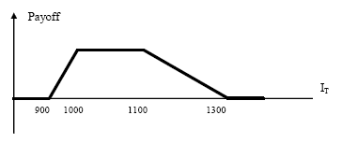
- The product is consistent with a view strongly expecting the S&P to be between 1000 and 1100 in 8 months (hence with a limited volatility), with some hopes of having the S&P 500 between 900 and 1000, or between 1100 and 1300. The investor does not expect an index lower than 900 nor higher than 1300.

- The payoff can be replicated with one long call with strike 900, short one call with strike 1000, short 0.5 calls with strike 1100, and long 0.5 calls with strike 1300.

- The cost should be 181.1836 – 108.8097 – 0.5 · 54.4109 + 0.5 · 7.5781 = 48.9575.

2. Solution

a)
u = 1.1
d = 1/u and therefore d = 0.9091

p = (1+R-d) / (u-d)
p = (1 + 0.02 - 0.9091)/(1.1 - 0.9091) = 0.5809
(1-p) = 0.4191

T = 0 T = 1 T = 2

2.0812 Put = Max(0; 1.75 - 2.0812) = 0
1.8920
1.72 1.72 Put = Max(0; 1.75 - 1.72) = 0.03
1.5636
1.4215 Put = Max(0; 1.75 - 1.4215) = 0.3285

American Puts can be exercised anytime before expiration even without dividend:

T = 1: Put_{american} = Max(P dead; P alive)
P_{t} = Max (K-St ; (p · P_{up} + (1 - p) · P_{down})/(1+R))
P_{up} = Max(1.75 - 1.8920 ; 0.5809 · 0 + 0.4191 · 0.03)/1.02))
P_{up} = Max(-0.1420 ; 0.0123)
P_{up} = 0.0123
P_{dwn} = Max(1.75 - 1.5636 ; (0.5809 · 0.03 + 0.4191 · 0.3285)/1.02))
P_{dwn} = Max(0.1864 ; 0.1521)
P_{dwn} = 0.1864 early exercise

T = 0: P_{ut} = Max(1.75 - 1.72 ; (0.5809 · 0.0123 + 0.4191 · 0.1864)/1.02))
P_{ut} = Max(0.03 ; 0.08359)
P_{ut} = 0.08359 CHF, no exercise in t=0

In t = 0, the price of 1 American Put is 8.359 centimes per USD.

b)
The put’s payoff is bounded: at maturity, the maximal gain is K (less the premium) if the underlying is worth 0 (It is not the same with the call where the potential gain is unlimited). In the case of an American put, this fact limits the benefit of waiting to exercise: an early exercise is optimal if the underlying spot price gets low enough (interest rate). The possible risk-free arbitrage takes place when the put is deep in-the-money. An early exercise provides X. If the difference between X and the present value of X is larger than the corresponding call price, one invests PV(X), buys the call and makes the risk-free profit. (notice: the foreign risk-free rate on the foreign currency can be viewed as a dividend yield)

c)
(Factors closer to 1) A smaller « up factor » (and therefore a larger « down factor ») would reduce the value of both puts and calls. The reason is that the level of these factors represents the volatility in the model:

d = 1/u and u=EXP(σ · √(t/n)) then σ = LN(u) / √(t/n)

As the derivative of the price of option with respect to the volatility is positive, if the volatility decreases, the option price decreases too. (δPut / δσ > 0) The intuitive reason is: as the volatility increases, the stock price distribution at maturity widens. In that case, the expected pay-off of the option at maturity increases, and so does the price of options. In our case, it is the opposite situation.

(if u = 1.10 then P = 0.08359
u = 1.08 then P = 0.0670
u = 1.05 then P = 0.0399)

Notice: if an American option is in-the-money and the volatility decreases, the probability of an early exercise increases (in our case, if u = 1.02 then the put is exercised immediately in t = 0). In this case the American put price is clearly higher than the European put.

3. Solution

a) We use the Black and Scholes formula. It gives a price per option of CHF 4.57.

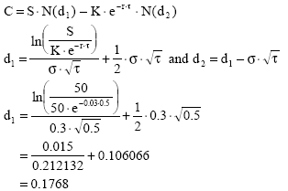
d₂ = -0.0354
Therefore:

N(d₁) = 0.5702
N(d₂) = 0.4859

And C = 50⋅0.5702 − 50⋅ e^{−0.03⋅0.5}⋅0.4859 = CHF4.57

b) The net profit would be CHF 7 per option, minus the premium of CHF 4.57, times the contract size (100). The final profit is therefore CHF 243.

c) The delta corresponds to the N(d₁) term in the Black and Scholes formula. It is equal to 0.57, which means that a unit variation of the stock price will result in a variation of 0.57 in the call price.
d) We simply use the put call parity. The answer is CHF 3.83.

e)
If the risk-free rate increases, the put price decreases while the call price increases.
The reasons can be the following:

Explanation 1:
For a put, Rho (change in option price per unit change in the interest rate) is given by

which is less than zero, since N(d₂) is always between zero and one. Hence for an increase in the risk-free rate, the put price decreases.

For a call, Rho is given by

which is greater than zero. Hence for an increase in the risk-free rate, the call price increases.

Explanation 2:
As risk-free rate increases, the general interest rates in the economy increase. Hence the expected growth rate of the stock price tends to increase. Secondly, the present value of any future cash flows received by the holder of the option decreases. These two effects tend to decrease the price of the put option. In case of the call option, the first effect tends to increase the call price while the second effect tends to decrease the price. However, the first effect dominates the second effect and hence price of call option always increases as risk-free rate increases.

4. (a) Our CEO wants to construct a portfolio whose value at time T will equal -Aln(S_{T}/K), as this portfolio will exactly neutralize her contract. She will have eliminated the uncertainty present in her contract, and will have no net cash flow at time T. The market is complete (assuming she can trade in the company stock), so the cost of implementing the hedge must be

(b) Since
we have that

(c) Substituting the parameters, the above expression equals

Note that the hedging cost is negative, which means that the net result of hedging is that she receives an immediate payment of $14345. She has basically traded a certain immediate payment for an uncertain (though possibly larger) future payment/debt.

5. Solution

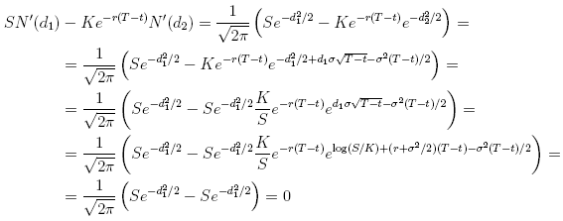

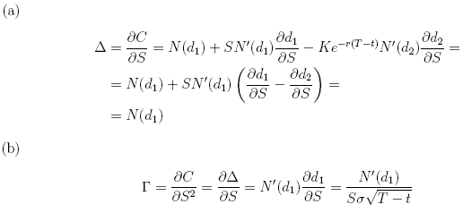
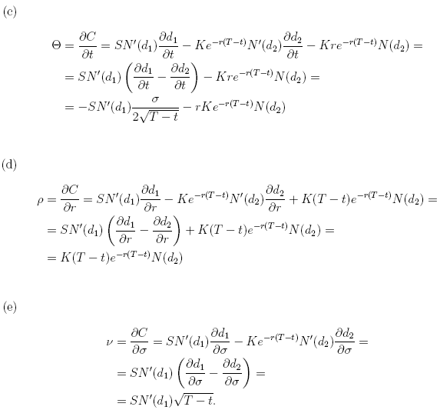

The partial differential equation holds because:

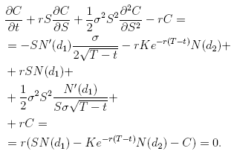

6. Solution

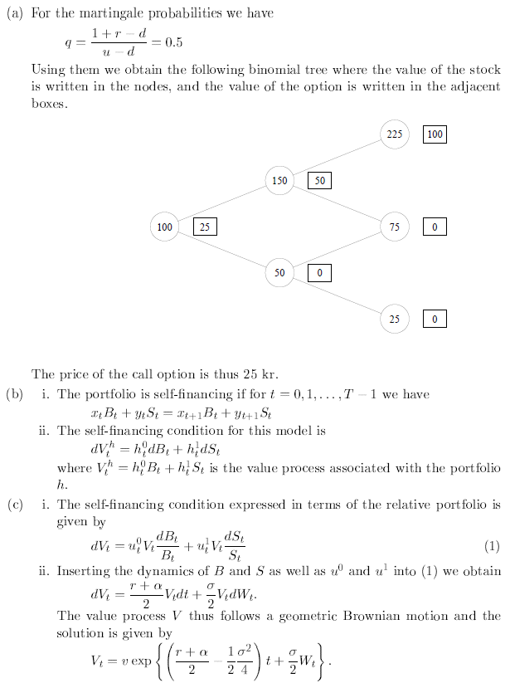
- (a) We have that
Using Ito's formula on this we get
The portfolio is therefore not self-financing.
(b) The price of a binary asset-or-nothing call is given by
where φ denotes the density of a N[(r - σ²/2)(T - t), σ²(T - t)]-distribution. Now use that the density function for a N[(r - σ²/2)(T - t), σ²(T - t)]-distributed and complete the square in the exponent. This yields
where ψ denotes the density of a N[(r + σ²/2)(T - t), σ²(T - t)]-distribution. We thus have that
.
Where we have used one of the hints to obtain the last equality. We recognize the first half of Black-Scholes formula for the price of a European call option. For the binary cash-or-nothing call we have
Where Z N[(r - σ²/2)(T - t), σ²(T - t)]. Rewriting a bit gives
where we have used one of the hints to obtain the last equality. We recognize the second half of Black-Scholes formula for the price of a European call option.

