1. (a) For the martingale probabilities we have  
     
       
     
   Using them we obtain the following binomial tree where the value of the stock is written in the nodes, and the value of the option in adjacent boxes.  
     
    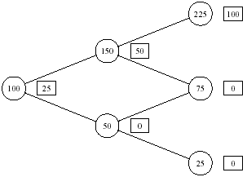  
   The price of the option is thus 25.  
     
   (b) i. The portfolio is self-financing if for *t = 0, 1, 2,…., T-1* we have  
     
      
     
    ii. The self-financing condition in this model is where  
     is the value process associated with the portfolio *h*.   
     
   (c) i. The self-financing condition expressed in terms of the relative portfolio is given by  
    

ii. Inserting the dynamics of *B* and *S* as well as *u0* and *u1* we obtain  
  
   
  
The value process *V* thus follows a GBM with the solution:  
  
   
  
(d) To obtain the replicating portfolio at *t* =0 we have to solve the following set of equations  
  
 *x* + 150*y* = 50  
 *x* + 50*y* = 0  
  
since regardless of whether the stock price goes up or down the value of the portfolio should equal the value of the option. This yields  
  
 *x* = 25, *y* = 1/2  
  
Using the same method we find the rest of the replicating portfolio strategy and it is shown in the figure below.  
 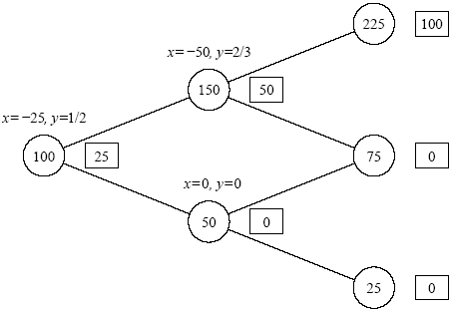  
  
That the portfolio strategy is self-financing is seen from the following equations  
  
 -25 + ½ x150 = -50 + 2/3 x 150  
 -25 + ½ x 50 = 0 + 0 x 50

1. (a) The arbitrage bounds for the interest rate *r* are 0.5 ≤ (1 + *r*) ≤ 1.5.   
     
   (b) Both the price of stock and the price of the option have to satisfy the risk-neutral valuation principle. This gives us the following set of equations   
     
      
      
   Solving these equations we find that *r* = 5% (and q = 0.55).
2. The Black-Scholes PDE is given by:  
     
      
   or  
      
   i.e.  
    
3. (a) See Lecture Notes  
   (b) The value process *V*(*t*) is given by:

*V*(*t*) = *hB*(*t*)*B*(t) + *hS*(*t*)*S*(*t*)

To be a self-financing portfolio strategy, the value process *V* must satisfy

*dV*(*t*) = *hB*(*t*)*dB*(t) + *hS*(*t*)*dS*(*t*)

In order for the relative portfolios, the value process *V* must satisfy  
  
   
where

  
  
To solve the above SDE we use *V0* = *v0* and define *Z* = ln(*V*) and use Itô:



Integrating gives

  
and

  
  
We also know that



The portfolio is now easily found to be (*B*= *e-rt*):



and

   
  
  
(c) Let *Zt* = *1/St*. Using Itô's formula we obtain the dynamic of *Z* under *Q* as  
  
   
  
where *V* is a *Q*-Wiener process. Integrate and take conditional expectation to obtain  
   
  
Let *m*(*u*) = *E*[*Zu* | *Ft*] and take the derivative w.r.t. *u*. This yields the following ODE for *m*  
  
   
  
Solving the ODE we obtain  
  
   
  
The price at time *t*  [*0*, *T0*) of "the inverse mean" is therefore given by  
  
 

5.

