PC Installation

- Extract the Add-in folder (Fred) on to your computer. You should not move this folder after you install the Add-in.
- Open Microsoft® Excel® and click on the Office Button in the upper left-hand corner of the window.

- Choose from the drop down menu, a window will appear.

- On the left side of the window choose Add-ins.

- On the bottom of the window choose Go.

- In the new window, choose and locate the file fred.xlam that you downloaded and click OK.

- Make sure the check box next to FRED is checked: . Click OK.

- You will be prompted with a security warning asking if you want to allow Macro’s and data connections from the Add-in. Click OK.

- Close and re-open Excel to verify that the Add-in has been installed correctly.

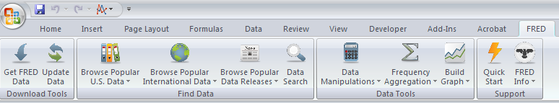

Important Security Note: You may need to change your Excel security settings to avoid the data connections warning each time you open Excel, you can do this two ways:

Option 1: Add the FRED folder as a “trusted location” (suggested).

- Open Excel and click on the Office Button in the upper left hand corner of the window.

- Choose from the drop down menu, a window will appear.

- On the left side of the window choose Trust Center.

- Click on .

- Choose Trusted Locations from the menu on the left.

- Click on Add new location.

- Browse for the FRED folder and click OK.

Option 2: Enable all data connections.
- Open Excel and click on the Office Button in the upper left hand corner of the window.

- Choose from the drop down menu, a window will appear.

- On the left side of the window choose Trust Center.

- Click on .

- Choose External Content.

- Choose Enable all Data Connections under the Security settings for Data Connections.

