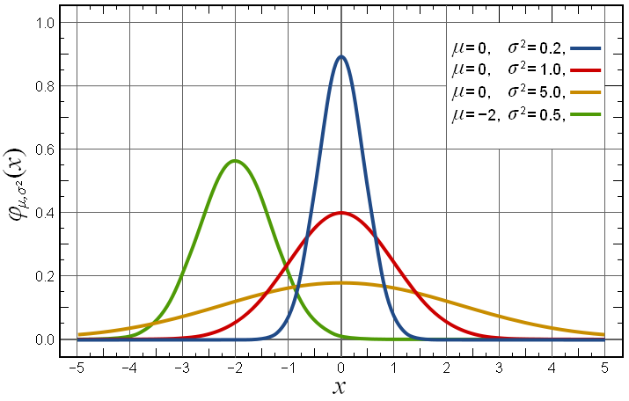

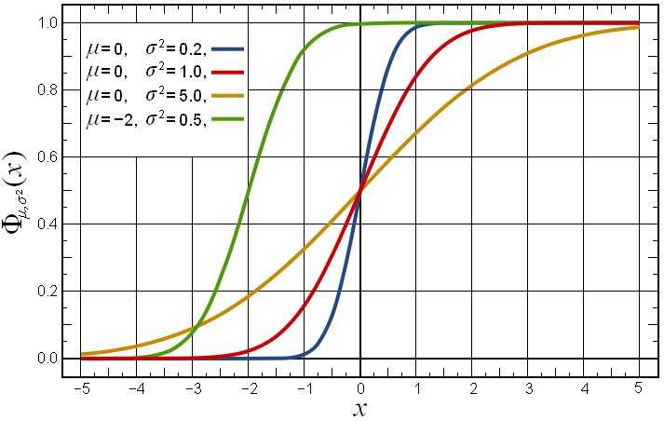

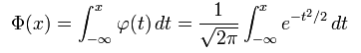
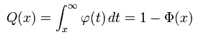

The family of normal distributions is closed under linear transformations. That is, if X is normally distributed with mean μ and variance σ², then a linear transform aX + b (for some real numbers a≠0 and b) is also normally distributed:
